VELOOP REWARDS
DATA ANALYST INTERNSHIP - TASK 01
FINAL CONSOLIDATED SUBMISSION
Made by Sai Sunil Gawaskar
Product Analytics, Data Readiness & Data Management Blueprint
Prepared as a student internship submission pack. All supplied and generated operational datasets are labelled simulated and are not production VELOOP statistics.
Task scope is aligned to the provided 44-page Task 01 document, including the 21 requested deliverables, data integrity rules, event design, data model, KPI catalogue, data profiling, quality controls, dashboard blueprint, developer handoff, governance and implementation backlog.

01 - Executive Summary
This project investigates what data a developing VELOOP Rewards product should collect, how the data should be structured, how data quality should be controlled, and how future analytics can be delivered reliably. The supplied workbook contains 1,000 clean simulated user records plus a 1,008-row messy audit version. Because the supplied workbook is Users-only, additional operational sheets were created strictly for analytical testing and are clearly labelled SIMULATED DATA - CREATED FOR ANALYTICAL TESTING.
- Primary finding: the biggest analytical dependency is not dashboard design; it is reliable instrumentation and stable identifiers across users, sessions, task activity, rewards, wallet transactions, referrals and withdrawals.
- The supplied Users data supports basic user/account profiling, but it does not contain the granular event and transaction history needed to calculate many product KPIs directly.
- The blueprint therefore separates Confirmed information, Proposed analytics requirements, To Be Verified implementation details, and Simulated testing data.
- The highest-priority controls are stable user/event/transaction IDs, event idempotency, controlled status values, referential integrity, timestamp standardization, and task-to-reward / transaction reversal linkage.
- The deliverable includes 34 governed KPIs, 34 event definitions, 122 data-dictionary fields, an engineer-readable ER model, data quality controls, seven dashboard blueprints, developer acceptance tests, a pipeline model, privacy roles, change management, a readiness scorecard, and a prioritized implementation backlog.
Supplied user-data observations: 1,000 records; account statuses include Active, Inactive, Suspended and Pending Verification. The source workbook documents a period of 01 Apr 2026 to 15 Sep 2026; the profiling also identified 72 missing last-login values and a small set of derived/date consistency items that should be verified before production use.
Recommendation for implementation sequence: establish the event and identity contract first, then validate data quality at collection and transformation, then publish the governed KPI layer, and only after that build production dashboards.

02 - Product Data Audit
Detailed row-level mapping is available in workbook sheets 03_Product_Data_Audit and 04_Data_Coverage_Matrix. The mapping distinguishes what the user does from what the system records and from the business outcome that management may measure.
Area | Representative feature | User action | Analytics state | Priority
Accounts | Registration/Login | Register or log in | user_registered / user_logged_in | Critical
Earning | Task-based earning | View/open/start/complete | task_* lifecycle + validation | High
Rewards | Daily reward / streak / spin | Claim, maintain, spin | reward_* and engagement events | High
Wallet | Wallet ledger | Receive/consume balance | wallet_transaction_* | Critical
Withdrawals | Payout lifecycle | Request / process / complete | withdrawal_* | Critical
Referrals | Referral funnel | Create / register / activate / convert | referral_* | High
Support | Help center | View content / raise issue | help_center_viewed / support ticket | Medium

Analytics Gaps Identified
Gap | Why it matters | Priority
GAP-01 - Stable session_id not verified | Session stitching and session funnels require a stable identifier. | Critical
GAP-02 - Stable event_id + idempotency not verified | Duplicate events can overstate activity and KPI counts. | Critical
GAP-03 - Task activity-to-reward linkage not verified | Activity and reward credit must be separated and reconciled. | Critical
GAP-04 - Wallet reversal/correction linkage not verified | Ledger auditability depends on parent transaction references. | Critical
GAP-05 - Status vocabulary needs governance | Inconsistent states break KPI filters and state machines. | High
GAP-06 - Snapshot cutoff mismatch needs verification | Supplied README ends 2026-09-15 while some last_login values extend later. | High
GAP-07 - Referral conversion definition needs product approval | Registration is not the same as activation or conversion. | High
GAP-08 - Withdrawal reason categories need approved taxonomy | Supports operational analysis without inventing confidential rules. | High
GAP-09 - Versioned KPI/data dictionary ownership not established | Prevents silent metric drift. | High
GAP-10 - Automated data quality gates are not running | Bad IDs/dates/statuses can reach BI. | Critical
GAP-11 - External provider outcome fields need standardization | Third-party dependencies may cause outcomes outside VELOOP control. | Medium
GAP-12 - Support/help-center dataset is absent from supplied workbook | Support KPIs cannot be computed from Users-only data. | Medium

03-08 - Analytics Specifications
The workbook contains the detailed user, earning/reward, wallet/withdrawal, referral/engagement and event-tracking specifications. The key design decision is to keep lifecycle stages separate so that an action being performed is not automatically treated as a completed business outcome.
Domain | Core measurement | Required identifiers | Important distinction
User | Registration, login, onboarding, lifecycle | user_id, event_id, session_id | Account state vs user event
Earning | Discovery -> Start -> Completion -> Validation -> Reward | user_id, task_id, task_activity_id | Activity occurred vs reward credited
Wallet | Ledger movements and reversals | transaction_id, user_id, reference_id | Transaction vs reversal/correction
Withdrawal | Requested -> Processing -> Completed + Rejected/Reversed | withdrawal_id, user_id | Pending queue vs final outcome
Referral | Created -> Registered -> Activated -> Converted | referral_id, referring/referred user IDs | Registration is not conversion
Engagement | Feature adoption, repeat usage, daily activity | user_id, timestamp, feature | Exposure vs meaningful use

Event Tracking Standard
Naming convention: object_action (for example, task_started, reward_credited, withdrawal_completed). This keeps event names simple, predictable and easy to query. Every event specification includes a trigger, definition, identifiers, timestamp, status, required/optional properties, validation, source, business purpose, KPI dependency and implementation status. The proposed registry contains 34 meaningful events.

09-10 - Data Dictionary and Logical Data Model
The analytical model contains the core entities requested by the task: Users, Tasks, Task Activity, Rewards, Wallet Transactions, Withdrawals, Referrals and Feature Events. Support Tickets is also proposed because the task requires support/help analytics, but no support dataset was supplied.
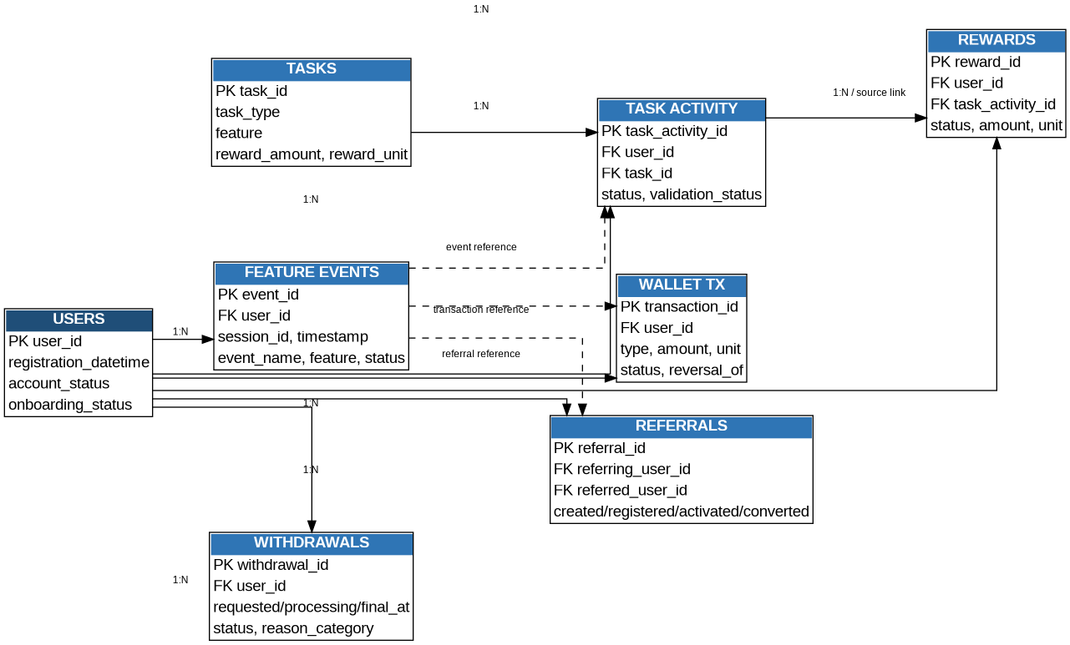
The full data dictionary contains 122 meaningful fields, including type, definition, example, required status, allowed values, validation, source, sensitivity, analytical use and status.

11 - KPI Catalogue
A first-pass KPI catalogue of 34 metrics was prepared. No fictional company targets are included. Each KPI has a reproducible formula and a stated limitation. Metrics must be calculated from governed production data once instrumentation is available.
Area | Example KPIs | Status
User | Registrations, DAU, Returning Users, Inactive 30d, Onboarding Completion | Proposed / partly calculable from supplied user fields
Engagement | Feature Adoption, Task Starts, Task Completion Rate, Failure Rate, Repeat Usage | Proposed; synthetic testing supported
Reward | Reward Transactions, Credits, Reversal Rate, Reward by Feature | Proposed; synthetic testing supported
Wallet | Transactions, Credit Volume, Redemption, Reversal Rate | Proposed; synthetic testing supported
Withdrawal | Requests, Completed, Pending, Rejected, Reversed, Processing Time, Completion Rate, Volume, Method Mix | Proposed; synthetic testing supported
Referral | Created, Registration Rate, Activation Rate, Conversion Rate | Proposed; conversion definition needs approval
Support / Data Quality | Help Views, Support Requests, Completeness, Referential Integrity | Proposed

12 - Simulated Data Profiling
Supplied data was profiled first, then additional simulated operational test data was generated to exercise the full analytical model. The generated datasets are labelled and should be replaced by governed production data when available.
Dataset | Records | Columns | Date range | Primary-ID check | Duplicate rows | Missing/notes
Users (supplied clean) | 1,000 | 27 | 2026-04-01 to 2026-09-17 | 1,000 | 0 | 953 cells
Users_Messy_Audit (supplied) | 1,008 | 28 | 2026-04-01 to 2026-09-17 | 1,000 | 8 | 965 cells
Tasks (simulated) | 10 | 12 | 2026-04 to 2026-06 | 10 | 0 | 15 cells
Task Activity (simulated) | 6,000 | 15 | 2026-04-01 to 2026-09-17 | 6,000 | 0 | -
Rewards (simulated) | 5,000 | 13 | 2026-04-01 to 2026-09-17 | 5,000 | 0 | -
Wallet (simulated) | 3,500 | 13 | 2026-04-01 to 2026-09-17 | 3,500 | 0 | -
Withdrawals (simulated) | 1,200 | 12 | 2026-04-01 to 2026-09-17 | 1,200 | 0 | -
Referrals (simulated) | 900 | 10 | 2026-04-01 to 2026-09-17 | 900 | 0 | -
Feature Events (simulated) | 12,000 | 13 | 2026-04-01 to 2026-09-17 | 12,000 | 0 | -
Messy Data (simulated) | 501 | 16 | 2026-04-14 to 2026-09-18 | 479 primary IDs | 1 duplicate row | 824 cells

Relationship checks on generated operational sheets passed against supplied Users IDs and the generated master-task / task-activity keys. The supplied workbook itself does not contain the expected operational tables; this absence is documented as an analytics-readiness gap rather than filled in silently.

13 - Data Quality Audit and Control Framework
The supplied Users_Messy_Audit sheet contains intentional quality issues. The audit identified duplicate IDs, missing values, malformed dates and negative derived values. A second synthetic Messy Data sheet was created to test invalid status, whitespace, negative numeric and orphan-reference controls.
Issue | Dataset | Records / rows | Severity | Control
Duplicate IDs | Users_Messy_Audit | 8 | High | Unique-key validation + quarantine
Malformed registration date | Users_Messy_Audit | 2 | High | Datetime schema validation
Missing last login | Users_Messy_Audit | 73 | Low/Medium | Conditional completeness rule
Missing age/city/source/device/status fields | Users_Messy_Audit | 1 each | Medium | Required/conditional field checks
Negative days_since_registration | Users_Messy_Audit | 4 | Medium | Snapshot/cutoff validation
Missing/invalid IDs | Messy_Data_SIM | 21 missing IDs + injected issues | High | ID validation before KPI use
Invalid status / whitespace | Messy_Data_SIM | 25 | Medium | Enum + trim normalization
Negative / invalid reward amount | Messy_Data_SIM | 21 | High | Numeric range validation
Orphan user references | Messy_Data_SIM | 8 | High | Referential integrity check

Control layers: Application -> Data Collection -> Raw Data -> Transformation -> Analytics Layer -> Dashboard. Critical controls include ID validation, event schema validation, duplicate transaction/event detection, timestamp standardization, referential integrity, lifecycle-state checks, unit-aware aggregation, metric-version mapping and BI freshness checks.

14 - Dashboard Blueprint
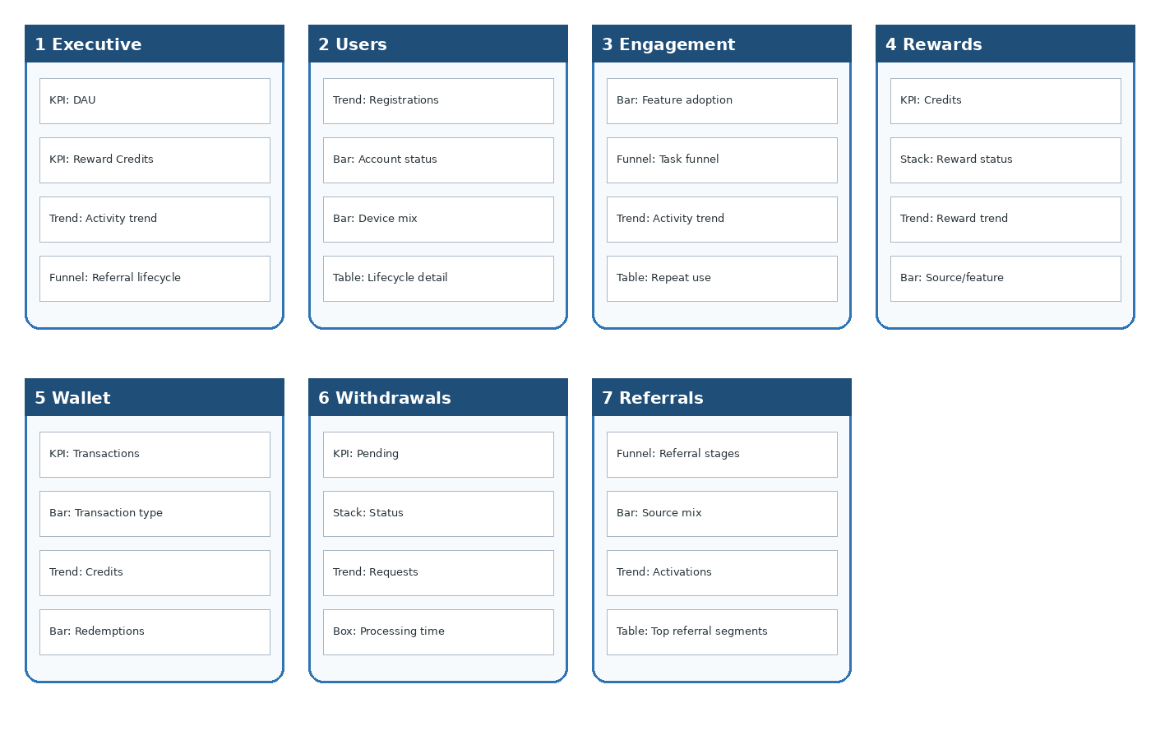
Seven future dashboards are specified: Executive Overview, User Analytics, Engagement, Rewards, Wallet, Withdrawals and Referrals. Each visual is defined in the workbook with metric, calculation, source, visualization, filters, dimensions, date range, refresh frequency, business question and decision supported.

15 - Developer Analytics Handoff
Critical event specifications are written so a developer can implement them without guessing. Each requirement contains a requirement ID, event, trigger, payload, validation, deduplication approach, timestamp rule, source, KPI dependency and acceptance test. High-priority examples include task_completed, reward_credited, wallet_transaction_created, withdrawal_requested and withdrawal_completed.
Requirement | Event | Key acceptance test | Priority
REQ-05 | task_completed | Exactly one analytically usable completion event per qualifying task instance; replay does not double-count. | High
REQ-07 | reward_credited | Reward credit references the source activity/transaction where applicable and records amount/unit/status. | High
REQ-08 | wallet_transaction_created | Unique transaction_id is emitted and accepted once. | High
REQ-10 | withdrawal_requested | Exactly one request record exists for each accepted request. | High
REQ-11 | withdrawal_completed | Completion event includes final timestamp/status and references the withdrawal_id. | High
REQ-12 | referral_converted | Conversion event uses the approved business definition and referral_id. | Medium

16-17 - Data Pipeline, Operating Model, Privacy & Governance
Role | Access model | Key rule
Engineering | Implementation-level analytics events | No passwords, API keys, auth secrets or payment credentials.
Data Analyst | Governed analytical datasets | Use approved/sanitized fields and stable IDs.
Product/Ops | Aggregated business reporting | Consume governed KPIs rather than raw credentials.
Content | Aggregated content performance | Use content IDs/categories and approved aggregates.
Intern | Approved/sanitized datasets only | Use simulated data or explicitly approved sanitized extracts.

The proposed architecture intentionally uses a practical layered flow rather than unnecessary infrastructure: application -> events -> raw storage -> quality gate -> transformation -> analytical layer -> BI -> reporting. Monitoring should cover freshness, failed loads, rejected records and KPI/data-quality changes.

18-20 - Change Management, Readiness, Assumptions
Analytics change management uses a versioned Metric/Event Change Log. Any feature, event, reward mechanic, withdrawal method, field, KPI or dashboard change must record the old and new definition, reason, affected KPIs/dashboards/reports, owner and version.
Readiness area | Score | Evidence | Next action
Product data mapping | 4/5 | 22 product/features mapped | Confirm release-level implementation states
Event coverage | 2/5 | 34 events specified; most proposed | Implement critical events
Logical model | 4/5 | Core entities + relationships documented | Engineering review
Data dictionary | 5/5 | 122 fields documented | Assign operational owners
KPI definitions | 4/5 | 34 reproducible definitions | Stakeholder approval
Data quality | 4/5 | Supplied + synthetic quality tests | Automate gates
Dashboard readiness | 3/5 | 7 dashboard blueprint | Build after governed KPI layer
Governance | 4/5 | Role-based access matrix | Approve final permissions

Mandatory assumptions are recorded in the workbook with owner, risk and verification status. Major unknowns are stable event_id/session_id availability, final withdrawal state rules, referral conversion definition, reward reversal linkage, snapshot cutoff and provider outcome fields.

21 - Final Implementation Backlog
Priority | Requirement | Reason | Stage
Critical | Stable user_id across events/transactions | Required for cross-domain joins and cohorting. | Pre-launch
Critical | Stable event_id + idempotency | Required to prevent duplicate analytics. | Pre-launch
Critical | Task activity -> reward linkage | Separates activity from actual reward credit. | Pre-launch
Critical | Transaction ID + reversal linkage | Required for wallet auditability. | Pre-launch
Critical | Controlled event/status taxonomy | Prevents definition drift. | Pre-launch
Critical | Referential integrity controls | Prevents orphan records. | Pre-launch
High | Withdrawal lifecycle instrumentation | Enables queue and processing analysis. | Pre-launch
High | Referral lifecycle instrumentation | Separates registration, activation and conversion. | Pre-launch
High | Timestamp standard/timezone | Required for accurate day-level reporting. | Pre-launch
High | Versioned KPI/data dictionary | Protects dashboards from silent metric changes. | Pre-launch
High | Automated data-quality gates | Stops invalid records from reaching BI. | Pre-launch
Medium | Governed BI dashboard layer | Enables recurring management reporting after production data exists. | Post-launch
Medium | Support/help-center instrumentation | Enables support/self-service KPIs. | Post-launch
Medium | Advanced segmentation | Useful after core instrumentation is stable. | Post-launch
Low | Experimentation metadata | Longer-term product measurement enhancement. | Later

Final Conclusion
The project delivers an analytics foundation rather than a fabricated performance story. The supplied dataset is treated as simulated; additional operational data is explicitly labelled as simulated testing data. The most valuable next step is to move the Critical identity, event, transaction, state and quality controls into the product/data implementation, then replace synthetic testing tables with governed production data. This keeps future dashboards and KPIs traceable, reproducible and safer to operate.

References and Source Register
- Provided VELOOP Rewards Data Analyst Internship - Task 01 PDF (44 pages).
- Provided VELoop_Rewards_Data_01.xlsx (Users_1000_Clean and Users_Messy_Audit).
- Official VELOOP Rewards Help Center: https://www.velooprewards.in/help-center (reviewed 2026-10-01; used for public feature terminology only, not as proof of internal implementation).
- Master workbook: VELOOP_Task01_Master_Analytics_Workbook.xlsx.

