Ryan Devlin

Comp281

Prof. Crawford

1. a)

|  |  |  |
| --- | --- | --- |
| TABLE | PRIMARY KEY(s) | FOREIGN KEY(s) |
| EMPLOYEE | EMP_CODE | STORE_CODE, JOB_CODE |
| STORE | STORE_CODE | REGION_CODE |
| REGION | REGION_CODE | NONE |
| JOB | JOB_CODE | NONE |

b)

|  |  |  |
| --- | --- | --- |
| TABLE | ENTITY INTEGRITY? (yes or no) | EXPLANATION |
| EMPLOYEE | Yes | No Null or duplicate values in PK |
| STORE | Yes | No Null or duplicate values in PK |
| REGION | Yes | No Null or duplicate values in PK |
| JOB | Yes | No Null or duplicate values in PK |

c)

|  |  |  |
| --- | --- | --- |
| TABLE | REFERENTIAL INTEGRITY? (yes or no) | EXPLANATION |
| EMPLOYEE | No | EMPLOYEE.JOB_CODE has a value of 5, which does not match any records in the JOB table |
| STORE | Yes | All values in Region_Code match values in its table |
| REGION | NA | No Foreign Key |
| JOB | NA | No Foreign Key |

1. a.) Each REGION can have many STOREs, but each STORE can only be in one REGION (1:M)  
   Each STORE is staffed by many EMPLOYEEs, but each EMPLOYEE can only work in one STORE(1:M)  
   Each JOB can be filled by many EMPLOYEEs, but each EMPLOYEE can only be assigned to one JOB(1:M)  
     
   b.) Each REGION can have many STOREs (1,N)  
   Each STORE belongs to one and only one REGION (1,1)  
   Each STORE has many EMPLOYEEs (1,N)  
   Each EMPLOYEE works at one and only one STORE (1,1)  
   Each JOB can be filled by many EMPLOYEEs (1,N)  
   Each EMPLOYEE can be assigned one and only one JOB (1,1)  
     
   c.)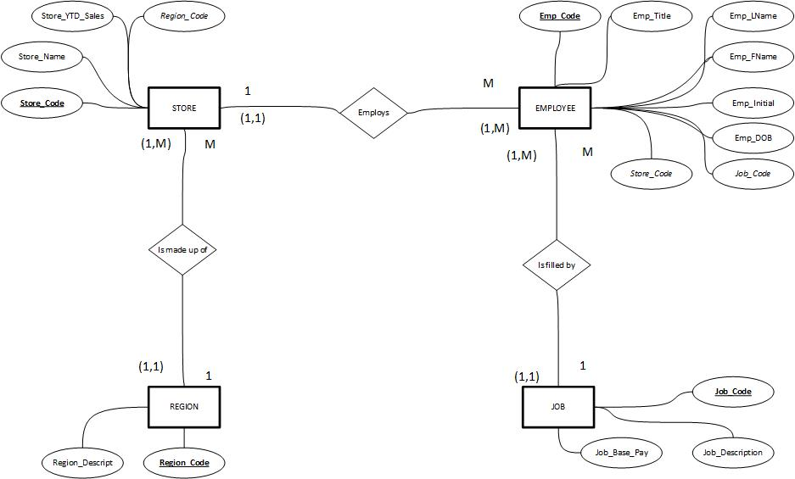  
     
   d.)