Ryan Devlin

Comp 281

Professor Crawford

1

1. EMPLOYEE: PK: EMP_CODE | FK: JOB_CODE  
   BENEFIT: PK: (EMP_CODE PLAN_CODE) | FK: EMP_CODE, PLAN_CODE  
   JOB: PK: JOB_CODE | FK: None  
   PLAN: PK: PLAN_CODE | FK: None
2. All tables exhibit entity integrity because they all have unique primary keys with no null values.
3. The EMPLOYEE and BENEFIT tables exhibit referential integrity because they both contain foreign keys that are primary keys in the related tables. Values in the foreign keys all correspond to values in the primary keys. The JOB and PLAN tables do not have foreign keys so they are not applicable to referential integrity

2.

1. Each JOB can have many EMPLOYEEs and each EMPLOYEE can have only one JOB, therefore the relationship between JOB and EMPLOYEE is (1:M)  
     
   EMPLOYEEs can have zero or many BENEFITS and each BENEFIT is tied to only one EMPLOYEE, therefore the relationship between EMPLOYEE and BENEFIT is (0:M)  
     
   PLANs can have zero or many BENEFITS and each BENEFIT is tied to only one PLAN, therefore the relationship between PLAN and BENEFIT is (0:M)
2. 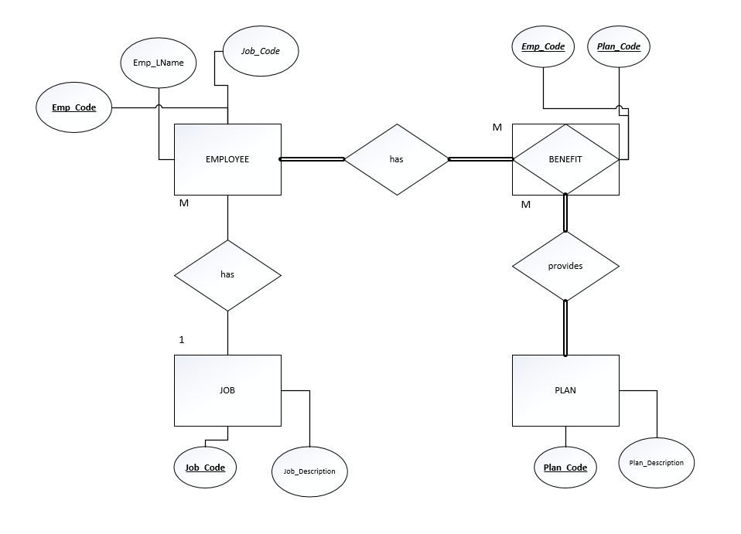
3. 