Ryan Devlin

Comp 281

Prof Crawfod

HW 5-1

1.

|  |  |  |  |  |  |
| --- | --- | --- | --- | --- | --- |
| **Patient Number** | **Room** **Number** | **Order** | **Cost ($)** | **Physician** | **Office Number** |
| 1120 | 312 | Blood Test | 45.00 | Gray | 124 |
| 1120 | 312 | X-Ray | 30.00 | Green | 125 |
| 1120 | 312 | Eye Test | 30.00 | Green | 125 |
| 1320 | 414 | Upper GI | 250.00 | Brown | 213 |
| 2143 | 520 | NMRI | 2400.00 | Gray | 124 |
| 2143 | 520 | Blood Test | 45.00 | Gray | 124 |
| 1432 | 360 | X-Ray | 30.00 | White | 321 |
| 1294 | 420 | Blood Test | 45.00 | Black | 104 |
| 1896 | 600 | Blood Test | 45.00 | Brown | 213 |

1NF(**Patient Number**, Room Number, **Order**, Cost ($), Physician, Office Number)

PARTIAL DEPENDENCIES  
(Patient Number 🡺Room Number)  
(Order 🡺 Cost ($)

TRANSITIVE DEPENDENCIES  
(Physician 🡺 Office Number)

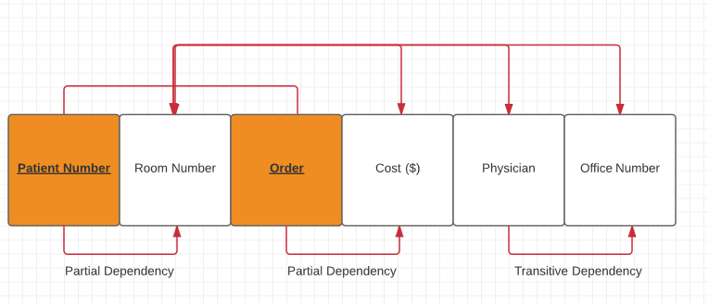  
2NF  
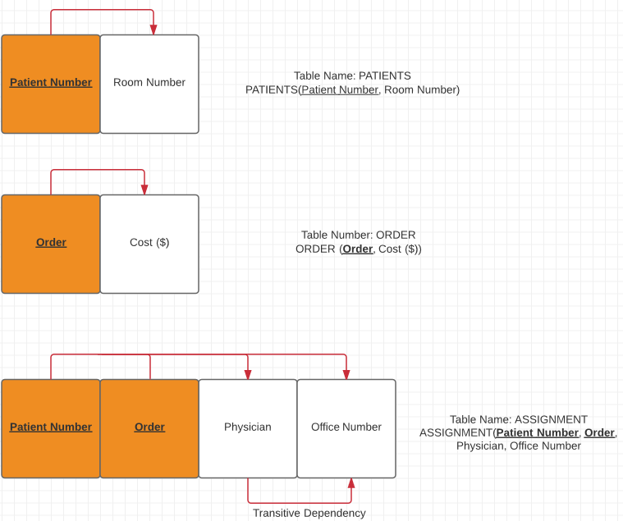

3NF  
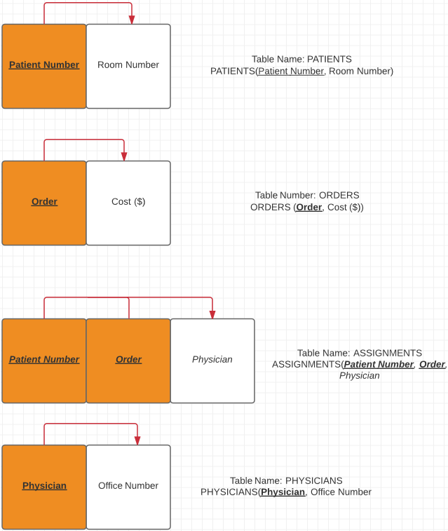

2.

|  |  |  |  |  |  |
| --- | --- | --- | --- | --- | --- |
| **Client Name** | **Client Address** | **Service Type** | **Cost ($)** | **Technician Name** | **Vehicle Ident. #** |
| Kim Jones | Worthington | Mowing | 25.00 | Carlos | L2 |
| John Smith | Dublin | Mowing | 75.00 | Fred | L3 |
| John Smith | Dublin | Aeration | 120.00 | Fred | L3 |
| John Smith | Dublin | Fertilizing | 75.00 | Albert | L4 |
| Barbara Wentz | Worthington | Mowing | 50.00 | Carlos | L2 |
| Charles Lee | Hilliard | Mowing | 60.00 | Louie | LT1 |
| Heinz Schmidt | Powell | Aeration | 255.00 | Louie | LT1 |
| Carrie Fisher | Columbus | Fertilizing | 45.00 | Gina | T25 |
| James Count | Dublin | Mowing | 60.00 | Sam | L21 |

1NF(**Client Name**, Client Address, **Service Type**, Cost ($), Technician, Vehicle Ident. #)

PARTIAL DEPENDENCIES  
(Client Name 🡺 Client Address)

TRANSITIVE DEPENDENCIES

(Technician Name 🡺 Vehicle Ident. #)

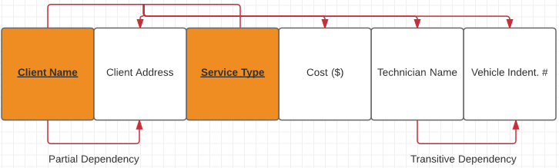

2NF

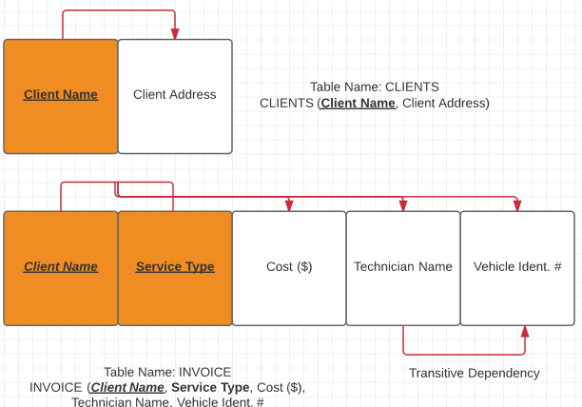

3NF

