Ryan Devlin

Prof Crawford

COMP281

Lab 7

Name Null Type

------------------ -------- ----------

CARDHOLDER_NUMBER NOT NULL NUMBER(38)

BOOK_NUMBER NOT NULL NUMBER(38)

DATE_CHECKED_OUT NOT NULL DATE

DUE_DATE NOT NULL DATE

ACTUAL_RETURN_DATE DATE

CARDHOLDER_NUMBER BOOK_NUMBER DATE_CHECKED_OUT DUE_DATE ACTUAL_RETURN_DATE

--------------------------------------- --------------------------------------- ---------------- --------- ------------------

10 1 01-DEC-00 11-DEC-00 05-DEC-00

2 2 06-DEC-00 16-DEC-00 20-DEC-00

8 3 01-JAN-02 11-JAN-02

5 4 15-DEC-00 25-DEC-00 28-DEC-00

3 6 07-DEC-00 17-DEC-00 15-DEC-00

9 8 02-JAN-02 12-JAN-02

10 9 05-DEC-00 15-DEC-00 20-DEC-00

1 10 29-DEC-00 08-JAN-02

6 12 02-JAN-02 12-JAN-02

9 rows selected

Name Null Type

------------ -------- ------------

BOOK_NUMBER NOT NULL NUMBER(38)

ISBN_NUMBER VARCHAR2(15)

BOOK_NAME VARCHAR2(30)

CATEGORY_NUM NUMBER(38)

BOOK_NUMBER ISBN_NUMBER BOOK_NAME CATEGORY_NUM

--------------------------------------- --------------- ------------------------------ ---------------------------------------

1 0-385-19237-1 San Francisco Encore 4

2 0-9604222-0-X The Memphis Cookbook 4

3 0-9613214-1-5 Charlotte Cooks Again 4

4 0-9603946-5-6 Colorado Cache Cookbook 4

5 0-960-79142-6 Atlanta Cooknotes 4

6 0-9607076-1-1 Beyond Parsley 4

7 09605788-0-3 Out of our League 4

8 0811826848 The Beatles Anthology 3

9 0-425-17139-6 Net Force 2

10 0684846098 Nothing Like it in the World 3

11 0385484518 Tuesdays with Morri 3

BOOK_NUMBER ISBN_NUMBER BOOK_NAME CATEGORY_NUM

--------------------------------------- --------------- ------------------------------ ---------------------------------------

12 0553111337 Flags of Our Fathers 3

12 rows selected

Name Null Type

----------------- -------- ------------

CARDHOLDER_NUMBER NOT NULL NUMBER(38)

FIRST_NAME VARCHAR2(10)

LAST_NAME VARCHAR2(15)

ADDRESS VARCHAR2(20)

CITY VARCHAR2(15)

STATE CHAR(2)

ZIP_CODE CHAR(5)

CARDHOLDER_NUMBER FIRST_NAME LAST_NAME ADDRESS CITY ST ZIP_C

--------------------------------------- ---------- --------------- -------------------- --------------- -- -----

1 Robert Downs 100 E. Town St. San Francisco CA 95409

2 John Johnson 2345 7th Avenue Denver CO 80222

3 Judy Toon 4012 Main Street Memphis TN 38118

4 Barbara Brown 2310 W. Fifth Avenue Richmond VA 23286

5 Robert Smith 25110 Central Park Denver CO 80222

6 Carol Carter 199 South Fourth Richmond VA 23286

7 Janice Johns 2020 State St. Greensboro NC 27408

8 Will Hamilton 56 E. Main St. Columbus OH 43215

9 Judy Smith 490 E. Lincoln San Francisco CA 95409

10 Betty Oliver 55 Sunshine Coast San Francisco CA 94588

10 rows selected

Name Null Type

------------ -------- ------------

CATEGORY_NUM NOT NULL NUMBER(38)

CATEGORY NOT NULL VARCHAR2(15)

CATEGORY_NUM CATEGORY

--------------------------------------- ---------------

1 Biography

2 Fiction

3 Non Fiction

4 Cookbook

5 History

**Part 2.**

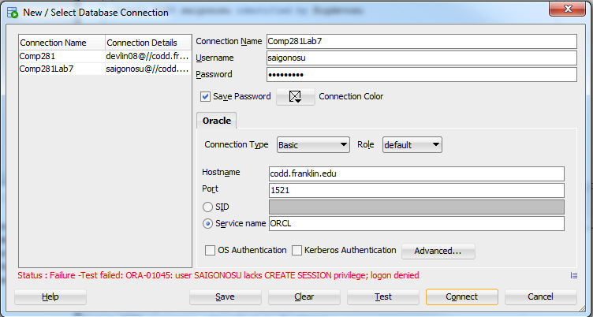

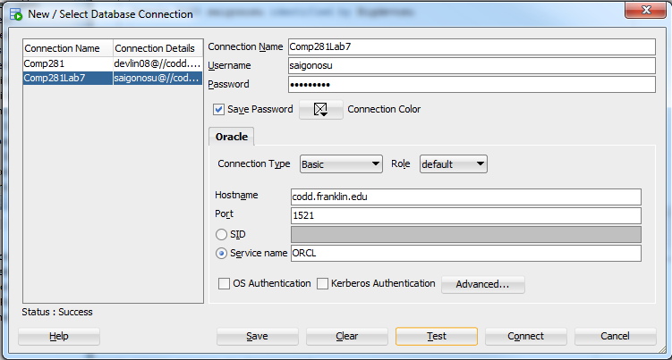

**Part 3**

Error starting at line : 1 in command -

SELECT * FROM crawforl.timesheets

Error at Command Line : 1 Column : 24

Error report -

SQL Error: ORA-00942: table or view does not exist

00942. 00000 - "table or view does not exist"

*Cause:

*Action:

INSERT INTO devlin08.CARD_HOLDERS VALUES (11, 'Mercy', 'Jackson', '1146 Howison

Avenue', 'Memphis', 'TN', '50134')

Error at Command Line : 1 Column : 22

Error report -

SQL Error: ORA-01031: insufficient privileges

01031. 00000 - "insufficient privileges"

*Cause: An attempt was made to perform a database operation without

the necessary privileges.

*Action: Ask your database administrator or designated security

administrator to grant you the necessary privileges

Error starting at line : 3 in command -

UPDATE devlin08.CARD_HOLDERS SET LAST_NAME = 'Black' WHERE

CARDHOLDER_NUMBER = 11

Error at Command Line : 3 Column : 17

Error report -

SQL Error: ORA-01031: insufficient privileges

01031. 00000 - "insufficient privileges"

*Cause: An attempt was made to perform a database operation without

the necessary privileges.

*Action: Ask your database administrator or designated security

administrator to grant you the necessary privileges

Error starting at line : 5 in command -

DELETE FROM devlin08.CARD_HOLDERS WHERE LAST_NAME = 'Black'

Error at Command Line : 5 Column : 22

Error report -

SQL Error: ORA-01031: insufficient privileges

01031. 00000 - "insufficient privileges"

*Cause: An attempt was made to perform a database operation without

the necessary privileges.

*Action: Ask your database administrator or designated security

administrator to grant you the necessary privileges

**Part 4**

create role awesome

grant select, insert, update on devlin08.CARD_HOLDERS to awesome

Grant succeeded.

Role AWESOME succeeded.

Commit complete.

CARDHOLDER_NUMBER FIRST_NAME LAST_NAME ADDRESS CITY ST ZIP_C

--------------------------------------- ---------- --------------- -------------------- --------------- -- -----

1 Robert Downs 100 E. Town St. San Francisco CA 95409

2 John Johnson 2345 7th Avenue Denver CO 80222

3 Judy Toon 4012 Main Street Memphis TN 38118

4 Barbara Brown 2310 W. Fifth Avenue Richmond VA 23286

5 Robert Smith 25110 Central Park Denver CO 80222

6 Carol Carter 199 South Fourth Richmond VA 23286

7 Janice Johns 2020 State St. Greensboro NC 27408

8 Will Hamilton 56 E. Main St. Columbus OH 43215

9 Judy Smith 490 E. Lincoln San Francisco CA 95409

10 Betty Oliver 55 Sunshine Coast San Francisco CA 94588

10 rows selected

1 row inserted.

1 row updated.

Error starting at line : 6 in command -

DELETE FROM devlin08.CARD_HOLDERS WHERE LAST_NAME = 'Black'

Error at Command Line : 6 Column : 22

Error report -

SQL Error: ORA-01031: insufficient privileges

01031. 00000 - "insufficient privileges"

*Cause: An attempt was made to perform a database operation without

the necessary privileges.

*Action: Ask your database administrator or designated security

administrator to grant you the necessary privileges

**Part 5**

Revoke succeeded.

CARDHOLDER_NUMBER FIRST_NAME LAST_NAME ADDRESS CITY ST ZIP_C

--------------------------------------- ---------- --------------- -------------------- --------------- -- -----

1 Robert Downs 100 E. Town St. San Francisco CA 95409

2 John Johnson 2345 7th Avenue Denver CO 80222

3 Judy Toon 4012 Main Street Memphis TN 38118

4 Barbara Brown 2310 W. Fifth Avenue Richmond VA 23286

5 Robert Smith 25110 Central Park Denver CO 80222

6 Carol Carter 199 South Fourth Richmond VA 23286

7 Janice Johns 2020 State St. Greensboro NC 27408

8 Will Hamilton 56 E. Main St. Columbus OH 43215

9 Judy Smith 490 E. Lincoln San Francisco CA 95409

10 Betty Oliver 55 Sunshine Coast San Francisco CA 94588

11 Mercy Black 1146 Howison Memphis TN 50134

CARDHOLDER_NUMBER FIRST_NAME LAST_NAME ADDRESS CITY ST ZIP_C

--------------------------------------- ---------- --------------- -------------------- --------------- -- -----

Avenue

11 rows selected

Error starting at line : 2 in command -

INSERT INTO devlin08.CARD_HOLDERS VALUES (12, 'Carol', 'Adams', '101 Arc Street',

'Seattle', 'WA', '01256')

Error at Command Line : 2 Column : 22

Error report -

SQL Error: ORA-01031: insufficient privileges

01031. 00000 - "insufficient privileges"

*Cause: An attempt was made to perform a database operation without

the necessary privileges.

*Action: Ask your database administrator or designated security

administrator to grant you the necessary privileges

1 row updated.

Error starting at line : 6 in command -

DELETE FROM devlin08.CARD_HOLDERS WHERE LAST_NAME = 'Camel'

Error at Command Line : 6 Column : 22

Error report -

SQL Error: ORA-01031: insufficient privileges

01031. 00000 - "insufficient privileges"

*Cause: An attempt was made to perform a database operation without

the necessary privileges.

*Action: Ask your database administrator or designated security

administrator to grant you the necessary privileges

Commit complete.

**Part 6**

View DEVLIN08.S_LIST created.

Grant succeeded.

CARDHOLDER_NUMBER LAST_NAME FIRST_NAME DUE_DATE

--------------------------------------- --------------- ---------- ---------

1 Camel Robert 08-JAN-02

6 Carter Carol 12-JAN-02

8 Hamilton Will 11-JAN-02

9 Smith Judy 12-JAN-02

Views are important because it administrators control over what data users are allowed to view

Create role teammates;

grant insert, delete on devlin08.BOOKS_CHECKED_OUT to teammates;

grant insert, delete on devlin08.BOOK_LIST to teammates;

grant insert, delete on devlin08.CARD_HOLDERS to teammates;

grant insert, delete on devlin08.BOOK_CATEGORIES to teammates;

grant teammates to student1;

grant teammates to student2;

grant teammates to student3;

grant teammates to student4;

grant teammates to crawforl;

set teammates;