Ryan Devlin

Prof Jones

MIS320

Week 7 Hands On

**Audience Analysis**

The main audience for this document will be people interested in learning how to play Magic: The Gathering. Other people likely to read this document are players with some level of knowledge of the game. Providing quick references will provide value to these readers. The relationship with the readers will be that of a colleague, though coming from a place of experience. This allows some informality, but too much might discredit the manual. Because this is a beginner’s manual, low level of technical detail will be used to not overwhelm new players.

**Statement of Purpose**

The purpose of this manual is to provide enough information to play a game of Magic: The Gathering while providing information in a way that can be referenced quickly for more experienced players.

**Task Analysis**

Main Task: Play a game of Magic

Subtasks:

1. Objectives of the game
2. Phases of the turn

Main Task: Building a deck  
Subtasks:

1. Learn different types of cards
2. Learn about formats

**Information Plan**

The goal of this manual is to allow new players interested in Magic: The Gathering to learn how to build a deck and play a game as soon as possible. The intended audience is people who have never played a game, but are interested. A secondary audience are players who are familiar with the game, but would like a quick reference guide for information such as phases in a turn. Potential problems to avoid are overwhelming new players with too much information too fast and assuming players will understand abstract concepts such as mana. The manual will begin with a brief description of the types of cards available to use, then move onto how to build a deck based on what format you have chosen. The final section will be explaining how to play a game, from start to finish. The manual will end with an appendix will quick reference sections on types of cards, formats, and the phases in a turn.

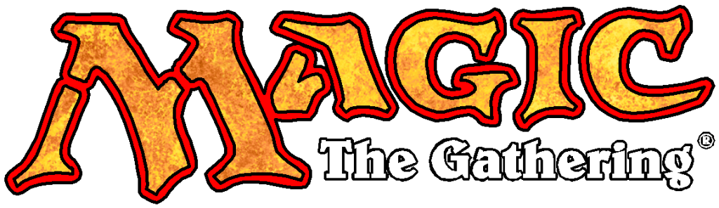Getting Started:

http://logonoid.com/magic-the-gathering-logo/

Magic: The Gathering

Table of Contents

1. **Card Types**
   * 1. Land
     2. Creature
     3. Sorcery
     4. Instant
     5. Enchantment
     6. Artifact
     7. Planeswalker
2. **Playing a Game**
   * 1. Building a Deck
     2. How to Win
     3. Starting the game
     4. Taking your turn
3. **Appendix**
   * 1. Card Types
     2. Phases of a Turn

Before we learn how to play a game of Magic: The Gathering, we have to learn about the different cards that make up the game. A game of Magic is played with two or more people using decks of cards made up of the various card types that exist in Magic. These card types are Land, Creature, Instant, Sorcery, Enchantment, Artifact, and Planeswalker.

**LAND**

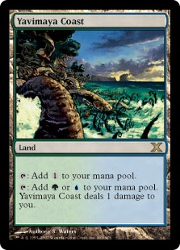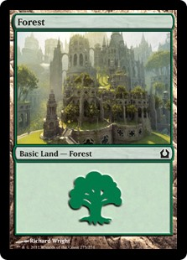The most basic card type in Magic is Land. In Magic, to play your cards, you must pay an amount of mana required by the cards mana cost. We’ll touch on mana cost later, but lands are what you use to generate mana. There are 5 colors in magic: White, Blue, Black, Red, and Green. Each color has a respective Basic Land: Plains, Island, Swamp, Mountain, and Forest. Here we have a forest. The symbol in the text box is called the green mana symbol. When tapped (tapped just means turning your card 90 degrees sideways to denote it has been used) these lands add one mana of their symbol to your mana pool. Once in your pool, this mana can be used to play your other cards.

http://gatherer.wizards.com/Pages/Card/Details.aspx?multiverseid=289327

Basic Land isn’t the only type of land card in the game. Lands can do a variety of things in Magic besides making mana. Yavimaya Coast is a non-basic land that has two abilities. Each ability requires you to tap (as denoted by the tap symbol before the colon ( : ) in each ability) Yavimaya Coast. The first ability adds one colorless mana to your mana pool, while the second lets you choose a green or blue mana, with the side effect of Yavimaya Coast dealing one damage to you (we’ll get to damage later).

http://gatherer.wizards.com/Pages/Card/Details.aspx?multiverseid=129810

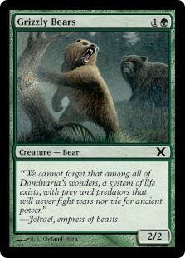**Creature**

The next card type is Creature. Creatures have a few important characteristics. Take Grizzly Bears, for example. The in the upper right hand corner is a card’s *mana cost*. This is the amount of mana required to play the card. Grizzly bear requires you to have one green mana, and one generic mana. Generic mana can be paid with any type of mana. The next important characteristic of creatures is its creature type. Grizzly Bears creature type is Bear, indicated directly under the art by Creature – Bear. The text box is the next important part is the text box. Grizzly Bears does not have any additional abilities or rules text. It does have flavor text. Flavor text is simply text meant to tell a story or add additional entertainment. Flavor text has no rules implications and is indicated by italicized font. The last characteristic of creatures is their power and toughness. Power and toughness are numbers in the bottom right corner of a creature, separated by a ‘/’. Grizzly Bears has a power and toughness of 2 each. Power is always the left number, while toughness is found on the right. Power is the amount of damage a creature deals when in combat, while toughness is the amount of damage it takes to destroy a creature. Grizzly Bears will do 2 points of damage in combat. If it is dealt 2 or more damage, it is put in the graveyard (the discard pile). We’ll discuss combat later when discussing taking a turn.

Green Mana Symbol http://mtgsalvation.gamepedia.com/Green

Grizzly Bear and Generic Mana Symbol http://gatherer.wizards.com/Pages/Card/Details.aspx?multiverseid=129586

**Instant**

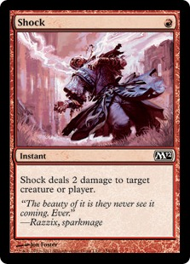Instants are cards that can be played at any time, even during your opponent’s turn! The same rules apply to all cards with respect to mana cost. Shock, requires a player to pay one red mana to play it. Unlike creatures, when you play an instant, you simply do what the card says, and place it in your graveyard (discard pile). Shock deals two damage to a creature or player. If we use Shock on our opponents Grizzly Bears, they will have to place it in the graveyard. Because of the ability to use instants almost whenever we choose, many things in Magic are described in terms such as ‘instant speed’. This means whatever is being described can be used whenever as instant could be used. An example would be a creature with an ability that can be activated for some payment.

http://mtg.wikia.com/wiki/Instant

**Sorcery**

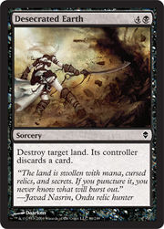Sorcery is another card type similar to instants. Like instants, when they are played, a player performs the actions required by the card and places the card in his or her graveyard. Desecrated Earth, for example, destroys a land, requiring its controller to place it in his or her graveyard. Afterwards, the land’s controller must discard a card from his or her hand as well. The difference between instants and sorceries are the timing restrictions placed on sorceries. While instants can be played whenever, sorceries can only be played during a player’s turn, and only during that player’s main phases, while nothing else is being played. This timing restriction is described as ‘sorcery speed’, and just as with instants, some actions are described using this terminology. Playing lands and creatures can only be done at sorcery speed, for example.

http://mtg.wikia.com/wiki/Sorcery

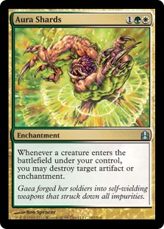**Enchantment**

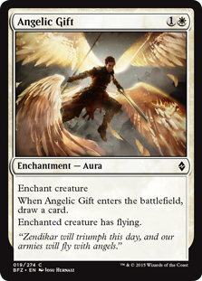Enchantments are cards that are played and have a sustained effect on the game. Like creatures, enchantments stay in play once they are played. Aura Shards, for example stays on the field after it is played. Until it is removed from play, whenever its controller has a creature enter the battlefield (come into play), its controller may destroy an artifact (our next card type) or enchantment.

A special type of enchantment, called *Aura,* is played on certain types of cards. The card types an aura can enchant will be written in the enchantment’s text box. For example, Angelic Gift says ‘Enchant creature’. This means that when you play Angelic Gift, you choose a creature to enchant. Enchanting means that an enchantment is attached to and affects the enchanted creature. A common representation for enchanting is placing the enchantment under whatever card it is enchanting. Once an aura enters play, players do anything required by the enchantment, and any effects to the creature apply until the enchantment leaves play. In the Angelic Gift example, the enchanted creature gains the flying ability until it is no longer enchanted by Angelic Gift. If a creature would leave play for any reason, all auras attached to it are placed in the graveyard.

http://gatherer.wizards.com/Handlers/Image.ashx?multiverseid=401812&type=card

http://gatherer.wizards.com/Handlers/Image.ashx?multiverseid=247184&type=card

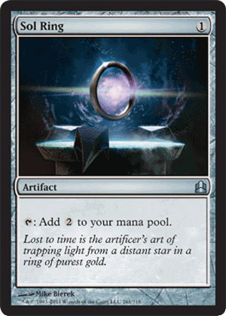**Artifact**

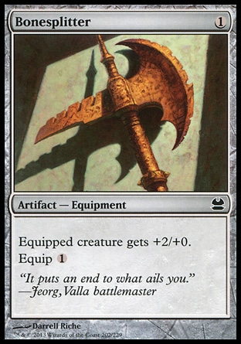Artifacts are similar to enchantments in that they are played and stay on the board. Some key differences between enchantments and artifacts are that enchantments typically require colored mana to play, whereas artifacts typically take generic mana. These two card types also tend to do different things. Enchantments tend to have effects that affect the entire playing field, whereas artifacts tend to do things, such as add colorless mana in the case of Sol Ring.

https://s-media-cache-ak0.pinimg.com/originals/ef/b2/65/efb2654bd0dc32c10aaa3e7823fce01a.jpg

Artifacts have a subtype, named equipment, that can be attached to creatures. These act very similar to auras, but with key differences. The first difference is that equipment does not require a creature to be on the field when played. Attaching an equipment to a creature is done by paying the equip cost, and can be done at sorcery speed. For example, a player may pay one generic mana to equip Bonesplitter to one of his or her creatures. Bonesplitter increases a creatures power by 2, while increasing its toughness by zero. Another difference between equipment and auras is what happens when the creature leaves play. Unlike auras, equipment simply become unattached when a creature leaves play, meaning we can reattach our equipment to another creature. We can also move equipment around, even when our creature has not left play.

http://magiccards.info/scans/en/mma/202.jpg

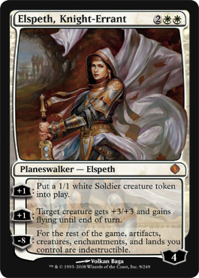**Planeswalker**

In Magic: The Gathering, the players in the game are supposed to be powerful wizards named planeswalkers. The Planeswalker card type is a way to represent these entities as actual cards. Think of them as allies that join in your battle. Planeswalkers are unique and complex, it takes some understanding to play with this advanced card type. Let’s look at Elspeth to get a basic understanding. Planeswalkers have a mana cost, and stay in play when played. Its planewalker type is denoted below its art with Planeswalker – Elspeth. This is important because you may only have one planewalker in play with a specific planeswalker type. Planeswalkers can be played at sorcery speed, and their abilities can only be used at sorcery speed, once per turn. Planeswalkers abilities are unique to this card type. Each ability is prepended with a number and a + or – sign. These indicate the amount of *loyalty counters* that must be added or subtracted from a planeswalker to use that ability. The number in the bottom right hand corner is the number of loyalty counters a planeswalker starts with. Loyalty counters are usually marked with dice, but you may use whatever you wish. In our Elspeth example, Elspeth enters play with four loyalty counters. When deciding what ability to use, we see that we cannot remove 8 counters, so Elspeth’s last ability is unable to be used yet. Elspeth’s first two abilities require us to add one counter to Elspeth, so we move the counter to 5 and do what the ability says.

http://www.planeswalkerslibrary.com/images/shards/009.jpg

When a planeswalker loses all its loyalty counters, it is placed in the graveyard. This can happen through use of abilities that remove loyalty counters as a cost, or through damage taken by creatures and spells (instants and sorceries). Each point of damage results in one loyalty counter being removed.

That wraps up card types. Before moving on, I want to note that any card type that stays in play after it is played is referred to as a permanent. If you come across this terminology, permanent covers all types except instants and sorceries. Now let’s play a game.

**Building A Deck**

The rules for building a deck in Magic: The Gathering are simple. Each deck must consist of at least 60 cards, with no more than 4 of any one specific card. Basic lands are the only cards you may have more than 4 of in a single deck, there is no restriction to the number of Plains, Island, Swamp, Mountain, or Forest you may have in your deck.

**Objective of the Game**

Once each player has their deck, we are ready to play a game of Magic. In Magic, the objective of the game is to reduce your opponent’s life total to zero. Each player begins the game with 20 life points. Players use their creatures to attack their opponents, while using other card types to enhance their creatures or remove their opponent’s cards from play. While there are other ways to defeat your opponent, these strategies are rare and beyond the scope of this manual. With our objective, we are ready to begin the game!

**Starting the Game**

At the beginning of the game, each player shuffles his or her deck to randomize the cards. Once this is complete, players decide who will play first. This can be done with a coin flip or dice roll. Whoever wins gets to choose whether they would like to play first or not. After this choice has been made, each player draws their initial opening hand of seven cards. If a player is not happy with his or her hand, that player may put their hand back into their deck and shuffle. That player then draws a new hand with one less card. This process is repeated by both players until both players are happy with their opening hand. Whoever is going first may now start his or her turn.

**Phases In a Turn**

**Untap Phase**

Untap phase in the first phase of every turn. The player whose turn it is untaps all of his or her permanents. Remember tapping is the act of turning a card sideways to denote use. Untapping reverses this process, so all cards are upright and available to be used during the turn. During the first turn of the game, the player has no tapped cards in play, so this phase can be skipped.

**Upkeep Phase**

The upkeep phase is a phase that can be referenced by certain cards. No actions inherently take place during this step. This means that most times, this phase can also be skipped. However, many cards say something to the effect of “At the beginning of your upkeep, do something”, those actions are done during this phase of the turn.

**Draw Phase**

The draw phase is the phase of the turn where the active player draws a card for the turn. Each player is required to draw one card during each of his or her turns, unless instructed otherwise by a card. This does not apply to the first turn of the game however. The player who plays first will skip his or her first draw step of the game, then proceed as normal for the rest of the game.

**Main Phase 1**

The first main phase of the turn gives players the first opportunity to play any sorcery speed cards. These include lands, creatures, planeswalkers, enchantments, artifacts, and, of course, sorceries. Each player is only allowed to play one land per turn, unless a card says otherwise.

**Combat Phase**

The combat phase is broken into smaller sections. At the beginning of combat, each player may spell instants or abilities before any actions are taken. Once both players have nothing to play, the active player declares what creatures are attacking. If the opponent has any planeswalkers, the active player must decide which, if any, creatures will be attacking the the planeswalker. After these are declared, the active player pays all costs to attack (usually just tapping the creatures chosen to attack). Both players are then given the opportunity to play instants and abilities again. Once both players are done playing spells, we move into the declare blockers step. The defending player chooses any of his creatures to block, and decides which attacking creatures to block. Once all costs are paid to block (rarely any), both players are given another opportunity to play spells and abilities. At this point, all damage is done simultaneously. Any creatures not blocked will deal damage equal to its power to the player’s life total or remove loyalty counters from planewalkers that creature was attacking. Creatures that are blocked deal damage to each other. Any creature dealt damage greater than or equal to its toughness is placed in its owner’s graveyard. Any planewalkers with zero counters also go to the graveyard.

**Main Phase 2**

This is identical to the first main phase before the combat phase.

End Of Turn Phase

At the end of turn, all damage dealt to creatures is erased. Any effects that last ‘until end of turn’ stop working here. Also any abilities with the text ‘at end of turn’ will trigger. Once all abilities are resolved and both players pass the opportunity to play instants or abilities, it now becomes the opponents turn, and the process repeats.

**APPENDIX**

**Card Types**

1. Land – the card type used to make mana. Mana is used to play all other card types
2. Creature – Card type will power and toughness. Used to attack the opponent
3. Instant – Card type that can be played at any time. It is put in graveyard after use
4. Sorcery – Similar to instant, except can only be played during your turn, during main phase, with no other cards being played
5. Enchantment – Card type that stays on the battlefield and provides some type of effect. Special type Aura can be attached to creatures to provide enhancements
6. Artifacts – Similar to enchantments, but typically cost generic mana. Equipment are similar to enchantment Auras. They attach to creatures, but unlike auras, are not destroyed when a creature leaves play.
7. Planeswalker – Card representations of the players in the game. They use loyalty counters to pay for abilities on each card. These abilities are sorcery speed, that can only be used once per turn.

**Phases Of A Turn**

1. Untap – Untap all cards that are currently tapped in play
2. Upkeep – Perform all requirements of cards that trigger during the upkeep step
3. Main Phase – Play creatures, sorceries, artifacts, enchantments, planeswalkers, and land during this phase
4. Combat Phase
   1. Beginning of Combat – All players may play instants or abilities at this time
   2. Declare Attackers – The active player decides what creatures are attacking, and in the case where the opponent has a planewalker, deciding which creatures are attacking the planeswalker versus the opponent. Once attackers are declared and costs are paid, Players may play instants or abilities
   3. Declare Blockers. Defending player chooses which of his or her creatures will block attackers. Once blockers are declared and costs are paid, players may play instants or abilities
   4. Combat Damage – In this step, all creatures do damage. Unblocked creatures deal damage to the defending player, unless that creature is attacking a planeswalker. In this case, a number of loyalty counters equal to the damage taken are removed. Creatures that were dealt more damage than their toughness are put into the discard pile. Planeswalkers that no longer have loyalty counters are also moved to the graveyard.
5. Main Phase 2 – This is the same as the previous Main Phase
6. End Of Turn – Any damage is removed from creatures that are still on the playing field. Abilities that trigger at ‘end of turn’ will trigger at this point. Effects that last until ‘end of turn’ will cease as well.

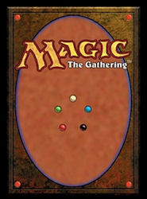**LEARN MAGIC: THE GATHERING!**

https://hydra-media.cursecdn.com/mtgsalvation.gamepedia.com/0/07/Cardback_yellow.jpg?version=a910a85527a40181584c04dafe06ec64