TRACE-X: An Explainable Digital Forensics Engine
Project Report
Submitted by | [INSERT: author name(s)]
Program / Department | [INSERT: department or program]
Institution | [INSERT: university / college name]
Academic year / Semester | [INSERT: year and semester]
Guide / Examiner | [INSERT: name, if applicable]
Purpose of report | [INSERT: college capstone / course project / hackathon / internship]
Audience | [INSERT: professor / evaluators / judges]

1. Title Page and Abstract
Digital forensics investigations require reconstructing a defensible chronology from heterogeneous artifacts — Windows event logs, filesystem metadata, browser history and structured exports — and communicating conclusions without overstating what the recovered records prove. TRACE-X is a self-hosted forensics engine that addresses this problem with an explicit three-layer analytical contract: evidence (what an artifact directly records), correlation (how observations relate in time or context) and hypothesis (what a sequence might indicate, with uncertainty and alternatives stated). The system ingests artifacts through a versioned parser registry, normalizes them into a unified event model that carries timestamp precision and confidence, persists them in a relational store, and derives timeline, rule-based anti-forensics findings, suspicion chains and a correlation graph. Eight conservative detection rules (AF-001 to AF-008) skip themselves when their required evidence is absent, and every finding declares what it does not establish. A controlled evaluation harness replays labelled synthetic scenarios under three configurations to measure the contribution of each analytical layer. The implementation comprises a FastAPI backend, a React front end, an automated test suite and a CI pipeline. Findings, reports and exports are generated exclusively from persisted rows, so every claim is traceable to a source record.
(Word count of abstract: [INSERT: recount after edits]; target 150–200 words.)

2. Introduction

2.1 Problem statement
An investigator who acquires a disk image or a set of log exports must answer three questions: what happened, in what order, and how strongly does the evidence support each conclusion. Existing workflows frequently collapse these questions. Timelines are assembled from raw tool output whose timestamps have differing precision and timezone semantics; correlations between two records are presented as if they were causal; and the absence of a record — which may simply reflect incomplete collection — is read as proof of deletion. The repository’s own README states this policy directly: “Correlation is never presented as causation; missing records are reported as missing coverage, not as proven deletion” (README.md).
A second problem is auditability. When a finding is reported, the analyst must be able to trace it back to the exact artifact row that produced it. Ad-hoc scripts make this difficult because intermediate results are rarely retained with their provenance.

2.2 Motivation
The motivation for TRACE-X is the gap between raw forensic output and defensible, explainable reporting. The project is organised around the observation that most forensic reasoning errors are not parsing errors but interpretation errors: an engine that ingests a file correctly can still mislead its user if it presents a temporal association as a proven mechanism, or an absent log line as proof of tampering. The design therefore treats the statement of uncertainty as a first-class output rather than a footnote.

2.3 Objectives
The objectives, as implemented in the repository, are:
- Artifact ingestion with provenance. Import Windows EVTX, filesystem metadata (FSAT/CSV/JSON, NTFS-style $MFT and USN exports), Chromium History databases, Recycle Bin $I records and structured JSON/CSV, storing the SHA-256 of the exact bytes, parser name/version, per-row rejection reasons and an audit entry for each import.
- Timeline reconstruction. Normalise records into a single event model that carries timestamp precision (second|minute|hour|day|unknown), confidence (high|medium|low|none) and timezone notes, and order them without pretending that date-only values are second-precise.
- Explainable anti-forensics detection. Apply a curated ruleset (AF-001…AF-008) in which each rule declares its required evidence, is skipped with a machine-readable reason when that evidence is absent, and emits an explanation containing alternatives and limitations.
- Correlation. Build suspicion chains (patterns A–E) and an entity/event graph that distinguishes observed relationships from inferred ones.
- Reproducible reporting. Produce HTML, JSON, PDF, CSV and interoperable (bodyfile/super-timeline) exports generated only from persisted rows.
- Evaluation. Replay labelled synthetic scenarios under three configurations (timeline only; + rules; + graph and uncertainty reasoning) to measure each layer’s contribution against declared ground truth.
- Multi-user operation and governance. Provide user accounts with PBKDF2 password hashing, HttpOnly session cookies, investigation ownership, an audit trail and an admin section for registered users and session revocation.

2.4 Scope
The scope covers the ingestion of the artifact classes listed above, offline analysis of imported data, and report generation. It does not include disk imaging or acquisition, live response agents, mobile-device extraction, or network capture analysis; the input to TRACE-X is always an already-acquired artifact. The system runs on a trusted local machine or a self-hosted deployment; it does not provide TLS termination, rate limiting or key rotation (see Section 9).

3. Literature Review / Existing Solutions
Note: this section describes categories of existing work. Claims that could not be verified against a citable source within this repository are explicitly marked [needs citation].

3.1 Timeline and super-timeline tooling
The established open-source approach to timeline construction is the super-timeline workflow of plaso / log2timeline, which aggregates many artifact types into a single timeline file consumed by psort.py for sorting and analysis, and the classic mactime bodyfile workflow from The Sleuth Kit. TRACE-X does not replace these tools; it produces outputs intended to be consumed by them — a TSK bodyfile(5) CSV (GET /investigations/{id}/export/bodyfile.csv) and a plaso-style super-timeline CSV (GET /investigations/{id}/export/supertimeline.csv), as documented in the README export table and implemented in backend/app/api/data.py. The performance characteristics and feature set of plaso and mactime are [needs citation].

3.2 Commercial forensic suites
Commercial suites (e.g., EnCase, FTK, Cellebrite) offer integrated acquisition, processing and reporting. Their internals are largely proprietary, so no verifiable technical comparison is possible from this repository; all comparative statements about them are [needs citation]. The differentiating claim of TRACE-X is not coverage but presentation: an explicit evidence/correlation/hypothesis separation enforced by the report generator (backend/app/services/reporting.py).

3.3 Anti-forensics detection
Anti-forensics — log clearing, artifact deletion, timestamp manipulation, timestomping — is a long-studied subject, and rule-based detectors for these techniques are described in the forensics literature [needs citation]. TRACE-X’s contribution in this report is limited to what the code demonstrates: eight rules whose metadata (required evidence, conditions, exclusions, severity, explanation template, limitations, version) is declared in backend/app/services/rules.py, executed by backend/app/services/detection.py, with the property that a rule lacking its required evidence is skipped rather than silently passing.

3.4 Explainability and calibrated uncertainty
Approaches that express forensic conclusions as numeric probabilities require calibration studies to be meaningful. TRACE-X deliberately reports qualitative support levels and keeps concepts separate rather than merging them into a single score; this rationale is documented in backend/app/services/uncertainty.py. The broader literature on calibrated probabilistic reporting and on explainable decision support is [needs citation].

3.5 Summary of positioning
Approach | Representative system(s) | TRACE-X relationship
Super-timeline aggregation | plaso / log2timeline, mactime [needs citation for feature claims] | Interoperable: TRACE-X exports bodyfile and plaso-style CSV
Integrated commercial suites | EnCase, FTK, Cellebrite [needs citation] | Not compared technically (proprietary internals)
Anti-forensics detection | Research detectors [needs citation] | In-repo implementation: rules AF-001…AF-008 with skip semantics
Uncertainty reporting | Calibrated probability methods [needs citation] | Contrasted: qualitative support levels, no pseudo-probabilities
Table 1: Positioning of TRACE-X relative to existing solution categories. All entries marked [needs citation] require an external reference before submission.

4. System Requirements

4.1 Functional requirements
ID | Requirement | Evidence in repository
FR1 | Create, update, delete and list investigations with ownership | backend/app/api/investigations.py
FR2 | Import evidence artifacts; preview before import; batch import with per-file failure isolation | POST /evidence, /evidence/preview, /evidence/batch
FR3 | Hash stored artifacts (SHA-256) and re-verify them on demand | POST /evidence/{source_id}/verify
FR4 | Report rejected rows with machine-readable reasons instead of dropping them | EvidenceSource.record_errors, GET /evidence/{id}/errors
FR5 | Reconstruct a filterable, exportable timeline with uncertainty metadata | app/services/timeline.py, GET /timeline/export
FR6 | Run analysis and persist findings, chains and graph | POST /analysis/run, app/services/*.py
FR7 | Generate reports and exports from persisted rows only | app/services/reporting.py
FR8 | Provide demo/synthetic data clearly labelled as such | app/demo.py, origin == "demo"
FR9 | Sign-up / sign-in / sign-out with HttpOnly session cookies | app/api/accounts.py, app/services/accounts.py
FR10 | Admin listing of registered users and per-session / per-user revocation | backend/app/api/admin.py
FR11 | Optional API-key auth for scripted access, with constant-time comparison | app/auth.py, TRACEX_AUTH_ENABLED
FR12 | Evaluation harness over labelled scenarios with ground truth | app/evaluation.py, app/datasets.py
Table 2: Functional requirements and their implementation locations.

4.2 Non-functional requirements
- Traceability. Every event retains raw_record / raw_record_reference, parser name and version, and an integrity hash (models.py).
- Integrity. Stored evidence is treated as immutable; re-hashing detects later modification of the stored copy.
- Isolation. All investigation-owned rows cascade from the investigation; the API applies an ownership guard to every router carrying an investigation id (backend/app/api/__init__.py).
- Honesty of output. Findings carry a three-layer explanation contract; the evaluation harness reports null precision instead of a misleading value when no positive prediction was made (docs/evaluation-results.md).
- Portability. Runs on SQLite with zero infrastructure; switches to PostgreSQL through environment variables (backend/app/config.py).
- Security hygiene. No eval/exec/subprocess/pickle in application code, restrictive CSP on HTML reports, X-Content-Type-Options: nosniff on every response, schema validation of all user-supplied values (README “Security hardening”, regression-tested in backend/tests/test_integrity_and_report.py).

4.3 Hardware requirements
Component | Minimum (development) | Recommended (classroom demo / small team)
CPU | 2 cores | 4+ cores
RAM | 4 GB | 8 GB+
Storage | ~1 GB for application and sample datasets | 10 GB+ for imported evidence copies
Network | None (localhost operation) | LAN only; TLS terminated externally if exposed
Table 3: Hardware requirements. Workload-dependent figures such as maximum events per import are not measured in this repository — [INSERT RESULT: ingestion throughput on target hardware].

4.4 Software requirements
Layer | Requirement | Source of truth
Runtime | Python (CI runs 3.12; the development environment uses a Python 3.14 virtual environment) | .github/workflows/ci.yml, .venv
Web framework | FastAPI 0.143.3, Uvicorn 0.54.0 | backend/requirements.txt
Persistence | SQLAlchemy 2.1.5; PostgreSQL 18 (Alembic 1.20.0) or SQLite fallback | backend/requirements.txt, docker-compose.yml
Graph analysis | NetworkX ≥ 3.0 | backend/requirements.txt
EVTX parsing | python-evtx 0.8.1 | backend/requirements.txt
Schema | Pydantic 2.14.1 | backend/requirements.txt
Front end | Node.js 22 (CI), React 18.3, TypeScript 5.6, Vite 5 | .github/workflows/ci.yml, frontend/package.json
Tests | pytest 9.1.1, httpx 0.28.1, Jest 29.7 + ts-jest | backend/requirements.txt, frontend/package.json
Browser | Any Chromium-based or modern browser serving frontend/dist | README
Table 4: Software requirements verified against dependency and CI files.

5. System Architecture and Design

5.1 Architectural overview
TRACE-X uses a two-tier client–server architecture: a React single-page application served either by the Vite development server or by the FastAPI process itself (which mounts frontend/dist when present), and a FastAPI JSON API that owns all persistence and analysis. All analytical computation occurs server-side; the browser renders values returned by the API and never computes findings itself.
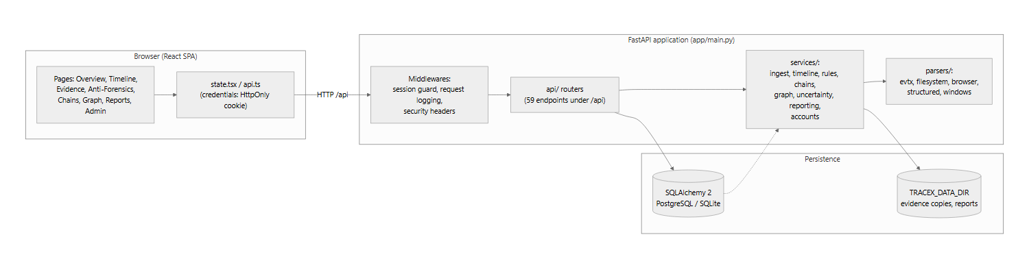
Diagram
Figure 1: System architecture. The browser holds no analytical logic; the session guard in app/main.py admits only authenticated requests to the API routers.

5.2 Data flow
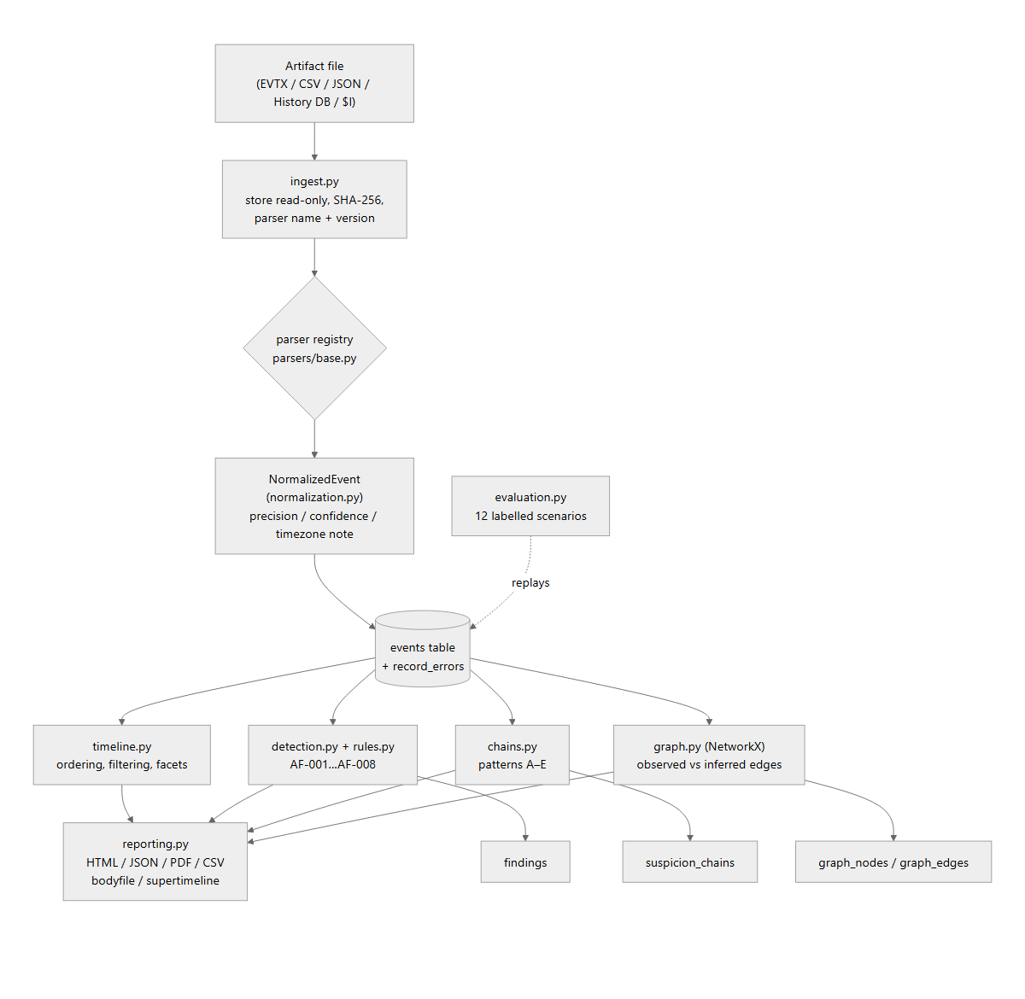
Diagram
Figure 2: Data flow from artifact import to report. Rejected rows are retained alongside accepted events; nothing is silently discarded.

5.3 Entity-relationship design
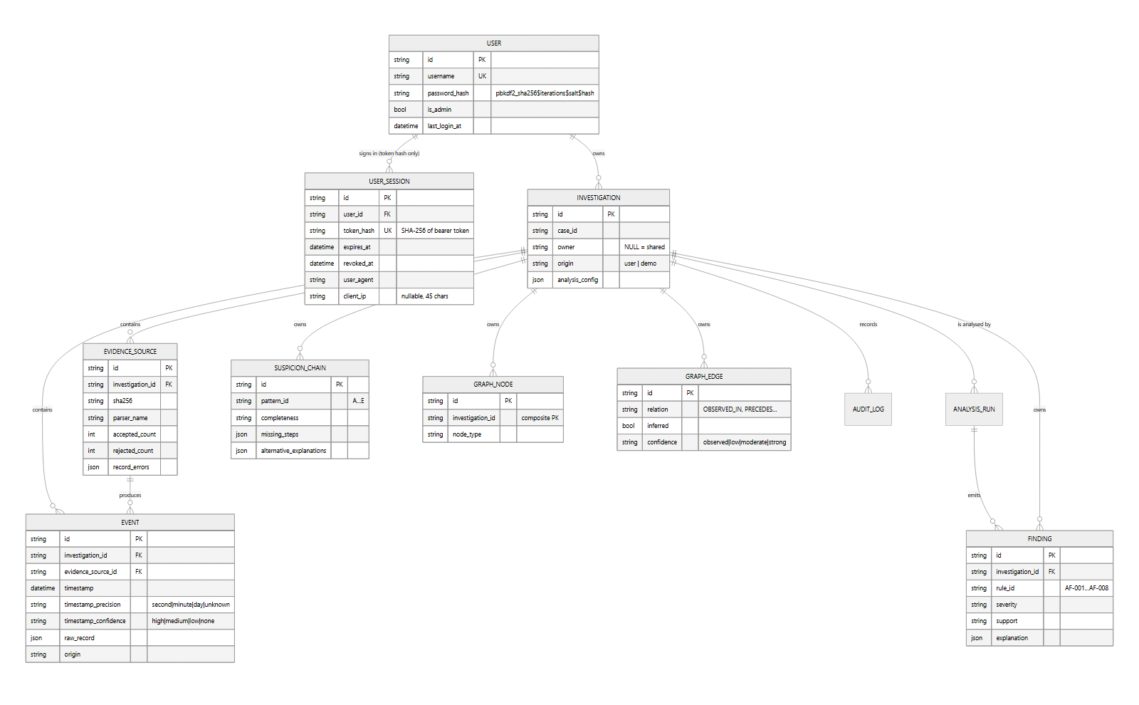
Diagram
Figure 3: Entity-relationship diagram derived from backend/app/models.py. Every investigation-owned table cascades from investigations; there are no cross-investigation foreign keys.

5.4 Technology stack and rationale
Choice | Reason recorded in the project
FastAPI + Pydantic | Schema validation is part of the security model: invalid input is rejected with structured 422 errors (main.py validation handler) rather than handled ad hoc.
SQLAlchemy 2 (typed Mapped columns) | Declarative, portable ORM allowing the same models to run on PostgreSQL (production) and SQLite (zero-infrastructure development).
Alembic | Controlled schema evolution for PostgreSQL; the SQLite development path is synchronised via create_all (README “Deployment”).
NetworkX | Graph construction and path/isolation queries server-side (app/services/graph.py), served to the browser as Cytoscape.js elements.
Cytoscape.js (+ dagre layout) | Client-side rendering of the forensic graph with layout algorithms, without moving graph computation into the browser (frontend/package.json).
React + TypeScript + Vite | Typed single-page front end with fast builds; tsc --noEmit runs as part of npm run build, so type errors fail the build.
python-evtx | Avoids re-implementing the EVTX binary format; the parser sits behind the shared BaseParser interface so a missing dependency fails loudly instead of fabricating records (README “Known limitations”).
Pydantic secrets-free config | All credentials come from environment variables; config.py stores no keys (README “Environment configuration”).
Table 5: Technology choices and the justification each one has in the repository.

6. Implementation
This section explains the system module by module. Line references and snippets are taken from the current repository state; the backend app/ package contains 33 Python files (10,938 lines) and the front end contains 19 TypeScript/TSX files (5,095 lines).

6.1 Application entry point and middleware — backend/app/main.py
The FastAPI application is assembled with a lifespan hook that creates directories and initialises the database before serving:
@asynccontextmanager
async def lifespan(_: FastAPI):
ensure_directories()
init_db()
logger.info("TRACE-X engine %s (ruleset %s) ready; env=%s", ENGINE_VERSION,
RULES_VERSION, APP_ENV)
yield
Three concerns are implemented as HTTP middleware. The session guard enforces user authentication: every /api request outside the public auth paths must carry a live session, resolved once and exposed as request.state.user:
token = _extract_token(request)
user = None
if token:
db = SessionLocal()
try:
user = resolve_session(db, token)
finally:
db.close()
if user is None:
if config.AUTH_ENABLED and token and _match_api_key(token):
return await call_next(request)
return JSONResponse(status_code=401, content={"detail": {
"code": "auth_required",
"message": "your session has expired or is invalid — sign in again"}})
request.state.user = user
The request-logging middleware measures duration, sets X-TRACE-X-Engine and X-Content-Type-Options: nosniff on every response, and deliberately excludes high-frequency /activity and /events paths from logging. Structured exception handlers convert validation failures and unhandled errors into machine-readable JSON bodies ({"error": {"code": "validation_error", …}}). If frontend/dist exists it is mounted at /, allowing a single process to serve the whole application.

6.2 Configuration — backend/app/config.py
All behaviour is environment-driven: database URL (explicit DATABASE_URL, else POSTGRES_*, else a local SQLite file), API prefix, auth flags, session lifetime (TRACEX_SESSION_HOURS, default 24), HttpOnly cookie name (TRACEX_SESSION_COOKIE, default tracex_session), admin usernames, login throttle (5 attempts / 300 s), and the PBKDF2 work factor (390,000 iterations by default). Analysis defaults — chain window, mass-deletion threshold, logging-gap and clock-drift thresholds, graph node cap — are declared once as DEFAULT_ANALYSIS_CONFIG and can be overridden per investigation.
USER_AUTH_ENABLED = os.environ.get("TRACEX_USER_AUTH_ENABLED", "true").lower() == "true"
SESSION_HOURS = int(os.environ.get("TRACEX_SESSION_HOURS", "24"))
SESSION_COOKIE_NAME = os.environ.get("TRACEX_SESSION_COOKIE", "tracex_session")
PASSWORD_PBKDF2_ITERATIONS = int(os.environ.get("TRACEX_PBKDF2_ITERATIONS", "390000"))
ENGINE_VERSION = "1.0.0"
RULES_VERSION = "1.0.0"

6.3 Data model — backend/app/models.py
Eleven tables implement the design of Figure 3. Three invariants are documented at the top of the module: evidence sources are immutable after ingestion, raw source data is kept separately from normalised fields, and no cross-investigation foreign keys exist. The event model carries uncertainty explicitly:
timestamp_precision: Mapped[str] = mapped_column(String(24), default="unknown")
timestamp_confidence: Mapped[str] = mapped_column(String(24), default="none")
timezone_note: Mapped[str | None] = mapped_column(String(255), nullable=True)
…
raw_record: Mapped[dict | None] = mapped_column(JSON, nullable=True)
raw_record_reference: Mapped[str | None] = mapped_column(String(255), nullable=True)
Composite indexes support the timeline access path (ix_events_investigation_ts, ix_events_investigation_type_ts). GraphNode/GraphEdge use a composite primary key of (id, investigation_id) because deterministic node ids such as file:<hash> recur across investigations. Schema evolution is managed by five Alembic revisions:
Revision | Change
0989628cf3b0 | initial schema
b7d21f4a9c32 | investigation owner column + performance indexes
d4a1e8b6c93f | users and user_sessions tables
f8c3a21d7e45 | users.is_admin
a7d5e1c9b402 | user_sessions.client_ip
Table 6: Migration chain (down_revision links verified in backend/alembic/versions/).

6.4 Parser framework — backend/app/parsers/
base.py defines the registry: each parser declares name, version, the source_type it produces, the file_type it accepts, and exposes parse(path) -> ParseResult, where the result carries accepted events and row-level errors:
# parsers/base.py
# `ParseResult` carries accepted events *and* row-level errors: invalid records
# are reported, never silently discarded.
Parser file | Handles | Notes from code
evtx.py | Windows Event Log (.evtx) | Uses python-evtx, parses each record’s XML rendering; SYSTEMTIME treated as UTC
filesystem.py | FSAT-style CSV/JSON, $MFT-like and USN records | “A file copy is NEVER confirmed from timestamps alone”
browser.py | Chromium History (SQLite urls + visits) | Chromium epoch converted to UTC; recorded as evidence of recorded activity only
structured.py | Normalised JSON/CSV import | Every rejected row returned with index, reason and raw excerpt
windows.py | Recycle Bin $I (binary FILETIME), $MFT/Prefetch/ShimCache/UserAssist export adapters | Adapters normalise third-party tools’ output and record that provenance
Table 7: Parser registry contents.

6.5 Normalisation and ingestion — normalization.py, services/ingest.py
NormalizedEvent is the contract between parsers and storage. Its governing rules are stated in the module docstring: “never fabricate a value the source does not provide — leave it None” and “keep the original timestamp string next to the normalized one”. The ingestion service stores the artifact read-only at a content-addressed path, computes its SHA-256, dispatches to the correct parser, persists normalised events, retains rejection detail and records provenance (parser name/version, import metadata).

6.6 Timeline engine — services/timeline.py
The timeline module implements filtering, ordering and export. Ordering is uncertainty-aware: date-only timestamps are not interleaved as if second-precise (precision and confidence are stored per event and surfaced by the API facets endpoint). The API layer exposes filtered paged reads (GET /investigations/{id}/events), facets for the filter UI, single-event detail with its raw record, and a CSV/JSON export that reflects the active UI filters.

6.7 Detection rules — services/rules.py, services/detection.py
rules.py (1,089 lines) defines the v1 ruleset AF-001…AF-008:
ID | Rule (title in code)
AF-001 | Audit log clearing (observed directly)
AF-002 | Suspicious deletion of forensic-relevant artifacts
AF-003 | Mass deletion pattern
AF-004 | Timestamp inconsistencies
AF-005 | Relevant activity followed by evidence loss
AF-006 | Suspicious gaps in expected logging
AF-007 | Modification of forensic-relevant artifacts
AF-008 | Suspicious execution followed by log clearing
Table 8: Detection ruleset (rule identifiers and titles as declared in rules.py).
The module documents the discipline each rule follows: it declares the evidence it needs and is skipped when that evidence is absent; a missing record is reported as missing evidence, never as proof of tampering; and every finding states what it does not establish together with plausible benign explanations. detection.py executes rule metadata — required evidence, conditions, exclusions, severity, explanation template, limitations, version — and produces findings with a qualitative support level and score components retained for explanation.

6.8 Suspicion chains — services/chains.py
Five patterns (A–E) are defined as candidate sequences, not verdicts; each chain carries missing steps, alternative explanations and the rules it triggered:
Pattern | Name
A | Sensitive access → possible copy → deletion
B | Suspicious execution → audit log clearing
C | Metadata modification → timestamp inconsistency
D | Relevant activity → loss of supporting evidence
E | File access → removable media → evidence anomaly
Table 9: Suspicion-chain patterns (app/services/chains.py). Incomplete patterns are still reported, annotated with which evidence is missing.

6.9 Correlation graph — services/graph.py
The graph is built server-side with NetworkX and served to Cytoscape.js. Node types are event, file, user, process, device, evidence_source, finding, hypothesis; relationship types are OBSERVED_IN, ASSOCIATED_WITH, SAME_USER, SAME_PROCESS, SAME_FILE, TEMPORALLY_NEAR, PRECEDES, SUPPORTS, CONTRADICTS, POSSIBLY_CAUSAL. Observed and inferred edges are distinguished by the inferred flag and a confidence of observed|low|moderate|strong. The endpoint set includes subgraph retrieval, graph actions, path queries and connected-component isolation, with a configurable node cap (graph_max_nodes, default 600) to bound the browser’s rendering load.

6.10 Uncertainty methodology — services/uncertainty.py
The module states that TRACE-X reports qualitative support levels and deliberately does not present arbitrary percentages as calibrated probabilities; the concepts it keeps separate are never merged into one number. The /api/uncertainty endpoint exposes this methodology to the UI so the legend shown to analysts comes from the same source as the analysis.

6.11 Reporting — services/reporting.py
Report generation (768 lines) produces the print-optimised HTML report, machine-readable JSON, a self-contained PDF, findings CSV, events JSON, TSK bodyfile CSV and plaso-style super-timeline CSV — always from persisted rows. The report structure enforces the three layers (evidence → correlation → hypothesis) and appends limitations and the audit trail. The HTML report ships a restrictive Content-Security-Policy (default-src 'none'; style-src 'unsafe-inline') because it contains no scripts, images or iframes.

6.12 Accounts, sessions and administration — services/accounts.py, api/accounts.py, api/admin.py
Passwords are stored as PBKDF2-HMAC-SHA256 with a per-password random salt; the work factor is embedded in the hash string so it can be raised later without invalidating accounts. Sessions are issued as an HttpOnly, SameSite=Lax cookie: the raw token never appears in a response body, and the database stores only its SHA-256 digest, so a database copy cannot be replayed. Login is throttled in-process (5 failed attempts → 300 s lockout by default). The first registered account becomes the instance administrator, as does any name listed in TRACEX_ADMIN_USERS. Administrators get four endpoints — list users, list a user’s sessions, revoke one session, revoke all of a user’s sessions — enforced server-side (backend/app/api/admin.py), and the admin session rows show the device user agent and the client IP captured at sign-in (stored in user_sessions.client_ip, added by migration a7d5e1c9b402).

6.13 API layer — backend/app/api/
59 endpoints are registered under the /api prefix across six routers. A single ownership_guard dependency is attached to the investigation, analysis and data routers so that every route carrying an investigation id is ownership-gated uniformly (backend/app/api/__init__.py):
_guard = [Depends(ownership_guard)]
api_router.include_router(accounts_router)
api_router.include_router(admin_router)
api_router.include_router(auth_router)
api_router.include_router(investigations_router, dependencies=_guard)
api_router.include_router(analysis_router, dependencies=_guard)
api_router.include_router(data_router, dependencies=_guard)
A complete endpoint listing appears in Appendix C.

6.14 Evaluation harness — evaluation.py, datasets.py
The harness replays controlled synthetic scenarios in throwaway in-memory databases under three configurations — A timeline only, B + detection rules, C + graph correlation and uncertainty-aware reasoning — computing micro-averaged precision, recall, false-positive rate, chain metrics, event-order accuracy and processing time against ground truth declared next to each scenario (expected_rules, expected_chains, ground-truth sort). The module docstring and the recorded results emphasise that numbers are computed, never hardcoded, and that limitations (such as a null precision when no positive prediction is made) are reported alongside them.

6.15 Front end — frontend/src/
Module | Role
main.tsx / App.tsx | Bootstraps React Router with ten routes (/, /investigations, /timeline, /evidence, /anti-forensics, /chains, /graph, /reports, /admin, /settings) and a catch-all redirect
api.ts | Typed fetch wrapper for the API; credentials ride on the HttpOnly cookie (no token in JavaScript)
state.tsx | Application context: active investigation, asynchronous data hooks, toasts
components/Layout.tsx | Navigation shell, active-case selector, session-aware chrome
components/ui.tsx | Shared primitives: StatCard, Distribution, ActivityChart, SeverityBadge, SupportBadge, Modal, Drawer, Skeleton, EmptyState
pages/*.tsx | Ten page components, one per route plus Login
types.ts | TypeScript mirrors of the API payloads, including AdminSession.client_ip
__tests__/fmtTs.test.ts | Jest tests for timestamp formatting
Table 10: Front-end module map. Charts render only values returned by the API — the Distribution and ActivityChart components take count maps and bucket counts as props, so the UI cannot originate data.
// frontend/src/components/ui.tsx
/** Horizontal distribution bars computed from a count map. */
export const Distribution: React.FC<{ data: Record<string, number>; … }> = ({ data, … }) => {
const entries = Object.entries(data || {}).sort((a, b) => b[1] - a[1]);
…
};

6.16 Demonstration data — demo.py
Demo generation creates investigations, sources and events that all carry origin == "demo" and are rendered with a synthetic badge, so demonstration data is never mixed with imported evidence unlabelled.

7. Testing and Results

7.1 Test approach
Testing is stratified into four layers, each with an independent entry point:
- Backend automated suite — pytest tests/ against SQLite, using shared fixtures in backend/tests/conftest.py. The suite covers parsers and invalid-row reporting, timeline ordering/filtering/search, uncertain timestamps, detection rules and three-layer explanations, suspicion chains, graph integrity, investigation isolation, evidence hashing, report/manifest generation, demo labelling, API-key auth and ownership, batch evidence import, integrity re-verification, bodyfile/super-timeline/PDF exports and API validation (README “Testing”).
- PostgreSQL integration suite — pytest -m pg, marked and deselected by default, requiring a live server (TRACEX_TEST_PG_URL). It covers the full Alembic chain on a fresh database, alembic check drift detection, ingest→analysis→timeline round-trip, timestamptz round-trip, date_trunc grouping and owner filtering.
- Front end — tsc --noEmit (run as the first step of npm run build) plus Jest unit tests for pure functions.
- End-to-end smoke test — scripts/smoke_test.sh, a curl-based acceptance path against a running API: health → create investigation → validation-rejection check → evidence preview and import → records/errors → timeline → analysis → findings → chains → graph → uncertainty → report → exports → isolation check.
Continuous integration (.github/workflows/ci.yml) runs three jobs on every push and pull request: the SQLite suite (pytest -q -m "not pg"), the PostgreSQL 18 integration suite (pytest -q -m pg, including alembic check), and the front-end typecheck/build.

7.2 Test modules
Test module | Primary coverage
tests/test_parsing.py | Parser outputs and per-row rejection reporting
tests/test_timeline.py | Ordering, filtering, search, uncertain timestamps
tests/test_detection.py | Rules AF-001…AF-008, three-layer explanations
tests/test_feature_batch.py | Batch import, integrity re-verification, exports
tests/test_graph_and_isolation.py | Graph integrity, cross-investigation isolation
tests/test_integrity_and_report.py | Evidence hashing, report/manifest, header-injection regression
tests/test_accounts.py | Signup, sign-in, sessions, HttpOnly cookie, throttling
tests/test_admin.py | Admin user listing and session revocation
tests/test_postgres_integration.py | Live-PostgreSQL suite (marker pg)
frontend/src/__tests__/fmtTs.test.ts | Timestamp formatting in the UI
Table 11: Test modules and their coverage areas.

7.3 Executed results
All figures below were produced by commands run against the current working tree; exit codes were captured directly.
Check | Command | Result | Exit code
Backend suite (default) | pytest tests/ -q -m "not pg" | 114 passed, 1 skipped, 6 deselected, 1 warning, 21.41 s | 0
Test collection | pytest --collect-only -q | 121 tests collected | 0
Front-end unit tests | npm test (Jest) | 6 passed, 1 suite, 0.775 s | 0
Front-end type check | npx tsc --noEmit | no errors | 0
Front-end production build | npm run build | built in 6.82 s → index-DgT3bX-e.js (813.47 kB, 251.67 kB gzip), index-DSanFapD.css (16.61 kB) | 0
PostgreSQL integration | pytest -q -m pg | not executed on this machine (no configured server) | not run
End-to-end smoke test | bash scripts/smoke_test.sh | not executed in this report’s run | not run
Table 12: Verification results executed while preparing this report. The single skipped test is intentional: it asserts behaviour for a deliberately incomplete detection scenario that the current ruleset does not define (tests/test_detection.py, skip reason “no deliberately incomplete scenario in this ruleset”).

7.4 Evaluation results
The controlled evaluation replayed eleven labelled scenarios (79 ingested events) under the three configurations described in Section 6.14. The table below reproduces the recorded output of the run documented in docs/evaluation-results.md (generated 2026-10-18T10:48:29Z, engine 1.0.0, ruleset 1.0.0, no errors, ≈1.9 s wall time for 33 scenario-configurations):
Metric | A (timeline) | B (+ rules) | C (+ graph/reasoning)
Rule TP / FP / FN / TN | 0 / 0 / 21 / 67 | 21 / 0 / 0 / 67 | 21 / 0 / 0 / 67
Rule precision | null (0/0 undefined) | 1.0 | 1.0
Rule recall | 0.0 | 1.0 | 1.0
Rule false-positive rate | 0.0 | 0.0 | 0.0
Chain TP / FP / FN / TN | 0 / 0 / 8 / 47 | not built | 8 / 0 / 0 / 47
Chain precision | null | null | 1.0
Chain recall | 0.0 | 0.0 | 1.0
Event-order accuracy | 1.0 | 1.0 | 1.0
Relationship accuracy | n/a | n/a | 1.0
Explainability coverage | n/a | 1.0 | 1.0
Mean analysis time | n/a | 7 ms | 18 ms
Mean wall time per scenario | 31 ms | 67 ms | 47 ms
Table 13: Recorded A/B/C evaluation output (docs/evaluation-results.md, run of 2026-10-18). These numbers are generated live by POST /api/evaluation/run; they are not hardcoded in the harness or the UI.
Interpretation and caveats, as stated by the project itself. The dataset is synthetic and authored by the same project, so the numbers measure consistency with declared ground truth, not real-world validity; eleven small scenarios cannot represent casework diversity; no independently labelled corpus or inter-rater agreement was used; and timings are wall-clock measurements on one developer machine intended for regression comparison. The project’s own documentation therefore characterises this as a regression baseline rather than a published benchmark. Reproducing the run:
cd backend && ../.venv/Scripts/python -m app.evaluation

7.5 Interface walkthrough (screenshots)
The captures below were taken from a running TRACE-X instance seeded with the repository’s sample artifacts (datasets/) in an isolated development database. Every value visible in them is computed by the API from persisted rows; the case shown is CAPSTONE-2026-01.
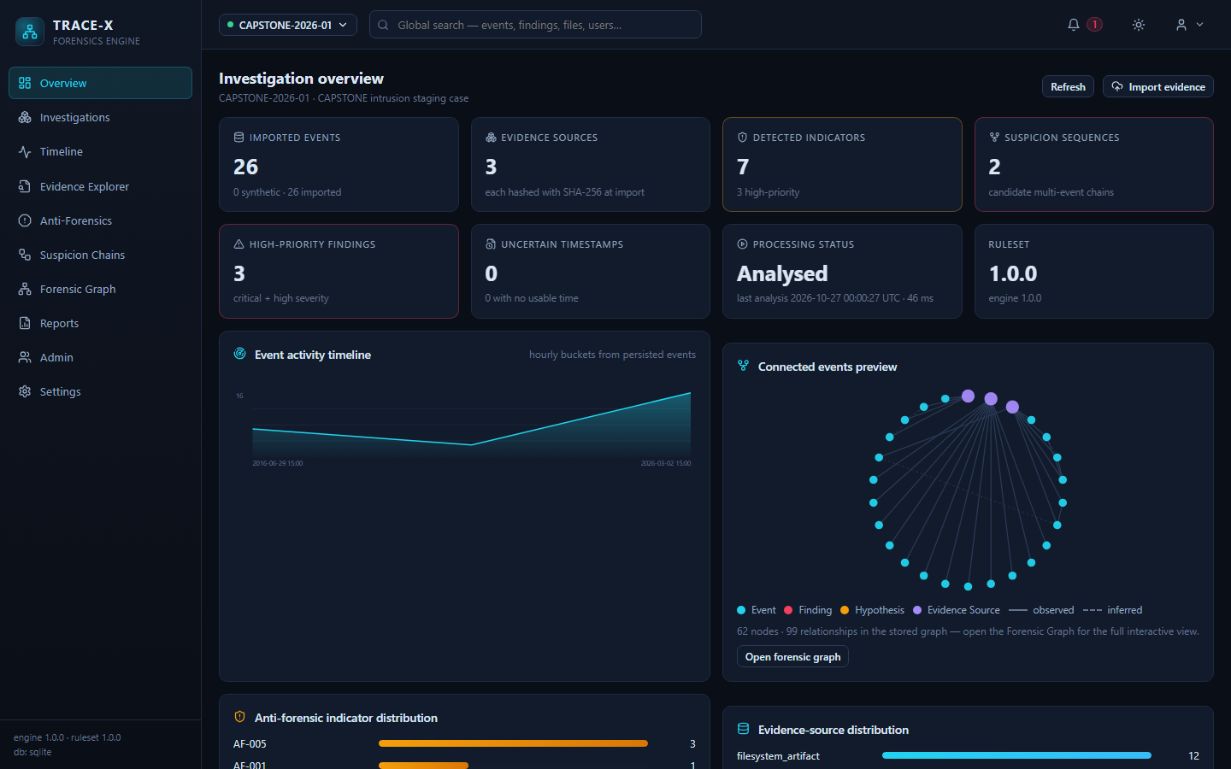
Overview page
Figure 4: Overview page — stat cards, hourly activity chart, graph preview and per-rule indicator distribution, all computed from persisted rows.
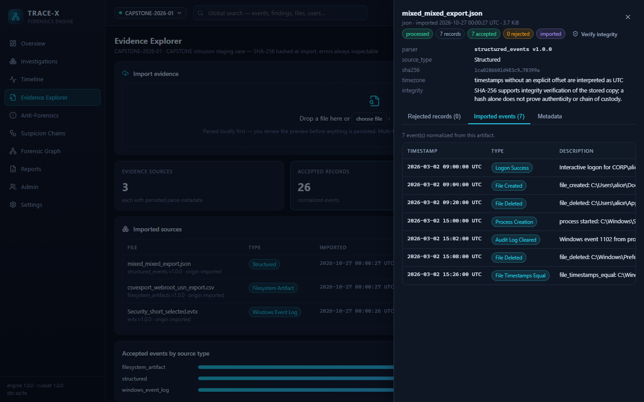
Evidence Explorer
Figure 5: Evidence Explorer — a selected source detail showing SHA-256, parser and version, integrity note, record counts and the normalized events it produced.
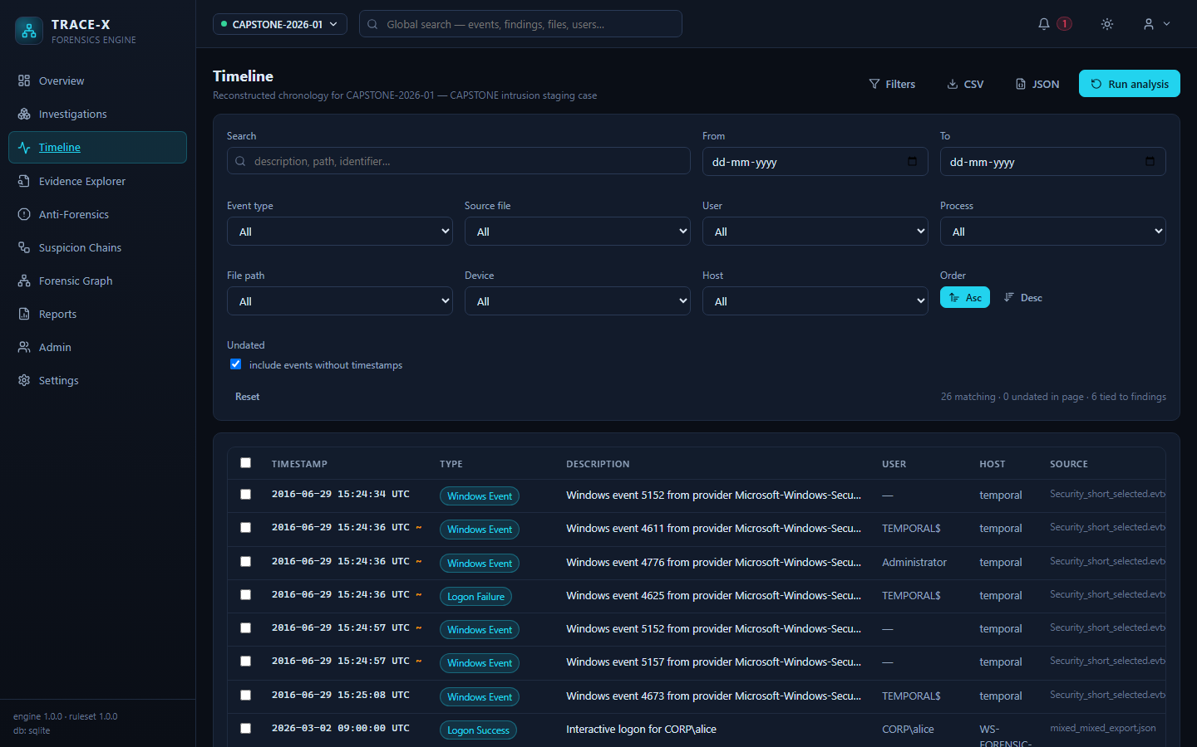
Timeline with filters
Figure 6: Timeline with the filter panel open — facet filters, ordering control and events carrying uncertainty flags.
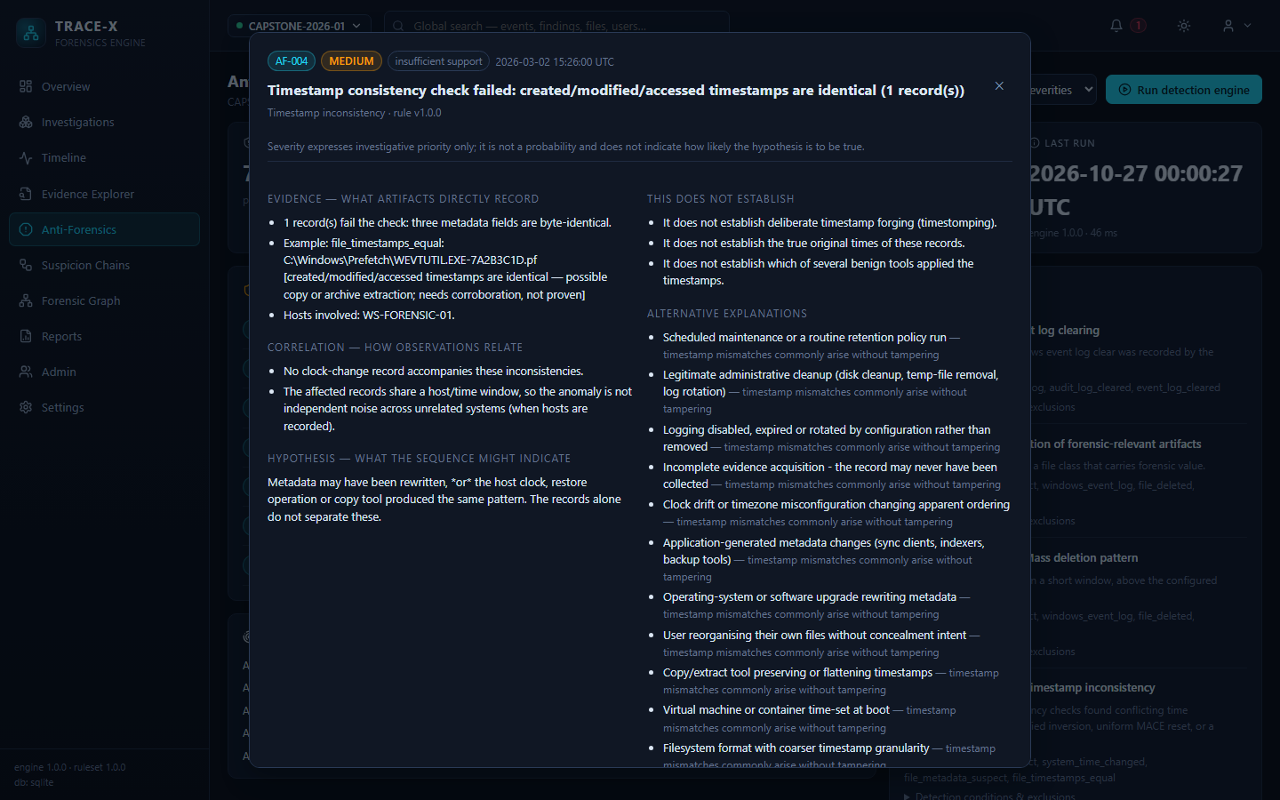
Finding detail
Figure 7: Explainable finding detail — the three layers (evidence, correlation, hypothesis), what the finding does not establish, and its alternative explanations.
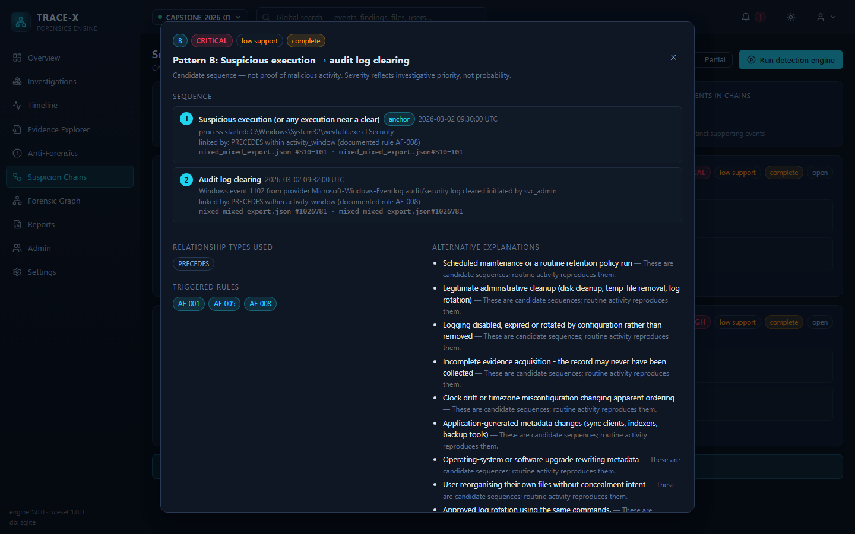
Suspicion chain detail
Figure 8: Suspicion chain detail — ordered sequence with anchor and linked steps, triggered rules and alternative explanations.
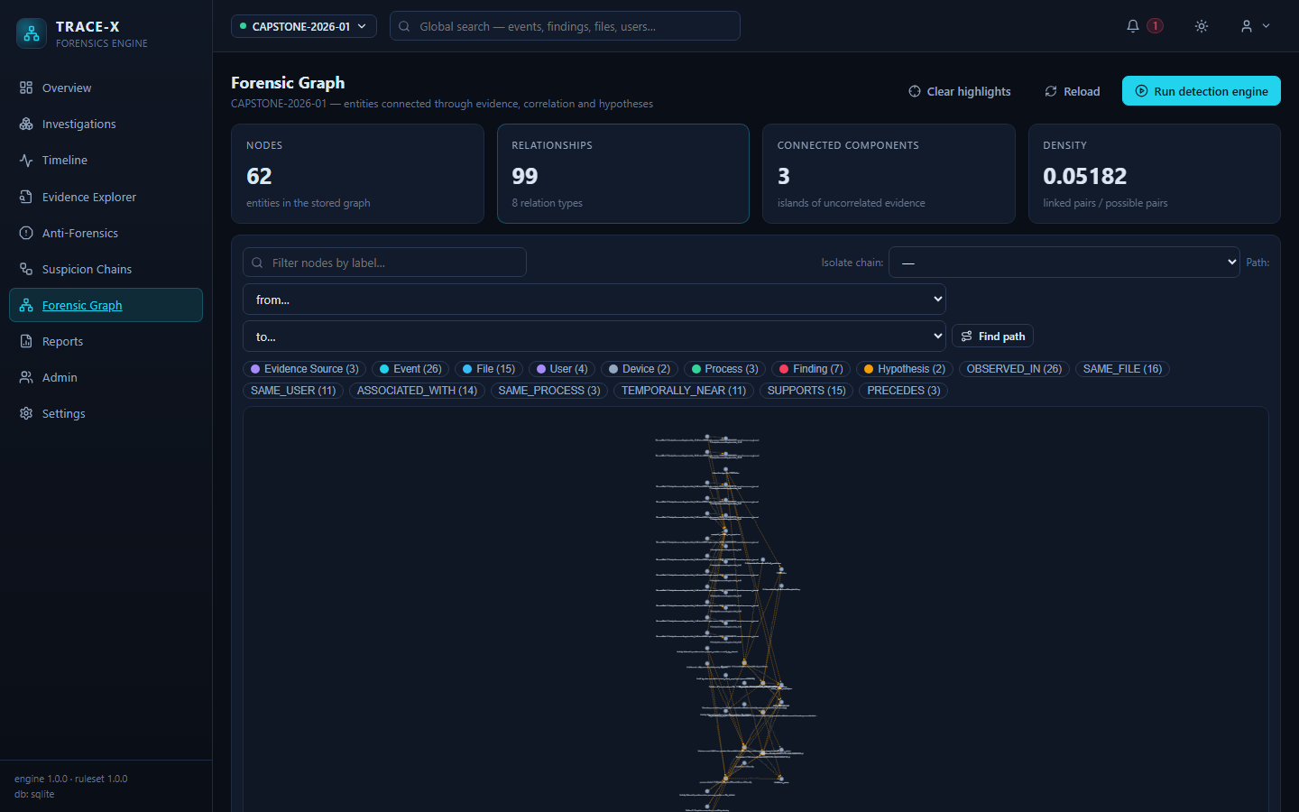
Forensic graph
Figure 9: Correlation graph — Cytoscape.js rendering with node/relationship filters, graph statistics and the observed/inferred legend.
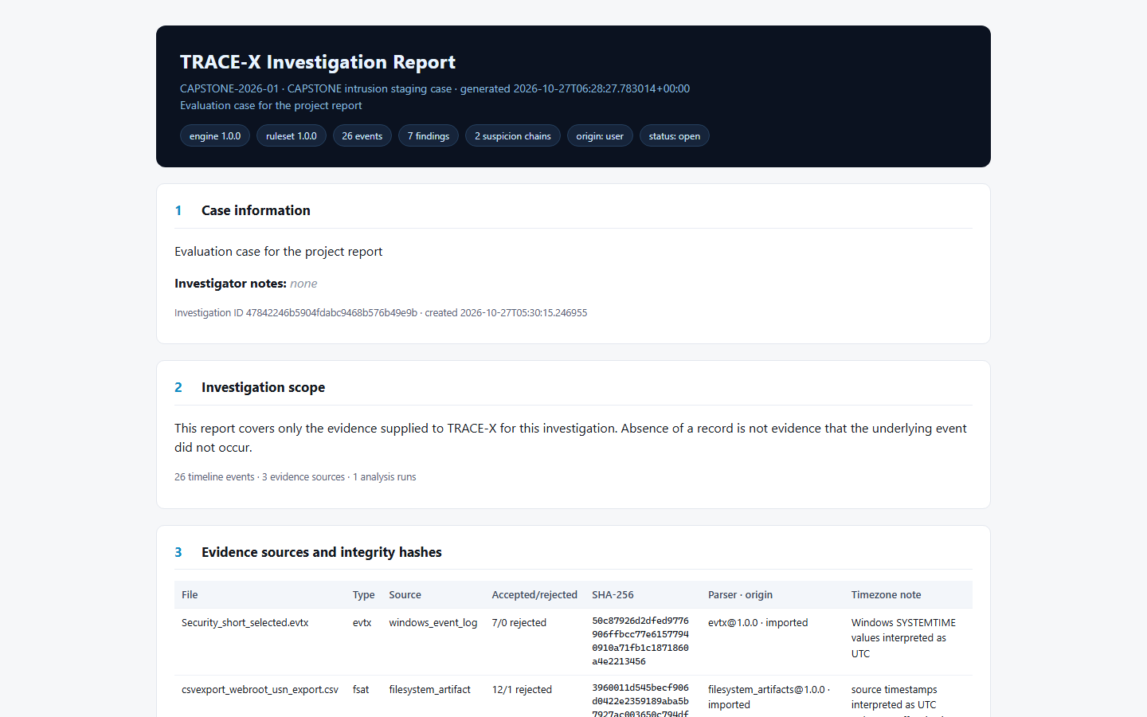
Generated report
Figure 10: Generated investigation report — case information, investigation scope and evidence sources with SHA-256 integrity hashes.
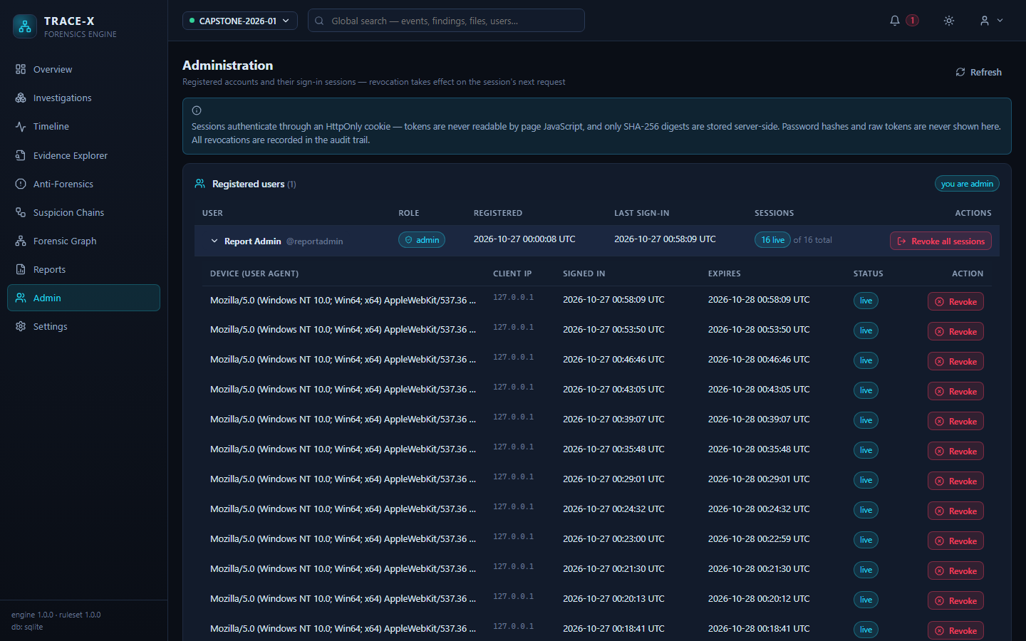
Admin sessions
Figure 11: Admin session management — registered users with the expanded session list showing device (user agent), client IP, expiry and per-session revocation.
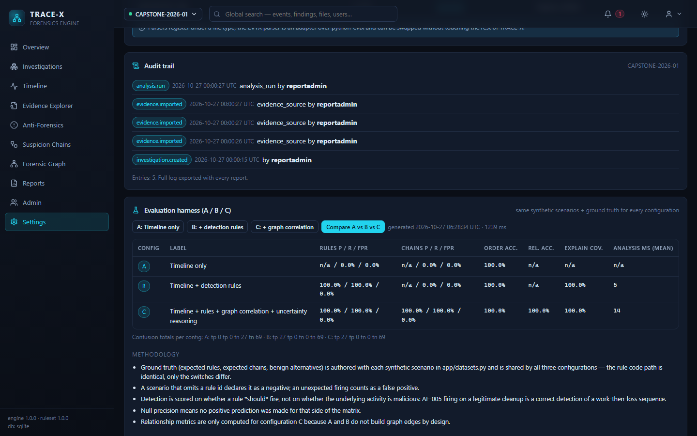
Evaluation harness
Figure 12: Evaluation harness output — the A/B/C comparison table with confusion totals and the metric methodology.

8. Challenges and Solutions
The following challenges are documented in the repository together with the solution adopted in code; each entry is traceable to the file cited.
# | Challenge | Solution implemented | Evidence
1 | Timestamps arrive with mixed precision, timezones and clock quality | Per-event timestamp_precision, timestamp_confidence and timezone_note; date-only values are never ordered as second-precise | models.py, normalization.py
2 | Anti-forensic rules fire on legitimate administrative activity | Rules declare required evidence and are skipped with a machine-readable reason when it is absent; benign “trap” scenarios are part of the evaluation ground truth | services/rules.py, docs/evaluation-results.md
3 | Absence of a record is easily misread as proof of deletion | Findings state what they do not establish; missing records are reported as missing coverage | README policy, reporting.py
4 | Correlation is easily presented as causation | Three-layer report structure; graph edges carry inferred and confidence; POSSIBLY_CAUSAL edges require a shared anchor | reporting.py, services/graph.py
5 | Header injection / response splitting through user-supplied values | All user values schema-validated against control characters; Content-Disposition sanitised, with a regression test | test_integrity_and_report.py, README “Security hardening”
6 | Session tokens exposed to page JavaScript | Sessions delivered only as an HttpOnly, SameSite=Lax cookie; database stores only the SHA-256 digest | config.py, services/accounts.py
7 | Simultaneous support for zero-infrastructure SQLite and production PostgreSQL | Single URL resolver in config; Alembic as the controlled path for PostgreSQL, create_all for SQLite development | config.py, alembic/versions/
8 | Legacy databases created before newer columns existed | Startup ensure-path adds pending columns to existing SQLite databases; migrations cover PostgreSQL | db.py, revisions f8c3a21d7e45, a7d5e1c9b402
9 | Graph rendering load in the browser with large cases | Configurable graph_max_nodes cap (default 600) on the graph endpoint | config.DEFAULT_ANALYSIS_CONFIG
10 | Cross-case data leakage between investigators | Uniform ownership_guard dependency on every investigation-bearing router; cascading delete-orphan relationships; isolation tests | api/__init__.py, test_graph_and_isolation.py
11 | Evaluation numbers drifting or being hardcoded | Harness replays scenarios in throwaway in-memory databases; results regenerated live and mirrored with their limitations | evaluation.py, docs/evaluation-results.md
12 | Duplicate findings across re-runs | dedupe_key columns on findings and chains | models.py
Table 14: Engineering challenges and the solutions present in the codebase.

9. Limitations and Future Scope

9.1 Limitations
The repository states the following limitations explicitly (README “Known limitations”); they are reproduced here without softening:
- PostgreSQL integration tests run separately. The default suite uses SQLite; the pytest -m pg suite requires a live server and could not be executed for this report because no server was configured in the environment used for these runs.
- Authentication is single-tenant in API-key mode. Keys map to actor names with investigation-level ownership; there is no key-rotation UI, TLS termination or rate limiting. The README instructs that TRACE-X must not be exposed beyond localhost with API-key auth disabled.
- Docker images are untested on the development machine. Docker is not installed in the development environment; the compose file is validated syntactically and exercised by CI, but the first docker compose up may surface platform-specific issues.
- EVTX parsing depends on python-evtx. If the dependency is unavailable the import fails loudly rather than fabricating records.
- Timezone assumptions. Timestamps without an offset are interpreted as UTC and flagged; naive local time and clock skew surface as uncertainty rather than being silently normalised.
- Curated ruleset. AF-001…AF-008 is a starting set, not an exhaustive anti-forensics catalogue; false positives are expected, and every finding states its alternative explanations.
- Synthetic evaluation data. The A/B/C numbers measure agreement with a self-declared ground truth on small scenarios — a regression baseline, not an external benchmark.
- One intentionally skipped test, and one README test-count figure that no longer matches the collection count (see Open Questions).
- Client IP capture uses the direct TCP peer address; a deployment behind a reverse proxy would require trusted X-Forwarded-For handling. Sessions created before the column was added display no client IP.

9.2 Future scope
The following are proposed extensions; none of them is implemented in the current repository, and each would need to be validated against the existing architecture:
- Wider artifact coverage (registry entries for additional Windows/Linux/macOS sources) by registering new parsers behind BaseParser.
- Independent, externally labelled evaluation corpus with inter-rater agreement, replacing the self-authored synthetic ground truth.
- Rate limiting, TLS guidance and API-key rotation tooling for non-localhost deployments.
- Deeper plaso/mactime round-trip validation of the bodyfile and super-timeline exports.
- [INSERT: additional future work items proposed by the team]

10. Conclusion
This report described TRACE-X, an explainable digital forensics engine implemented as a FastAPI service and a React client. The system ingests heterogeneous forensic artifacts through a versioned parser registry, normalises them into an uncertainty-aware event model, and derives timelines, rule-based anti-forensics findings, suspicion chains and a correlation graph — each output carrying the evidence, correlation and hypothesis layers that justify it. Engineering concerns that usually erode trust in such tools — silent row loss, ambiguous timestamps, findings without provenance, cross-case leakage and tokens readable by page JavaScript — are addressed by explicit design decisions recorded in the code and enforced by an automated suite of 121 collected tests (114 executed and passed in the run recorded in Section 7.3), six front-end unit tests, type checking, continuous integration and an end-to-end smoke script. A controlled three-configuration evaluation harness quantifies the contribution of the detection and correlation layers while reporting its own limits. The remaining limitations — chiefly the synthetic evaluation corpus and the curated ruleset — are documented rather than hidden, consistent with the project’s central claim that a forensics tool must never state more than its evidence proves.

11. References
- TRACE-X project repository — README.md, docs/evaluation-results.md (accessed October 2026). [Internal source: cite the repository URL or submission portal here — INSERT: repository URL.]
- FastAPI documentation, https://fastapi.tiangolo.com/
- SQLAlchemy 2.0 documentation, https://docs.sqlalchemy.org/en/20/
- Alembic documentation, https://alembic.sqlalchemy.org/
- Pydantic documentation, https://docs.pydantic.dev/
- React documentation, https://react.dev/
- TypeScript documentation, https://www.typescriptlang.org/docs/
- Vite guide, https://vitejs.dev/guide/
- NetworkX documentation, https://networkx.org/documentation/stable/
- Cytoscape.js documentation, https://js.cytoscape.org/
- W. Ballenthin, python-evtx — Windows Event Log parser, https://github.com/williballenthin/python-evtx
- plaso — super-timeline framework (log2timeline), https://plaso.readthedocs.io/
- The Sleuth Kit project, https://www.sleuthkit.org/ [verify the exact citation for the mactime bodyfile(5) format before submission — INSERT: preferred citation]
- E. Zimmerman, MFTECmd, https://github.com/EricZimmerman/MFTECmd
- NirSoft, WinPrefetchView, https://www.nirsoft.net/utils/win_prefetch_view.html
- pytest documentation, https://docs.pytest.org/
- NIST Special Publication 800-132, Recommendation for Key Derivation Using Pseudorandom Functions, https://nvlpubs.nist.gov/nistpubs/Legacy/SP/nistspecialpublication800-132.pdf [verify URL before submission]
- GitHub Actions documentation, https://docs.github.com/en/actions
[needs citation] entries in Section 3 must be completed with sources for any comparative claim retained in the final submission.

12. Appendix

Appendix A: Setup and run instructions
Reproduced from README.md, frontend/package.json and scripts/smoke_test.sh:
# 1. Backend dependencies (project virtual environment at ./.venv)
python -m venv .venv
.venv/Scripts/pip install -r backend/requirements.txt
# 2. Run the API on 127.0.0.1:8000 (SQLite by default)
cd backend && ../.venv/Scripts/python -m uvicorn app.main:app --host 127.0.0.1 --port 8000
# 3. Front end (separate terminal): dev server on 127.0.0.1:5173, proxies /api to :8000
cd frontend && npm install && npm run dev
# 4. Open http://127.0.0.1:5173
# Tests
cd backend && ../.venv/Scripts/python -m pytest tests/ -q # SQLite suite
cd backend && ../.venv/Scripts/python -m pytest -q -m pg # live PostgreSQL suite
cd frontend && npm run build # tsc --noEmit + vite build
cd frontend && npm test # Jest
bash scripts/smoke_test.sh # end-to-end (API on :8000)
# PostgreSQL deployment: run migrations once
cd backend && alembic upgrade head
# Full stack with Docker (requires Docker; .env with POSTGRES_PASSWORD)
docker compose up --build
Key environment variables (README “Environment configuration”): DATABASE_URL, POSTGRES_HOST/PORT/USER/PASSWORD/DB, TRACEX_DATA_DIR, TRACEX_AUTH_ENABLED, TRACEX_API_KEYS, TRACEX_USER_AUTH_ENABLED, TRACEX_SESSION_HOURS, TRACEX_SESSION_COOKIE, TRACEX_ADMIN_USERS, TRACEX_TEST_PG_URL, TRACEX_TEST_PG_ADMIN_URL. No secrets are stored in source.

Appendix B: Directory tree
TraceX/
├── README.md project overview, setup, security, limitations
├── docker-compose.yml PostgreSQL 18 + backend + nginx-served frontend
├── .env.example environment template (no secrets)
├── .github/workflows/ci.yml CI: SQLite suite, PG 18 integration, frontend build
├── backend/
│ ├── requirements.txt pinned runtime + test dependencies
│ ├── app/
│ │ ├── main.py FastAPI app, middlewares, exception handlers
│ │ ├── config.py environment-driven configuration, version constants
│ │ ├── db.py engine/session, create_all, column-ensure path
│ │ ├── models.py 11 ORM tables
│ │ ├── schemas.py Pydantic request/response models
│ │ ├── auth.py API-key extraction and constant-time matching
│ │ ├── normalization.py NormalizedEvent contract
│ │ ├── evaluation.py A/B/C evaluation harness
│ │ ├── datasets.py labelled synthetic scenarios
│ │ ├── demo.py labelled demo data generation
│ │ ├── api/ accounts, admin, analysis, auth, data, investigations
│ │ ├── parsers/ base, evtx, filesystem, browser, structured, windows
│ │ └── services/ accounts, chains, detection, evidence, graph, ingest,
│ │ reporting, rules, timeline, uncertainty
│ ├── alembic/versions/ 5 revisions (initial → session client_ip)
│ └── tests/ 9 test modules (121 collected tests)
├── frontend/
│ ├── package.json React 18, Vite 5, Cytoscape, Jest
│ ├── vite.config.ts dev server + /api proxy to :8000
│ └── src/
│ ├── App.tsx 10 routes
│ ├── api.ts, state.tsx, types.ts
│ ├── components/ Layout, ui primitives
│ ├── pages/ Overview, Investigations, Timeline, EvidenceExplorer,
│ │ AntiForensics, SuspicionChains, ForensicGraph, Reports,
│ │ Admin, Login, Settings
│ └── __tests__/ Jest tests
├── datasets/ sample EVTX, filesystem exports, JSON event sets (15 files)
├── docs/evaluation-results.md recorded A/B/C evaluation output
├── scripts/smoke_test.sh end-to-end API acceptance script
├── migrations/ database backup/restore artifacts from development
└── tools/ local PostgreSQL cluster used during development
Table 15: Repository structure (verified against the working tree). Codebase size: backend app/ — 33 Python files, 10,938 lines; backend tests/ — 2,359 lines; frontend src/ — 19 TypeScript/TSX files, 5,095 lines.

Appendix C: API endpoint list
All endpoints are served under the /api prefix (59 routes, verified from the router decorators). Routers marked with (guard) are ownership-gated by ownership_guard.
# | Method | Path | Router file
1 | GET | /api/health | data.py
2 | GET | /api/version | data.py
3 | GET | /api/rules | data.py
4 | GET | /api/parsers | data.py
5 | GET | /api/uncertainty | data.py
6 | GET | /api/dashboard | data.py
7 | GET | /api/search | data.py
8 | GET | /api/demo | data.py
9 | POST | /api/demo/generate | data.py
10 | POST | /api/evaluation/run | data.py
11 | GET | /api/evaluation/run | data.py
12 | GET | /api/auth/status | accounts.py
13 | POST | /api/auth/signup | accounts.py
14 | POST | /api/auth/login | accounts.py
15 | POST | /api/auth/logout | accounts.py
16 | GET | /api/auth/me | accounts.py
17 | GET | /api/auth/verify | auth.py
18 | GET | /api/admin/users | admin.py
19 | GET | /api/admin/users/{user_id}/sessions | admin.py
20 | DELETE | /api/admin/sessions/{session_id} | admin.py
21 | POST | /api/admin/users/{user_id}/revoke-sessions | admin.py
22 | GET | /api/investigations (guard) | investigations.py
23 | POST | /api/investigations (guard) | investigations.py
24 | GET | /api/investigations/{id} (guard) | investigations.py
25 | PATCH | /api/investigations/{id} (guard) | investigations.py
26 | DELETE | /api/investigations/{id} (guard) | investigations.py
27 | PUT | /api/investigations/{id}/config (guard) | investigations.py
28 | GET | /api/investigations/{id}/audit (guard) | investigations.py
29 | GET | /api/investigations/{id}/evidence (guard) | investigations.py
30 | GET | /api/investigations/{id}/evidence/{sid}/errors (guard) | investigations.py
31 | GET | /api/investigations/{id}/evidence/{sid}/events (guard) | investigations.py
32 | POST | /api/investigations/{id}/evidence/preview (guard) | investigations.py
33 | POST | /api/investigations/{id}/evidence (guard) | investigations.py
34 | POST | /api/investigations/{id}/evidence/batch (guard) | investigations.py
35 | POST | /api/investigations/{id}/evidence/{sid}/verify (guard) | investigations.py
36 | POST | /api/investigations/{id}/evidence/{sid}/reparse (guard) | investigations.py
37 | POST | /api/investigations/{id}/analysis/run (guard) | analysis.py
38 | GET | /api/investigations/{id}/analysis/runs (guard) | analysis.py
39 | GET | /api/investigations/{id}/findings (guard) | analysis.py
40 | GET | /api/investigations/{id}/findings/{fid} (guard) | analysis.py
41 | GET | /api/investigations/{id}/chains (guard) | analysis.py
42 | GET | /api/investigations/{id}/chains/{cid} (guard) | analysis.py
43 | PATCH | /api/investigations/{id}/chains/{cid} (guard) | analysis.py
44 | GET | /api/investigations/{id}/graph (guard) | analysis.py
45 | GET | /api/investigations/{id}/graph/actions (guard) | analysis.py
46 | POST | /api/investigations/{id}/graph/path (guard) | analysis.py
47 | GET | /api/investigations/{id}/graph/isolate (guard) | analysis.py
48 | GET | /api/investigations/{id}/events (guard) | data.py
49 | GET | /api/investigations/{id}/timeline/facets (guard) | data.py
50 | GET | /api/investigations/{id}/events/{eid} (guard) | data.py
51 | GET | /api/investigations/{id}/timeline/export (guard) | data.py
52 | GET | /api/investigations/{id}/report.html (guard) | data.py
53 | GET | /api/investigations/{id}/report.json (guard) | data.py
54 | GET | /api/investigations/{id}/report/manifest (guard) | data.py
55 | GET | /api/investigations/{id}/export/findings.csv (guard) | data.py
56 | GET | /api/investigations/{id}/export/events.json (guard) | data.py
57 | GET | /api/investigations/{id}/export/bodyfile.csv (guard) | data.py
58 | GET | /api/investigations/{id}/export/supertimeline.csv (guard) | data.py
59 | GET | /api/investigations/{id}/report.pdf (guard) | data.py
Table 16: Complete API endpoint listing (59 routes).

Open Questions
Items that could not be resolved from the repository alone, rather than guessed:
- Report context. The purpose (capstone / course project / hackathon / internship), audience, author name(s), institution, year and expected length were supplied as template placeholders; they appear as [INSERT: …] on the title page and must be filled in.
- README test count is stale. The README states “93 automated tests”, while the current collection is 121 tests. The report uses the executed figure (121 collected / 114 passed / 1 skipped / 6 PG-deselected); confirm whether the README should be corrected.
- Scenario count disagrees across files. app/datasets.py’s docstring says “10 scenarios”, docs/evaluation-results.md says “11 labelled scenarios”, and the code defines 12 entries in SCENARIOS. The evaluation table reproduced in Section 7.4 is the recorded output of the 2026-10-18 run; confirm which scenario count the report should state, or re-run the harness and regenerate the results document.
- README limitation wording. “Auth is single-tenant API-key” predates the user-account and admin features now present in the code; confirm whether that limitation text should be updated before submission.
- Re-running evaluation for the report. Section 7.4 reproduces the recorded run rather than a fresh one; decide whether a new run should be attached (results are generated live and may differ in timings only).
- Citation gaps. Every comparison in Section 3 marked [needs citation], plus the bodyfile/mactime and NIST references in Section 11, require URL/author confirmation before submission.
- Not executed in this environment. The pytest -m pg suite and scripts/smoke_test.sh were not re-run for this report (no PostgreSQL server configured; the smoke test needs a running API). CI runs the PostgreSQL suite on every push. The default backend suite, Jest, tsc --noEmit and npm run build were all executed and passed (Table 12).
- Screenshot provenance. Figures 4–12 were captured from an isolated development instance seeded with the repository’s sample artifacts (data and accounts from that run are not part of any production database). Replace them with captures from your own submission build if the evaluation case differs.

