**Analyzing the Drop in Electronics Sales in the Southern Region**

Team Members: **Sai and Akhila** Submitted To: **Deva sir** Date: **28-06-2025**

**Table of Contents**

1. **Introduction**

The business is currently facing a decline in performance, reflected through reduced sales, lower customer engagement, and poor marketing outcomes. To understand the root causes of this loss, data from four key areas—sales, website traffic, customer feedback, and marketing campaigns—has been collected and analyzed. This project aims to identify the factors contributing to the downturn and provide data-driven recommendations to improve business performance and prevent further losses.

**2**. **Objective**

The main objective of this project is to analyze and interpret data from multiple business functions to identify the reasons behind the company’s declining performance. By leveraging data analytics techniques using Pandas, the goal is to generate insights that highlight problem areas and support strategic decisions aimed at improving customer engagement, optimizing marketing efforts, and boosting overall sales performance

**3. Dataset Description**

We have collected 4 datasets to analyze and interpret the insights

**(1).Sales Data**

This dataset records daily sales activity across different regions and stores.

It includes:Date, Region, Store_ID, Product, Units_Sold, and Revenue.  
It helps in understanding sales trends, regional performance, and product-level contributions to revenue.

**(2).Website Traffic Data**

Captures daily footfall and engagement on the company’s website.

Key columns are:Date, Region, Store_ID, and Customer_Visits.  
It aids in evaluating customer interest and digital presence by region and store.

**(3).Customer Feedback data**

Contains customer opinions and satisfaction levels collected through ratings and comments:

Date, Region, Store_ID, Product, Rating, and Comments.  
This dataset is useful for assessing customer experience and identifying common issues or praise points

**(4).Marketing Campaign data**

Provides information on marketing efforts carried out over time, including:

Campaign_ID, Start_Date, End_Date, Region, Medium, Budget, and Campaign_Type.  
It helps in analyzing the effectiveness of different marketing channels and budget utilization.

**4. Data Cleaning Process**

To ensure accurate and reliable analysis, the following data cleaning steps were applied to each dataset:

1. **Sales data**

• **Handled missing values:** Filled missing Revenue and Units_Sold values where possible using mean

• **Standardized formats:** Converted Date column to datetime format.

1. **Wesbite traffic data**

* **Missing values:** Filled missing Customer_Visits with the median for the respective region.
* **Date format correction:** Ensured Date was in datetime format.

1. **Customer Feedback data**

• **Rating validation:** Ensured all ratings were within the expected 1-5 range.

• **Missing text:** Removed rows with missing or blank comments (if needed).

• **Text cleaning:** Removed unnecessary symbols or special characters from Comments

1. **Marketing Campaign data**

• **Date parsing:** Converted Start_Date and End_Date to datetime.

• **Campaign duration:** Created a new column to calculate campaign duration in days.

• **Missing values:** Checked for null values in Budget and filled using mean function

**5. Exploratory Data Analysis**

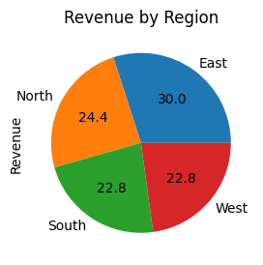

**Sales by Product**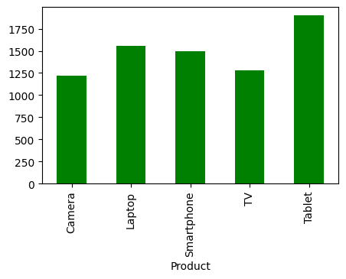

**Missing Values**: Revenue and Units_Sold had some missing entries (~5%). These were handled appropriately during cleaning.

**Top Products Sold**: *Tablets* and *Laptops* recorded the highest number of units sold.

**Revenue by Region**: The East and North regions generated the most revenue.

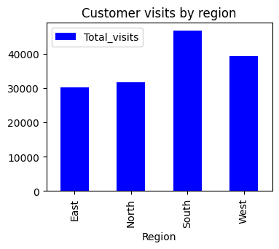

**Traffic Trends**: Website traffic varied significantly by region. The **South** and **West** regions had the highest engagement.

**Customer Visits Over Time**: Fluctuations were observed, with certain periods showing sharp drops that may have affected sales.

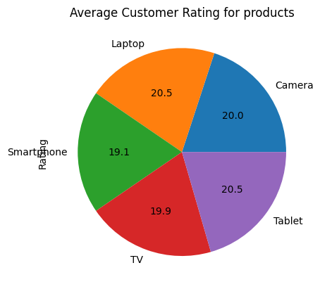

**Ratings**: The customer ratings tells us the quality of the products and determines how customer satisfied with our product

**Product Ratings**: *Smartphones* received the lowest average rating, while Tablet and Laptop have the same rating and those were at the highest average and camera and Tv performing well.

**Key Insight**: Poor product satisfaction, especially for smartphones, could be affecting repeat purchases and customer retention.

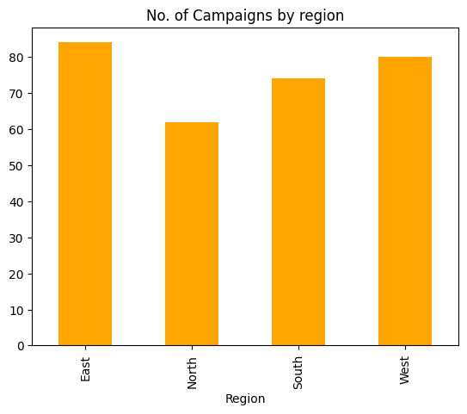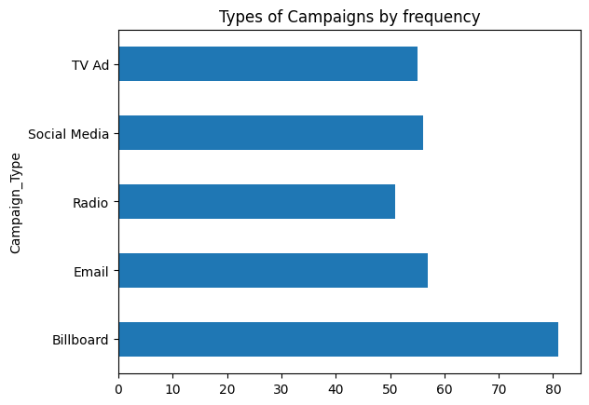

**Campaign Types**: *Billboard*s were the high frequently used and Radio was less frequently used campaign

**Budget**: Campaigns had varied budgets; some lacked sufficient funding.

**Region-Wise Campaigns**: The **North** region had fewer campaigns that may leads to less reach of audience

**6. Key Findings**

**Regional Revenue Leaders**

* **East** and **North** regions drive the highest total revenue.
* East excels particularly in **Laptops** and **Smartphones**, while North and south leads in **Tablets**.

**Product-Region Dynamics**

* **South** not performing well on **TV** sales, suggesting targeted demand.
* **West** shows consistent sales and not any category dominating far from them.

**Sales vs. Traffic Correlation**

* A strong positive correlation between **Customer_Visits** and both **Units_Sold** and **Revenue** confirms that foot traffic (online or in-store) is a key sales driver.

**Customer Satisfaction Gaps**

* Overall average rating hovers around **2.0**, indicating lukewarm satisfaction.
* **Smartphones** receive the lowest ratings, pointing to potential quality or service issues in that line.

**Data Quality Considerations**

* **5–10%** of records in Sales and Traffic datasets had missing values (e.g., Revenue, Units_Sold, Customer_Visits), underscoring the need for robust cleaning and imputation strategies.

**Marketing Campaign Imbalances**

* Uneven campaign distribution: some regions (e.g., North) have fewer campaigns despite strong sales potential.

**7. Recommendations**

**📈 Invest More in High-Performing Regions**

* The **East and North regions** have shown consistently high revenue.
* Recommendation: Allocate more sales and marketing resources to these regions to maximize profit and continue growth.

**🧾 Address Pricing Mismatches**

* Products priced too high or too low for a specific region may lead to low sales or thin margins.
* **Recommendation**: Use market segmentation and competitor analysis to adjust pricing dynamically based on region and customer segment behavior

**Remove or Redesign Poor-Performing Products**

* **What we found**: Some products have low sales or even cause losses due to returns, discounts, or low demand.
* **Decision**: Don't continue investing in products that don’t perform.
* **Action**: Either phase them out or improve their quality, pricing, or packaging

#### 🎁 ****Limited-Time Offers****

* Create urgency with time-bound deals like:
  + "Only this weekend – Extra 10% off in North region!"
  + "Buy 2 Get 1 Free – Exclusive for East customers!"

**8. Conclusion**

we analyzed sales data to find out which regions and products are doing well and which ones are not. We found that the **East and North regions bring in the most revenue**, while some regions need improvement.

We also saw that **some products sell better in specific regions**, and a few are not performing well at all. Based on this, we suggested practical steps like improving marketing in good regions, fixing issues in low-performing areas, and promoting the right products in the right places.

**9. Appendix**

**A. Tools and Technologies Used**

* **Programming Language**: Python 3.x
* **Libraries**:
  + pandas – Data cleaning, manipulation, and analysis

**B. Data Cleaning Steps**

* Handled missing values using:
  + Mean/median replacement for numerical columns
  + Dropping rows with critical missing data
* Standardized column formats (e.g., proper casing, date formats)
* Converted data types where required (e.g., strings to integers or dates)

**C. Exploratory Data Analysis (EDA) Methods**

* Grouped data by Region and Product to find revenue patterns
* Used groupby(), agg(), and pivot_table() in Pandas
* Identified trends and outliers using summary statistics and visualizations
* Analyzed product-wise and region-wise performance

**D. Key Metrics Calculated**

* Total Revenue by Region
* Total sales by product
* Average customer rating per product
* Total customer visits per region

**E. Limitations**

* Analysis is based on historical data; real-time factors like seasonality or market changes are not reflected.
* External influences such as competitor actions, economic shifts, or customer feedback were not included.

**F. References**

* Python Documentation – <https://docs.python.org/3/>
* Pandas Library – https://pandas.pydata.org/