WaterNet - Water Quality Prediction Report

# Project Overview

WaterNet is a web-based machine learning application that predicts whether a water sample is safe to drink. The system takes physicochemical input parameters and predicts safety using a trained Random Forest model. This approach is ideal for areas where hardware-based monitoring systems are not feasible.

# Why This Project?

Manual water testing requires time, resources, and equipment. WaterNet replaces this with a smart, software-based solution using real-world data. It provides quick and accessible water safety assessment using AI.

# Model Prediction Mechanism

The model is trained on labeled data indicating water potability. It learns from values like pH, hardness, and turbidity to classify the sample. When new values are entered, the model outputs whether the sample is safe or not.

# How Physicochemical Properties Are Obtained

In real-time scenarios, physicochemical properties of water are obtained using water quality testing kits, digital sensors, or lab testing methods. Parameters like pH and turbidity can be measured using portable meters, while more advanced attributes such as Trihalomethanes and Organic Carbon may require laboratory analysis.  
  
Since our project is simulation-based, we use dataset-driven input, allowing users to enter values as if they were obtained from sensors or kits. This approach allows the system to act as a virtual testing interface, making it useful for training, academic research, and areas without access to real-time hardware monitoring systems.

# Feature Importance

The bar chart below shows which features the model considers most important

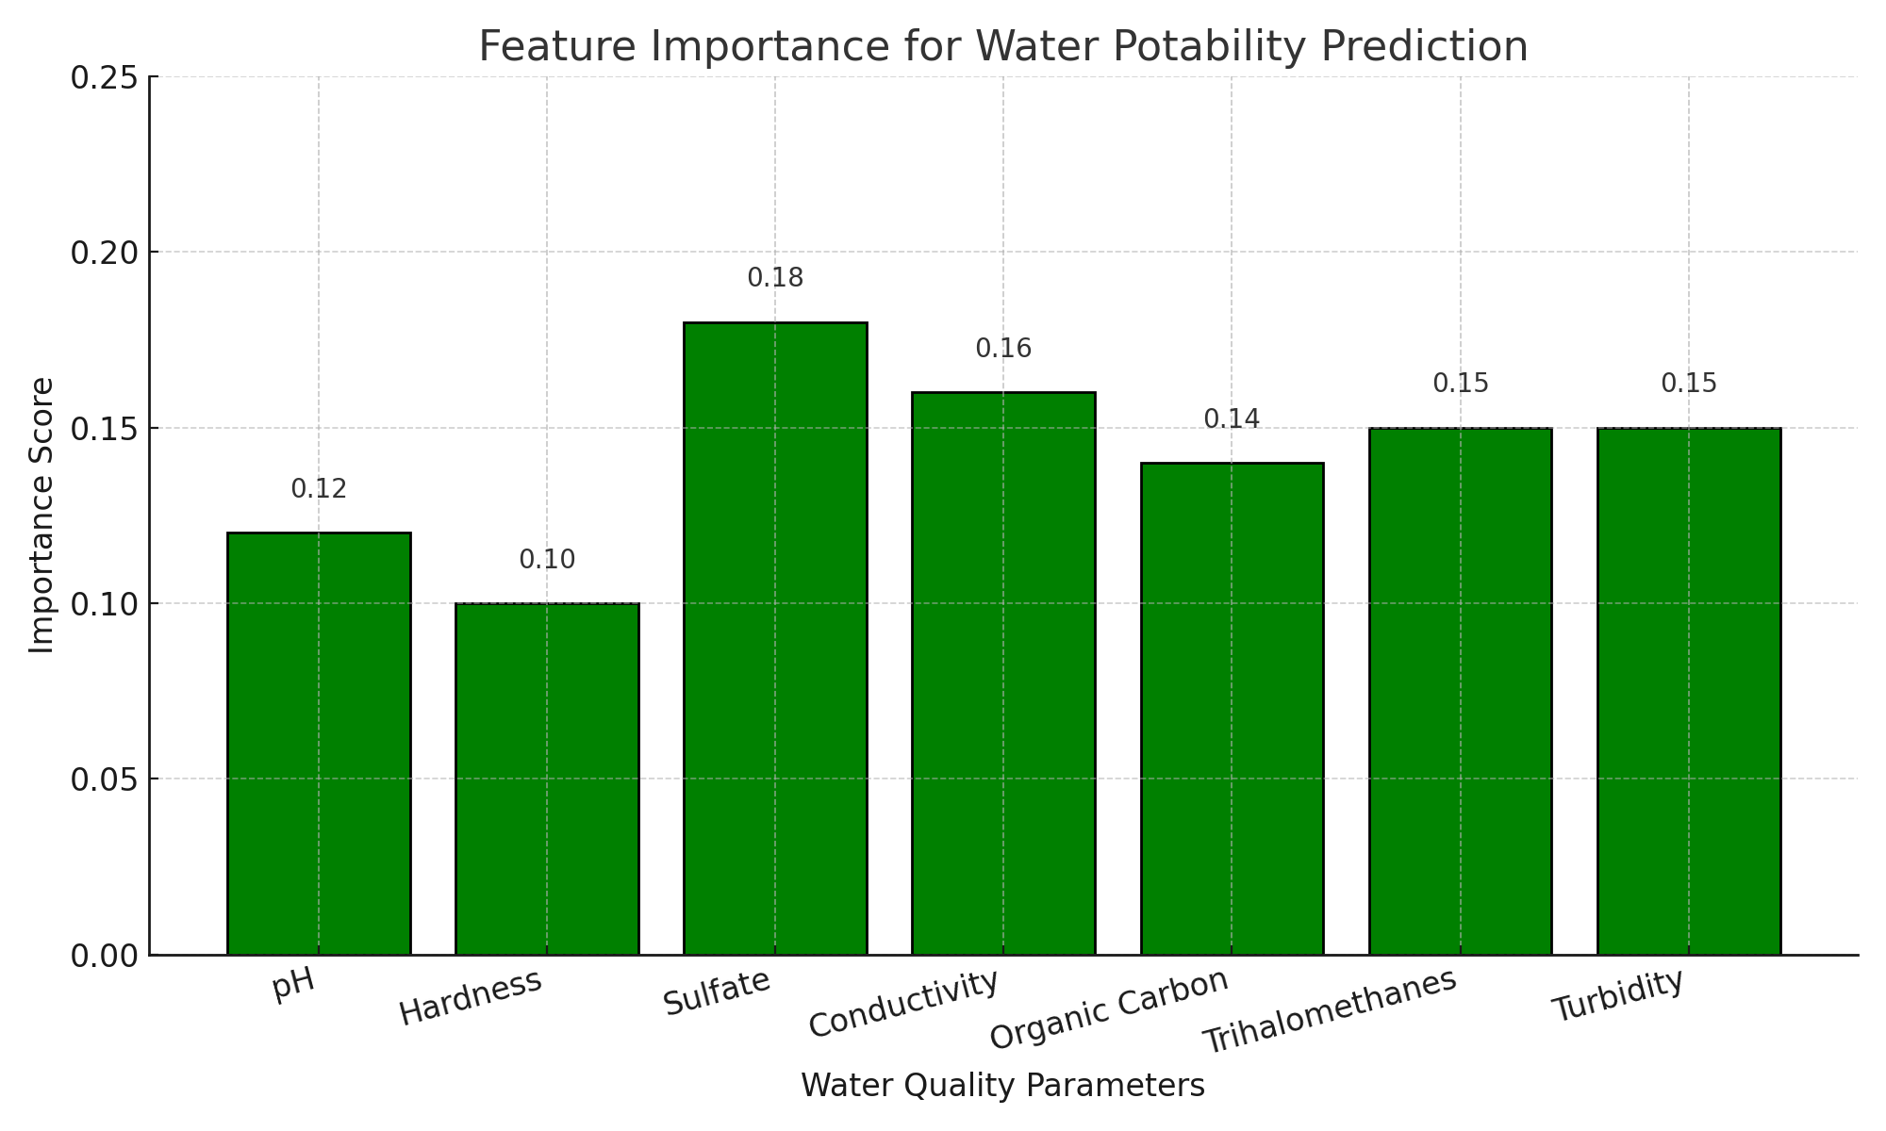

# Recommended Safe Ranges

These are ideal values for safe drinking water:

|  |  |  |
| --- | --- | --- |
| **Parameter** | **Safe Range** | **Reason** |
| pH | 6.5 – 8.5 | Too low or high pH can cause corrosion and health issues. |
| Hardness | < 120 mg/L | Excess hardness can lead to scale buildup and digestive discomfort. |
| Sulfate | < 250 mg/L | High levels can cause laxative effects. |
| Conductivity | < 500 µS/cm | Indicates total dissolved solids. |
| Organic Carbon | < 10 mg/L | High levels suggest organic contamination. |
| Trihalomethanes | < 80 µg/L | Toxic byproducts of water treatment. |
| Turbidity | < 5 NTU | Cloudy water may indicate microbial contamination. |

# Conclusion

WaterNet helps address water quality challenges using AI. It predicts safety without needing sensors, making it ideal for resource-limited environments and digital education tools. This system bridges the gap between data science and environmental health.