**Jsf**

Java server faces.

Created a new workspace 🡪 folder 🡪 jsf

Added tomcat server.

Create a dynamic web project named as staticnavigation and select dynamic web module version 3.0

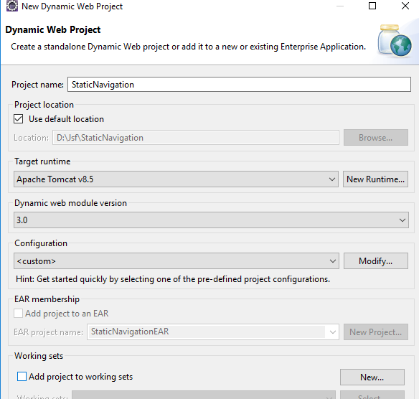

Next click the generate web.xml

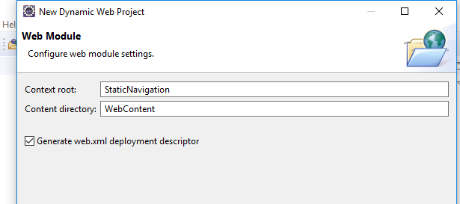

Web.xml

<?xml version=*"1.0"* encoding=*"UTF-8"*?>

<web-app xmlns:xsi=*"http://www.w3.org/2001/XMLSchema-instance"* xmlns=*"http://java.sun.com/xml/ns/javaee"* xsi:schemaLocation=*"http://java.sun.com/xml/ns/javaee http://java.sun.com/xml/ns/javaee/web-app_3_0.xsd"* id=*"WebApp_ID"* version=*"3.0"*>

<display-name>StaticNavigation</display-name>

<welcome-file-list>

<welcome-file>index.html</welcome-file>

<welcome-file>index.htm</welcome-file>

<welcome-file>index.jsp</welcome-file>

<welcome-file>default.html</welcome-file>

<welcome-file>default.htm</welcome-file>

<welcome-file>default.jsp</welcome-file>

</welcome-file-list>

<servlet>

<servlet-name>Faces Servlet</servlet-name>

<servlet-class>javax.faces.webapp.FacesServlet</servlet-class>

<load-on-startup>1</load-on-startup>

</servlet>

<servlet-mapping>

<servlet-name>Faces Servlet</servlet-name>

<url-pattern>*.jsf</url-pattern>

</servlet-mapping>

</web-app>

Any url with jsf will be mapped to faces servlet.

Now add faces-config.xml in the web-inf folder.

In the web-content folder create a jsf file with name Main

Now in the lib folder add the libraries(copy and paste)

**Main.jsp**

<%@ page language=*"java"* contentType=*"text/html; charset=UTF-8"*

pageEncoding=*"UTF-8"*%>

<%@taglib uri=*"http://java.sun.com/jsf/core"* prefix=*"f"*%>

<%@taglib uri=*"http://java.sun.com/jsf/html"* prefix=*"h"*%>

<!DOCTYPE html>

<html>

<f:view>

<head>

<title>Static Navigation</title>

<head>

<body>

<h:form>

<h1 align=*"center"*>Main Page</h1>

<hr size=*"2"* />

<div align=*"center"*>

<h:commandLink value=*"go first"* action=*"first"* />

<h:commandLink value=*"go second"* action=*"second"* />

</h:form>

</div>

<body>

</f:view>

<body>

</body>

</html>

**First.jsp**

<%@ page language=*"java"* contentType=*"text/html; charset=UTF-8"*

pageEncoding=*"UTF-8"*%>

<!DOCTYPE html>

<html>

<head>

<title>First page</title>

</head>

<body>

<h1 align=*"center"*>First page</h1>

<hr size=*"2"*>

</body>

</html>

**Second.jsp**

<%@ page language=*"java"* contentType=*"text/html; charset=UTF-8"*

pageEncoding=*"UTF-8"*%>

<!DOCTYPE html>

<html>

<head>

<title>Second page</title>

</head>

<body>

<h1 align=*"center"*>Second page</h1>

<hr size=*"2"*>

</body>

</html>

Instead of link we can have a button also.

**Main.jsp**

<%@ page language=*"java"* contentType=*"text/html; charset=UTF-8"*

pageEncoding=*"UTF-8"*%>

<%@taglib uri=*"http://java.sun.com/jsf/core"* prefix=*"f"*%>

<%@taglib uri=*"http://java.sun.com/jsf/html"* prefix=*"h"*%>

<!DOCTYPE html>

<html>

<f:view>

<head>

<title>Static Navigation</title>

<head>

<body>

<h:form>

<h1 align=*"center"*>Main Page</h1>

<hr size=*"2"* />

<div align=*"center"*>

<h:commandButton value=*"go first"* action=*"first"* />

<h:commandButton value=*"go second"* action=*"second"* />

</h:form>

</div>

</body>

</f:view>

</html>

In the web.xml add Main.jsf as the welcome file

<?xml version=*"1.0"* encoding=*"UTF-8"*?>

<web-app xmlns:xsi=*"http://www.w3.org/2001/XMLSchema-instance"*

xmlns=*"http://java.sun.com/xml/ns/javaee"*

xsi:schemaLocation=*"http://java.sun.com/xml/ns/javaee http://java.sun.com/xml/ns/javaee/web-app_3_0.xsd"*

id=*"WebApp_ID"* version=*"3.0"*>

<display-name>StaticNavigation</display-name>

<welcome-file-list>

<welcome-file>Main.jsf</welcome-file>

</welcome-file-list>

<servlet>

<servlet-name>Faces Servlet</servlet-name>

<servlet-class>javax.faces.webapp.FacesServlet</servlet-class>

<load-on-startup>1</load-on-startup>

</servlet>

<servlet-mapping>

<servlet-name>Faces Servlet</servlet-name>

<url-pattern>*.jsf</url-pattern>

</servlet-mapping>

</web-app>

Navigating back to main.jsf from first and second

**First.jsp**

<%@ page language=*"java"* contentType=*"text/html; charset=UTF-8"*

pageEncoding=*"UTF-8"*%>

<%@taglib uri=*"http://java.sun.com/jsf/core"* prefix=*"f"* %>

<%@taglib uri=*"http://java.sun.com/jsf/html"* prefix=*"h"* %>

<!DOCTYPE html>

<html>

<f:view>

<head>

<title>First page</title>

</head>

<body>

<h1 align=*"center"*>First page</h1>

<hr size=*"2"*>

<h:form>

<div align=*"center"*>

<h:commandLink value=*"go to the main page"* action=*"home"*/>

</div>

</h:form>

</body>

</f:view>

**</html>**

**Second.jsp**

<%@ page language=*"java"* contentType=*"text/html; charset=UTF-8"*

pageEncoding=*"UTF-8"*%>

<%@taglib uri=*"http://java.sun.com/jsf/core"* prefix=*"f"*%>

<%@taglib uri=*"http://java.sun.com/jsf/html"* prefix=*"h"*%>

<!DOCTYPE html>

<html>

<f:view>

<head>

<title>Second page</title>

</head>

<body>

<h1 align=*"center"*>Second page</h1>

<hr size=*"2"*>

<h:form>

<div align=*"center"*>

<h:commandLink value=*"go to the home page"* action=*"home"* />

</div>

</h:form>

</body>

</f:view>

</html>

**Now in the faces.config file**

<?xml version=*"1.0"* encoding=*"UTF-8"*?>

<faces-config xmlns=*"http://java.sun.com/xml/ns/javaee"*

xmlns:xsi=*"http://www.w3.org/2001/XMLSchema-instance"*

xsi:schemaLocation=*"http://java.sun.com/xml/ns/javaee*

*http://java.sun.com/xml/ns/javaee/web-facesconfig_2_0.xsd"*

version=*"2.0"*>

<navigation-rule>

<from-view-id>/Main.jsp</from-view-id>

<navigation-case>

<from-outcome>first</from-outcome>

<to-view-id>/First.jsp</to-view-id>

</navigation-case>

<navigation-case>

<from-outcome>second</from-outcome>

<to-view-id>/Second.jsp</to-view-id>

</navigation-case>

</navigation-rule>

<navigation-rule>

<from-view-id>/First.jsp</from-view-id>

<navigation-case>

<from-outcome>home</from-outcome>

<to-view-id>/Main.jsf</to-view-id>

</navigation-case>

</navigation-rule>

<navigation-rule>

<from-view-id>/Second.jsp</from-view-id>

<navigation-case>

<from-outcome>home</from-outcome>

<to-view-id>/Main.jsf</to-view-id>

</navigation-case>

</navigation-rule>

</faces-config>

Now its better to have an id for the button so add id for the buttons in main.jsp

<%@ page language=*"java"* contentType=*"text/html; charset=UTF-8"*

pageEncoding=*"UTF-8"*%>

<%@taglib uri=*"http://java.sun.com/jsf/core"* prefix=*"f"*%>

<%@taglib uri=*"http://java.sun.com/jsf/html"* prefix=*"h"*%>

<!DOCTYPE html>

<html>

<f:view>

<head>

<title>Static Navigation</title>

<head>

<body>

<h:form>

<h1 align=*"center"*>Main Page</h1>

<hr size=*"2"* />

<div align=*"center"*>

<h:commandButton id=*"btn1"* value=*"go first"* action=*"first"* />

<h:commandButton id=*"btn2"* value=*"go second"* action=*"second"* />

</h:form>

</div>

</body>

</f:view>

</html>

In the similar way create a new dynamic web project DynamicWebProject

To calculate the tax from application which takes the input as employee name and income and calculates the tax and displays in another page through navigation.

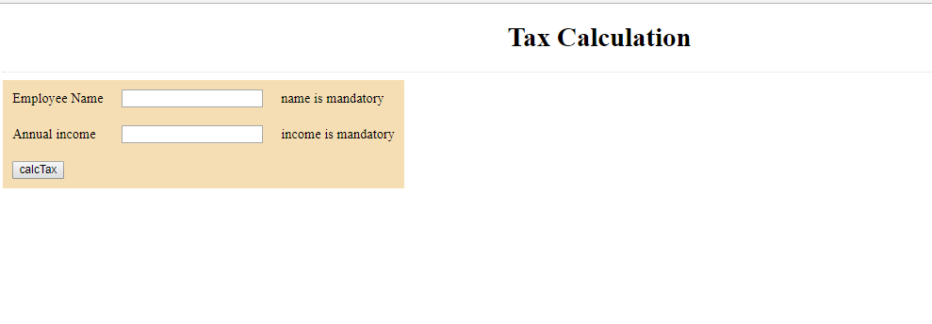

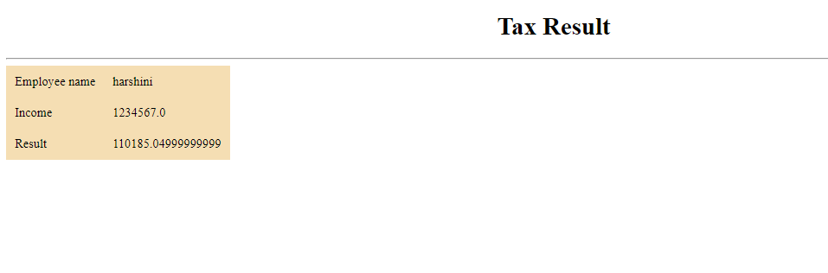

Then add libraries

Create a package com.hexa.bean

Add a class TaxBean

* In the class have three fields ename,income and tax.
* Generate getters and setters.
* Writing an action method llr to controller method which returns a view name and controls a business logic.

**package** com.hexa.bean;

**public** **class** TaxBean {

**private** String ename;

**private** **double** income;

**private** **double** tax;

**public** String getEname() {

**return** ename;

}

**public** **void** setEname(String ename) {

**this**.ename = ename;

}

**public** **double** getIncome() {

**return** income;

}

**public** **void** setIncome(**double** income) {

**this**.income = income;

}

**public** **double** getTax() {

**return** tax;

}

**public** **void** setTax(**double** tax) {

**this**.tax = tax;

}

// action method

**public** String calcTax() {

**if** (income > 1000000)

**this**.tax = 750000 * 0.1 + (income - 1000000) * 0.15;

**else** **if** (income > 250000)

**this**.tax = (income - 250000) * 0.1;

**return** "success";

}

}

Now create a jsp file in webcontent folder

**TaxFrm.jsp**

Now here the input are given and the controller method is called and the tax value is stored in the tax instance variable.

<%@ page language=*"java"* contentType=*"text/html; charset=UTF-8"*

pageEncoding=*"UTF-8"*%>

<%@taglib uri=*"http://java.sun.com/jsf/core"* prefix=*"f"*%>

<%@taglib uri=*"http://java.sun.com/jsf/html"* prefix=*"h"*%>

<!DOCTYPE html >

<html>

<f:view>

<head>

<title>Tax Calculation</title>

<body>

<h1 align=*"center"*>Tax Calculation</h1>

<hr size=*"2"* />

<h:form id=*"tfrm"*>

<h:panelGrid id=*"pg1"* columns=*"3"* cellpadding=*"10"* bgcolor=*"wheat"*>

<h:outputText value=*"Employee Name"*></h:outputText>

<h:inputText id=*"aname"* value=*"*#{tbean.ename}*"* required=*"true"*

requiredMessage=*"name is mandatory"*></h:inputText>

<h:message for=*"aname"*></h:message>

<h:outputText value=*"Annual income"*></h:outputText>

<h:inputText id=*"aincome"* value=*"*#{tbean.income}*"* required=*"true"*

requiredMessage=*"income is mandatory"*></h:inputText>

<h:message for=*"aincome"*></h:message>

<h:commandButton value=*"calcTax"* action=*"*#{tbean.calcTax}*"* />

</h:panelGrid>

</h:form>

</body>

</head>

</f:view>

</html>

**As the inputs are given and the tax is calculated by the action or controller method we need an another form to display the result so create a another jsp file**

**TaxSubmit.jsp**

<%@ page language=*"java"* contentType=*"text/html; charset=UTF-8"*

pageEncoding=*"UTF-8"*%>

<%@taglib uri=*"http://java.sun.com/jsf/core"* prefix=*"f"*%>

<%@taglib uri=*"http://java.sun.com/jsf/html"* prefix=*"h"*%>

<!DOCTYPE html >

<html>

<f:view>

<head>

<title>Tax Calculation</title>

</head>

<body>

<h1 align=*"center"*>Tax Result</h1>

<hr size=*"3"* />

<h:panelGrid id=*"pg"* columns=*"2"* bgcolor=*"wheat"* cellpadding=*"10"*>

<h:outputText value=*"Employee name"* />

<h:outputText value=*"*#{tbean.ename}*"* />

<h:outputText value=*"Income"* />

<h:outputText value=*"*#{tbean.income}*"* />

<h:outputText value=*"Result"* />

<h:outputText value=*"*#{tbean.tax}*"* />

</h:panelGrid>

</body>

</f:view>

</html>

**Now the navigations should be done so that when the user gives the input and clicks on the button calcTax then it should display him a page of taxresult with the details given by him and the calculated tax .**

<?xml version=*"1.0"* encoding=*"UTF-8"*?>

<faces-config xmlns=*"http://java.sun.com/xml/ns/javaee"*

xmlns:xsi=*"http://www.w3.org/2001/XMLSchema-instance"*

xsi:schemaLocation=*"http://java.sun.com/xml/ns/javaee*

*http://java.sun.com/xml/ns/javaee/web-facesconfig_2_0.xsd"*

version=*"2.0"*>

<managed-bean>

<managed-bean-name>tbean</managed-bean-name>

<managed-bean-class>com.hexa.bean.TaxBean</managed-bean-class>

<managed-bean-scope>request</managed-bean-scope>

</managed-bean>

<navigation-rule>

<from-view-id> /TaxFrm.jsp </from-view-id>

<navigation-case>

<from-outcome>success</from-outcome>

<to-view-id> /TaxSubmit.jsp</to-view-id>

</navigation-case>

</navigation-rule>

</faces-config>

**Till now there was no css now adding the css for both TaxFrm.jsp and TaxSubmit.jsp**

<%@ page language=*"java"* contentType=*"text/html; charset=UTF-8"*

pageEncoding=*"UTF-8"*%>

<%@taglib uri=*"http://java.sun.com/jsf/core"* prefix=*"f"*%>

<%@taglib uri=*"http://java.sun.com/jsf/html"* prefix=*"h"*%>

<!DOCTYPE html >

<html>

<f:view>

<head>

<title>Tax Calculation</title>

<style>

**table** {

margin: *0 auto*;

border-collapse: *collapse*;

}

*.css1* {

background-color: *orange*;

}

*.css3*{

color:*red*;

}

</style>

<body>

<h1 align=*"center"*>Tax Calculation</h1>

<hr size=*"2"* />

<h:form id=*"tfrm"*>

<h:panelGrid id=*"pg1"* columns=*"3"* columnClasses=*"css1,,css3"* cellpadding=*"10"* bgcolor=*"wheat"*>

<h:outputText value=*"Employee Name"*></h:outputText>

<h:inputText id=*"aname"* value=*"*#{tbean.ename}*"* required=*"true"*

requiredMessage=*"name is mandatory"*></h:inputText>

<h:message for=*"aname"*></h:message>

<h:outputText value=*"Annual income"*></h:outputText>

<h:inputText id=*"aincome"* value=*"*#{tbean.income}*"* required=*"true"*

requiredMessage=*"income is mandatory"*></h:inputText>

<h:message for=*"aincome"*></h:message>

<h:commandButton value=*"calcTax"* action=*"*#{tbean.calcTax}*"* />

</h:panelGrid>

</h:form>

</body>

</head>

</f:view>

</html>

**TaxSubmit.jsp**

<%@ page language=*"java"* contentType=*"text/html; charset=UTF-8"*

pageEncoding=*"UTF-8"*%>

<%@taglib uri=*"http://java.sun.com/jsf/core"* prefix=*"f"*%>

<%@taglib uri=*"http://java.sun.com/jsf/html"* prefix=*"h"*%>

<!DOCTYPE html >

<html>

<f:view>

<head>

<title>Tax Calculation</title>

<style>

**table** {

margin: *0 auto*;

border-collapse: *collapse*;

}

*.css1* {

background-color: *orange*;

}

</style>

</head>

<body>

<h1 align=*"center"*>Tax Result</h1>

<hr size=*"3"* />

<h:panelGrid id=*"pg"* columns=*"2"* columnClasses=*"css1"* bgcolor=*"wheat"* cellpadding=*"10"*>

<h:outputText value=*"Employee name"* />

<h:outputText value=*"*#{tbean.ename}*"* />

<h:outputText value=*"Income"* />

<h:outputText value=*"*#{tbean.income}*"* />

<h:outputText value=*"Result"* />

<h:outputText value=*"*#{tbean.tax}*"* />

</h:panelGrid>

</body>

</f:view>

</html>

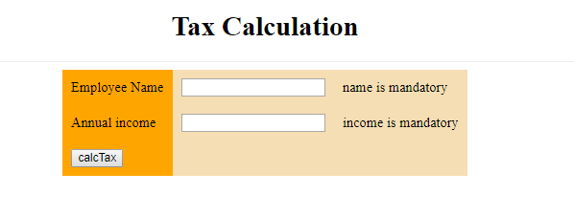

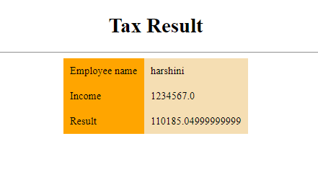

**Now adding header and footer css**

<%@ page language=*"java"* contentType=*"text/html; charset=UTF-8"*

pageEncoding=*"UTF-8"*%>

<%@taglib uri=*"http://java.sun.com/jsf/core"* prefix=*"f"*%>

<%@taglib uri=*"http://java.sun.com/jsf/html"* prefix=*"h"*%>

<!DOCTYPE html >

<html>

<f:view>

<head>

<title>Tax Calculation</title>

<style>

**table** {

margin: *0 auto*;

border-collapse: *collapse*;

}

*.css1* {

background-color: *orange*;

}

*.css3* {

color: *red*;

}

**tfoot,** **thead** {

background-color: *red*;

text-algin: *center*;

color: *white*;

}

</style>

<body>

<h1 align=*"center"*>Tax Calculation</h1>

<hr size=*"2"* />

<h:form id=*"tfrm"*>

<h:panelGrid id=*"pg1"* columns=*"3"* columnClasses=*"css1,,css3"*

cellpadding=*"10"* bgcolor=*"wheat"*>

<f:facet name=*"header"*>

<h:outputText value=*"TaxForm"* />

</f:facet>

<h:outputText value=*"Employee Name"*></h:outputText>

<h:inputText id=*"aname"* value=*"*#{tbean.ename}*"* required=*"true"*

requiredMessage=*"name is mandatory"*></h:inputText>

<h:message for=*"aname"*></h:message>

<h:outputText value=*"Annual income"*></h:outputText>

<h:inputText id=*"aincome"* value=*"*#{tbean.income}*"* required=*"true"*

requiredMessage=*"income is mandatory"*></h:inputText>

<h:message for=*"aincome"*></h:message>

<h:commandButton value=*"calcTax"* action=*"*#{tbean.calcTax}*"* />

<f:facet name=*"footer"*>

<h:outputText value=*""* />

</f:facet>

</h:panelGrid>

</h:form>

</body>

</head>

</f:view>

</html>

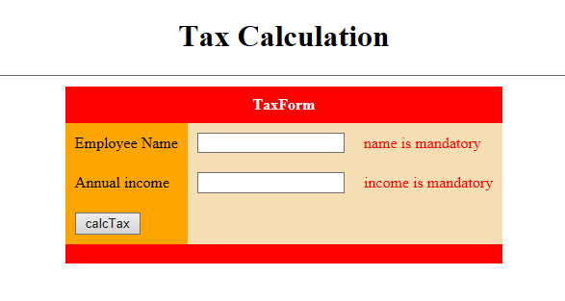

**Life cycle:**

**at when the request is fired for the first time:**

before RESTORE_VIEW 1

after RESTORE_VIEW 1

before APPLY_REQUEST_VALUES 2

after APPLY_REQUEST_VALUES 2

before PROCESS_VALIDATIONS 3

after PROCESS_VALIDATIONS 3

before UPDATE_MODEL_VALUES 4

after UPDATE_MODEL_VALUES 4

before INVOKE_APPLICATION 5

method is invoked

after INVOKE_APPLICATION 5

before RENDER_RESPONSE 6

tax bean constructor is invoked

ename getter

income getter

after RENDER_RESPONSE 6

/TaxFrm.jsp

**When the data is entered for the first time.**

before RESTORE_VIEW 1

after RESTORE_VIEW 1

before APPLY_REQUEST_VALUES 2

after APPLY_REQUEST_VALUES 2

before PROCESS_VALIDATIONS 3

tax bean constructor is invoked

ename getter

income getter

after PROCESS_VALIDATIONS 3

before UPDATE_MODEL_VALUES 4

ename setter

income setter

after UPDATE_MODEL_VALUES 4

before INVOKE_APPLICATION 5

method is invoked

after INVOKE_APPLICATION 5

before RENDER_RESPONSE 6

ename getter

income getter

tax getter

after RENDER_RESPONSE 6

/TaxSubmit.jsp

**Given no proper input then**

before RESTORE_VIEW 1

after RESTORE_VIEW 1

before APPLY_REQUEST_VALUES 2

after APPLY_REQUEST_VALUES 2

before PROCESS_VALIDATIONS 3

tax bean constructor is invoked

after PROCESS_VALIDATIONS 3

before RENDER_RESPONSE 6

after RENDER_RESPONSE 6

/TaxFrm.jsp

**Lifecycle with Phaselistener code**

package com.hexa.listener;

import javax.faces.event.PhaseEvent;

import javax.faces.event.PhaseId;

import javax.faces.event.PhaseListener;

public class MyPhaseListener implements PhaseListener {

@Override

public void afterPhase(PhaseEvent event) {

System.out.println("after "+ event.getPhaseId());

if(event.getPhaseId()== PhaseId.RENDER_RESPONSE){

System.out.println(event.getFacesContext().

getViewRoot().getViewId());

}

}

@Override

public void beforePhase(PhaseEvent event) {

System.out.println("before " + event.getPhaseId());

}

@Override

public PhaseId getPhaseId() {

return PhaseId.ANY_PHASE;

}

}

**Now in the TaxBean add the messages to get proper info:**

**package** com.hexa.bean;

**public** **class** TaxBean {

**private** String ename;

**private** **double** income;

**private** **double** tax;

**public** TaxBean() {

System.***out***.println("tax bean constructor is invoked");

}

**public** String getEname() {

System.***out***.println("ename getter");

**return** ename;

}

**public** **void** setEname(String ename) {

System.***out***.println("ename setter");

**this**.ename = ename;

}

**public** **double** getIncome() {

System.***out***.println("income getter");

**return** income;

}

**public** **void** setIncome(**double** income) {

System.***out***.println("income setter");

**this**.income = income;

}

**public** **double** getTax() {

System.***out***.println("tax getter");

**return** tax;

}

**public** **void** setTax(**double** tax) {

System.***out***.println("tax setter");

**this**.tax = tax;

}

// action method

**public** String calcTax() {

system.out.prinltn(“method is invoked”);

**if** (income > 1000000)

**this**.tax = 750000 * 0.1 + (income - 1000000) * 0.15;

**else** **if** (income > 250000)

**this**.tax = (income - 250000) * 0.1;

**return** "success";

}

}