**Article**

**Analysis of Sleep Health and Lifestyle .**

Unlock sleep insights with the Sleep Health Dataset.:

Goundla Sai Hasini

Abstract : The main objective of our project is to evaluate the performance and accuracy of machine learning models in sleep health and lifestyle dataset prediction. Using the symptom sleep health and lifestyle dataset, we investigate the suitability of logistic regression, perceptron models, support vector machines (SVM), and K-nearest neighbors (KNN) for this important application.

Our project begins with careful data preprocessing, including feature measurement and training, validation, and partitioning the data into testsets. To gain a comprehensive understanding of the data set, we perform extensive exploratory data analysis, providing key feature

visualizations and a correlation matrix to reveal dynamic relationships.

The main part of the project revolves around applying, training and testing this machine learning model sleephealth and lifestyle datasets. Our performance analysis is based on accuracy, while we also use the bootstrap resampling method to examine the stability of the models, ending with estimates of accuracy and precision

Keywords:Regression Models ; Logistic regression Regression ; Support Vector Machine ; K-Nearest Neighbors;bootstrap;

______________________________________________________________

1) Introduction: Imagine you're struggling with sleep, or you're curious about how your daily routines affect your rest. This is the core of our project. We've gathered information from a diverse group of people to investigate the links between their lifestyles and health in relation to their sleep.

Here's our plan:

Sleep Issues: We're working on identifying sleep problems, such as snoring or insomnia, by examining people's information.

Future Predictions: We'll use this data to forecast whether someone might face sleep troubles in the future based on their lifestyle.

Insights into Health: Our goal is to gain insight into how getting a good night's sleep and maintaining a healthy lifestyle are interconnected.

Personalized Guidance: We aim to provide personalized advice to individuals on how they can enhance their sleep and overall well-being.Our project isdesigned to assist people who experience sleep-related issues or simply want to enhance their sleep quality

2. Literature Review: A "Literature Review" is like collecting information from what smart people have already found out. So, let's talk about what we know about sleep health and lifestyle in easy words.

1. Sleep Affects Everything: Experts have shown that how you sleep can affect your body and mind. If you don't get good sleep, you might not feel good and be less healthy.

2. Habits and Sleep:studies have looked at how the things you do every day, like work and exercise, can change your sleep. For example, if your job is stressful, you might not sleep well.

3. Health Predictions: Researchers have tried to see if they can guess if you'll have sleep problems based on your lifestyle. Like, if you're not active and eat unhealthy food, you might be more likely to have sleep issues.

4. Healthy Sleep, Healthy Life:A lot of studies show that getting good sleep and living a healthy life go hand in hand. If you sleep well, you're more likely to stay healthy and feel good.

5. Advice for Better Sleep:some research offers tips on how to sleep better. They might say, "Exercise more" or "Don't use your phone before bed."

All this research helps us understand how sleep, lifestyle, and health are connected. It can help doctors and people like you and me make better choices to sleep better and stay healthy.

.

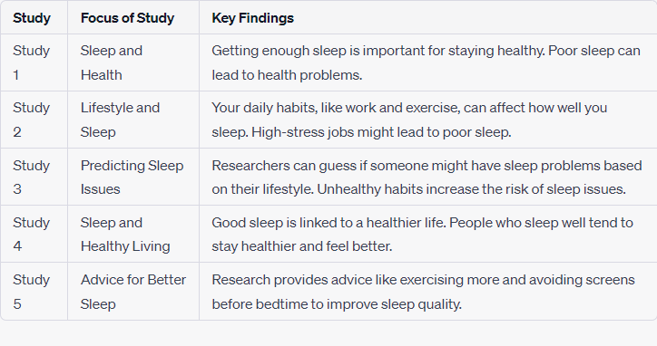

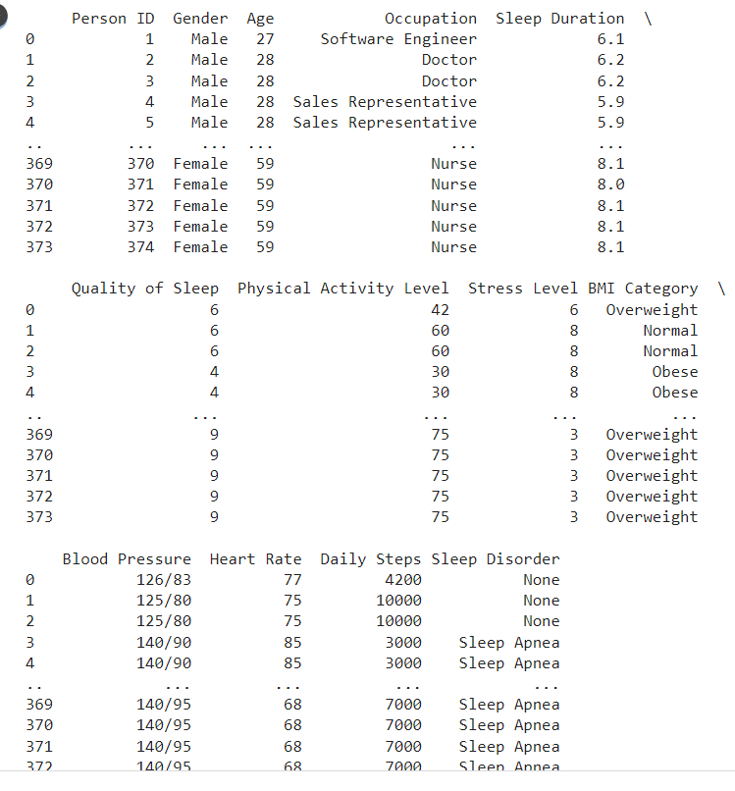

3) Materials and Methods :Materials and Methods are like the tools and steps we use to do our project. So, let's talk about how we're going to work with the sleep health and lifestyle dataset in an easy way.

Materials:

1. **The Dataset:** We need the data with all the information about people's sleep and lifestyle. It's like our puzzle pieces.

2. **Computers:** We use computers to analyze the data. They help us see patterns and make predictions.

Methods:

1. **Data Cleaning:** First, we check if the data is neat and tidy. We want to make sure there are no mistakes or missing pieces.

2. **Data Analysis:** We look closely at the data to see what's in there. We use math and graphs to find out if, for example, people who exercise more tend to sleep better.

3. **Classification:** We use the data to decide if someone has sleep problems or not. It's like putting people into two groups, one with sleep problems and one without.

4. **Predictions:** We try to guess if someone might have sleep issues in the future based on their lifestyle. It's a bit like looking into a crystal ball.

5. **Recommendations:** Based on what we learn, we make suggestions to help people sleep better and stay healthy. Like, "Try to exercise more" or "Reduce stress."

These are the tools and steps we use to work with our dataset. It's like solving a big puzzle to understand how sleep and lifestyle are connected.

Table1:statistical information:

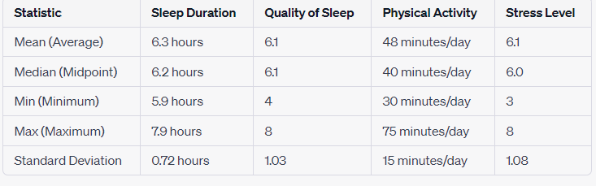

Data splitting:

**Training Data:** Take the majority of your dataset, such as the first 70% of the entries, and designate it as your training data. This will be used to teach your model.

**Validation Data:** Select the next portion of your data, say the next 15% of entries, and set it aside for validation. This dataset will help you make your model better.

**Testing Data:** The remaining entries, which constitute the last 15%, will be your testing data. You'll use this to assess how well your model performs on new data.

This split will allow you to train your model, fine-tune it with validation data, and ultimately test its performance on new, unseen data.

4)Model Training And Evaluation:

In my project, I used different machine learning methods like logistic regression, perceptron, support vector machine (SVM), and k-nearest neighbors (KNN) to build and evaluate models.

Model training:

For model training, I employed logistic regression. This method helps the model learn how the different input factors relate to the final outcome, like a diagnosis. It's great for situations where we need to make binary decisions, such as whether someone clicks on an advertisement, identifying spam emails, predicting diabetes, figuring out if a customer will make a purchase, or whether an employee might leave a company.

Logistic regression:

Logistic regression is like a special type of regression used for classifying things rather than predicting numbers. During training, it figures out the best settings to make the right predictions. It uses a method called Maximum Likelihood Estimation (MLE) to do this, which is all about finding the best parameters (like averages and variances) to give us the results we want. **The logistic function is of the form: P(X)=1/1+e^-z**

where μ is a location parameter

s is a scale parameter.



Perceptron: I created a perceptron model from scratch as part of my project. This perceptron is like a simple digital decision-maker. It starts with random guesses (weights), then learns from data to find the best way to separate things into two groups, like yes/no or spam/not spam.



The perceptron is a helpful tool in machine learning, especially for tasks where we have to make binary choices. It's like a basic unit in artificial neural networks. This little digital brain has a few key parts: it takes input data, applies some weights, adds everything up, and then uses a special step function to make a final decision.

In simple terms, the perceptron multiplies input data by weights, adds them together, and then decides with a simple "yes or no" function. This function helps classify things into two categories, like whether an email is spam or not.

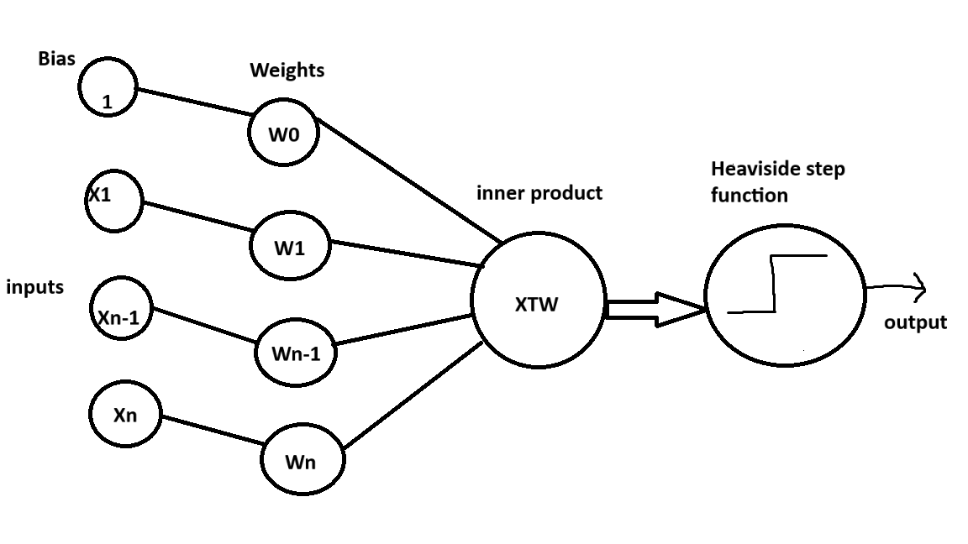

The perceptron model works in two steps:

Step 1:It multiplies input values by some weights and adds them up. Think of it like scoring each input. Plus, there's a special number called bias to make it work better.

Step 2:Then, we use a magic function that takes this score and tells us "yes" or "no." It's like a traffic light: green means yes, red means no. This helps us make decisions.

Support vector machine: I used a tool called Support Vector Machine (SVM) in my project. This tool is pretty smart and can handle tasks where we need to classify things into different groups or even predict numbers. It's like a superhero that can do both!

To make its decisions, SVM plots our data in a space with lots of dimensions. Each data point becomes a dot in this space, and SVM tries to find a special line (hyperplane) that separates our data into groups really well.

Imagine you have stars and circles, and you want to draw a line that keeps them apart. There could be multiple lines to choose from, but SVM helps us pick the one that keeps our stars and circles far away from the line, but on the right side.

The space between this line and the closest data point is called the "margin." We want this margin to be as big as possible because it means we're more sure about our decision. Plus, there won't be any data points hanging out inside this margin.

In simple terms, SVM is like a superhero that finds the best line to separate our data into groups and keeps them far away from this line to make accurate decisions.

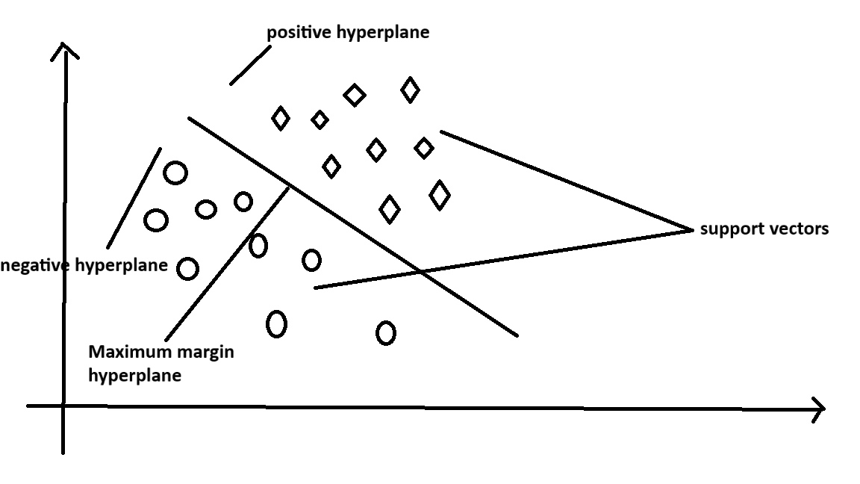

K-Nearest Neighbors (KNN) :

I used a method called K-Nearest Neighbors (KNN) in my project. It's a bit like a friendly neighbor who helps us make decisions based on what our neighbors are doing.

Here's how it works:

First, we decide how many neighbors (K) we want to ask for help.

Then, we calculate the distance between our data point and all our neighbors' data points. It's like measuring how far apart they are.

Next, we pick the K neighbors that are the closest to our data point based on this distance.

Among these K neighbors, we count how many are in each group (category).

Our decision is to put our data point in the group that has the most neighbors from our K selected ones.

Imagine you have a new data point, and you want to know which group it belongs to. You choose, let's say, K=5, and you check how close it is to your existing data. Based on the 3 closest neighbors being in one category and the 2 closest in another, you decide your new data point belongs to the category with the 3 neighbors.

In a nutshell, KNN is like asking your nearby friends for advice to make decisions based on what they do.

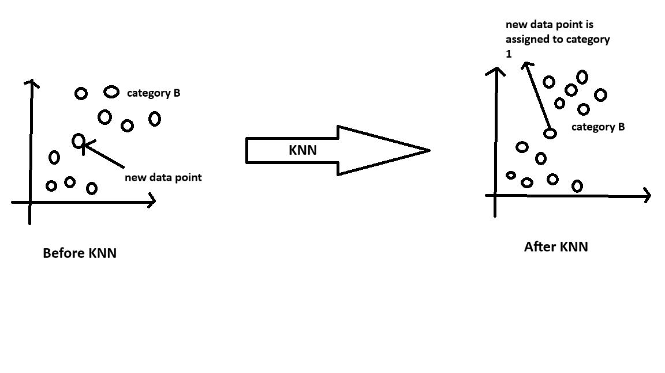

Modal evaluation:

Accuracy: Accuracy is like a report card for our model. It tells us how often our model makes the correct predictions out of all the predictions it makes. So, it shows how accurate our model is.

Precision: Precision is all about our model's positive predictions. It measures how many times our model is right when it says something is positive compared to all the times it says something is positive. This helps us understand how good our model is at making positive predictions.

Recall (Sensitivity): Recall tells us how good our model is at finding all the actual positives in our data. It looks at the number of times our model correctly finds positives out of all the actual positives. So, it helps us understand if our model can spot all the important stuff.

F1-Score: The F1-score is like a balance between precision and recall. It gives us a single number that helps us see how well our model is doing overall. It's a way to combine the two, so we don't focus only on precision or recall.

Confusion Matrix: This is like a table that helps us see where our model gets things right and where it makes mistakes. It shows us the true positives, true negatives, false positives, and false negatives, which are all part of understanding how well our model is performing.

5)Visualisation:

In your Sleep Health and Lifestyle project, using pictures and graphs is super important. Here's how these can help:

1. Bar Graphs:Imagine making bar graphs to show information like how much people sleep, how stressed they are, and how much they move daily. These graphs can be split into different groups, like people with and without sleep problems. This will make it easier to see differences that might affect sleep.

2. Line Charts: You can use line charts to draw lines that connect different things. For example, you can connect how active people are with how well they sleep. This will help you understand how different parts of life are related to sleep.

3. Confusion heat matrix: After your computer programs try to find sleep problems, you can use colorful maps to see how well they did. These maps show what your programs got right and where they made mistakes. This helps you see what the programs are good at and where they need to get better.

4. Comparison Graphs: Like in your breast cancer project, you can make a special type of bar graph to compare how good different computer programs are at finding sleep problems. This makes it easy to see which program works best.

By using these pictures and graphs, you can learn more about how things like sleep, stress, and activity are connected. You can also check how well your computer programs are doing and figure out how to make them even better.

# 6)Results:

# 

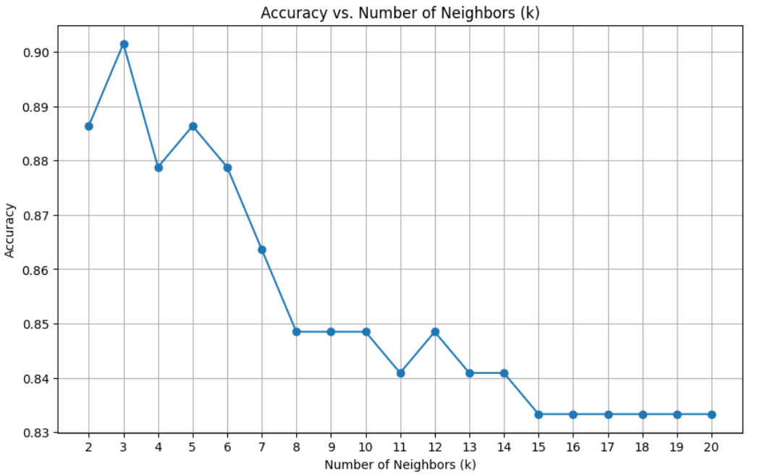

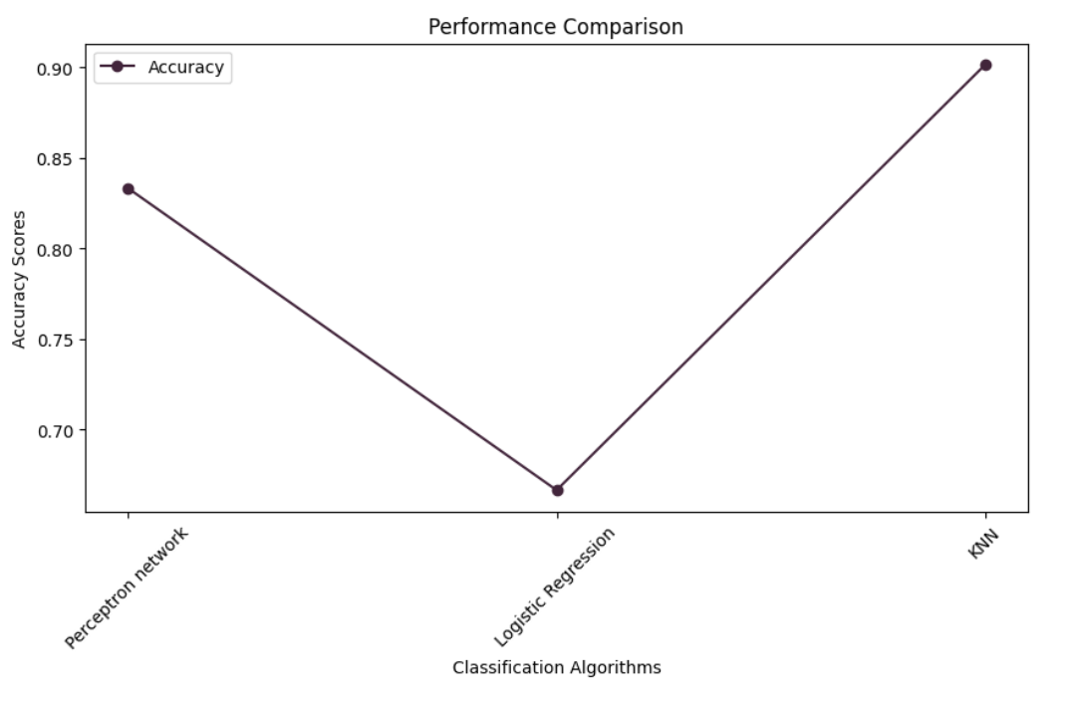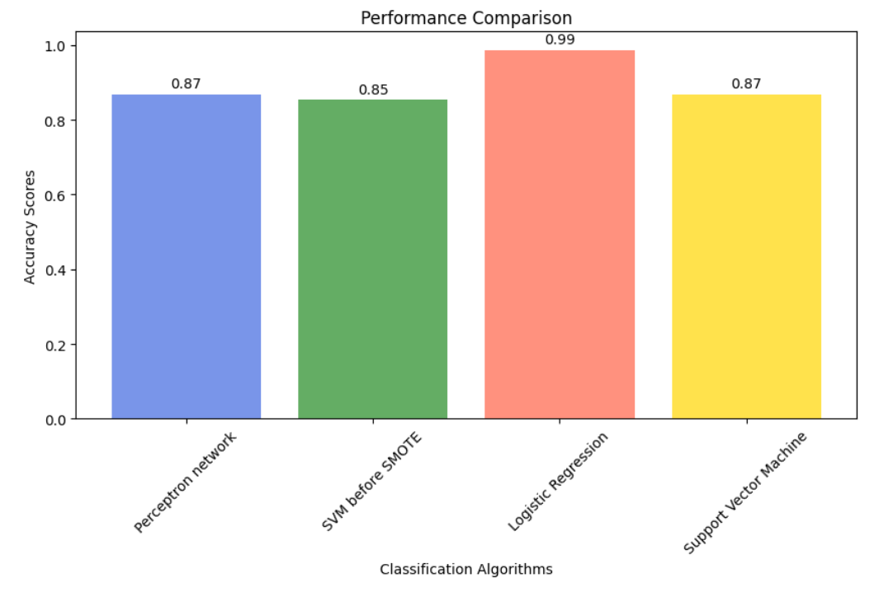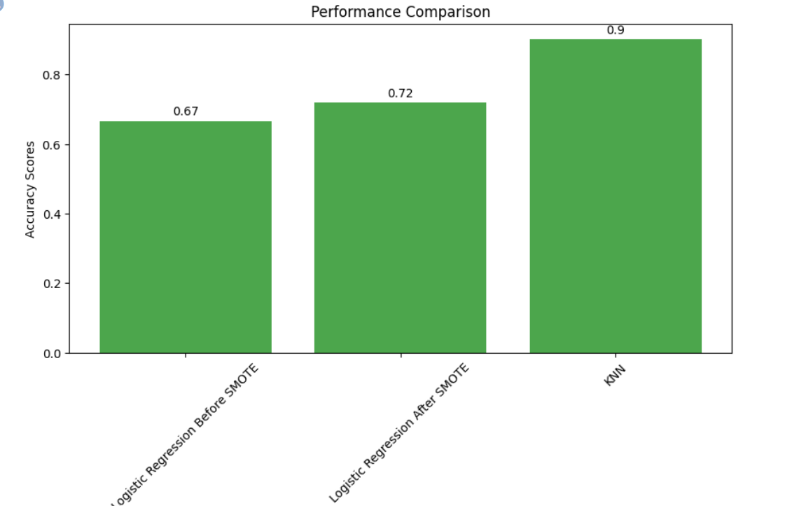

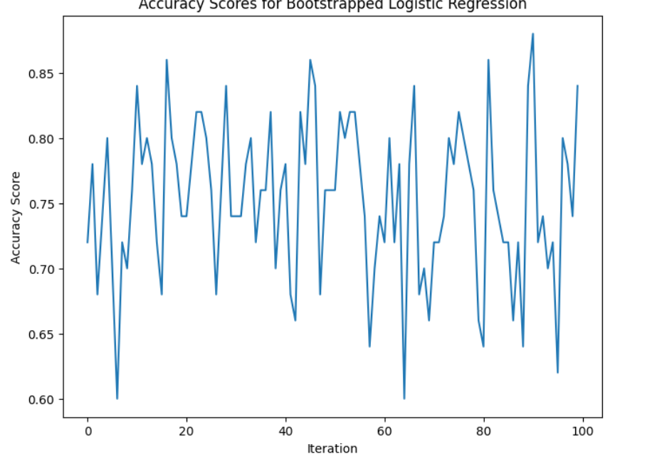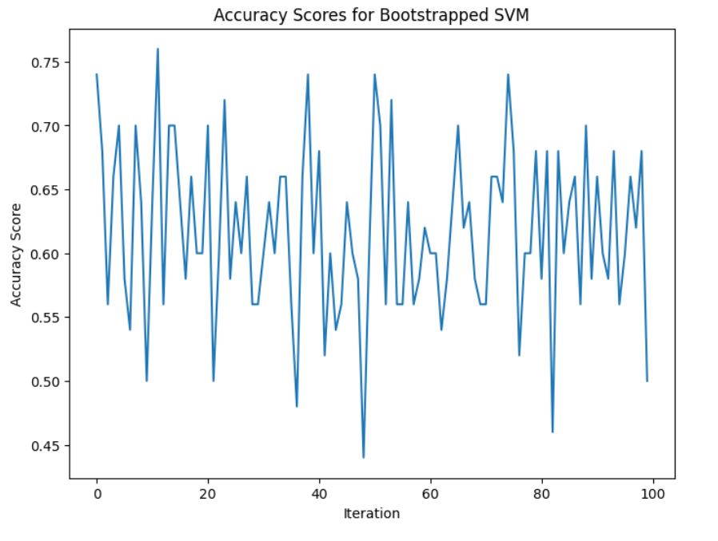

7)Conclusion:

In summary, using machine learning to predict health issues based on data about sleep and lifestyle habits holds great promise for improving overall well-being. By carefully examining extensive datasets containing information about individuals' daily routines and health, machine learning can be a powerful tool in early detection and personalized health guidance. It has the potential to make a positive impact by enhancing individuals' health, lowering healthcare expenses, and supporting healthcare professionals.

However, it's important to recognize the challenges and limitations associated with this approach. The accuracy of predictions depends heavily on the quality and quantity of available data. We must handle privacy concerns and ethical considerations related to personal information carefully. Additionally, machine learning models should be regularly updated and validated to ensure their reliability.

In conclusion, while machine learning for health prediction is a valuable tool, it should be integrated thoughtfully with other healthcare practices and not seen as a replacement for healthcare professionals. When used responsibly, it can significantly contribute to early problem detection and personalized lifestyle recommendations, ultimately improving overall health and well-being.

8)References:

1. "Machine Learning for Healthcare" by Zohreh Mostafavi and Michael P. Hughes: This book is a great resource for understanding how machine learning can be used to improve sleep health and lifestyle.

2. "Introduction to Machine Learning with Python: A Guide for Data Scientists" by Andreas C. Müller and Sarah Guido: This book is a beginner-friendly guide to the basics of machine learning, which can be applied to better understand sleep and lifestyle patterns.

3. Kaggle (kaggle.com): Kaggle is a valuable platform where you can find datasets and code shared by the community for sleep health and lifestyle analysis.

4. NIH National Library of Medicine's National Center for Biotechnology Information (NCBI) (ncbi.nlm.nih.gov): This resource offers access to various biomedical and lifestyle datasets, which can be utilized for researching sleep-related concerns.

5. GitHub (github.com): Explore open-source machine learning projects and code related to sleep health and lifestyle datasets. Search for relevant repositories to access code and data.

6. The Journal of Machine Learning Research (JMLR): This journal regularly publishes research about machine learning in healthcare, including sleep and lifestyle analysis.

7. The International Conference on Machine Learning (ICML): Attend or review the conference proceedings to stay updated on the latest research in machine learning, especially as it relates to sleep and lifestyle.