

**EC60064**

**Biomedical System Engineering and Automation**

**Experiment-2**

**Report**

Prepared by

Sai Joshitha Annareddy

21EE62R10

MTech

Control systems engineering

Question 1:

Problem Statement:

**Part 1: Implement Widrow-Hoff Least Mean Square (LMS) Adaptive Filter in python.**

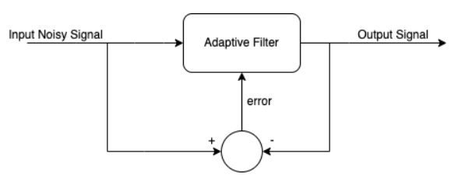

Theory:

**Least mean squares** (**LMS**) algorithms are a class of adaptive filter used to mimic a desired filter by finding the filter coefficients that relate to producing the least mean square of the error signal (difference between the desired and the actual signal).

Designing steps of Widrow Hoff LMS adaptive filter is given by following formulas…

Let

Input signal is x(n),

Reference signal is r(n),

Filter length is M, length of W vector is M.

Output signal is y(n)=WT*r(n)

Reference signal is taken as Delayed input signal

Delayed input signal is Input signal is delayed by samples that is equal to filter length,r(n)= x(n-M)

Error signal is e(n)=x(n)-y(n)

Updated weight W’=W-*(n)

E(e2(n)) = (x(n)- WT(n)*r(n))2

(n)=d(E(e2(n))) /d(W)

= -2x(n)r(n)+2*WT(n)r(n)2

= -2*e(n)*r(n)

W’=W+2*mu*e(n)*r(n)

Output Results:

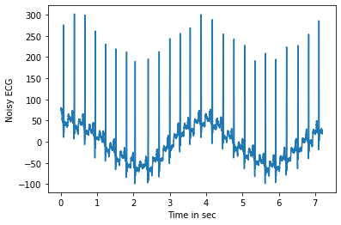

**Figure 1: input given signal**

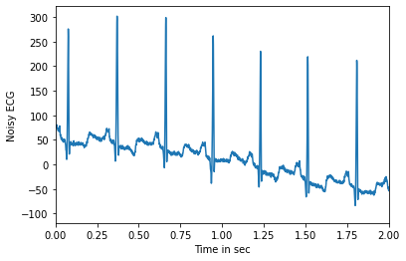

**Figure 2:** **input ECG noisy signal of x-axis 0-2**

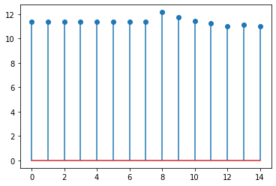

**Figure 3:** **Widrow Hoff LMS Adaptive filter of length M=15 designed for given input noisy ECG signal**

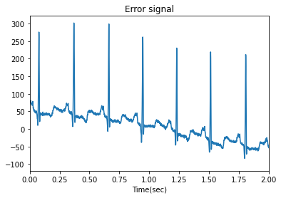

**Figure 4:** **Error signal for M=15(figure 5)**

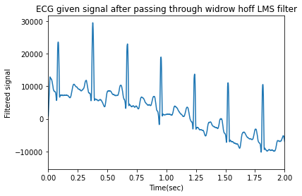

**Figure 5: ECG given signal after passing through widrow Hoff LMS filter of length M=15**

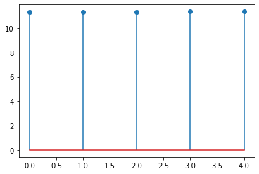

**Figure 6: Widrow Hoff LMS Adaptive filter of length M=5 designed for given input noisy ECG signal**



**Figure 7: Error signal for M=5**

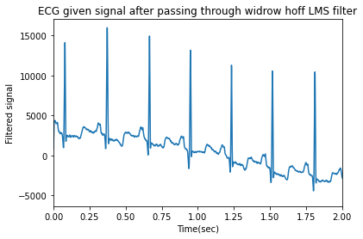

**Figure 8: ECG given signal after passing through widrow Hoff LMS filter of length M=5**

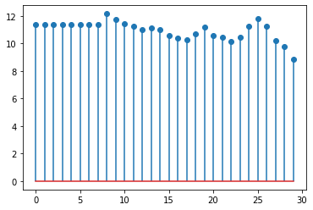

**Figure 9: Widrow Hoff LMS Adaptive filter of length M=30 designed for given input noisy ECG signal**



**Figure 10: Error signal for M=30.**

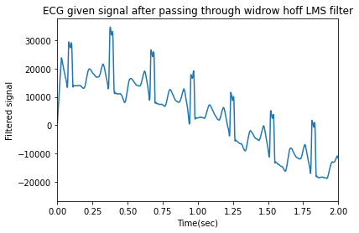

**Figure 11: ECG given signal after passing through widrow Hoff LMS filter of length M=30**

Problem Statement:

Part 2:

On the above input noisy signal, add noise component due to power frequency artefacts (Sin wave with a frequency of 50Hz) and run the same filter again to observe its effect.

Output Results:

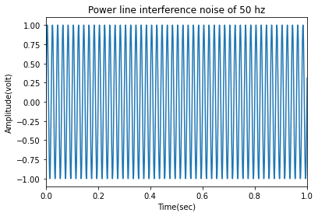

**Figure 12: Powerline interference noise of 50hz**

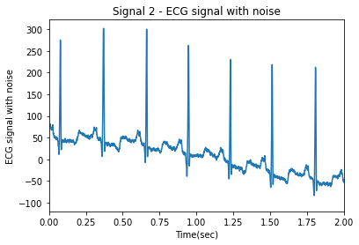

**Figure 13: ECG signal with powerline interference noise of 50hz and Amplitude 1**



**Figure 14: Widrow Hoff LMS Adaptive filter of length M=15 for ECG signal with powerline interference noise 50hz**



**Figure 15:** **Error signal for M=15 for powerline interference(50hz) noisy signal**

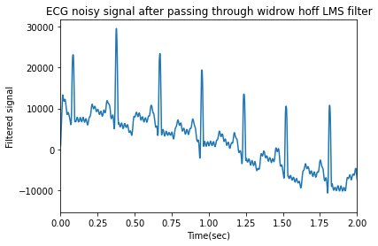

**Figure 16:** **ECG noisy (powerline interference of 50hz) signal after passing through widrow Hoff LMS filter of length M=15.**



**Figure 17: Widrow Hoff LMS Adaptive filter of length M=5 designed for given powerline interference noisy ECG signal**



**Figure 18: Error signal for M=5 for powerline interference(50hz) noisy signal**

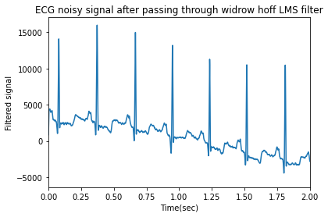

**Figure 19:**  **ECG noisy (powerline interference of 50hz) signal after passing through widrow Hoff LMS filter of length M=5.**



**Figure 20: Widrow Hoff LMS Adaptive filter of length M=30 designed for given powerline interference noisy ECG signal**



**Figure 21: Error signal for M=30 for powerline interference(50hz) noisy signal**

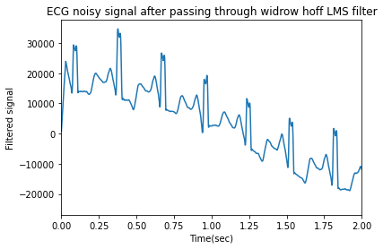

**Figure 22:** **ECG noisy (powerline interference of 50hz) signal after passing through widrow Hoff LMS filter of length M=30.**

Conclusions and discussions:

* The plots of input noisy signal, filtered signal and errors are in results section.
* **ECG noisy (powerline interference of 50hz) signal after passing through widrow Hoff LMS filter**



**M=30** M=15



**M=5**

* I implemented the filter length of 5,15 and 30,  
  From these 3 filtered outputs I observed that…  
  Filter with less length removes less noise i.e., filter length of 5 doesn’t remove the noise properly from the noisy input signal as well as powerline interference noisy ECG signal.  
    
  Filter with medium length of 15 removes the noise properly from the noisy input signal as well as powerline interference noisy ECG signal.  
    
  Filter with medium length of 30 removes the noise from the noisy input signal as well as powerline interference noisy ECG signal but it also removes some important parts of required ECG signal too which is undesirable.
*   
   **Fig 1:** Filtered Input noisy signal **Fig 2:** Filtered ECG powerline interference noisy signal
* Compare the above two figures which are filtered through widrowhoff LMS filter.where 1st figure is filtered signal of input noisy signal and 2nd figure is filtered signal of input signal with powerline interference(50hz) noisy signal.

We observe that the 1st figure has less noise component compared to 2nd figure.