**2. OBSERVER BASED CONTROLLER DESIGN FOR TWO   
 INTERACTING TANK PROCESS FOR LINEAR MODEL**

**Case 1:**

**Given…**

Desired closed loop pole location J = [-10, -100]

Observer Pole Locations L = [-1+j*2, -1-j*2]

**Step 1:** Check the observability condition of the system. The observability matrix is

O = [CT ATCT]

= $\left[\begin{matrix}0 & 0.1111 \\ 1 & -0⋅3889\end{matrix}\right]$ $≠0$

We find that O $≠0$,rank of observability matrix O=2.Hence the system is completely state observable.

**Step 2:** Assume that the state x is to be approximated by the state x′ of the dynamic model of observer

${\dot{x}}^{'}=$ A x’ + B u + Ke (y – y’)

y’ = C x’

where x′ is the estimated state and Cx′ is the estimated output. The matrix Ke is called observer gain matrix.

${\dot{x}}^{'}=$ [ A – Ke C] x’ + B u + Ke y

The system equation which is already known is given as

$\dot{x}$ = A x+ B u

y = C x

Now the observer error equation is defined as:

x - ${\dot{x}}^{'}=$ [ A – Ke C] x- x’

where the above dynamics is error vector and the dynamic behaviour depends on eigen values of [A-KeC].

**Step 3:** By defining the desired state feedback gain matrix Ke =[ Ke1T Ke2T]

|SI – A + KeC|=0

s2+(0.5 + Ke2)s+(0.0308 + (Ke1+Ke2)/9)=0 …(a)

**Step 4:** Comparing (a) with the desired characteristics equation from desired poles (L) =

[-1+j*2, -1-j*2]

(s+1+j2)(s+1-j2)=0

s2+2s+5=0

Ke1 = 43.22

Ke2 = 1.5

**Step 5:** For calculating k = [k1 k2] for given closed loop poles(J) = [-10, -100]

|SI-A+Bk|=0

s2+(0.5+100k1)s+(38.89k1+0.16666+11.11k2)=0 …(b)

comparing (b) with s2+110s+1000 =0

k1= 1.095

k2=86.15

k1 k2 can also be calculated in MATLAB using acker formula which is mentioned in below code.

**Simulink model:**

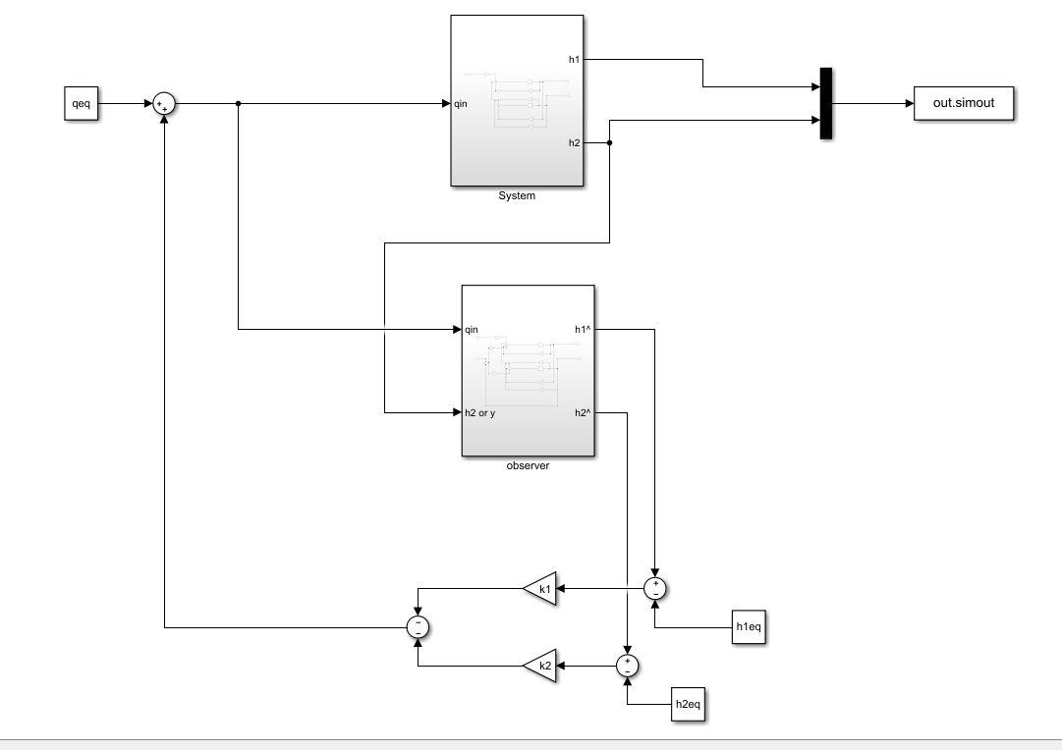

**Subsystem(system block)**

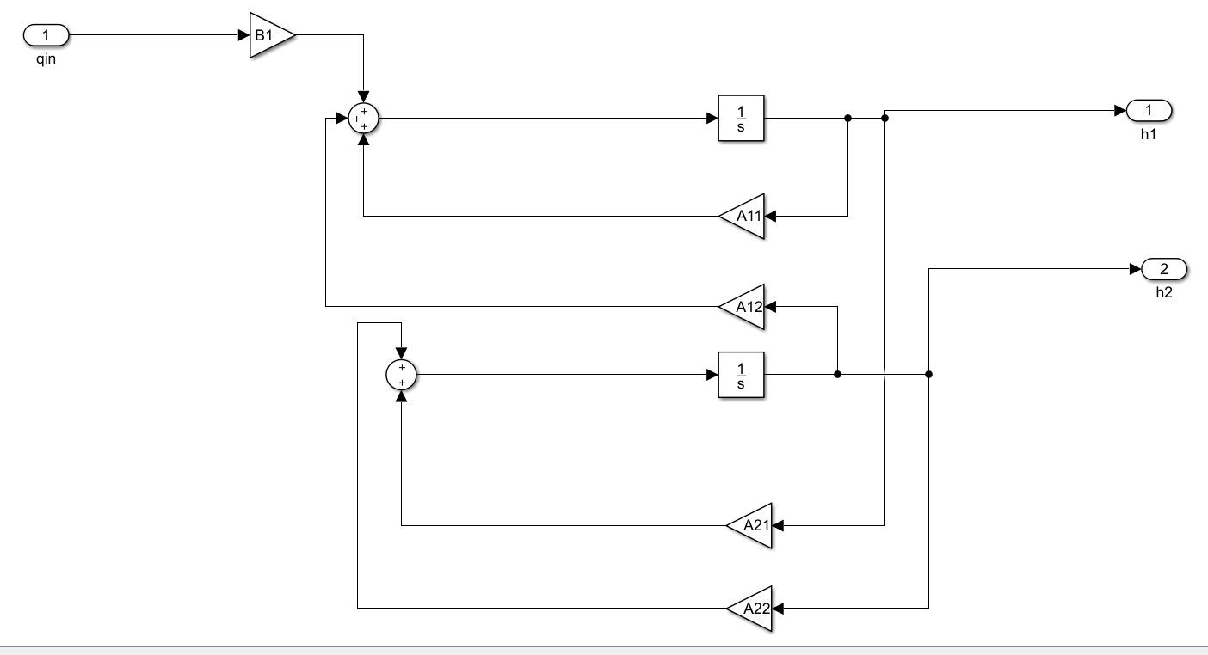

**Sub System (Observer)**

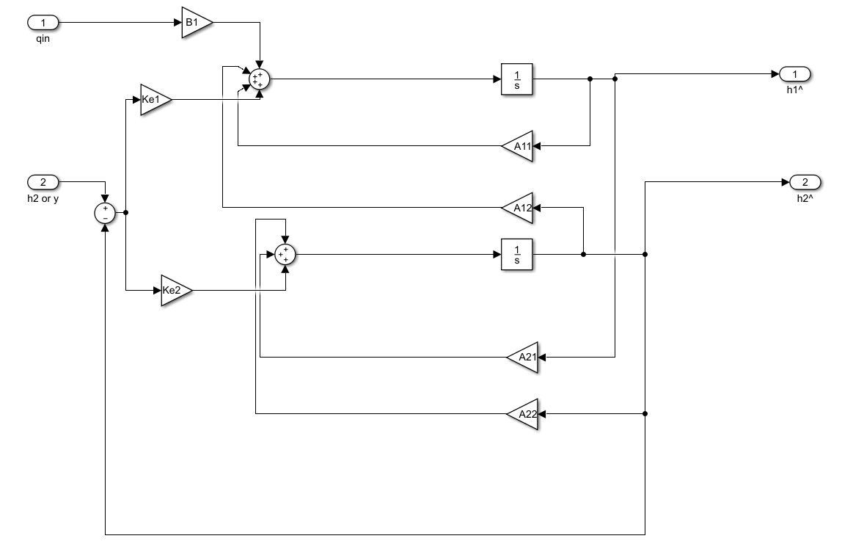

Code:

clc

clear all

close all

tsim=2

qeq=0

h1eq=0

h2eq=0

A=[-1/9 1/9;1/9 -0.3889]

B=[100;0]

C=[0 1]

A11=A(1,1)

A12=A(1,2)

A21=A(2,1)

A22=A(2,2)

B1=B(1)

h1_init=0

h2_init=1

Ac=[A zeros(2,1);-C 0]

Bc=[B;0]

poles=[-10,-100]

k=acker(A,B,poles)

%case:1

k1=1.095

k2=86.15

Ke1=43.22

Ke2=1.5

sim("observerbaseddesign");

t=ans.tout

x1=ans.system.data(:,1)

x2=ans.system.data(:,2)

z1=ans.observer.data(:,1)

z2=ans.observer.data(:,2)

subplot(211)

plot(t,x1,"linewidth",2);

hold on;

plot(t,z1,"linewidth",1.5);

legend("actual","estimated")

xlabel("time")

ylabel("x1")

title("Height of tank1(h1)")

hold on;

subplot(212)

plot(t,x2,"linewidth",2);

hold on;

plot(t,z2,"linewidth",1.5);

title("Height of tank1(h2)")

legend("actual","estimated")

xlabel("time")

ylabel("x2")

hold off;

Simulation Results(graph):

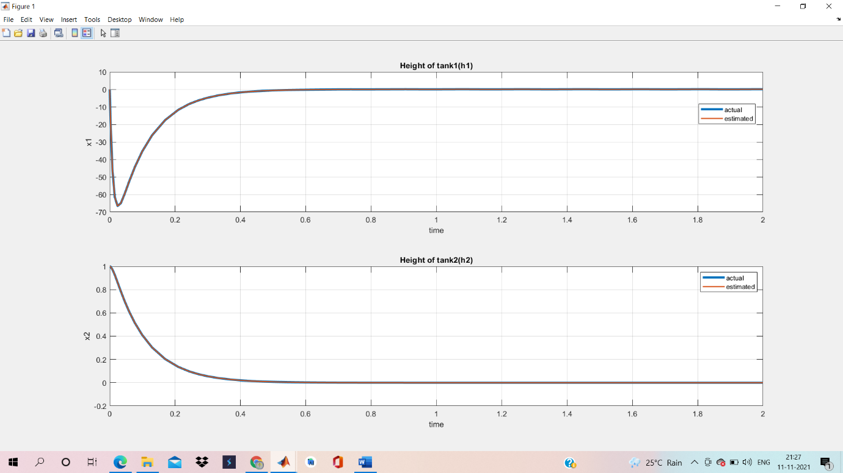

Figure: Response curve of actual output and estimated output of system with full order observer with initial condition [0 1] for case 1.