In below screen admin is adding employee details

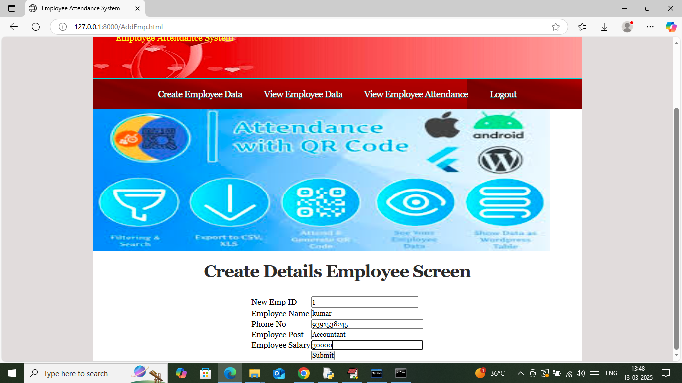

After pressing button application will forward to capture face of employee

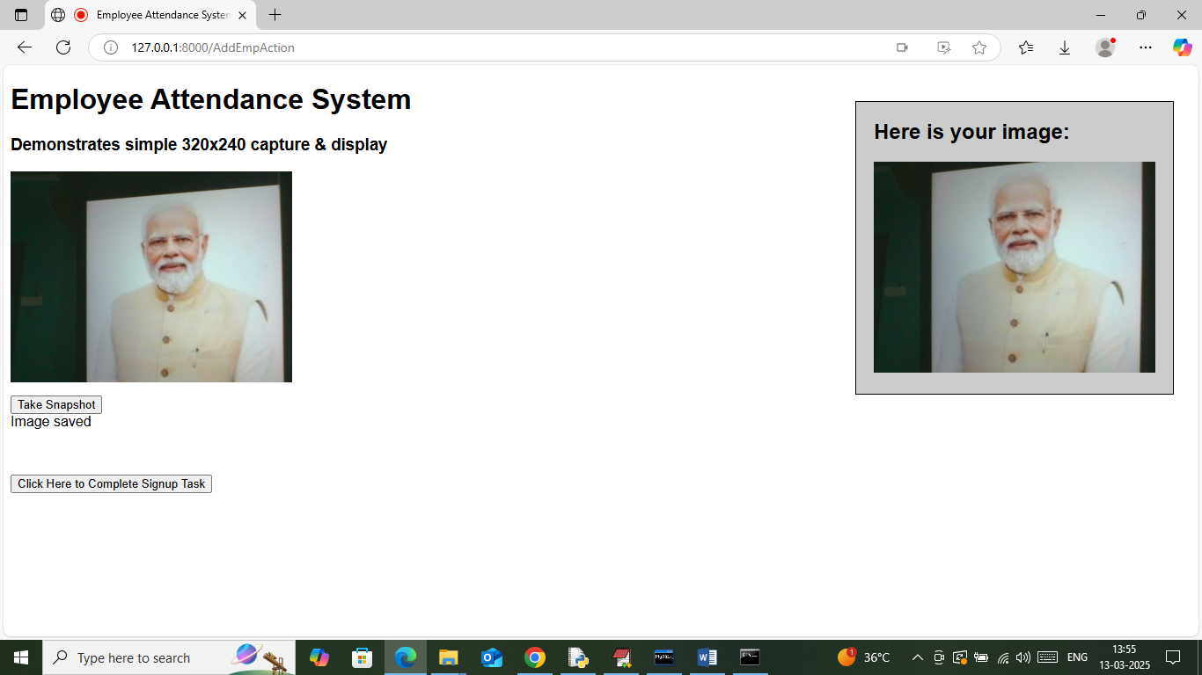

In above screen capturing face and then click on ‘Click Here to Complete Sign up Task’ button to get below page

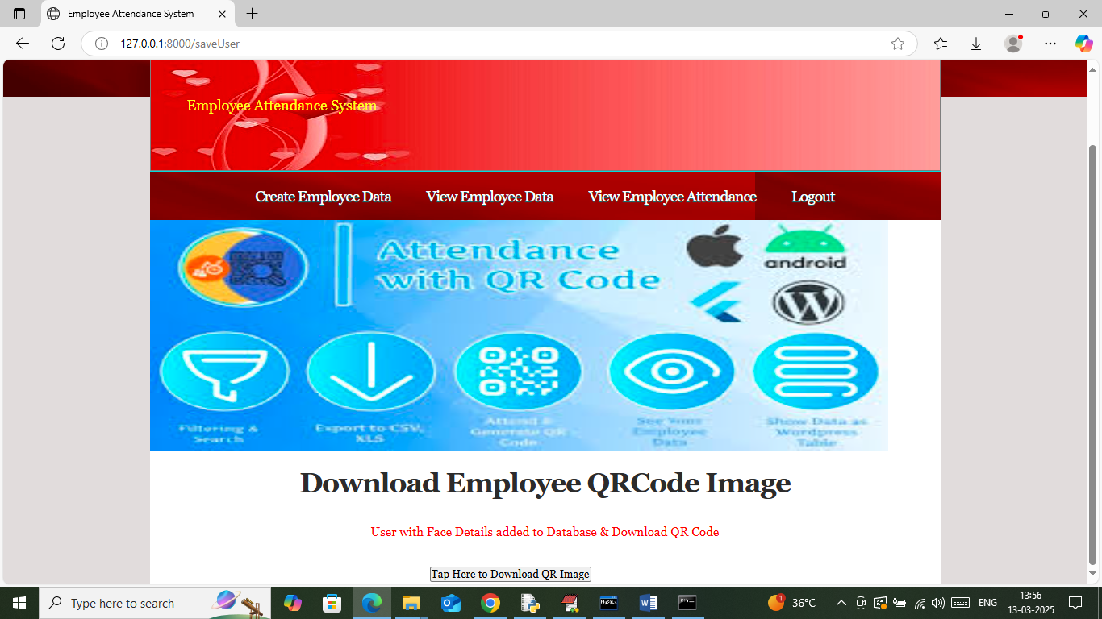

In above screen employee face detail added and you can download qr code also and now login as employee to mark face attendance

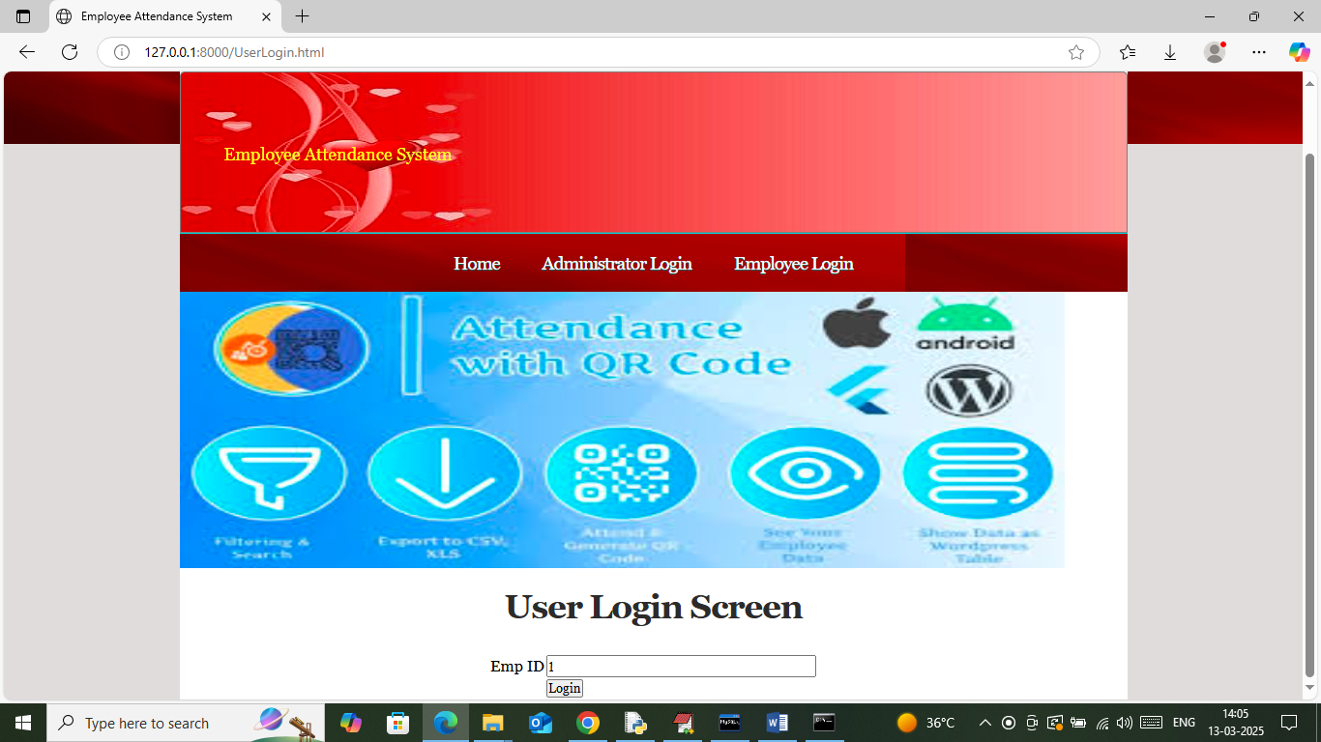

In above screen employee is login and then will get below page

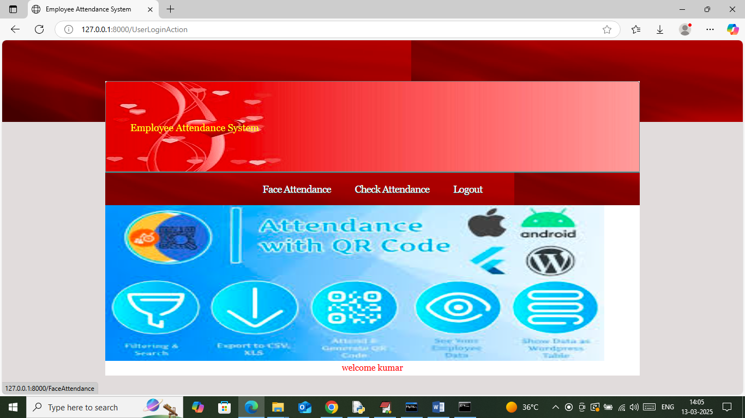

In above screen click on ‘Face Attendance’ link to get below page

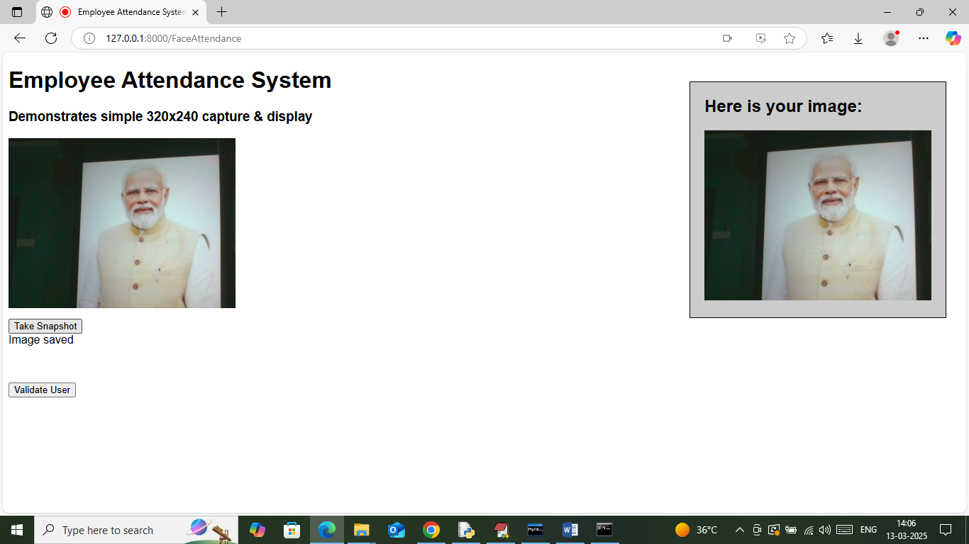

In above screen capturing face for attendance

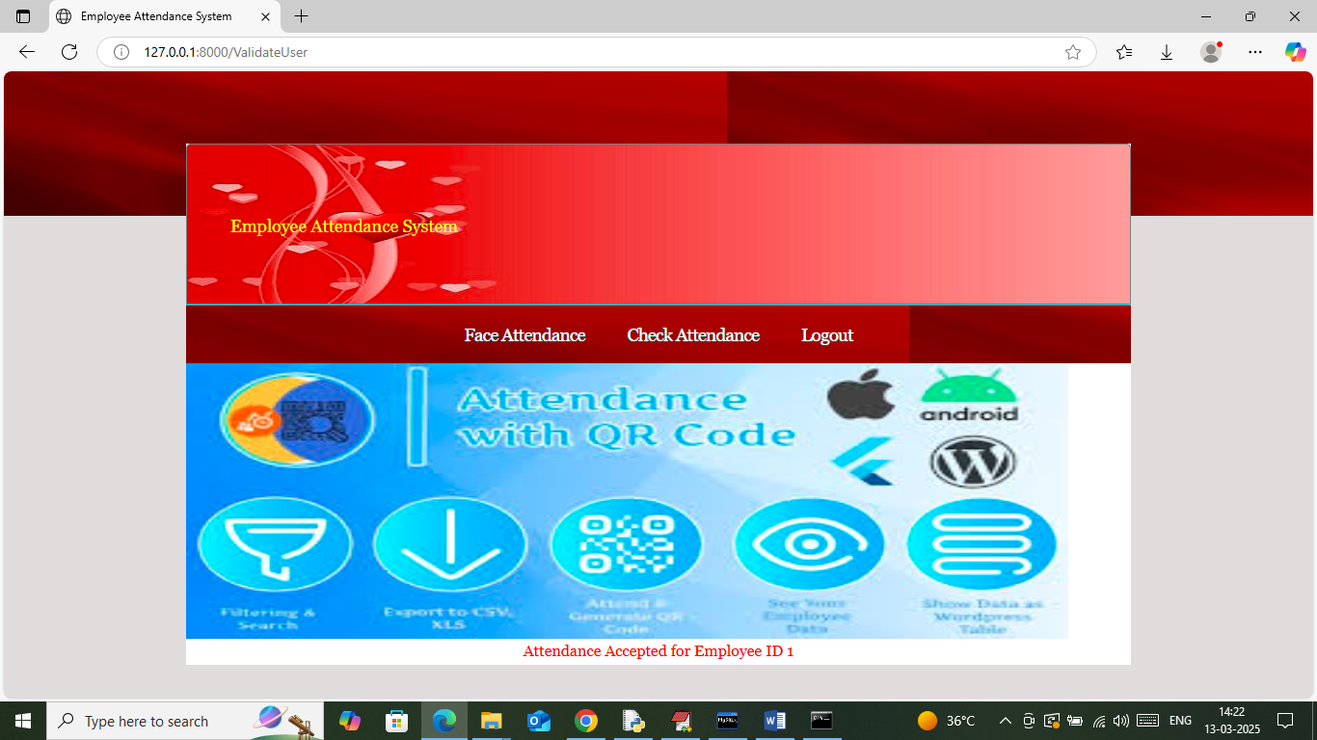

In above screen in red text can see attendance marked for employee ID =1

Similarly you can check attendance also