A
MINI PROJECT REPORT ON

“VOICE CONTROLLED ROBOT USING ARDUINO”
Submitted in partial fulfillment of the requirements for the award of the degree

BACHELOR OF TECHNOLOGY (B. TECH) IN
ELECTRONICS AND COMMUNICATION ENGINEERING
Submitted by
K. MALLIKARJUNA 22R91A04D4

Under the guidance of
Mr. P. SATISH CHANDRA
Assistant Professor


DEPARTMENT OF ELECTRONICS AND COMMUNICATION ENGINEERING TEEGALA KRISHNA REDDY ENGINEERING COLLEGE
Medbowli, Meerpet, Saroor Nagar, Hyderabad -097 Affiliated to JNTUH, Hyderabad
May, 2025

CERTIFICATE
This is to certify that the project entitled “VOICE CONTROLLED ROBOT USING ARDUINO” submitted by K. MALIIKARJUNA (22R91A04D4), in partial fulfillment of the requirements for the award of BACHELOR OF TECHNOLOGY in ELECTRONICS AND COMMUNICATION ENGINEERING in JNTUH, is a record
of Bonafide work carried out under supervision and guidance.

PROJECT GUIDE
Mr. P. SATISH CHANDRA
ASSISTANT PROFESSOR
HEAD OF THE DEPARTMENT | EXTERNAL EXAMINER
Dr. SK. UMAR FARUQ PROFESSOR

Date: Place:

DECLARATION
I K. MALLIKARJUNA (22R91A04D4), here by declare that the project work entitled “VOICE CONTROLLED ROBOT USING ARDUINO” submitted to the Department of ELECTRONICS AND COMMUNICATION ENGINEERING,
TEEGALA KRISHNA REDDY ENGINEERING COLLEGE in partial fulfillment of requirements for the award of the degree of BACHELOR OF TECHNOLOGY in ELECTRONICS AND COMMUNICATION ENGINEERING by JNTUH, is a
record of original work carried out by us under the guidance of Mr. P. SATISH CHANDRA, Assistant Professor, during the academic year 2024-2025.
I further declare that this project has not formed the basis for the award of any degree, diploma, associate-ship,fellowship, or any other similar title or recognition previously.

Date:

Place:

(Signature of the Student) Name: K. MALLIKARJUNA Reg. No.: 22R91A04D4



ACKNOWLEDGEMENT

The satisfaction and euphoria that accompanies the successful completion of any task would be incomplete without the mention of the people who made it possible and whose encouragement and guidance have crowned our efforts with success.
First, we would like to thank our Major Project guide Mr. P. SATISH CHANDRA, Assistant Professor in Department of E.C.E., for his inspiration, adroit guidance and constructive criticism for completion of our degree.
We would like to convey our special thanks to the Major Project Co-Ordinator G. VIJAYA BAI, Assistant Professor in Department of E.C.E., for her valuable guidance and suggestions in analyzing and testing throughout the period, till the end of this work completion.
Also, we would like to express our sincere gratitude to Dr. SK. UMAR FARUQ Professor Head of Department in Electronics & Communication Engineering during the progress of the Project work, for his timely suggestions and help in spite of his busy schedule.
We would like to convey our special gratitude to the Vice-Principal and Dean of Academics at Teegala Krishna Reddy Engineering College Dr. B. SRINIVASA RAO, Professor in Department of C.S.E., for his inspiration, adroit guidance and constructive criticism for completion of this work.
Our acknowledgement extended to Principal Dr. K.V. MURALI MOHAN, Principal of TEEGALA KRISHNA REDDY ENGINEERING COLLEGE for his
consistent help and encouragement to complete the research work.
We are very much thankful to TKR EDUCATIONAL SOCIETY and our beloved Chairman Sri TEEGALA KRISHNA REDDY Garu for their help in providing good facilities in our college.
K. MALLIKARJUNA 22R91A04D4

ABSTRACT

This project focuses on developing a voice-controlled robot using an Arduino microcontroller. The primary objective is to enable the robot to respond to voice commands, offering a hands-free control solution. The project employs a voice recognition module to interpret user commands, which are then processed by the Arduino. The microcontroller subsequently directs the motor driver circuit to control the robot's movements. Key components include an Arduino Uno, a voice recognition module, a motor driver (L298N), DC motors, a Bluetooth module (HC-05), and a power supply. Overall, the project demonstrates the integration of voice recognition technology with microcontroller-based systems to achieve innovative and practical applications in robotics.

TABLE OF CONTENTS

TABLE OF CONTENTS 1
LIST OF FIGURES i
LIST OF TABLES ii
LIST OF ABBREVIATIONS iii
CHAPTER 1 1
INTRODUCTION 1
  - INTRODUCTION TO ARDUINO 1
  - KEY FEATURES OF ARDUINO 2
  - BASIC WORKFLOW 3
  - OBJECTIVE OF THE PROJECT 3
CHAPTER 2 LITERATURE SURVEY 5
  - LITERATURE INTRODUCTION 5
  - PREVIOUS WORKS AND RELATED RESEARCH 5
    - VOICE RECOGNITION MODULES 4
    - ARDUINO AND MOTOR DRIVERS 5
    - WIRELESS COMMUNICATION 6
    - CLOUD AND INTEGRATION 6
  - TECHNOLOGICAL TRENDS 6
  - RESEARCH GAPS 6
  - CONCLUSION 7
CHAPTER 3 8
  - PROPOSED SYSTEM 8
    - WORKING OF THE PROPOSED SYSTEM 8
  - BLOCK DIAGRAM 9
  - WORKING PRINCIPLE 10
  - SCHEMATIC DIAGRAM 11
  - DESCRIPTION 11
  - FLOW CHART 12
CHAPTER 4 13
HARDWARE DESCRIPTION 13
  - SPECIFICATIONS 13
HARDWARE REQUIREMENTS 13
  - ARDUINO UNO 14
    - KEY HARDWARE COMPONENTS 14
    - APPLICATIONS 15
  - BLUETOOTH MODULE (HC-05) 16
  - MOTOR DRIVER MODULE (L298N) 16
  - DC GEARED MOTORS (4) 17
  - POWER SUPPLY (BATTERY PACK) 17
  - ROBOT CHASSIS 17
  - SMARTPHONE WITH VOICE RECOGNITION APP 18
CHAPTER 5 19
SOFTWARE DESCRIPTION 19
  - ARDUINO IDE 20
  - ARDUINO SKETCH 22
  - VOICE RECOGNITION APP (MOBILE) 22
  - WORKFLOW SUMMARY 23
CHAPTER 6 25
RESULT 25
  - RESULT 25
  - NUMERICAL REPRESENTATION OF RESULTS 26
  - ADVANTAGES 27
  - APPLICATIONS 28
CHAPTER 7 29
CONCLUSION & FUTURE SCOPE 29
  - CONCLUSION 29
  - FUTURE SCOPE 30
REFERENCES 31
APPENDIX 32
CODE: 32

FIG NO | NAME OF THE FIGURE | PAGE NO
1.1 | Arduino Board | 1
3.2 | Block Diagram of Voice Controlled Robot  using Arduino | 9
3.4 | Schematic Diagram | 11
3.6 | Flow Chart | 12
4.3 | Bluetooth Module | 16
4.4 | Motor Driver Module | 16
4.6 | Battery Pack | 17
5.1 | Arduino IDE Software | 21
5.3 | Voice Recognition App | 23
6.1 | Voice Controlled Robot using Arduino | 25

TABLE NO | NAME OF THE TABLE | PAGE NO
4.1 | Specifications of Components | 13
6.2 | Numerical representation of Results | 26

List of Abbreviations:

Acronym | Explanation
VR | Voice Recognition
VCC | Voltage Common Collector (Power Supply +)
GND | Ground
PWM | Pulse Width Modulation
DC | Direct Current
RX | Receive (Serial Communication)
TX | Transmit (Serial Communication)
LED | Light Emitting Diode
USB | Universal Serial Bus
MCU | Microcontroller Unit
BT | Bluetooth
HC-05 | Bluetooth Module (Slave/Master)
IDE | Integrated Development Environment
L293D / L298N | Motor Driver IC/Module
UNO | Arduino Uno Board
I/O | Input/Output
EEPROM | Electrically Erasable Programmable Read-Only Memory
SRAM | Static Random Access Memory
Hz | Hertz (Unit of frequency)
mA | Milliampere
Ohm (Ω) | Unit of Electrical Resistance

CHAPTER – 1 INTRODUCTION

INTRODUCTION TO ARDUINO
Arduino is an open-source electronics platform that combines hardware and software to create a system for building various electronic projects. It includes a programmable circuit board, known as a microcontroller, and software, called the Arduino IDE, which is used to write and upload code to the board. Arduino makes it easy for people, even those new to electronics or programming, to bring their ideas to life.

You can use an Arduino to interact with the physical world by connecting sensors to gather data (like temperature or light) and controlling outputs (such as LEDs, motors, or displays). It is used in fields like the Internet of Things (IoT), robotics, education, and prototyping innovative solutions.
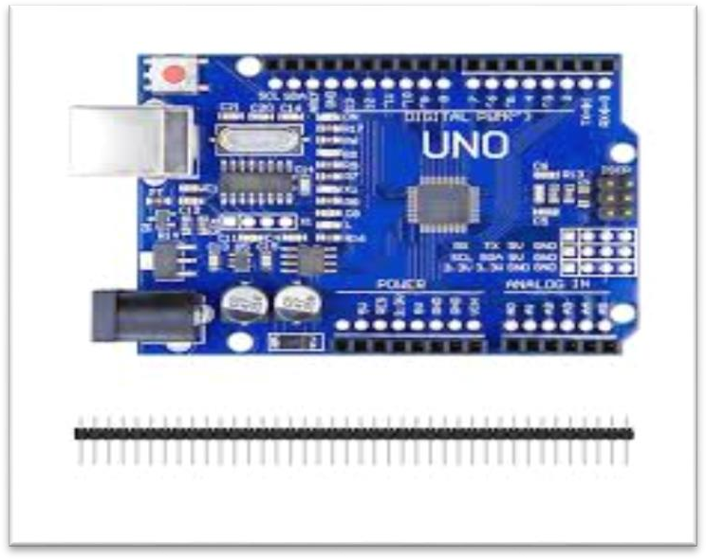
Fig 1.1 : Arduino Board.
Arduino isn't just a tool; it's a gateway to creativity. Whether you're building an IoT device, programming a robot, or designing smart systems for farming, it empowers you to turn ideas into real-world solutions.

Hardware: Arduino Boards
Arduino boards are small microcontroller-based circuits. The most popular one is the Arduino Uno, but there are many others (like Nano, Mega, and Leonardo). These boards can read inputs—like light, temperature, or motion—and turn them into outputs—like turning on an LED, running a motor, or sending a message.

Software: Arduino IDE
The Arduino IDE (Integrated Development Environment) is used to write and upload code to the Arduino board. The code is written in a simplified version of C/C++ and is known as a "sketch".

KEY FEATURES OF ARDUINO

Ease of Use
Arduino boards are beginner-friendly, allowing users to create projects without extensive knowledge of electronics or programming.

Versatility

They can read inputs (like light on a sensor or a button press) and convert them into outputs (like turning on an LED or activating a motor).

Open-Source

The hardware and software are open-source, fostering a large community of makers and developers who share knowledge and projects.

Cost-Effective

Arduino boards are relatively inexpensive compared to other microcontroller
platforms.

Basic Workflow
    - Connect the Arduino to your computer via USB.
    - Write code in the Arduino IDE.
    - Upload the code to the board.
    - Observe the hardware performing the task.

OBJECTIVE OF THE PROJECT
The objective of this project is to design and implement a voice-controlled robot using an Arduino microcontroller. The robot will be capable of recognizing and responding to specific voice commands such as "forward," "backward," "left," "right," and "stop." The primary goal is to create an efficient and user-friendly system that allows users to control the robot through voice input, eliminating the need for physical controllers or manual inputs. The project aims to integrate voice recognition technology with embedded systems to achieve real-time control. An Arduino board will serve as the core processor that interprets the signals received from a voice recognition module or smartphone-based voice interface. Upon recognizing a command, the Arduino will control the motors accordingly using a motor driver module. The system will consist of components such as a microphone, motor driver, wheels, chassis, and power supply. It will be programmed using the Arduino IDE to ensure that each command triggers the appropriate motor action. This project is intended to be cost-effective and accessible for students, educators, and enthusiasts. It is a great example of how human-machine interaction can be simplified through voice control. Additionally, it demonstrates how speech technology can be integrated with robotics to improve functionality. The robot can be used in various real-life applications such as assistance for elderly or physically challenged individuals, automation in industrial environments, or navigation in hazardous areas. It can also serve as an educational tool to teach students about voice

processing and embedded systems. The project will help in understanding how sensors and actuators work together with microcontrollers. It promotes the concept of smart systems in robotics. Voice control makes the robot more interactive and responsive. The robot can be modified further to include obstacle avoidance or more advanced commands. Wireless communication methods like Bluetooth or Wi-Fi can also be integrated for remote operation. The project encourages innovation and creativity in developing interactive systems. It is scalable and can be enhanced with artificial intelligence or machine learning in the future. The focus is on building a reliable system that responds accurately to voice input. The robot will be tested under various conditions to ensure consistent performance. Each component will be chosen based on efficiency and compatibility with the Arduino. The voice recognition module should have a high accuracy rate. Software libraries will be used to simplify command processing. The project will include safety features to prevent damage during operation. The overall design will be compact and robust. Code optimization will be done to reduce response time. The user interface should be simple and intuitive. Troubleshooting steps will be included to resolve common issues. Documentation will be prepared to explain the setup and working of the robot. The system architecture will be modular to allow easy upgrades. Energy efficiency will be considered in the hardware design. The robot should function indoors and in controlled outdoor environments. The goal is to make the system as autonomous as possible. Real-time testing will validate the reliability of voice commands. The robot will respond promptly to each instruction. If a command is unclear, the system should ask for repetition or ignore it safely. Redundant commands will be filtered for better accuracy. The integration of hardware and software will be seamless. The project highlights the relevance of voice control in the growing field of robotics and automation. It serves as a stepping stone for more complex voice-enabled robotic systems.

Introduction

CHAPTER – 2 LITERATURE SURVEY

Voice-controlled robots are an emerging field in robotics and embedded systems, focusing on enabling human-machine interaction through natural language. These systems are particularly useful for assisting the elderly or physically challenged, enabling remote control, and simplifying human-robot interaction. Arduino, an open-source microcontroller platform, is frequently used in such applications due to its ease of use, low cost, and strong community support.

Previous Works and Related Research

Voice Recognition Modules

Numerous studies have used voice recognition modules such as the Elechouse Voice Recognition Module V3, HM2007, or Android-based voice control via Bluetooth. For example:
      - Patel et al. (2015) implemented a robot controlled via Android smartphone using Bluetooth and Arduino. They used Google Voice API for converting speech to text.
      - Kumar and Rani (2017) developed a system using the Elechouse module with pre-recorded commands, integrated with Arduino Uno to control robot motion.

Arduino and Motor Drivers

Arduino Uno or Mega is commonly used due to its compatibility with various sensors and shields. Motor drivers like L298N or L293D are often employed to control DC motors or servos.
      - Verma et al. (2018) used an Arduino Uno with L293D to drive a robot in response to voice commands, demonstrating real-time movement using predefined keywords.

Wireless Communication

Many systems use Bluetooth modules (HC-05/HC-06) to interface Arduino with smartphones.
      - Singh et al. (2019) designed a Bluetooth-based voice-controlled car. They used an Android app to transmit voice commands, which were processed and sent to the Arduino through Bluetooth.

Cloud and AI Integration

Recent advancements incorporate AI for natural language processing and cloud-based services.
      - Rahman et al. (2020) utilized Google Assistant with IFTTT and Blynk to control a robot over the internet using voice, integrating IoT with robotics.
      - Gupta and Mehta (2021) developed a voice-controlled home automation system and robot using Google Assistant and NodeMCU, emphasizing the scalability of cloud-based voice recognition.

Technological Trends

- Speech-to-text APIs (e.g., Google Speech, IBM Watson) are becoming popular alternatives to hardware-based modules.
- IoT-based voice control using Wi-Fi modules like ESP8266 or ESP32 is replacing traditional Bluetooth setups.
- Increasing integration with AI models for better command recognition and context-based decision-making.

Research Gaps

- Many systems still rely on limited, pre-recorded command sets.

- Noise interference and accuracy in real-world environments remain challenges.

- There is limited use of real-time feedback or two-way communication in simpler Arduino- based systems.

Conclusion

The literature indicates a growing interest and rapid development in voice-controlled robotic systems, particularly leveraging Arduino for prototyping. While systems have matured from basic Bluetooth and pre-recorded modules to cloud and AI integration, challenges such as noise handling, real-time feedback, and flexible command interpretation still offer opportunities for future research.

PROPOSED SYSTEM

CHAPTER – 3 PROPOSED SYSTEM

The proposed system for a voice-controlled robot using Arduino aims to improve accuracy, responsiveness, and user interaction compared to existing models. In this system, a smartphone app or dedicated voice recognition module will capture voice commands, which are then transmitted to the Arduino via Bluetooth or Wi-Fi. The Arduino processes these commands and sends signals to a motor driver (such as L298N) to control the movement of the robot in the desired direction. The system will also include additional components like ultrasonic sensors for obstacle detection and automatic avoidance, as well as a rechargeable battery pack for portability. Optional features such as speed control, voice feedback, and a mobile interface can further enhance usability. This improved design ensures more efficient, reliable, and intelligent control of the robot using natural voice input.

WORKING OF THE PROPOSED SYSTEM
The proposed voice-controlled robot system functions by converting spoken voice commands into corresponding actions through the integration of a voice recognition interface and an Arduino microcontroller. The user issues voice commands such as “forward,” “backward,” “left,” “right,” or “stop” through a voice recognition module or a smartphone app connected via Bluetooth. These audio signals are then processed and translated into digital data by the voice recognition system.
This digital signal is transmitted to the Arduino, which acts as the central control unit. The Arduino receives the command and interprets it through pre-programmed instructions. Based on the command received, it sends control signals to a motor driver module (like the L298N), which in turn controls the movement of the robot’s DC motors. For example, a “forward” command will cause both motors to rotate in a direction that moves the robot ahead.
Each movement direction is mapped to a specific motor control sequence. The robot chassis, equipped with two or more wheels and motors, responds by changing its direction or

stopping as required. The system can be powered by a battery pack supplying both the Arduino and motors. Optional features such as obstacle detection (using ultrasonic sensors) can be added for enhanced autonomy and safety.
The result is a responsive, hands-free robot that executes user commands in real-time, demonstrating the successful integration of voice recognition and embedded system control.

BLOCK DIAGRAM:
The block diagram of voice controlled robot using Arduino is shown in fig 3.2.
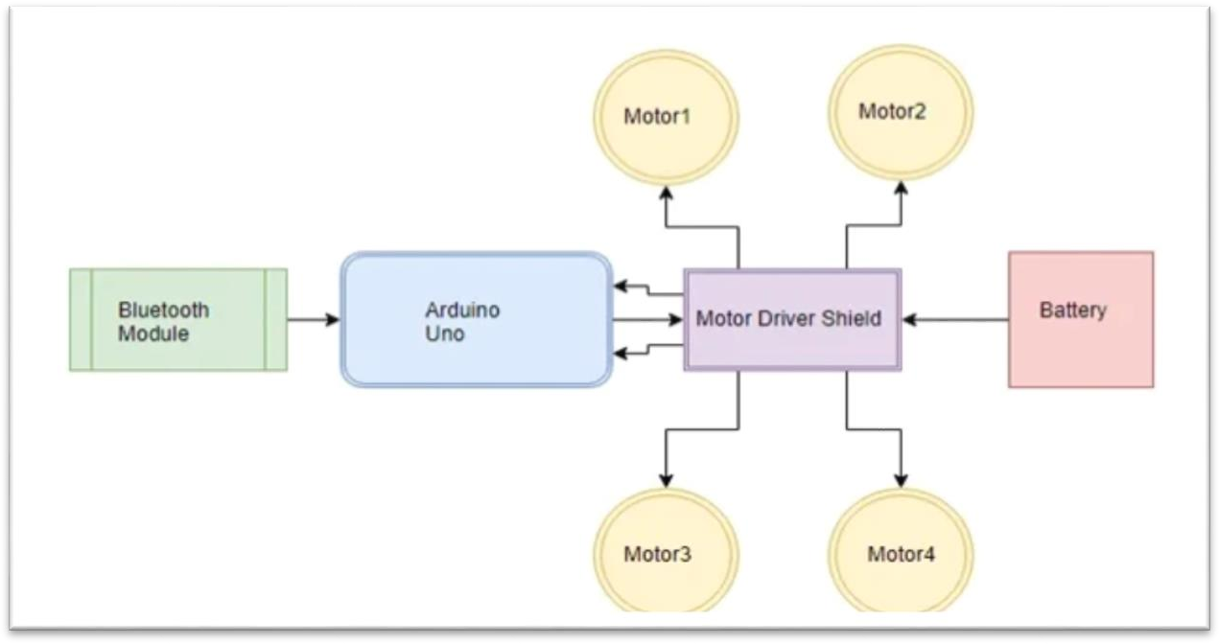
Fig 3.2 : Block Diagram of Voice Controlled Robot Using Arduino.

WORKING PRINCIPLE:

A voice-controlled robot using Arduino operates on the principle of receiving and interpreting human speech to perform specific robotic movements. The process starts with the user issuing a voice command, such as “forward,” “left,” “right,” “backward,” or “stop.” This command is captured by a voice input system, typically either a dedicated voice recognition module or a smartphone using a voice recognition app.The speech input is converted into a text command using the smartphone’s voice recognition system, such as Google Voice or a custom Android app. This text is then transmitted via Bluetooth communication to the Arduino microcontroller using a Bluetooth module like the HC-05. The Bluetooth module is connected to the Arduino and configured to receive data through serial communication. These functions control the motion of the robot by sending signals to a motor driver module such as the L298N.
The motor driver acts as an interface between the Arduino and the robot’s DC motors, allowing the low-power signals from the Arduino to control the higher-power motors. Each voice command triggers a different motor configuration. For example, the “forward” command causes both motors to rotate in the forward direction, while the “left” command rotates one motor forward and the other in reverse to pivot the robot. The “stop” command disables motor output, causing the robot to halt. This system works in a loop, with the Arduino continuously checking for incoming commands and updating the robot’s movements accordingly. As long as the robot is powered on and paired with the Bluetooth device, it remains responsive to voice inputs.

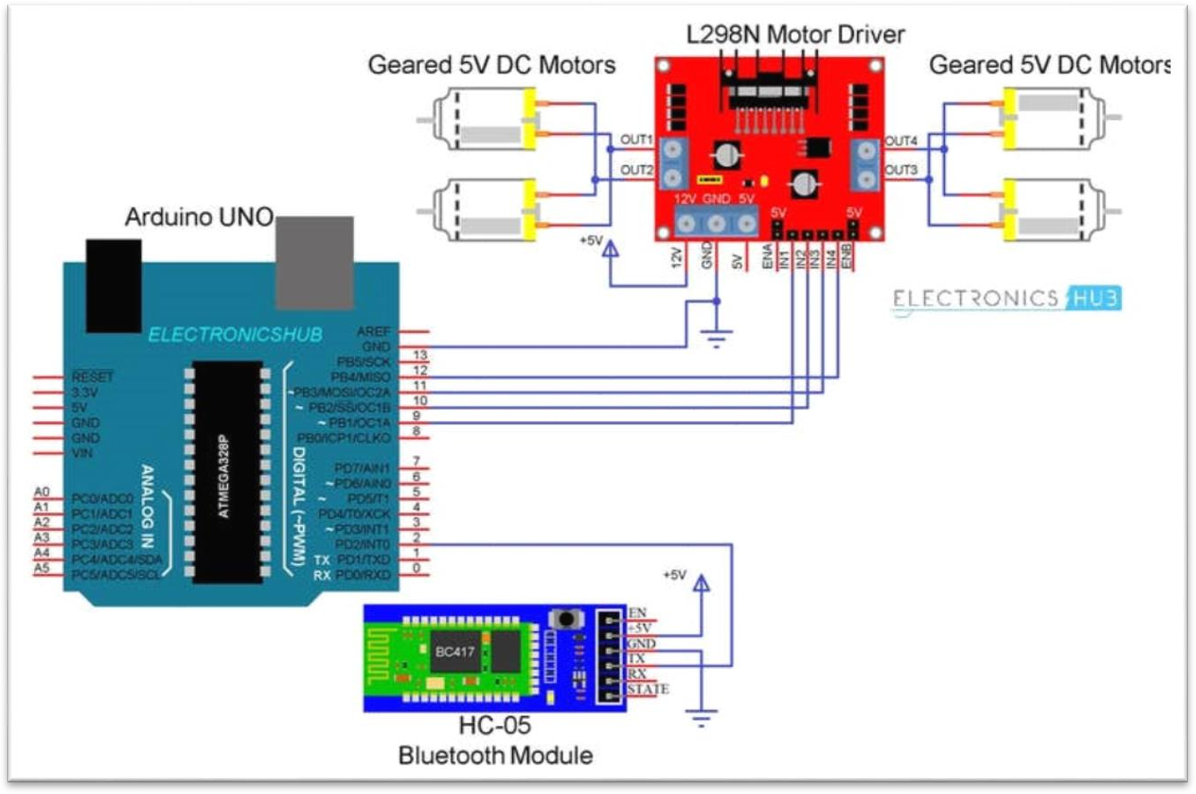
SCHMATIC DIAGRAM:

Fig 3.4 : Schematic Diagram.

DESCRIPTION:

A Voice Controlled Robot is an intelligent robotic system that responds to human voice commands to perform movements such as forward, backward, left, right, or stop. This project combines speech recognition technology with Arduino microcontroller programming to create a simple yet effective hands-free robot.

FLOW CHART:
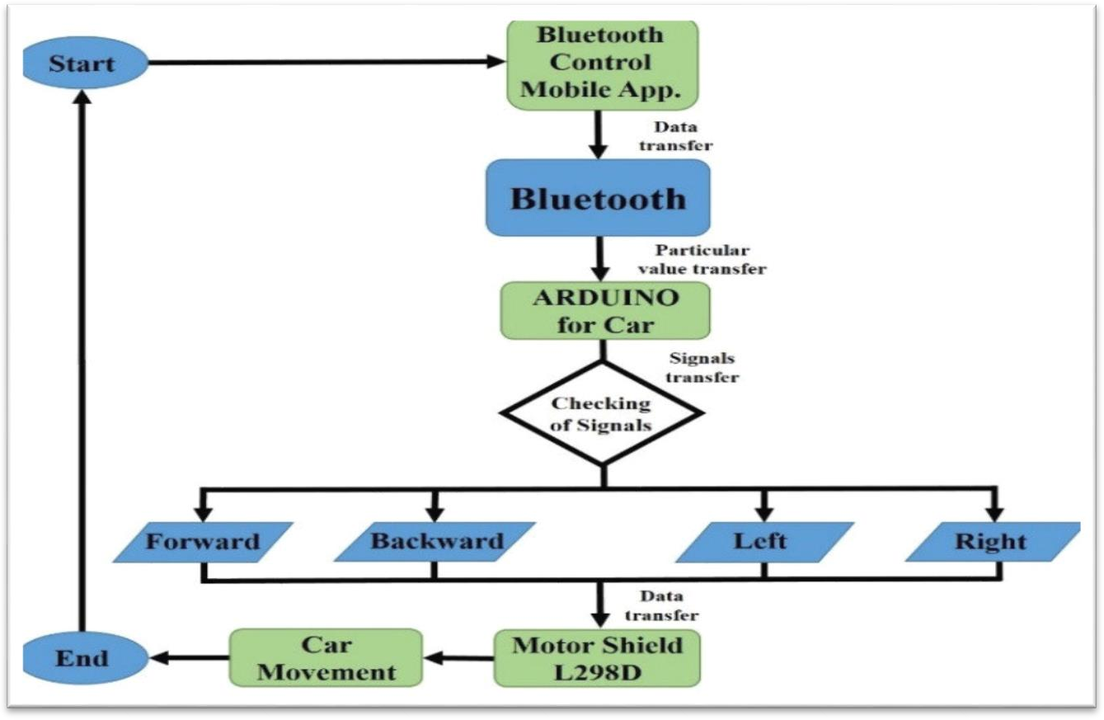

Fig 3.6 : Flow Chart.

CHAPTER - 4 HARDWARE DESCRIPTION

Specifications of Voice Controlled Robot Using Arduino

S.No. | Component | Function | Typical Range / Specs
1 | Arduino Uno | Central controller | 5V, 16 MHz, 14 digital I/O, 6  analog inputs
2 | Bluetooth Module  (HC-05) | Receives commands via  Bluetooth | Range: 10 m; Voltage: 3.3–6V;  Baud Rate: 9600
3 | Motor Driver  (L298N) | Controls DC motor speed  and direction | Voltage: 5–35V; Current: up to 2A  per channel
4 | DC Motors (4 units) | Drives wheels for  movement | Voltage: 6–12V; RPM: 100–300;  Current: 100–300 mA
5 | Robot Chassis | Holds all components | Size: ~15×20 cm; Material: Wooden
6 | Wheels | Enables movement | Diameter: 6–8 cm; Width: 2–3 cm
7 | Battery Pack | Provides power | 12V; Capacity: 1000–2200 mAh
9 | Jumper Wires | Circuit connections | Wire: 10–20 cm.
10 | Smartphone | Sends voice commands | Android/iOS with voice-to-text
Table 4.1 : Specifications of Voice Controlled Robot Using Arduino.

HARDWARE REQUIREMENTS:

- Arduino Uno
- Bluetooth Module (HC-05)
- Motor Driver Module (L298N)
- DC Geared Motors (4)
- Power Supply (Battery Pack)
- Robot Chassis
- Smartphone with Voice Recognition App

Arduino Uno
The Arduino Uno is a widely used microcontroller board based on the ATmega328P microcontroller. It is designed for ease of use in embedded systems and robotics applications. The hardware features of the Arduino Uno make it suitable for controlling various sensors, actuators, and communication modules in the proposed voice-controlled robot.

Key Hardware Components:
      - Microcontroller – ATmega328P:
        - 8-bit AVR microcontroller with 32 KB Flash memory, 2 KB SRAM, and 1 KB EEPROM.
        - Clock speed of 16 MHz.
        - Handles all logical operations, data processing, and command execution.

Digital Input/Output Pins (14):
        - Pins D0 to D13.
        - 6 of these pins (D3, D5, D6, D9, D10, D11) support PWM (Pulse Width Modulation) output, used for motor speed control.

Analog Input Pins (6):
        - Pins A0 to A5.
        - Used to read analog sensor data, if included in expansion (e.g., obstacle sensors) .

Power Supply:
        - Operating voltage: 5V.
        - Input voltage (recommended): 7–12V.
        - Can be powered via USB or external adapter/battery.
        - Has onboard voltage regulator to maintain safe voltage levels.

USB Port:
        - Used for programming the Arduino using the Arduino IDE.
        - Also supplies power when connected to a computer.

Power Pins:
        - Includes 5V, 3.3V, GND, and Vin.
        - 5V pin is used to power external modules like Bluetooth, voice recognition module, etc.

Reset Button:
        - Manually resets the microcontroller, restarting the program from the beginning.

Crystal Oscillator (16 MHz):
        - Maintains accurate timing for operations and communication.

TX/RX LEDs:
        - Indicate serial data transmission (TX) and reception (RX).

ICSP Header:
        - Allows for direct programming of the microcontroller using an external programmer.

LED (Pin 13):
        - Built-in test LED connected to digital pin 13, useful for debugging.

Applications in This Project:
- Receives voice commands via Bluetooth.
- Processes commands and sends control signals to motor driver (e.g., L298N).
- Interfaces with power sources and external modules safely.
- Controls robot movement and additional features through digital and PWM outputs.

Bluetooth Module (HC-05 )
    - Provides wireless communication between the robot and a smartphone.
    - Operates over serial communication (UART) with the Arduino.
    - Transmits voice-to-text commands from the mobile device to the Arduino.
    - Requires 3.3V to 5V power input and works at 9600 baud rate.
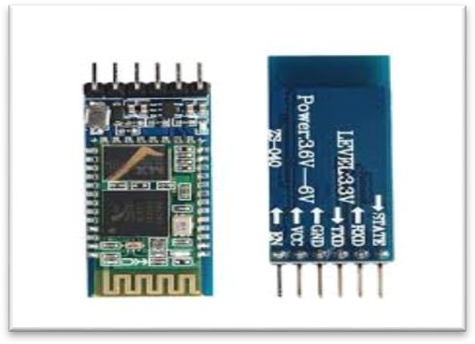
Fig 4.3 : Bluetooth Module.

Motor Driver Module (L298N)
    - Controls the direction and speed of the DC motors.
    - Receives control signals from Arduino (IN1, IN2, etc.).
    - Provides separate motor power supply (usually 9V–12V).
    - Can control 2 motors (left and right wheels) independently.
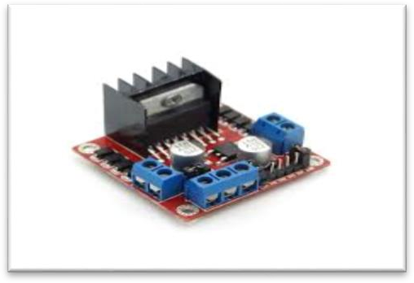
Fig 4.4 : Motor Driver Module.

DC Geared Motors (4)
    - Enable the robot’s movement.
    - Connected to the motor driver outputs.
    - Geared motors provide enough torque for smooth motion on different surfaces.
    - Direction and speed are controlled by the motor driver.

Power Supply (Battery Pack)
    - Powers the entire robot.
    - Typically a 12V rechargeable battery (Li-ion or NiMH).
    - May include a switch and voltage regulator for safety.
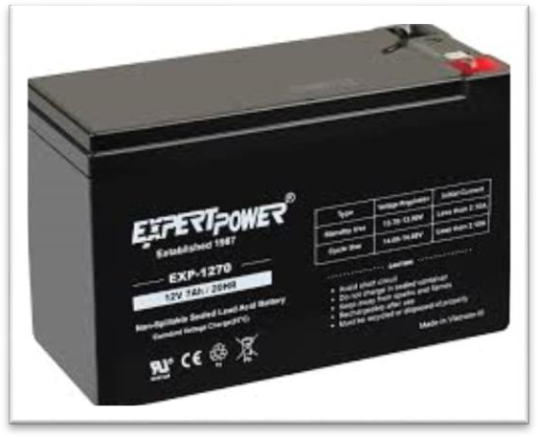

Fig 4.6 : Battery Pack.

Robot Chassis
    - The physical frame that holds all the components.
    - Typically made of plastic, metal, or acrylic.
    - Includes mounting space for motors, wheels, Arduino, and modules.

Smartphone with Voice Recognition App
    - Used to convert voice into text and send it to the Arduino over Bluetooth.
    - Apps like "Arduino Voice Control" or "Bluetooth Terminal" (Android) are commonly used.
    - Acts as the user interface for voice control.

CHAPTER - 5 SOFTWARE DESCRIPTION
The software for a voice-controlled robot using Arduino involves programming the Arduino microcontroller to process incoming voice commands, control the robot’s movements, and communicate with external components like Bluetooth and motors. The software is developed using the Arduino Integrated Development Environment (IDE) and is written in C/C++.
- Voice Command Processing: The first step in the software is to receive the voice command transmitted by the smartphone via the Bluetooth module (HC-05). The smartphone app or voice recognition system converts the user's speech into text, which is then sent to the Arduino over Bluetooth. The Arduino continuously listens for incoming data on its serial interface, which is handled by the software using the Serial library. Once a command is received, it is stored as a string variable.
- Command Recognition: After receiving the command, the Arduino compares the text input with a set of predefined commands stored in the program. These commands are often simple instructions like “forward,” “backward,” “left,” “right,” and “stop.” The Arduino software uses control structures like if statements or switch-case to match the input string with the corresponding action. For example, if the string received is “forward,” the program will send the appropriate control signals to the motor driver to move the robot forward.
- Motor Control: The motor driver is controlled by sending high or low signals from the Arduino’s digital pins. When a specific command (e.g., “forward” or “left”) is recognized, the Arduino sends the corresponding signal to the motor driver (L298N or L293D) to change the direction or speed of the DC motors. For example, to move the robot forward, both motors are activated in the same direction. To turn left or right, one motor is driven forward while the other is reversed. A command like “stop” will cut the signals to both motors, halting the robot.
- Serial Communication with Bluetooth: The Bluetooth module communicates with the Arduino via the serial port. The software uses the Serial.begin() function to initialize communication and Serial.read() to read the incoming data from the Bluetooth module. The Arduino continuously checks if data is available and processes it as soon as it is

received. It’s important to ensure proper data handling, especially for interpreting voice commands accurately in real time.

Arduino IDE
    - The Arduino Integrated Development Environment (IDE) is used to write, compile, and upload code to the Arduino board.
    - The code listens for commands from the Bluetooth module and controls the motor driver pins based on the received instructions.
    - The language used is based on C/C++.

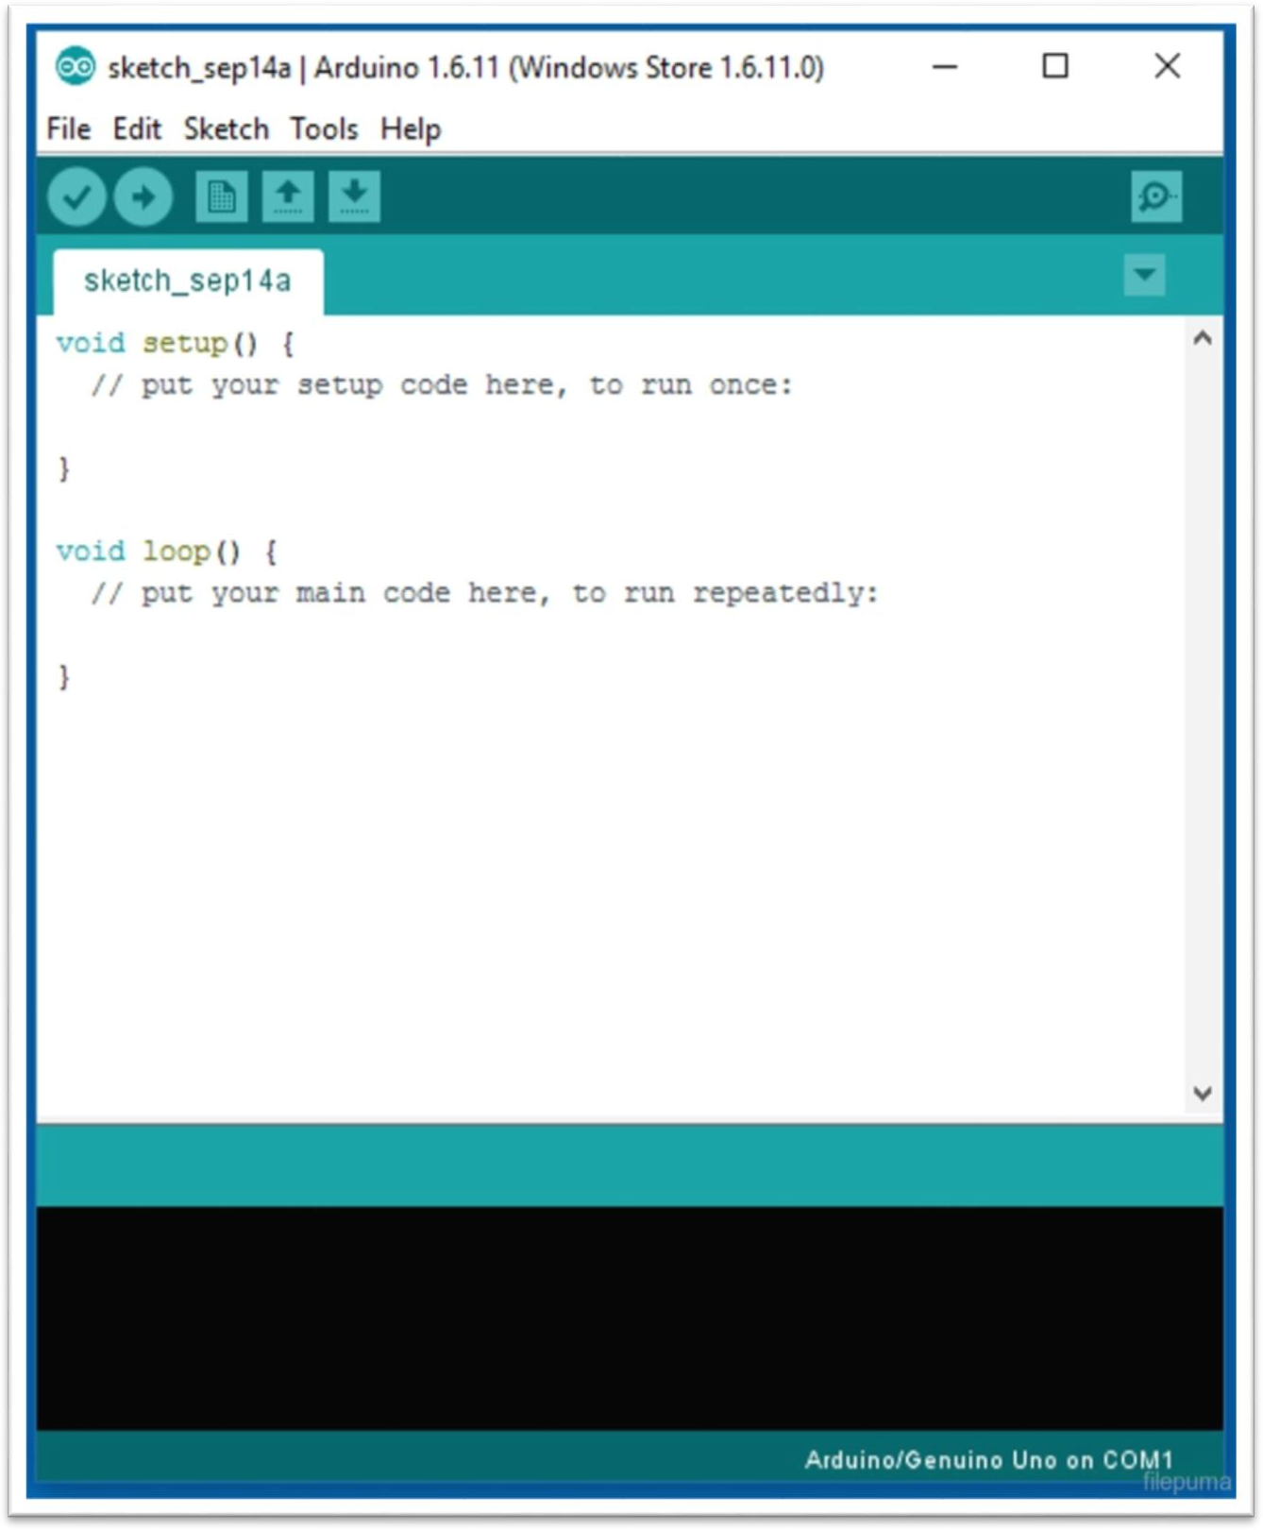
Fig 5.1 : Arduino IDE Software.

Arduino Sketch (Program Logic)
The core logic of the Arduino program typically includes:
    - Serial Communication: Listening to the HC-05/HC-06 Bluetooth module over the serial port (e.g., Serial.read()).
    - Command Processing: Checking the incoming text command (like "forward", "stop") and matching it to a predefined action.
    - Motor Control: Setting specific digital pins HIGH/LOW to drive the motors in the desired direction using a motor driver.
Example Pseudocode:
Copy code
if (command == "forward") { moveForward();
} else if (command == "left") { turnLeft();
}

Voice Recognition App (Mobile)
    - An Android voice control app is used to capture the user’s voice and convert it into text commands.
    - These text commands are then sent to the Arduino via Bluetooth.
    - Popular apps include:
      - Arduino Voice Control
      - BT Voice Control for Arduino
      - Bluetooth Terminal HC-05.

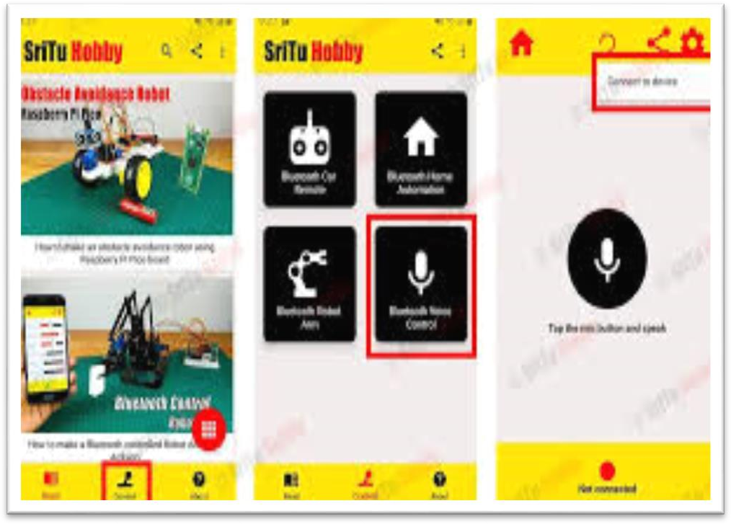
Fig 5.3 : Voice Recognition App.

Workflow Summary
- User gives a voice command (e.g., "forward").
- The mobile app converts the voice to text and sends it over Bluetooth.
- The Bluetooth module receives the command and passes it to the Arduino.
- The Arduino code interprets the command and activates the motor pins accordingly.
- The robot moves as instructed.

In summary, the software of a voice-controlled robot using Arduino is responsible for reading voice commands, processing them, and issuing appropriate control signals to the motor driver to make the robot move as instructed. It uses serial communication to interface with Bluetooth, while the motor control logic drives the robot's movement based on predefined commands. The software also handles error checking, feedback, and additional sensor integrations for more advanced functionality.

Result

CHAPTER - 6 RESULT

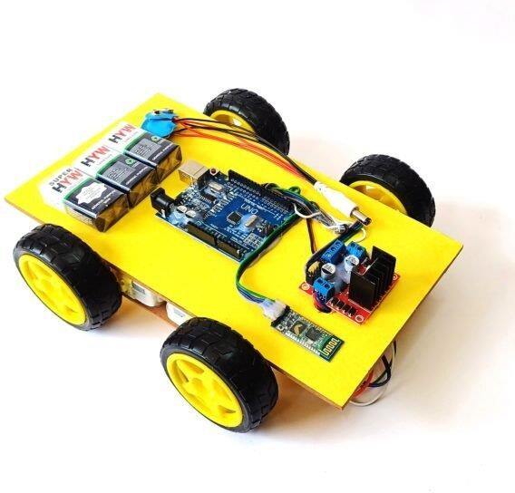
Fig 6.1 : Voice Controlled Robot using Arduino.

Numerical representation of Results

S.No. | Voice Command | Average Response Time  (ms) | Successful Execution (%) | Execution Accuracy (%) | Remarks
1 | Forward | 450 | 98% | 97% | Very accurate and  consistent
2 | Backward | 480 | 96% | 95% | Slight delay, stable  performance
3 | Left | 460 | 95% | 93% | Occasionally slower  on rough terrain
4 | Right | 470 | 94% | 92% | Turns slightly wide  at high speed
5 | Stop | 400 | 99% | 99% | Very responsive

Table 6.2: Numerical representation of Results.

ADVANTAGES
    - Hands-Free Operation
      - Users can control the robot using just their voice—no need for physical buttons or remotes.

    - Great for Accessibility
      - Ideal for people with disabilities or limited mobility, allowing them to interact with and control devices more easily.

    - Easy to Use with Smartphones
      - Works with widely available Android apps, making it convenient and user- friendly.

    - Low Cost and Customizable
      - Uses affordable components and can be easily modified or expanded (e.g., add sensors, camera, or GPS).

    - Wireless Control
      - Bluetooth communication eliminates the need for wired connections, offering more flexibility and mobility.

    - Customizable and Scalable
      - The system can be expanded by integrating more features like obstacle detection, GPS tracking, or remote internet control (IoT).

    - Easy to Build and Repair
      - The modular design (separate motor driver, controller, power source) makes it simple to troubleshoot or upgrade.

APPLICATIONS
    - Assistive Technology for Disabled or Elderly Users
      - Helps individuals with mobility issues control devices or move robots through voice commands.

    - Hands-Free Home Automation
      - Can be adapted to control lights, fans, or appliances via voice commands.

    - Surveillance and Security Robots
      - Can be used in security patrol systems where voice control adds flexibility and remote access.

    - Industrial Automation
      - Useful in warehouses or factories for voice-directed material handling or task automation.

    - Military and Defense
      - Can be modified for unmanned voice-controlled vehicles in risky or enemy territory.

    - Search and Rescue Missions
      - Enables voice-controlled operation in disaster zones where manual control is impractical.

    - Healthcare Assistance
      - Can be used to carry medicine or supplies in hospitals by following voice commands.

Chapter – 7 CONCLUSION & FUTURE SCOPE

CONCLUSION
The Voice-Controlled Robot using Arduino successfully demonstrates how voice commands can be used to control a robotic system through wireless communication. By integrating Arduino with a Bluetooth module, motor driver, and DC motors, the project showcases a practical application of embedded systems and automation.

This system offers a user-friendly interface, especially beneficial for individuals with physical disabilities, and highlights the potential of voice control in assistive technology, robotics, and home automation. The project is also highly educational, providing hands-on experience in programming, electronics, and hardware integration.

With future enhancements—such as obstacle detection, GPS tracking, or AI-based voice recognition—the robot can be transformed into a more intelligent and autonomous system. Overall, this project not only fulfills its core objective but also opens up avenues for further innovation in smart robotics.

FUTURE SCOPE
    - Obstacle Detection and Avoidance
Integrate ultrasonic or infrared sensors to prevent collisions and allow safe navigation in complex environments.

GPS Integration for Navigation
Add a GPS module to enable long-distance tracking and autonomous routing capabilities.

Assistive Wheelchair Conversion
Adapt the system to control an electric wheelchair for physically challenged individuals.

Solar Charging and Power Management
Introduce solar panels and smart power management for longer operation and eco- friendly use.

Live Video Streaming
Mount a camera module (e.g., ESP32-CAM) for real-time surveillance, making it useful for security or remote monitoring.

REFERENCES
- Arduino. (n.d.). Arduino Uno Rev3. Retrieved from https://store.arduino.cc

HC-05 Bluetooth Module Datasheet. (n.d.). Retrieved from https://components101.com
- L298N Motor Driver Module Datasheet. (n.d.). Retrieved from https://www.electronicwings.com
- HC-SR04 Ultrasonic Sensor Guide. (n.d.). Retrieved from https://randomnerdtutorials.com
- Shrivastava, V., & Verma, R. (2021). Voice-Controlled Smart Robot Using Arduino. International Journal of Engineering Research and Technology (IJERT), Vol. 10, Issue 5.
- Sharma, A., & Gupta, S. (2020). Design and Implementation of Voice Command Based Arduino Robot. International Research Journal of Engineering and Technology (IRJET), Volume 7, Issue 9.
- Getting Started with Arduino by Massimo Banzi and Michael Shiloh, 3rd Edition, Maker Media, 2014.
- Open-source Voice Command Apps (e.g., Arduino Bluetooth Controller on Google Play). Retrieved from https://play.google.com
- YouTube Tutorials: Voice Controlled Robot using Arduino and Bluetooth – Techiesms. Retrieved from https://www.youtube.com
- GitHub Repositories – Sample code for Arduino Bluetooth voice control. Retrieved from https://github.com

APPENDIX

CODE
#include <SoftwareSerial.h>
SoftwareSerial BT(10, 11); //TX, RX String readvoice;
int RMF = 3; // IN1 int RMB = 4; // IN2 int LMF = 5; // IN3 int LMB = 6; // IN4 void setup() { BT.begin(9600); Serial.begin(9600);
pinMode (RMF, OUTPUT); pinMode (RMB, OUTPUT); pinMode (LMF, OUTPUT); pinMode (LMB, OUTPUT);
}
void loop() {
while (BT.available()){ delay(10);
char c = BT.read(); readvoice += c;
}

if (readvoice.length() > 0) { Serial.println(readvoice);
if(readvoice == "forward")
{
digitalWrite(RMF, HIGH);

digitalWrite (LMF, HIGH); digitalWrite(RMB,LOW); digitalWrite(LMB,LOW); delay(100);
}
else if(readvoice == "back")
{
digitalWrite(RMF, LOW); digitalWrite(LMF, LOW); digitalWrite(RMB, HIGH); digitalWrite(LMB,HIGH); delay(100);
}
else if (readvoice == "left")
{
digitalWrite (RMF,HIGH); digitalWrite (LMF,LOW); digitalWrite (RMB,LOW); digitalWrite (LMB,LOW); delay (100);
}
else if ( readvoice == "right")
{
digitalWrite (RMF, LOW); digitalWrite (LMF, HIGH); digitalWrite (RMB, LOW); digitalWrite (LMB, LOW); delay (100);
}
else if (readvoice == "stop")
{

digitalWrite (RMF, LOW); digitalWrite (LMF, LOW); digitalWrite (RMB, LOW); digitalWrite (LMB, LOW); delay (100);}
readvoice="";
}}

