Application to book movie tickets

# Features:

1. Web application to book movie tickets
2. User can login to application and select shows based on cities and movies that are running
3. User needs select theatre and the show timing and choose from the list of available seats
4. User needs to reserve the seats and make a payment to complete purchase
5. User will have 2 minutes before they can make the payment to confirm the booking
6. If a user cannot make a payment, his/her reservation will be revoked

# Assumption

1. User authentication is not needed
2. This application will be used to book tickets only
3. Separate application will be used to create data related to:
   1. cities in which this application is available
   2. movies for which tickets are available
   3. Show dates and timings
   4. Theatres which run the shows
   5. Seat inventory
   6. Ticket pricing
4. Separate application runs the payment gateway, integration with payment gateway is considered out of scope

# Technology components

1. Front end is developed using java 8 (Spring boot framework), Java Script, JQuery and Thymeleaf framework
2. Backend is MySQL database

# Database ERD

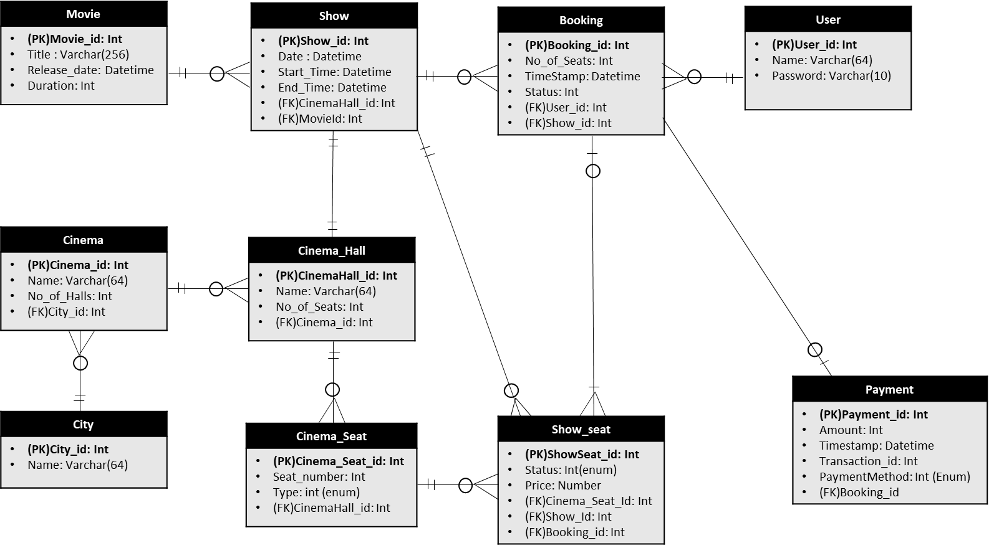

# Application Flow

* Select City

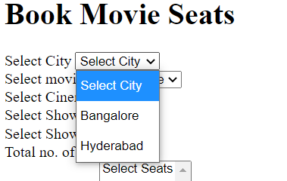

* Select Movie

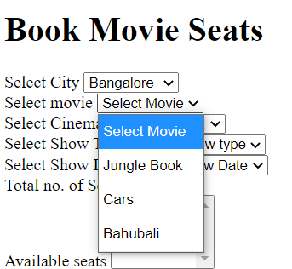

* Select Theatre

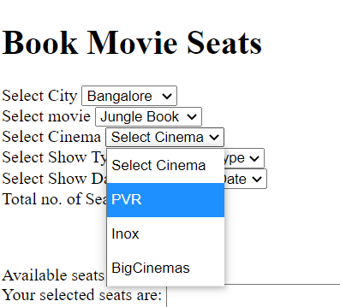

* Select show type

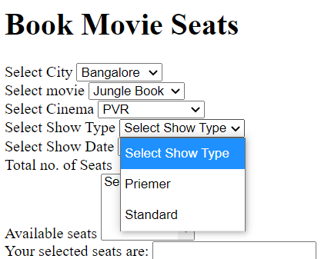

* Select show date and time

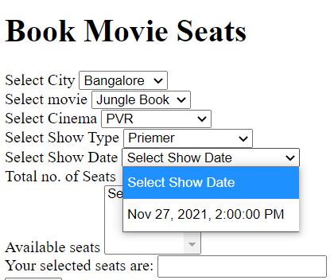

* Select seats

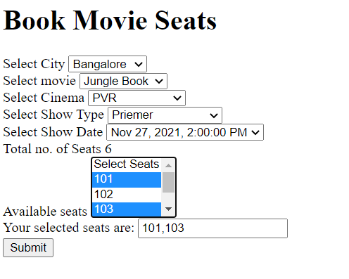

* Click Submit. On submit, user receives a message on time limit to complete booking

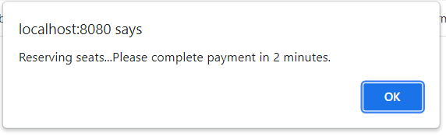

* User receives the booking reference number and the amount to be paid

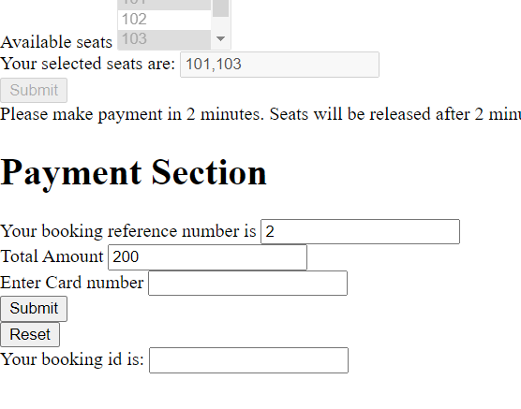

* User enters card number to complete booking and receives a confirmation of booking

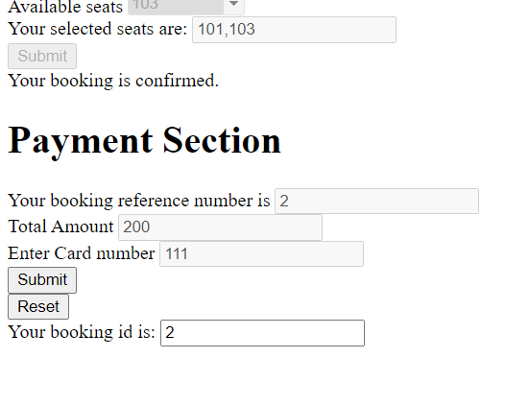

* User selects the “Reset” button to start another booking
* If the user is not able to make the payment complete within 2 minutes, a notification is displayed to user – that the booking stands cancelled, and the seats are released

**Layout of the application**

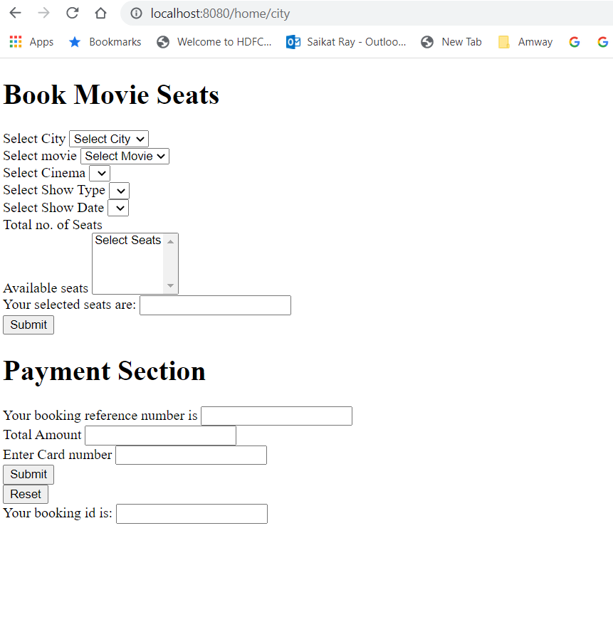

# Database components

1. Tables:
   1. Booking: Stores all user bookings
   2. Cinema: Stores all cinemas that have signed up for this application in the cities where the services are available
   3. Cinema_hall: Stores the various types of halls available in the cinema, eg. Standard, premium, etc. It also stores the number of seats in each hall
   4. City: stores the city information where this service is available
   5. Movie: Movies currently running in the cinemas
   6. Movie_show: Show date and time
   7. Payment: Payment information related to a booking
   8. Show_seat: Stores seat inventory for each cinema_hall
2. Events:
   1. A scheduled event will run (every 30 seconds) which will check the bookings which are in “booked” status (not “paid”) for more than 2 minutes. This event will run an update script on the “show_seat” table and update the “status” column to “Available”. It will also remove the corresponding booking from the “Booking” table.