cp-anlyzr

Competitive Programmer's Analyzer

A Tool to Visualize Problem Solving
Activity and Progress
April 17, 2018

https://github.com/Saikat-S/cp-anlyzr

Our Supervisor
Mohammad Ashraful Islam
Lecturer
Department of Computer Science and Engineering
Mawlana Bhashani Science and Technology University
Our Team
Rasedul Islam, CE16007
Riazul Islam, CE16015
Arafat Hasan, CE16024
Saikat Sharma, CE16036
Department of Computer Science and Engineering
Mawlana Bhashani Science and Technology University
Competitive Programmer's Analyzer
Our plan is to make a competitive programmer's analyzer which will take handle_name or username or email of a competitive programmer and show some graphs and statistics for that handle. We will show many graphs to represent current condition of a user, his activity, progress in problem solving.

Our Planed Features
- Verdicts chart
- Show progress chart after a training session on specific topic
- Progress of a training based on weighted average of problem hardness
- Solved problems languages chart
- Solved problems tags chart
- Solved problems levels chart
- Total tried problems count
- Total solved problems count
- Average and max attempts
- Max AC for a single problem (It indicates in how many ways someone solved a problem)
- List of unsolved problems

We will try
- Suggestion for problems based on ones solved problem categories and hardness.
- A make activity chart show which will show how active the user is in previous months.

Implementation Idea
We planed to build a Web App or a Desktop App using Java. Codeforces and most other platforms provide public APIs, through which machine-readable JSON formated data is available, generally. We will use these APIs to get data of a user by sending HTTP-request to the server. There are many library to consume APIs in Java. Some of them are:
- http://hc.apache.org/httpcomponents-client-ga/
- https://github.com/square/okhttp
- http://square.github.io/retrofit/
Making a Web App will be difficult then building Desktop App. Java Swing or JavaFx will be enough to build a Desktop App. On other side to build web based App we have to use Servlet, JSP, JDBC and a database.

Objectives
- Determine individuals programming skill on various categories.
- Easily shows ones powerful area of problem solving categories
- One will able to know his particular weak area of problem categories.
- Will be able to know his progress through months.
- Suggested problems will be helpful to and guide a competitive programmer.

License
The tool is given under MIT license, read more: https://opensource.org/licenses/MIT.

Some Sample Charts

Verdicts chart
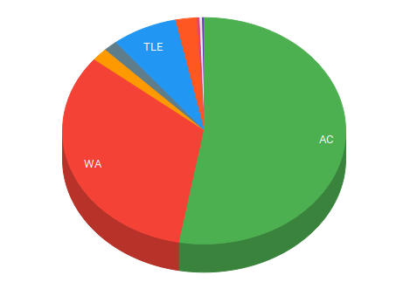

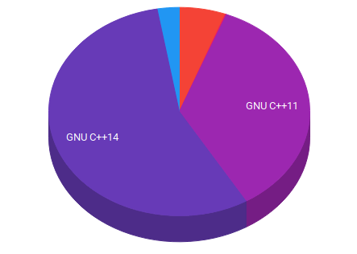
Languages chart
Tags chart
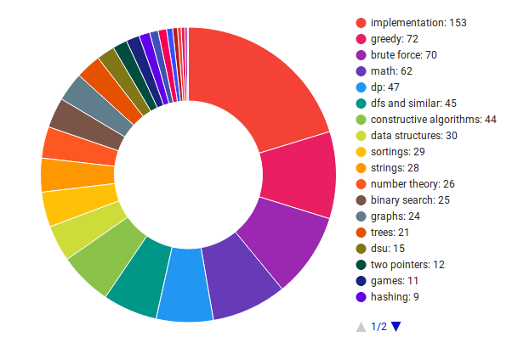

Levels chart
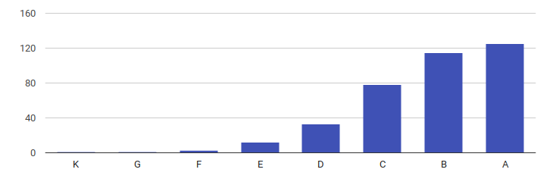

Activity Chart
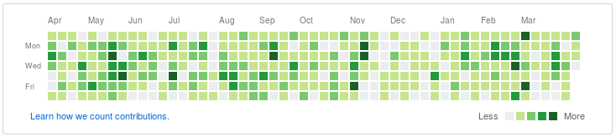

Rating Chart
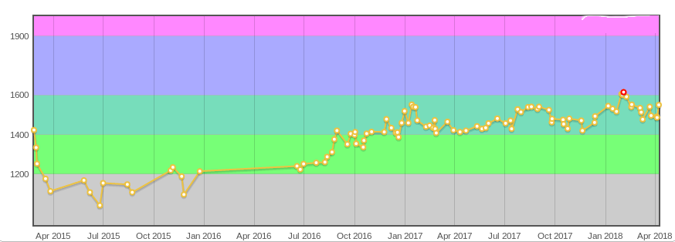
Courtesy of Charts: http://codeforces.com/, http://cfviz.netlify.com/, http://stopstalk.com/

