Software Requirements Specification

for

Enterprise Concurrent Signal Broadcast Framework
(ECSBF)

Version 0.1

Prepared by

Saikat Sheet

Date | Version | Author | Brief Description of Changes
19-05-2026 | 0.0 | Saikat Sheet | Initial draft, requirements identified
20-05-2026 | 0.1 | Saikat Sheet | System features and diagrams added

Table of Contents

Section | Title | Page
 | Revision History | i
1. | Introduction | 1
1.1 | Purpose | 1
1.2 | Document Conventions | 1
1.3 | Intended Audience and Reading Suggestions | 1
1.4 | Project Scope | 1
1.5 | References | 2
2. | Overall Description | 2
2.1 | Product Perspective | 2
2.2 | Product Features & Use Case Diagram | 2
2.3 | Operating Environment | 3
2.4 | Design and Implementation Constraints | 3
2.5 | User Documentation | 3
2.6 | Assumptions and Dependencies | 3
3. | System Features | 4
3.1 | System Feature 1 – Node-Engine Handshake | 4
3.2 | System Feature 2 – Node Provisioning & Identity Verification | 5
3.3 | System Feature 3 – Persistent Session Management | 6
3.4 | System Feature 4 – Signal Broadcast | 7
3.5 | System Feature 5 – Cryptographic Protection | 8
3.6 | System Feature 6 – Multi-Level Diagnostic Logging | 9
3.7 | Class Diagram | 10
4. | External Interface Requirements | 11
4.1 | User Interfaces | 11
4.2 | Hardware Interfaces | 11
4.3 | Software Interfaces | 11
4.4 | Communications Interfaces | 11
5. | Other Non-Functional Requirements | 12
5.1 | Performance Requirements | 12
5.2 | Safety Requirements | 12
5.3 | Software Quality Attributes | 12
6. | Other Requirements | 13
 | Appendix A: Glossary | 13

1. Introduction
The Enterprise Concurrent Signal Broadcast Framework (ECSBF) is a real-time communication backbone designed for signal propagation across a distributed node network. The system uses a centralized Engine to manage connections, verify node identities, and securely broadcast encrypted data packets to all connected nodes. It maintains persistent session states and provides diagnostic logging for system observability.

1.1 Purpose
The purpose of ECSBF is to provide a secure, high-concurrency platform for broadcasting signals from any single node to all active nodes in the network. It ensures that every message is encrypted, every sender is authenticated, and every session is tracked and recoverable.

1.2 Document Conventions
The document uses the Times New Roman font with bold for headings. The main heading size is 18pt. The sub-heading size is 14pt. The body text is 12pt. Requirement identifiers follow the pattern ECSBF_XX where XX is a two-digit number.

1.3 Intended Audience and Reading Suggestions
The document is intended for all stakeholders including developers, testers, designers, and maintainers. The reader is assumed to have basic knowledge of networking, client-server architecture, and understanding of use case and class diagrams.

1.4 Project Scope
The scope of this project is to develop and implement the ECSBF system involving a centralized Engine and multiple Endpoint Nodes. The Engine handles node registration, identity verification, session management, and signal broadcasting. All communication is encrypted. The system also provides multi-level diagnostic logging and network identity resolution.

1.5 References
- RFC 793 – Transmission Control Protocol
- RFC 5246 – TLS Protocol Specification
- IEEE 829 – Standard for Software Test Documentation
- https://www.geeksforgeeks.org/client-server-model/

2. Overall Description

2.1 Product Perspective
The ECSBF system involves two main actors: the Endpoint Node and the central Engine. An Endpoint Node connects to the Engine, authenticates itself, and can send or receive signals. The Engine is the sole authority for routing broadcasts and maintaining the identity of all nodes. The system follows a client-server model where the Engine is the server and each Endpoint Node is a client.

2.2 Product Features
The main features of ECSBF are:
- Secure handshake protocol between each Endpoint Node and the Engine.
- Node registration and management via a Global Identity Registry.
- Mandatory identity verification for every session request.
- Persistent session management with automatic recovery on network failure.
- Multi-threaded Engine capable of handling many simultaneous nodes.
- Broadcast of any signal from one node to all active nodes, with a source tag.
- String-based encryption for all credentials and payload data.
- IP-to-node-name resolution for human-readable addressing.
- Multi-level diagnostic logging: FATAL, INFO, WARNING, and DEBUG.

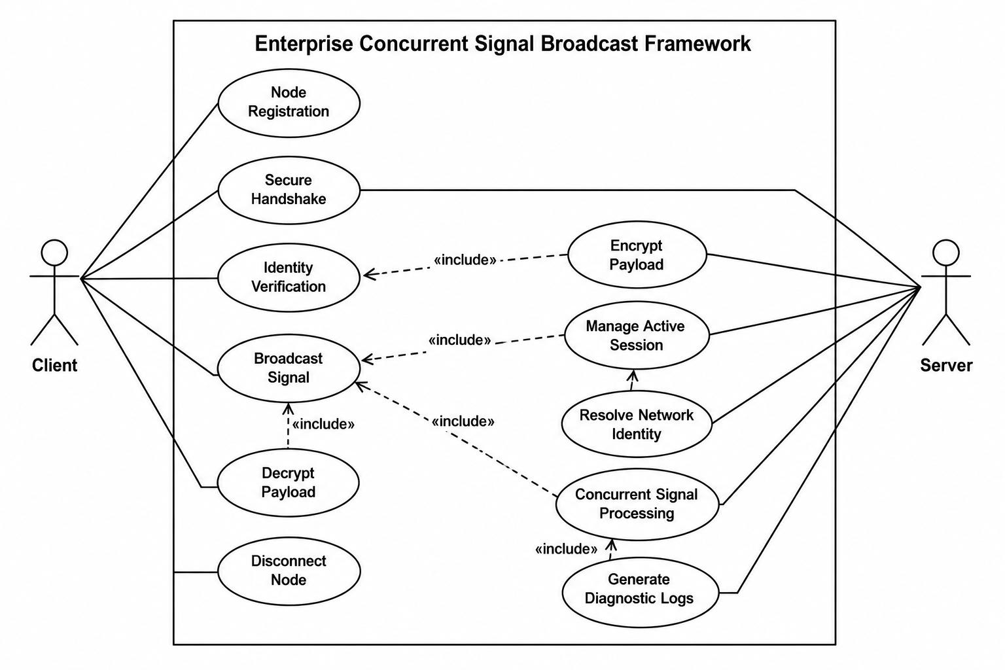
Figure 1: ECSBF Use Case Diagram

2.3 Operating Environment
- Operating System: Linux Ubuntu 22.04 LTS terminal.
- Language used: C++17.
- Network Protocol: TCP with TLS encryption.

2.4 Design and Implementation Constraints
- All communication must pass through the central Engine. Direct node-to-node messaging is not allowed.
- The Engine must enforce encrypted connections. Plain-text connections are rejected.
- A node can only use the system after it has been registered in the Global Identity Registry.
- The thread pool size must be configurable and bounded to prevent resource exhaustion.

2.5 User Documentation
The project will be uploaded to a GitHub repository which is publicly accessible. A README file and setup guide will be included with the source code for ease of installation and use.

2.6 Assumptions and Dependencies
- All nodes must have a working network connection to the Engine host.
- The system clock on all nodes must be synchronized (NTP) for session token expiry checks.
- The Global Identity Registry database must be running before the Engine starts.
- The network must be reliable enough to support TCP persistent connections.

3. System Features
The following is a list of features of the Enterprise Concurrent Signal Broadcast Framework.

3.1 System Feature 1 – Node-Engine Handshake

3.1.1 Description and Priority
A secure connection must be established between an Endpoint Node and the Engine before any signal exchange can begin. This is a HIGH priority feature as no other operation can proceed without it.

3.1.2 Stimulus/Response Sequences
- The node sends a connection request with its node ID and credentials to the Engine.
- The Engine verifies the node ID against the Global Identity Registry.
- On success, the Engine returns a session token to the node.
- On failure, the Engine returns an AUTH_FAILED error and closes the connection.

3.1.3 Functional Requirements
ECSBF_01: The Engine must verify node credentials against the Global Identity Registry on every connection attempt.
Each time a node tries to connect, the Engine checks the node ID and credential. If the node is not registered or the credential does not match, the connection is refused.
ECSBF_02: A session token must be issued to the node on successful handshake.
The session token contains the node ID and an expiry time. The node must use this token in all subsequent requests to prove its identity.

3.2 System Feature 2 – Node Provisioning and Identity Verification

3.2.1 Description and Priority
New nodes must be registered in the Global Identity Registry before they can connect. Existing nodes must be authenticated on every session request. Both are HIGH priority requirements.

3.2.2 Stimulus/Response Sequences
- Admin submits a new node profile (node ID, name, IP, credential) to the registry.
- The registry stores the profile and confirms registration.
- On a session request, the node presents its token to the Engine.
- The Engine validates the token signature and checks if the node is still active.
- Valid tokens allow access. Expired or tampered tokens are rejected.

3.2.3 Functional Requirements
ECSBF_03: A new node must be registered in the Global Identity Registry before it can use any Engine service.
The registration engine API accepts a node ID, human-readable name, IP address, and credential. Duplicate node IDs are rejected with a conflict error.
ECSBF_04: Every session request must carry a valid token. The Engine must reject expired or tampered tokens.
The Engine checks the token expiry time and its cryptographic signature on each request. If either check fails, the request is denied and the event is logged.

3.3 System Feature 3 – Persistent Session Management

3.3.1 Description and Priority
The Engine must keep session information for all connected nodes and restore sessions automatically after a temporary network failure. Priority: HIGH.

3.3.2 Stimulus/Response Sequences
- The Engine stores session state (node ID, token, last heartbeat) for each connected node.
- A heartbeat check runs every 15 seconds per node.
- If a node misses three heartbeat checks, the Engine marks the session as disconnected.
- When the node reconnects with a valid token, the session is restored without re-authentication.
- If the token has expired before reconnection, the session is terminated and purged.

3.3.3 Functional Requirements
ECSBF_05: The Engine must store an active session state and restore it automatically after a transient network failure.
Session data must be saved to persistent storage so it survives Engine restarts. A node that reconnects within the token validity window must be restored without re-entering credentials.
ECSBF_06: The Engine must terminate and purge a session when a node disconnects or its token expires.
On graceful disconnect or heartbeat timeout, the Engine removes the session record and frees the associated thread allocation. A log entry is written at INFO level for each finalized session.

3.4 System Feature 4 – Signal Broadcast

3.4.1 Description and Priority
Any signal sent by one node must be delivered to all currently active nodes, with a source identifier appended. Priority: HIGH.

3.4.2 Stimulus/Response Sequences
- Node A sends a signal payload to the Engine.
- The Engine decrypts and validates the payload.
- The Engine appends a source tag (e.g., [from: NODE_A]) to the payload.
- The Engine delivers the tagged payload to all other active nodes.
- If no other nodes are active, the Engine logs a warning and acknowledges the sender.

3.4.3 Functional Requirements
ECSBF_07: Any signal sent by a node must be delivered to all other active nodes with a source identifier tag.
The Engine appends the sender node ID as a source tag to every broadcast. The sender itself does not receive its own broadcast. All delivery events are logged at INFO level.
ECSBF_08: The Engine must support many simultaneous signal requests using a multi-threaded concurrency model.
A bounded thread pool handles incoming signal requests. If the pool reaches capacity, the Engine returns a QUEUE_FULL error and logs a WARNING. Deadlocks must be detected and logged at FATAL level.

3.5 System Feature 5 – Cryptographic Protection and Decryption

3.5.1 Description and Priority
All credentials and payload data must be encrypted during transmission. The receiving end must be able to decrypt and verify the data. Priority: HIGH.

3.5.2 Stimulus/Response Sequences
- The node encrypts its credential and payload before sending.
- The Engine receives the encrypted data and decrypts it using the shared key.
- If decryption fails (bad key, tampered data), the Engine drops the packet and logs a WARNING.
- On success, the decrypted payload is validated and forwarded for broadcast.
- Network identity resolution is available: given an IP address, the Engine returns the registered node name.

3.5.3 Functional Requirements
ECSBF_09: All node credentials and signal payloads must be encrypted using AES-256. Plain-text transmissions must be rejected.
The Engine refuses any connection that does not use the required encryption. Failed decryption events are logged at WARNING level and the payload is discarded.
ECSBF_10: The system must provide an IP-to-node-name resolution service.
Given an IP address, the resolveIp() function returns the human-readable node name from the Global Identity Registry. Unknown IP addresses return NODE_NOT_FOUND. Results are cached for 60 seconds.

3.6 System Feature 6 – Multi-Level Diagnostic Logging

3.6.1 Description and Priority
The system must log diagnostic events at four verbosity levels: FATAL, INFO, WARNING, and DEBUG. Priority: HIGH.

3.6.2 Stimulus/Response Sequences
- Any system event triggers the logging engine at the appropriate level.
- Log entries include a timestamp, log level, node ID (if applicable), and message.
- The log verbosity level can be configured at runtime without restarting the Engine.

3.6.3 Functional Requirements
ECSBF_11: The logging engine must support at least four verbosity levels: FATAL, INFO, WARNING, and DEBUG.

Level | When to Use | Example
FATAL | Irrecoverable error forcing shutdown | Engine crash, registry unavailable
INFO | Normal operation milestones | Node connected, broadcast sent
WARNING | Recoverable problem, operation continues | Retry attempt, token near expiry
DEBUG | Detailed trace for engineers | Packet contents, thread allocation

ECSBF_12: Every log entry must include a timestamp (UTC), log level, node ID, and message text.
FATAL-level events must also be written to a separate audit log file. Log output must support structured JSON format for integration with external monitoring tools.
ECSBF_13: The system must handle standard error cases and return specific error codes for each.
Standard error codes include AUTH_FAILED, TOKEN_EXPIRED, INVALID_SIGNATURE, NODE_NOT_FOUND, QUEUE_FULL, and DECRYPTION_FAILED. Each code must be logged with the triggering event.

3.7 Class Diagram
The class diagram below shows the main classes of the ECSBF system and describes what each class is responsible for. Arrows show which classes interact with or depend on each other.

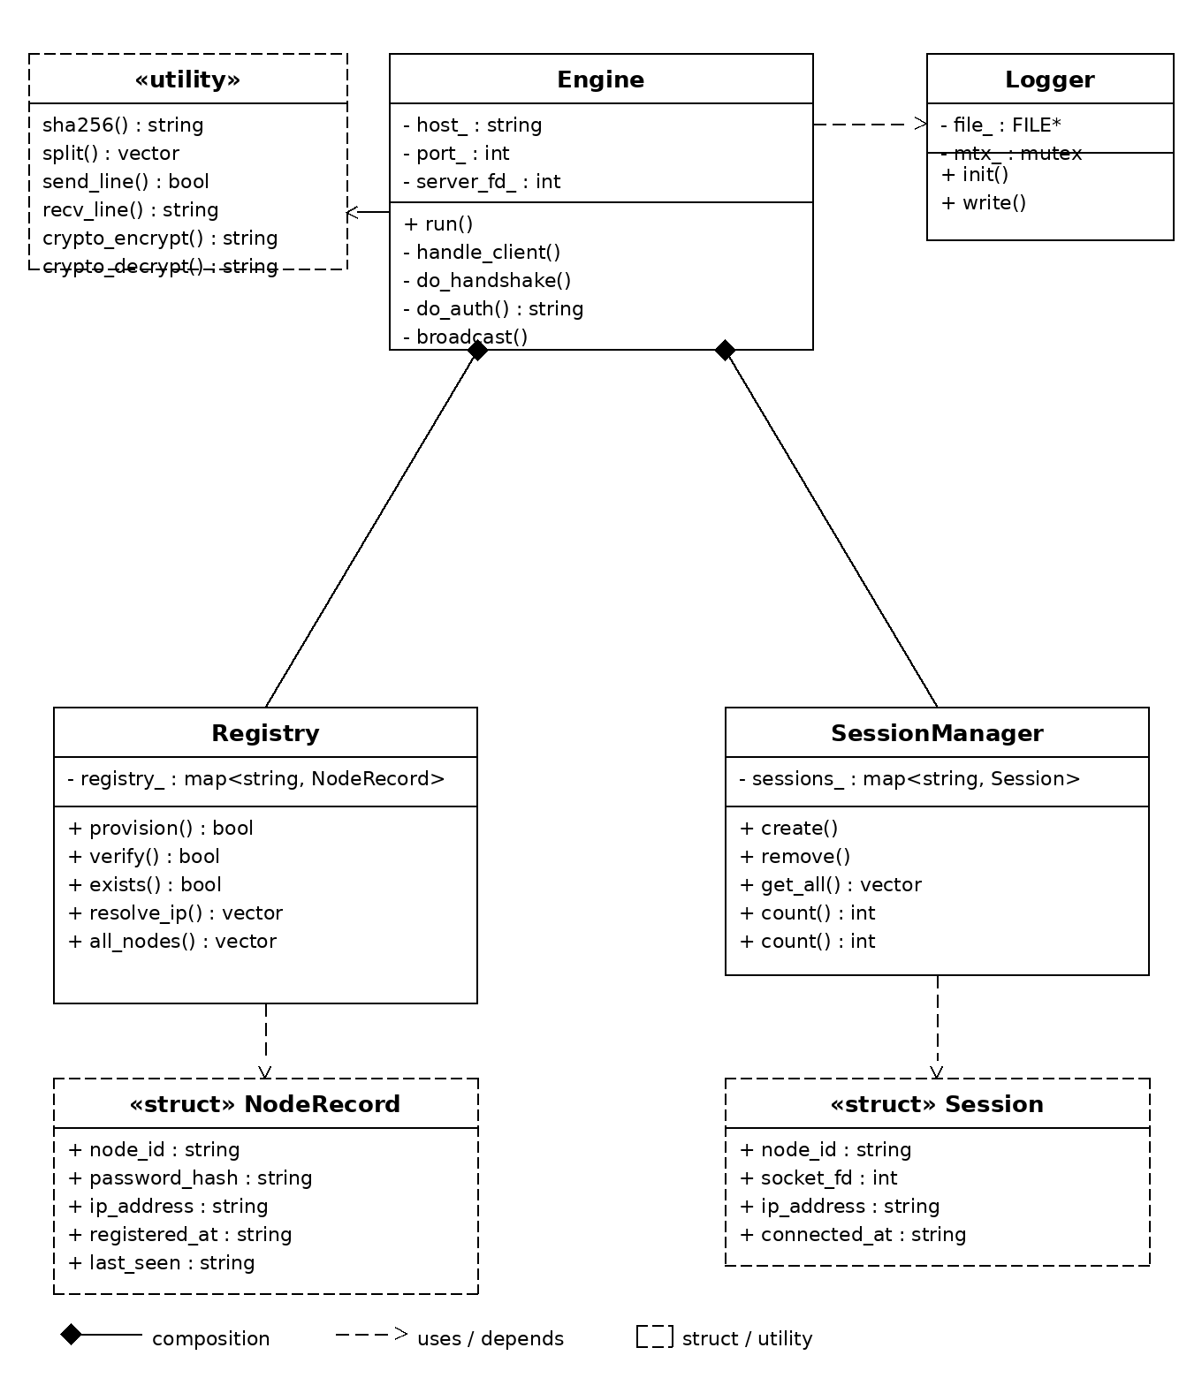
Figure 2: ECSBF Class Diagram

4. External Interface Requirements

4.1 User Interfaces
ECSBF does not have a graphical user interface. Interaction with the system takes place through a command-line interface. The Node SDK provides connect(), disconnect(), sendSignal(), and receiveSignal() functions. An admin command-line tool is provided for node provisioning and log monitoring.

4.2 Hardware Interfaces
Engine side hardware:
- 4-core CPU, 2 GHz or higher
- 8 GB RAM
- Internet connection with 100 Mbps NIC
- Linux terminal
Node side hardware:
- 2-core CPU
- 2 GB RAM
- Internet connection
- Linux or Windows terminal

4.3 Software Interfaces
- Operating System: Linux Ubuntu 22.04 LTS (Engine), Linux or Windows (Node).
- Language / Compiler: g++ (C++17).

4.4 Communications Interfaces
- TCP (Transmission Control Protocol) – used for all persistent connections between nodes and the Engine.
- TLS (Transport Layer Security) – applied on top of TCP to encrypt all data in transit.
- Custom framing protocol – a simple 8-byte header (version, message type, payload length) precedes each encrypted payload.
- Heartbeat: a 15-second keep-alive signal sent by the Engine to each connected node to detect disconnections.

5. Other Non-Functional Requirements

5.1 Performance Requirements
- The Engine must handle at least 1,000 simultaneously connected nodes without performance degradation.
- A broadcast signal must be delivered to all active nodes within 500 milliseconds under normal load.
- Authentication response time must be under 100 milliseconds.
- Session restoration must complete within 5 seconds of network recovery.

5.2 Safety Requirements
- The Engine must maintain a blocklist of IP addresses that fail authentication more than 5 times within 60 seconds.
- All node credentials must be stored as hashed values in the Global Identity Registry. Plain-text credentials must never be stored.
- Payload size must be validated before decryption. Payloads larger than 64 KB are rejected.
- The Engine must perform a graceful shutdown, allowing up to 30 seconds for active broadcasts to complete before terminating.

5.3 Software Quality Attributes
- Reliability: The system must maintain uptime of 99.9% per calendar month.
- Maintainability: All public functions must be documented. Code coverage must be at least 75%.
- Security: All OWASP Top-10 relevant mitigations must be applied. A security review must be completed before release.
- Portability: The Engine must run on Linux and Windows Server without code changes. A Docker image must be provided for easy deployment.

6. Other Requirements
The ECSBF software may be included in other software systems as a backend communication component. The following additional requirements apply:
- The Engine must be packaged as a Docker container for cloud deployment.
- All error code strings must remain stable across versions so that monitoring scripts do not break on upgrade.
- Log messages must be written in English. Timestamps must use UTC format.

Appendix A: Glossary
Term / Acronym | Definition
ECSBF | Enterprise Concurrent Signal Broadcast Framework – the system described in this document
Engine | The centralized server that manages all node connections, authentication, and broadcast routing
Node | An Endpoint Node – a client that connects to the Engine to send and receive signals
Signal | A data packet sent by one node and broadcast by the Engine to all other active nodes
Session | A stateful, authenticated connection between a Node and the Engine
GIR | Global Identity Registry – the database of all registered node profiles
Caesar Cipher | It is encrypting text via alphabet shifting and then encoding it into universally transferable data.
TLS | Transport Layer Security – the protocol used to encrypt all TCP connections
TTL | Time To Live – the validity duration of a session token
TCP | Transmission Control Protocol
IP | Internet Protocol
SRS | Software Requirements Specification
CPU | Central Processing Unit
RAM | Random Access Memory
NIC | Network Interface Card
NTP | Network Time Protocol – used to synchronize clocks across nodes
RFC | Request for Comments – IETF technical standard documents
FATAL | Log level for irrecoverable errors that force a shutdown
INFO | Log level for normal operational events
WARNING | Log level for recoverable problems or unusual conditions
DEBUG | Log level for detailed diagnostic information used by engineers
SDK | Software Development Kit – the library provided for node integration
OWASP | Open Web Application Security Project – security best-practice reference

— End of Document —

