Gamma-Inverse Gamma Models

Saikat Kar

13/08/2021

library(rstan)  
library(ggmcmc)  
library(bayesplot)

# Gamma-Inverse Gamma models:

Here, in our model we take likelihood i.e $X_{1},X_{2},....,X_{p}|θ Gamma(n,θ)$ where pdf of Gamma distribution is

$$p(\underset{∼}{x}|θ)=\frac{1}{(θ^{n})^{p}}\frac{e^{−\frac{\sum_{i=1}^{p}{x_{i}}}{θ}}}{(Γn)^{p}}\prod_{i=1}^{p}{x_{i}^{n−1}}$$

and taking prior distribution of $θ$ ~ InverseGamma($α$, $β$). where pdf of InverseGamma($α$, $β$) is

$$τ(θ)=\frac{β^{α}}{Γα}e^{−\frac{β}{θ}}{\left(\frac{1}{θ}\right)}^{α+1}$$

Now, our target is to draw random sample from the posterior distribution i.e. from distribution of $π(θ|\underset{∼}{x})$

Now, we defining models of likelihood and prior as well as parameters as the following:

data{  
 int<lower=0> N; //Number of Trials  
 real<lower=0> x; //random sample values taken from Gamma distribution  
}  
  
parameters{  
 real<lower=0> theta; //scale parameter of Gamma distribution; theta(>0)   
}  
  
  
model{  
 target+= inv_gamma_lpdf(theta|3,4); //Prior distribution  
 target+= gamma_lpdf(x|10,theta); //Likelihood  
}

Here we taking hyperparamters $α$, $β$ as 3,4 respectively(as W.K.T in InverseGamma($α$, $β$) $α$, $β$ >0).

As $θ$ ~InverseGamma; so theta belong to (0, $∞$). That’s why we define theta in *parameter block* and that belong to $R^{+}$.

Taking n of Gamma(n, $θ$) as 10 and theta is unknown parameter. Now,constructing 4 chains of markov models to draw random samples from required posterior distribution.

model_file=file.choose()  
N=100  
theta=0.5  
x=rgamma(N,shape=1,scale = theta)  
  
stan_data = list(N=N,x=sum(x))  
stan_model=stan(model_file, #Stan Program   
 data=stan_data, #named list of data  
 chains=4, #Number of Markov Chain  
 iter=2000, #Total number of iterations per chain  
 warmup= 1000, #Number of Warmup iterations per chain  
 refresh=0)

Note: Here,instead of running a markov chain of 8,000; we run 4 chains each for 2000 iterations and treat 1,000 as warmup value($T_{0}$)

After finishing the computations,summaries of the inferences and convergences are shown below:

print(stan_model,digits=2)

## Inference for Stan model: Gamma_Inv_Gamma.  
## 4 chains, each with iter=2000; warmup=1000; thin=1;   
## post-warmup draws per chain=1000, total post-warmup draws=4000.  
##   
## mean se_mean sd 2.5% 25% 50% 75% 97.5% n_eff Rhat  
## theta 0.34 0.00 0.06 0.24 0.30 0.34 0.38 0.48 1464 1  
## lp__ -11.78 0.02 0.70 -13.82 -11.94 -11.51 -11.34 -11.28 1527 1  
##   
## Samples were drawn using NUTS(diag_e) at Sat Aug 21 18:57:25 2021.  
## For each parameter, n_eff is a crude measure of effective sample size,  
## and Rhat is the potential scale reduction factor on split chains (at   
## convergence, Rhat=1).

- potential scale reduction factor on split chains

n_eff is a crude measure of effective sample size(# of samples required to reach convergence)

In the above table, mean is the estimated standard posterior mean,se_mean is the estimated standard error of mean of simulations,sd is the standard deviation.

## Diagnostics of checking convergence of chain:

1. **Use multiple starting points**
2. **Trace Plots**
3. **Autocorrelation Plots/Autocorrelogram**

## 1. **Use multiple starting points(Gelman Rubin Test)**:

In this model, we see that $\hat{R}$ i.e. estimated potential scale reduction factor is 1; means that the between chains the average variance isn’t so large; after certain points it converges.

## 2. **Trace Plots:**

traceplot(stan_model,inc_warmup=T)

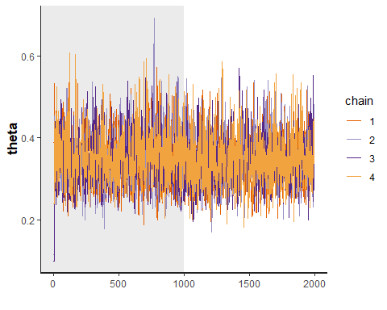

In the dark shaded area i.e. that is of first 1,000 iteration and after 1,000 we see that 4 chains are converging in such a manner that, we can’t distinguish 4 chains one from another.So,for surity in convergence; we have to look at only at the Traceplot of warmup values.

## 3.**Autocorrelation Plot/Autocorrelogram:**

obj =ggs(stan_model)  
ggs_autocorrelation(obj)

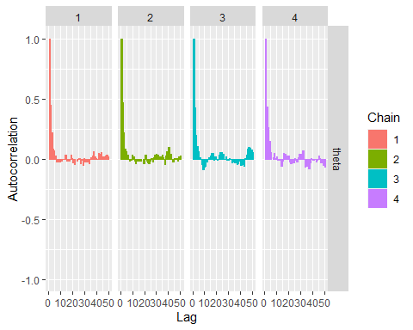

1st plot showing autocorrelation plot for each chain; after how much lag it is going to thin that means there is absence of dependency/non stationarity in the samples as per our required.We always want to draw random samples from required/target distribution; so if from autocorrelation plot we understand autocorrelation is not coming thin(i.e. significant) after certain points; then we have to take more iterations for drawing random samples.In this fig, we can say there is no dependency present after certain point for each chain.

gamma_invgamma_fit_score = as.data.frame(stan_model)  
mcmc_acf(gamma_invgamma_fit_score,pars="theta")

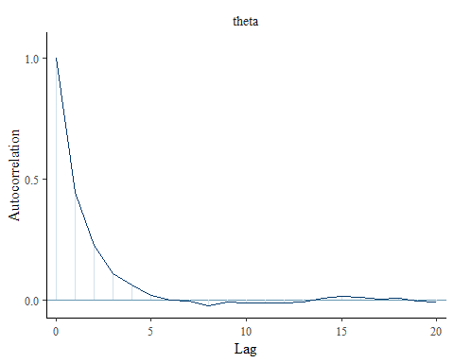

W.K.T. for stationary series the ACF plot dies off very quickly.2nd plot showing after lag 5 there is no more significant values.So,the series of data/samples are stationary

**Credible Interval for theta:**

plot(stan_model,ci_level=0.8,outer_level=0.95)

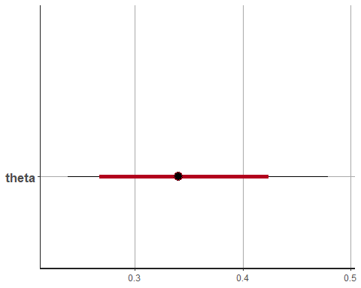

Here red highlighted line is 95% credible interval for $θ$; whereas light black line is the 80% credible interval for $θ$.

**95% confidence Interval:**

print(stan_model,"theta",probs = c(0.05,0.95))

## Inference for Stan model: Gamma_Inv_Gamma.  
## 4 chains, each with iter=2000; warmup=1000; thin=1;   
## post-warmup draws per chain=1000, total post-warmup draws=4000.  
##   
## mean se_mean sd 5% 95% n_eff Rhat  
## theta 0.34 0 0.06 0.25 0.45 1464 1  
##   
## Samples were drawn using NUTS(diag_e) at Sat Aug 21 18:57:25 2021.  
## For each parameter, n_eff is a crude measure of effective sample size,  
## and Rhat is the potential scale reduction factor on split chains (at   
## convergence, Rhat=1).

So, here (0.25,0.45) is the 95% credible interval for $θ$. Also, we can see Posterior mean i.e. $E(θ|\underset{∼}{x})$  = 0.34 which is also Bayes Estimator; if we consider loss function as squared error loss. $L(θ,δ(\underset{∼}{x}))=(δ(\underset{∼}{x})−θ)^{2}$

**Histogram of Posterior distribution:**

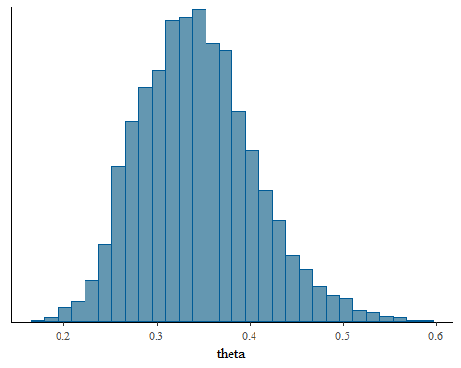

This is the histogram of Posterior distribution; $π(θ|\underset{∼}{x})$. Basically we drawing likelihood from Gamma(n=10, $θ$) and prior from InverseGamma($α$ =3, $β$ =4); so from calculation W.K.T posterior should come from InverseGamma($α$ +np=1003, $β$ + $\sum_{i=1}^{p}{x_{i}}$ =59.38003) as $\sum_{i=1}^{p}{x_{i}}$ =55.38003.

So,Basically the above histogram is of distribution of $π(θ|\underset{∼}{x})$ ~InverseGamma(1003,59.38003)

**Traceplot Of Warmup values:**

ggs_traceplot(obj)

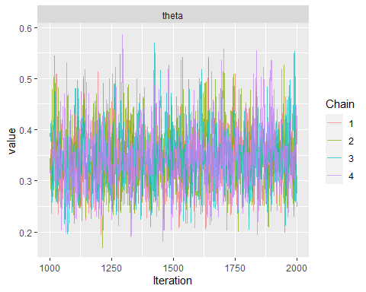

This is the traceplot of iteration of 4 chains after warmup i.e. after $T_{0}$. From this, we get more clear idea about convergence of marcov chains.

**Density plots:**

ggs_density(obj)

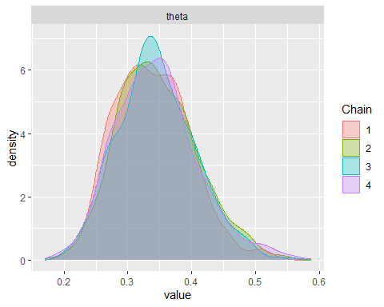

This is the density plot of 4 chains of posterior distribution.These density plots are same;overlapping on each other.

**Complete vs Partial plots for each chain:**

ggs_compare_partial(obj)

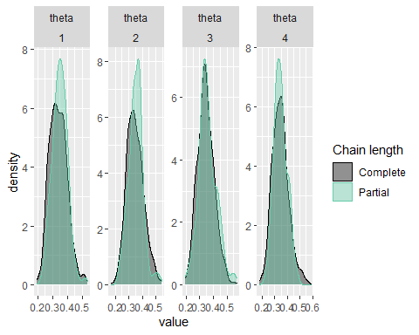

Complete means density plot of total 4000 post warmup samples and partial means 1000 samples for each chain and here is 4 graphs fro each chain.This also shows for each chain; how samples partially drawn for each chain.

ggs_running(obj)

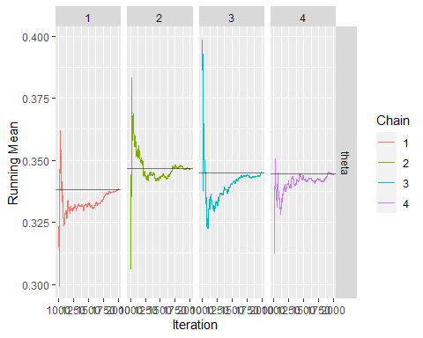

This shows how samples are going for each chain;i.e. whaether it is going to converge quickly or it is taking time for any chain or how much time it’s taking.