Angular

* Installing Angular
  + Go to the installation directory and open cmd there and type the following command
    - npm install -g @angular/cli@10.0.4
  + Create a new workspace
    - Workspace-Angular
  + Change directory to the workspace and create a new project
    - cd Workspace-Angular
    - ng new DemoNissan2023
      * It will ask for angular routing – Yes
      * It will ask for stylesheet format – Select CSS
  + Change directory to the newly created project
    - cd DemoNissan2023
  + To start coding
    - code .
  + To open Angular project, type this is new terminal in VS Code
    - ng serve –open

***SECURE ENDPOINTS***

* Protect Endpoint: RouteGuard
  + Install routeguard
    - 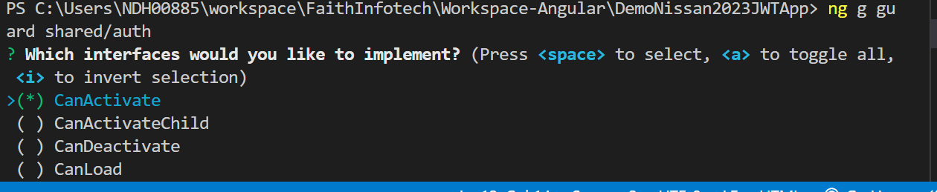ng g guard shared/auth
    - Select CanActivate
  + Check the user is Logged in -> Role based authentication
  + Give access to the pages based on role