* Database – Collection of objects.
* Candidate key: Keys that can potentially be the primary key.
  + Select the PK based on memory usage as well. For eg, and Aadhar no. can be a primary key, and so can be the Nissan Employee ID. But the Nissan Employee ID will consume less memory (6 characters – 12 bits) than Aadhar no (12 characters – 24 bits). So, Nissan Employee ID will be the better choice.
* SQL Server Management Studio (SSMS) – Tool (IDE) to communicate with the SQL server
  + 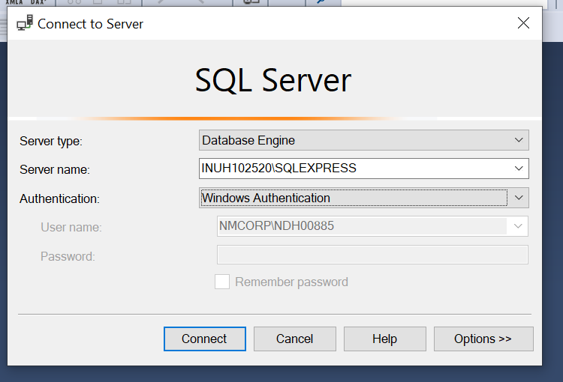SQL authentication
  + 3 objects in DBMS:
    - Table
    - Views
    - Stored procedures
  + 2 types of authentications:
    - Windows authentication
    - SQL authentication
  + Microsoft SQL Server: RDBMS + ORDBMS (Object Relational Database Management System)
  + master database: The most important database of the system. It records all the system level information for a SQL system server. This includes instance wide metadata such as logon accounts, endpoints, linked servers and system configuration settings.

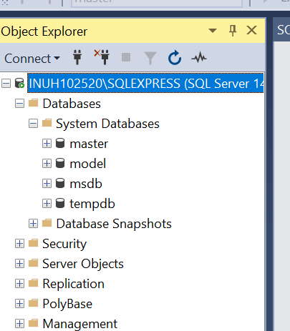

* + model: it is used as the template for all databases created on an instance of SQL server.
  + tempdb: It is created every time SQL server is started. The model database must exist on SQL Server System. The entire content of the model database are copied to a new a new database.
  + When a CREATE DATABASE is issued, the first part of the database is created by copied in the contents of the model database. The rest pf the new database is then filled with empty pages.
    - 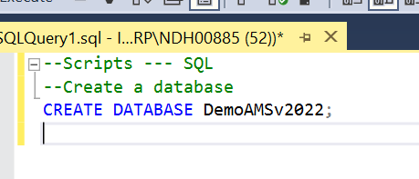CREATE A DATABASE -> CREATE DATABASE <dbname>;

* + - 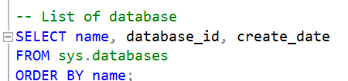SELECT
    - BACKUP
* NOTATION
  + PascalCasing – MainTester (class name), database name
  + camelCasing – firstName (variable name)
  + hungerianNotation (datatype + variable) – int intSalary (variable name)
* SQL – Structured Query Language
  + Parts of SQL:
    1. DDL - Data Definition Language
       - CREATE
       - DROP
       - ALTER
       - TRUNCATE
    2. DML – Data Manipulation Language
    3. TCL – Transaction Controls Language
* DELETE vs TRUNCATE
  + The Delete statement removes rows one at a time and inserts an entry in the transaction log for each removed data row.
  + Truncate table statement deleted the data by allocating the data pages used to store the table data and insert all the pages deallocating in the transaction log.

