**Stages of git**

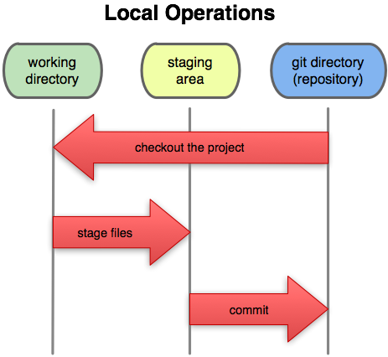

* To check git version
* git –version
* To configure the username and email
* git config --global user.name “<name>”
* git config --global user.email “<email_address>”
* To check configurations
* git config --list
* To initialize the git
* git init
* To see the status
* git status
* To add files to the working stage
* git add <file_name>
* git add -A (To add all the files)
* To commit the changes
  + git commit -m “message”
* To remove the file
* git rm “<file_name>”
* To remove the file from the staging area but not deleting it from local directory
* git rm --cached “<file_name>”
* git restore –staged “<file_name>”
* To undo a modified file which has been added to the workstage
* git checkout “<file_name>”
* To see the modification in a file which hasn’t been staged yet
* git diff
* To see the modification in a file which has been staged but not committed
* git diff –staged
* To see the modification in a file which has been committed
* git diff HEAD
* To show objects
* git show
* To see logs
  + git log

* To see limited logs
  + git log -p -2
* To see modified logs
  + git log –stat
* To remove a file permanently
  + git rm -f “<file_name>”
* To check for branches
  + git branch --list
* To create a branch
  + git branch “<branch_name>”
* To change working branch
  + git checkout “<branch_name>”
* To delete a branch
  + git branch -D “<branch_name>”
* To merge branch
  + git merge “<branch_name>”
* To create and switch the branch
  + git checkout -b “<branch_name>”
* Adding the origin
  + git remote add origin “<repository_link>”
* Adding the master branch to main branch
  + git branch -M main
* Pushing the files
  + git push -u origin main
* Pushing a different branch
  + git push -u origin “<branch_name (other than main)>”
* To clone a repository
  + git clone “<repository_url>”
* To delete a branch locally
  + git branch -d “<branch_name>”
  + git branch -D “<branch_name>” (Deletes forcefully)
* To delete a branch remotely
  + git push origin --delete “<branch_name>”

or

* + git push origin :<branch_name>”
    - after delete, synchronise using
      * git fetch -p (The -p flag means "prune". After fetching, branches which no longer exist on the remote will be deleted.)
* Renaming a file in git
  + git mv oldFileName newFileName
* To point the origin to a particular commit
  + git push -f origin commit_id:branch_name
* To remove commit/commits
  + git reset --hard <commit_id>