**Table of Contents**

1. Abstract 1

2. Introduction 1

3. Components 2

3.1 Arduino Mega 2560 2

3.2 LED Array 2

3.3 Webcam (Logitech C922) 3

3.4 DC Power Adapter 4

3.5 Bread Board 4

3.6 Jumper Wires 5

4. Circuit Diagram 6

5. Methodology 6

Design Considerations 7

Advantages over Gyro-sensors 8

Disadvantages 8

6. Practical Implementation 8

7. Results and Discussion 9

8. Conclusion 10

9. Reference 10

# Abstract

Optical Camera Communication (OCC) is a form of visible light communication where data is sent using LED lights and received by a camera. Instead of radio signals, light intensity is used to carry information. This project demonstrates a simple OCC system using a regular webcam as the receiver and an LED array as the transmitter. The LED blinks very fast in specific patterns that represent digital data, and the camera captures these patterns as a video. A Python program then processes the frames in real time to extract the data. The project also uses Manchester coding to make communication more reliable and avoid flickering. The purpose of this project is to show that even without expensive optical hardware, a working OCC system can be built using common electronic parts and free software tools.

# Introduction

Every year, more and more devices connect to the internet through wireless signals. Most of these devices use radio frequency (RF) communication such as Wi-Fi and Bluetooth. However, RF frequencies are becoming crowded, and there are limits on how much data can be transmitted.

To solve this, engineers have been exploring Visible Light Communication (VLC) — a technology that uses LED light to transmit information. Optical Camera Communication (OCC) is one branch of VLC that uses LEDs as transmitters and cameras as receivers.

The idea is simple: a light source turns ON and OFF very quickly — faster than human eyes can detect. These light pulses can represent binary 1s and 0s. A camera captures the blinking pattern as a video, and computer software decodes it to recover the data.

This project demonstrates a low-cost implementation of OCC using a common Logitech C922 webcam and a custom-made LED transmitter panel. The aim is to help students, hobbyists, and beginners understand how OCC works and how they can build their own version using affordable components.

The application of this type of communication can be found in:

* Indoor secure data transfer (e.g., device-to-device communication).
* Localization and IoT applications (interference-free with RF systems).
* Vehicle-to-everything (V2X) and smart lighting systems using existing infrastructure.

# Components

## 3.1 Arduino Mega 2560

The Arduino Mega 2560, the successor to the Arduino Mega, is a microcontroller board based on a ATmega2560 AVR microcontroller. It has 70 digital input/output pins (of which 14 can be used as PWM outputs and 16 can be used as analog inputs), a 16 MHz resonator, a USB connection, a power jack, an in-circuit system programming (ICSP) header, and a reset button. The Arduino has an extensive support community, which makes it a very easy way to get started working with embedded electronics.[1]

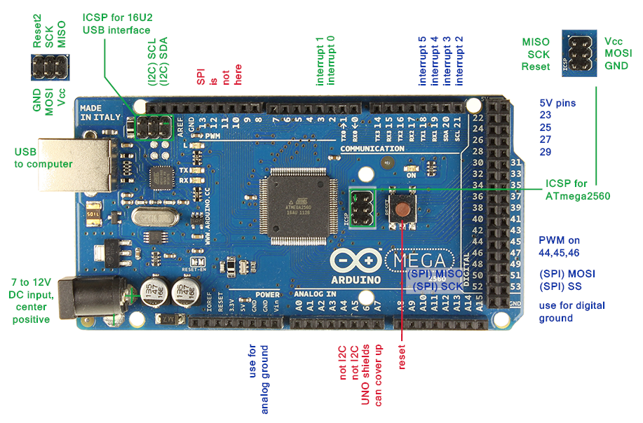

Figure 1: Arduino Mega 2560

## 3.2 LED Array

The LED array acts as the transmitter. In this project, **236 white LEDs** were arranged on a perforated board (barro board) of about 6 cm × 32 cm. Each LED group receives 3 volts, and four LEDs are connected in series. Multiple such groups are connected in parallel to share the 12V power supply. A **TIP122 transistor** is used as a driver so that the Arduino does not need to supply large current directly. When the Arduino sends a digital HIGH signal, the transistor switches ON the LED array.

|  |  |
| --- | --- |
|  |  |
| 1. Transmitter LED Array |
|  |
| 1. Shielding for uniform lighting | 1. Transmitter on power |

Figure 2: LED Array

## 3.3 Webcam (Logitech C922)

The Logitech C922 Pro Full HD Webcam can create 720p at 60 fps and 1080p at 30 fps videos. It also comes with background replacement feature and autofocus technology. It can be connected directly to a computer through an USB interface and can be tuned using Logi Tune software. The camera is discoverable as an external device and can easily be read from using python OpenCV.

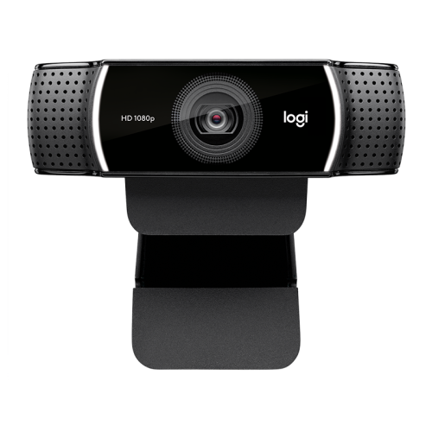

Figure 3: Webcam (Logitech C922)

## 3.4 DC Power Adapter

A spherical container filled with salt water and probed periodically at a fixed space interval is required as the main sensing component. A standard table tennis ball has a diameter of 40 millimeters and thickness of 1 millimeter. Taking the number of probes to be around 10, the periodic interval is found to be 10 degrees which fits nicely within parameters. Therefore, a typical table tennis ball is mounted on the gimbal and pierced with jumper wires.

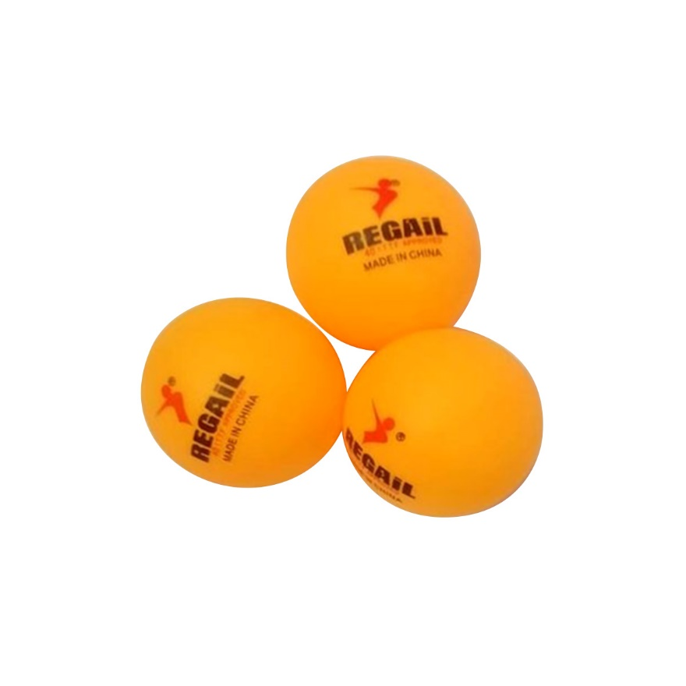

Figure 4: Table Tennis Balls

## 3.5 Bread Board

A modern solderless breadboard socket (invented by Ronald J Portugal for E&L Instruments, Derby CT) consists of a perforated block of plastic with numerous tin-plated phosphor bronze or nickel silver alloy spring clips under the perforations. The clips are often called tie points or contact points. The number of tie points is often given in the specification of the breadboard. The spacing between the clips (lead pitch) is typically 0.1 inches (2.54 mm). Integrated circuits (ICs) in dual in-line packages (DIPs) can be inserted to straddle the centerline of the block. Interconnecting wires and the leads of discrete components (such as capacitors, resistors, and inductors) can be inserted into the remaining free holes to complete the circuit. Where ICs are not used, discrete components and connecting wires may use any of the holes. Typically, the spring clips are rated for 1 ampere at 5 volts and 0.333 amperes at 15 volts (5 watts). The edge of the board has male and female dovetail notches so boards can be clipped together to form a large breadboard.[3]

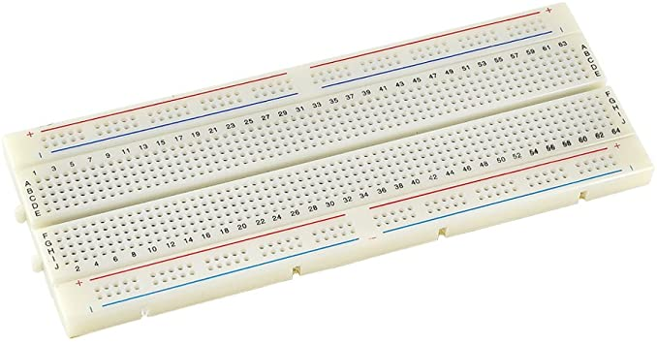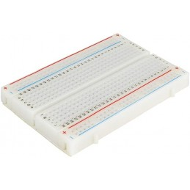

Figure 5: Bread Boards

## 3.6 Jumper Wires

A jumper wire is a conducting wire used to transfer electrical signals between two points in a circuit**.** The wires can either be used to modify circuits or to diagnose problems within a circuit. Jumper wires typically vary in color and size depending on what they are being used for. In breadboards, jump wires are used to establish connections between the central micro controller and other devices such as buttons and sensors. If possible, the jumper wire should always be placed on the component side of a circuit board during assembly. The wires should also be routed in an X-Y manner, avoiding any bends. Jump wires should never be raised more than 1/8 of an inch above the surface of the circuit board.

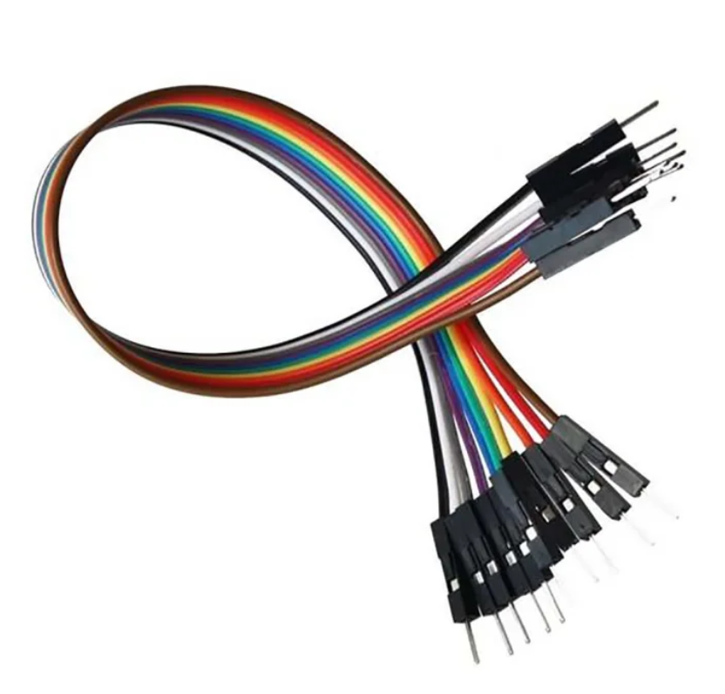

Figure 6: Jumper Wires

# Circuit Diagram

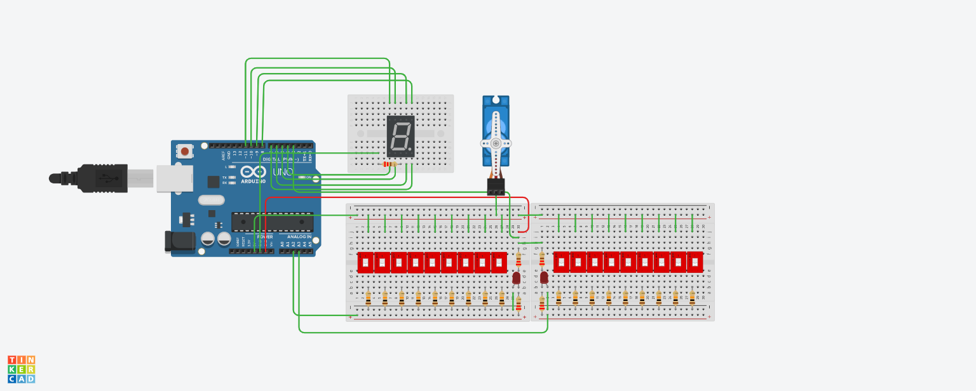

Figure 7: Circuit Diagram for Inclinometer

# Methodology

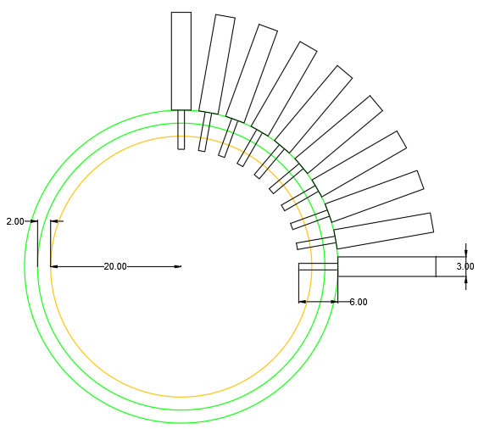

Figure 8: Cross-Section of Inclinometer

The Circuit Diagram given above is a simple ammeter implementation using Arduino. The switches shown in the circuit are replaced by electrodes of jumper wires. The basic principle on which the sensor works is that the surface of a Newtonian liquid always stays parallel to the ground, no matter at what angle it is tilted. Therefore, as the conductive liquid within the spherical container contacts the pins inserted within the container, current flows through the pins and the liquid. The more the setup is tilted, the more pins the liquid touches, and the more current flows through the circuit. The change in current is realized by parallelly connecting the pins along with a fixed 10k Ohm resistance in series each. An Atmel328 IC based control circuit detects the change in current level with the help of a sophisticated algorithm and suitable calibration. The entire setup is placed on a flat gimbal sustained on a servo motor shaft with a bearing mechanism to provide two degrees of freedom. The servo motor is used to make necessary corrections to the platform periodically. The angular value is also displayed in seven segment display.

## Design Considerations

The Conductive liquid must have the following properties:

* Non-Corrosive
* Non-Electrolytic
* Good conductor of electricity
* Moderate viscosity
* Low degree of contact angle
* Consistent voltage level - surface tension characteristics

Highly viscous liquid will prevent abrupt vibration and improve stability but will have slower response time. For demonstration purposes, low concentration brine solution is used.

The containing system should have the following properties:

* The electrodes should be chemically inert and highly conductive. Their penetration depth should be proportionate to their distance from each other and the surface tension of the liquid.
* The container size should be proportional to the precision required and properties of construction components. It should be made of lightweight durable material with smooth hydrophobic surface inside. Wax coating can be applied to further increase repelling force on the liquid.
* The gimbal and the servo motors should be strong enough to hold the moving platform and show robustness towards disturbances.
* In bigger designs, the effect of localized ripples and waves must be considered as it may lead to false readings. As a preventive measure, a vibration resistant semi-submersible rig covering the entire surface area can be used.

## Advantages over Gyro-sensors

1. No start-up calibration is required, once constructed.
2. Can start measurement from any arbitrary angle and display with minimal error.
3. The precision can be increased arbitrarily with a tradeoff of size.
4. Robust against abrupt disturbances which can damage the calibration of gyro-sensors.
5. Simple construction, easier to build.

## Disadvantages

1. High size to accuracy ratio.
2. Does not work in microgravity.
3. Increased error margin in bigger designs.

# Practical Implementation

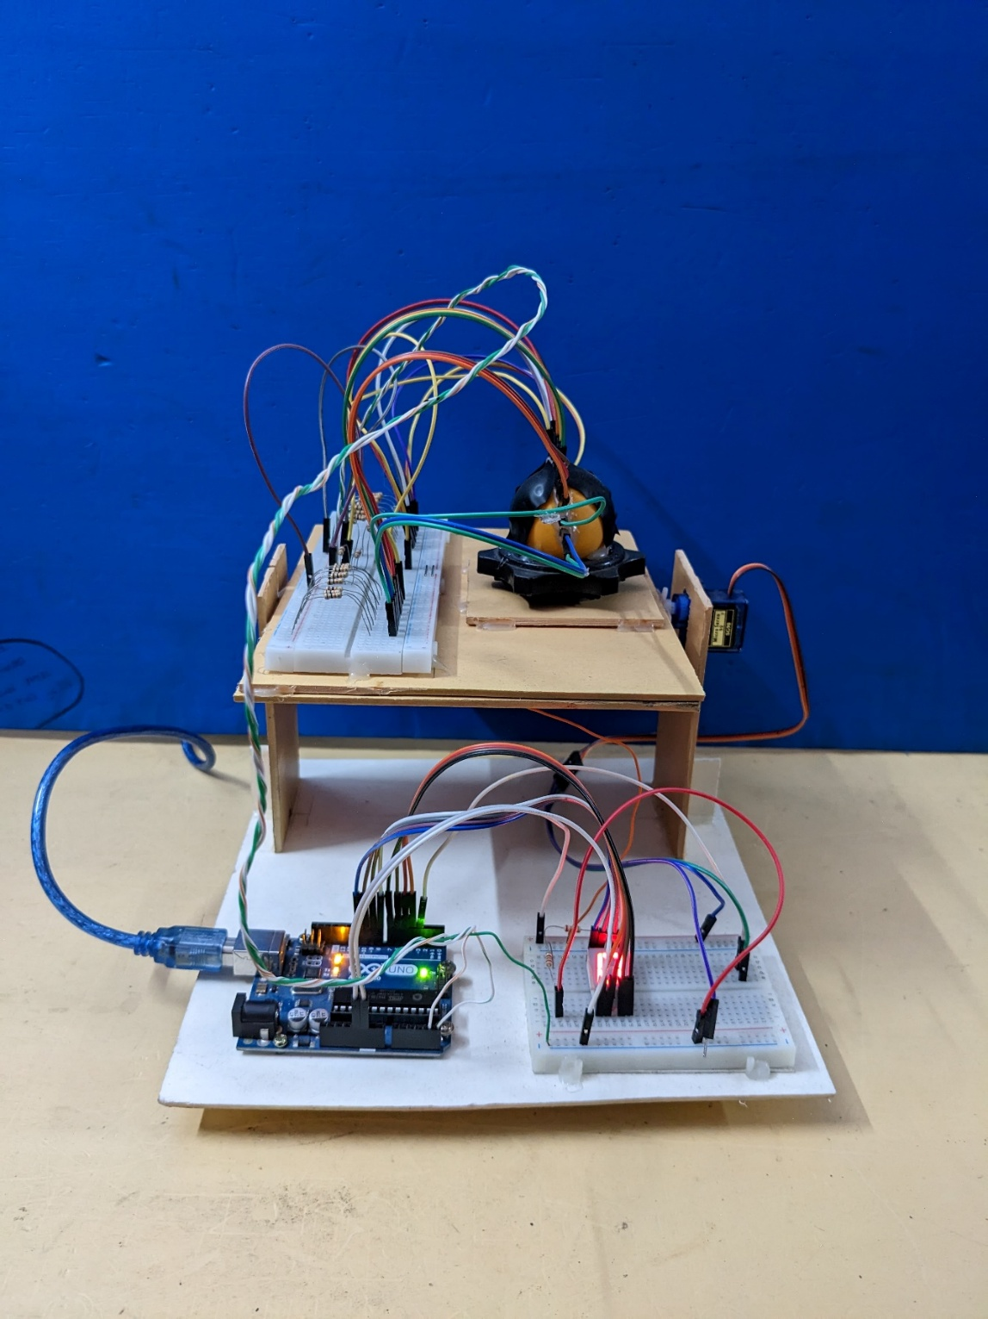

Figure 9: Practical Implementation

|  |  |
| --- | --- |
|  |  |
| 1. Output at surface level (0 degrees) | 1. Output at 10-degrees inclination |

Figure 10: Output at 10-degrees inclination

# Results and Discussion

For practical implementation of the concept, a simple structure was constructed with cardboards and plastics. The table tennis ball and sensory breadboard was put atop a platform that was held by the servo motor above a foothold; all made with cardboard. The sensor was built with drilling the table tennis ball and inserting the jumper wires. Hot glue was used in the junctions as insulation, waterproof seal, and to reduce the insertion depth. The Arduino Board was attached using screws whereas the breadboards were with hot glue. The program above was compiled and uploaded to the Arduino Uno U16 attached to the setup. In the beginning, when the platform held by the servo motor is at plane level, the seven-segment display showed 0. The setup has a precision of 10 degrees, which means, with every 10 degrees of inclination, the output of the seven-segment display will increase by 1, the maximum limit of inclination being 90 degrees each side to prevent tangling of the wires. The setup does not provide information on direction but can be understood intuitively. A more elaborate implementation can include much wider-angle measurement, dual axis inclination information, and direction by involving more electrodes, seven-segment displays, and code extensions.

# Conclusion

This project was a part of the course EE3200 titled Electrical and Electronic Project Design, performed by Saikat Chakraborty, and arranged by The Department of Electrical and Electronic Engineering, Khulna University of Engineering and Technology, Khulna. It was about designing and developing a project that encompasses the knowledge attained from the journey through the previous courses of Electrical and Electronic Engineering discipline. Following the criterion of novelty, a two directional inclinometer was selected for this project.

The initial idea was to make a movable platform with an entangled plane within a computer simulation. But to keep the project more focused on Electrical Engineering, it was shifted towards a self-correcting platform.

A prototype was built as proof of concept where vertically inserted pins in a water bottle indicated water level using LED array. The design was later modified into a spherical shape with more pins and changed value of series resistors.

The project employed some physical concept to demonstrate a different approach towards achievement of solution to an existing problem. Although in some cases it may outperform the typical sensors used, the biggest achievement was application of theoretical knowledge learned from the curriculum of Electrical Engineering.

# Reference

[1] <http://www.pololu.com/product/2191>

[2] <https://protosupplies.com/product/servomotor-micro-sg90>

[3] <https://en.wikipedia.org>

[*] <https://www.tinkercad.com>

[*] <https://www.create.arduino.cc/projecthub>