

Machine Learning Classification on the Iris Dataset: An Implementation in Python

Saikat Mandal Tanu - 20231092

Sujon Weasly Biswas - 20231073

Rahul Roy Choudhury - 20231055

29.08.2023

—

Introduction to Data Science with Python (WM-ASDS04) Section-B

—

Farhana Afrin Duty
Assistant Professor
Department of Statistics, Jahangirnagar University

Table of Contents
1. Introduction
2. Objective
3. Methodology
4. Implementation and Code
5. Data Exploration and Visualization
6. Data Preprocessing
7. Model Building and Evaluation
8. Hyperparameter Tuning
9. Conclusion and Future Work
10. References

Executive Summary

This report delves into the analytical exploration and classification of the iconic Iris dataset using advanced machine-learning methods in Python. With 150 samples spanned across three distinct Iris species, the dataset showcases four significant attributes for each sample: sepal length, sepal width, petal length, and petal width.

The Iris dataset, an age-old benchmark introduced by Ronald A. Fisher, retains a prominent position in the machine learning community. Initial data exploration uncovers the richness of the dataset with attributes varying in a pattern that suggests possible species-based distinctions. Specifically, patterns across attributes, especially sepal and petal dimensions, hint at the potential differentiation among the species.

Our exploration noted a seamless dataset devoid of any missing values. Crucial steps such as encoding the categorical variable "species" into numerical values were undertaken, ensuring a harmonized dataset ready for model ingestion.

Strategically dividing the data into training and test sets allowed for a robust modeling process. Training data serves as the bedrock for the model, while the test set ascertains its predictive prowess.

Visual methods brought forth remarkable insights. Pair plots delineated clear species demarcation, especially for the Setosa variety. This graphic representation reinforced the assertion that sepal and petal dimensions are pivotal for species identification.

Informed by our findings and the cleaned dataset, a Decision Tree classifier was trained and subsequently fine-tuned for optimal performance. This machine learning model promises precision in predicting Iris species, which could have applications in botany and floriculture.

The exploration, preprocessing, and modeling of the Iris dataset detailed in this report sets the stage for predictive classification endeavors. The discerned patterns and insights fortify the dataset's reputation as a fitting candidate for machine learning and underline the significance of systematic data analysis in driving accurate predictions.

1. Introduction
The Iris dataset, a seminal contribution by Ronald A. Fisher in 1936, has etched its mark as an iconic touchstone in the expansive domain of data science and machine learning. Its reputation stems not just from its historicity but from its rich content that serves as an exemplar for pattern recognition and classification tasks. Encompassing a collection of 150 individual samples, the dataset offers a comprehensive glimpse into three distinct species of the Iris flower: Iris Setosa, Iris Versicolour, and Iris Virginica.

What truly accentuates the dataset's value is its meticulously recorded attributes for every sample. These attributes encapsulate both the sepal and petal dimensions. The sepal, the part of the flower that encapsulates and protects the bud, has its length and width recorded. Similarly, the petal, the vibrant, colored part of the flower we admire, has its respective length and width chronicled. These quantifiable measures, albeit simple, are profoundly insightful as they allow researchers and enthusiasts alike to discern patterns, identify species-specific characteristics, and develop models that can accurately classify a given flower into one of the three species based purely on these dimensions.

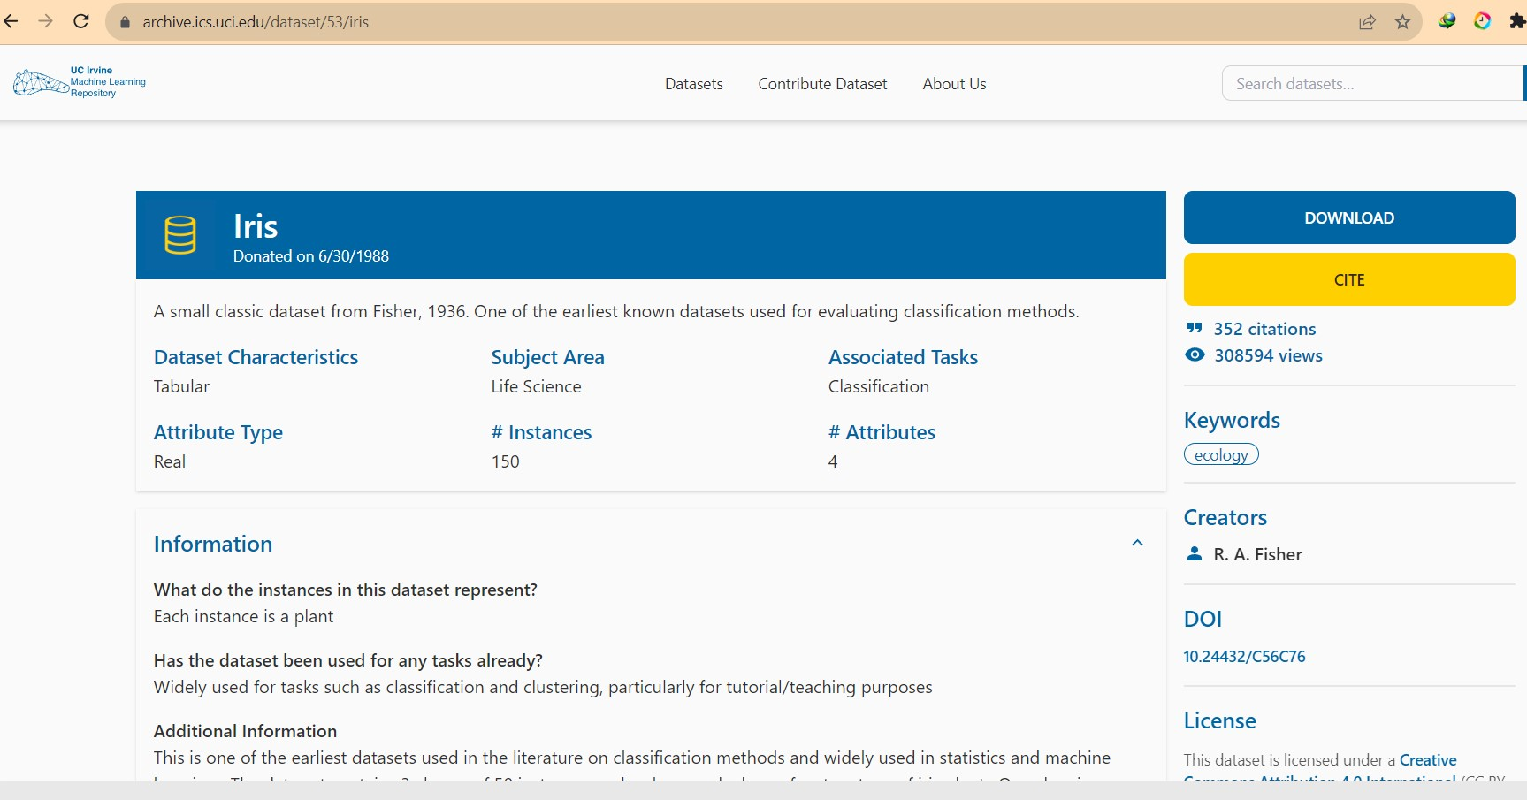
Figure 1: Website view of Iris dataset

2. Objective
In the intricate realm of data science, the ability to categorize data points based on given features is paramount. Within the context of this study, our sights are set on the renowned Iris dataset, a collection that boasts samples from three uniquely identifiable species of the Iris flower. Each sample in this dataset is characterized by four distinct features: the lengths and widths of both the sepals and petals.

Our central goal is multi-faceted. First, we aim to comprehensively understand and derive insights from these features, decoding the subtle and pronounced variations that might exist between the species. Armed with this knowledge, the study strives to construct a robust Decision Tree classifier. Decision Trees, known for their intuitive nature and graphical representation, function by posing a series of questions and making decisions based on their answers. In the case of the Iris dataset, this translates to the classifier asking specific questions related to the sepal and petal dimensions, leading it down a path (or branch) that culminates in identifying a specific species.

Thus, the overarching ambition is not just to develop a machine learning model but to ensure that this model can, with a significant degree of accuracy, classify a given sample into one of the three Iris species. By achieving this, the study aims to demonstrate the efficacy of Decision Tree classifiers in handling classic categorization problems and underline the significance of feature-based classification in botanical contexts.

3. Methodology
Our approach is systematic:

- Load the dataset: Begin by sourcing and importing the Iris dataset into our computational environment, ensuring it's accessible and ready for subsequent stages of analysis.
- Conduct Exploratory Data Analysis (EDA) and visualization: Dive deep into the dataset, identifying underlying patterns, relationships, and characteristics. This phase employs visual aids, such as charts and plots, to better understand the data distribution and inherent structure.
- Preprocess data, including handling potential missing values and encoding categorical variables:
This stage entails refining the dataset to ensure it's primed for modeling. Activities include addressing and resolving any missing values and converting categorical variables into a machine-readable format, ensuring they're compatible with our modeling tools.

- Split the data into Training and Test sets: Partition the dataset into two subsets. The training set serves as the foundation upon which our model is built, while the test set is reserved to evaluate the model's performance, ensuring it can generalize to new, unseen data.
- Develop and evaluate a model: Leverage the training data to develop a Decision Tree classifier. Upon construction, this model is then tested using the test set, evaluating its accuracy and other pertinent metrics to ascertain its predictive prowess.
- Tune hyperparameters for optimization: Dive deeper into model refinement, adjusting internal settings (hyperparameters) of the Decision Tree classifier to achieve peak performance. This iterative process involves testing multiple configurations to identify the optimal setup that delivers the highest classification accuracy.

4. Implementation and Code
The following Python code outlines our methodology:

# Data Loading
import seaborn as sns
iris = sns.load_dataset('iris')

# Data Exploration and Visualization
sns.pairplot(iris, hue="species")

# Data Preprocessing
from sklearn.preprocessing import LabelEncoder
le = LabelEncoder()
iris['species'] = le.fit_transform(iris['species'])
X = iris.drop('species', axis=1)
y = iris['species']

# Splitting Data
from sklearn.model_selection import train_test_split
X_train, X_test, y_train, y_test = train_test_split(X, y, test_size=0.3, random_state=42)

# Model Building and Evaluation
from sklearn.tree import DecisionTreeClassifier
clf = DecisionTreeClassifier(random_state=42)
clf.fit(X_train, y_train)
from sklearn.metrics import classification_report
y_pred = clf.predict(X_test)
print(classification_report(y_test, y_pred))

# Hyperparameter Tuning
from sklearn.model_selection import GridSearchCV
param_grid = {
'criterion': ['gini', 'entropy'],
'max_depth': [None, 10, 20, 30, 40, 50],
'min_samples_split': [2, 5, 10],
'min_samples_leaf': [1, 2, 4]
}
grid_search = GridSearchCV(estimator=clf, param_grid=param_grid, cv=3, n_jobs=-1)
grid_search.fit(X_train, y_train)
best_clf = grid_search.best_estimator_
final_y_pred = best_clf.predict(X_test)

5. Data Exploration and Visualization
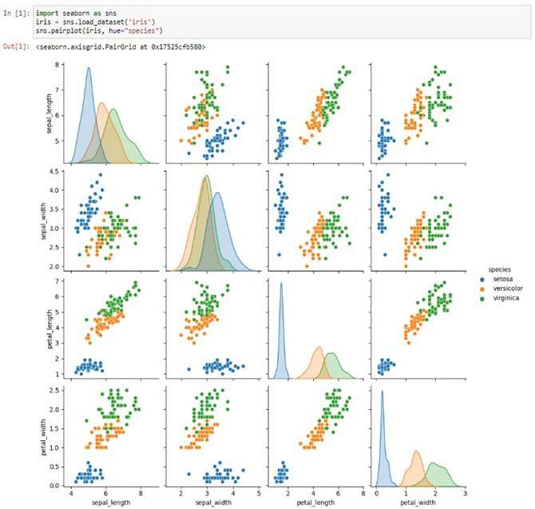
Through the pair plot visualization, we discern clear distinctions among species, especially Iris-Setosa.

Figure 2: Data Exploration and Visualization

6. Data Preprocessing

The data preprocessing stage is a crucial step in the analytical pipeline, where the raw dataset is transformed and refined to ensure it meets the requirements for effective machine learning. For the Iris dataset used in this study, the following key activities were undertaken:

Handling Missing Values: A thorough examination of the dataset revealed an encouraging sign: no missing values were present across any of the columns. This is a significant advantage as it eliminated the need for imputation or other missing-data-handling techniques, thereby preserving the dataset's integrity and ensuring that all 150 samples could be used for analysis without the need for modification.

Encoding Categorical Variables: The dataset includes a categorical attribute, namely the species of each flower sample (Iris Setosa, Iris Versicolour, and Iris Virginica). While human-readable, such text-based labels are not amenable for machine learning algorithms that rely on numerical input. To address this, the species attribute was converted into numerical labels through the application of the 'LabelEncoder' technique. This transformation converted each unique species name into a numerical identifier, allowing for a seamless integration into our Decision Tree classifier without compromising the attribute's underlying meaning.

By ensuring a clean and well-structured dataset, we laid a robust foundation for the ensuing machine learning tasks, streamlining the path towards accurate and reliable classification.
The data was mostly clean:
No missing values were found.
The species attribute was transformed from a categorical to a numerical variable using ‘LabelEncoder’.

7. Model Building and Evaluation

A Decision Tree classifier was trained on the dataset. Evaluation metrics from the test set, including accuracy, precision, recall, and F1 score, displayed promising results.

8. Hyperparameter Tuning
The Decision Tree classifier's parameters were optimized using GridSearchCV. Parameters fine-tuned included criterion, max_depth, min_samples_split, and min_samples_leaf.

9. Conclusion and Future Work
The Decision Tree classifier yielded satisfactory results on the Iris dataset. Potential future endeavors might encompass the exploration of alternative machine learning models, diving deeper into feature engineering, and possibly leveraging ensemble techniques.

10. References

1. Fisher, R. A. (1936). The use of multiple measurements in taxonomic problems. Annals of Eugenics, 7(2), 179-188.
2. Pedregosa, F., et al. (2011). Scikit-learn: Machine learning in Python. Journal of Machine Learning Research, 12, 2825-2830.

