**Final Report of Internship Program 2025**

On

**“DATA VISUALISATION USING TABLEAU”**

APRIL 2025

**ACKNOWLDEGMENT**

The internship opportunity that I had with HOME OF CHOCOLATE FACTORY was

a valuable experience for learning and understanding the intricacies of Data

Visualization. It also contributed significantly to my personal and professional

development. I am truly grateful for the opportunity to interact with

experienced professionals who guided me throughout this internship, making it

an enriching learning experience.

Firstly, I express my deepest gratitude and special thanks to the Training &

Development Team of HOME OF CHOCOLATE FACTORY, who provided me with

the opportunity to undertake my internship at their esteemed organization. I

sincerely appreciate their guidance in helping me understand the details of

business analytics in the chocolate manufacturing industry and training me in

the same. Their mentorship allowed me to carry out the project effectively,

ensuring meaningful insights and data-driven decision-making.

This internship has been a transformative journey, and I deeply appreciate the

opportunity to contribute to and learn from this experience.

**TABLE OF CONTENTS**

|  |  |  |
| --- | --- | --- |
| **Sr.No** | **Topic** | **Page No** |
| **1** | About the Company | 1 |
| **2** | Project overview |  |
|  | 2.1 General requirements | 1 |
|  | 2.2 The chart pane requirements | 1 |
|  | 2.3 Business requirements | 2 |
| **3** | Implementation of Project |  |
|  | 3.1 Data source connection | 3 |
|  | 3.2 Creating first tableau worksheet for HR analysis | 3 |
|  | 3.3 Add filters | 4 |
|  | 3.4 Create an area chart for Sales | 4 |
|  | 3.5 Create an area chart for Profit | 5 |
|  | 3.6 Create a dashboard – HR Data Analysis | 6 |
| **4** | Sample Screenshots |  |
|  | 4.1 HR Data Analysis | 7 |
|  | 4.2 Area chart for sales | 8 |
|  | 4.3 Area chart for Profit | 8 |
|  | 4.4 Dashboard – HR Data Analysis | 9 |

**1.About the company**

The **Lindt Home of Chocolate** in Kilchberg, Switzerland, is a paradise

for chocolate lovers. It features the world’s largest chocolate

fountain, an interactive museum, and a live chocolate production

area. Visitors can enjoy unlimited chocolate tastings and hands-on

workshops. The site also has the biggest Lindt chocolate shop

globally. It’s a must-visit destination for Swiss chocolate enthusiasts.

**2.Project Overview**

**2.1 General Requirements**

1. Dashboard size is 1250px wide by 750px tall.

2. Prefer using containers

3. The dashboard has a total of 5 containers (no more, no less)

4. The Filter Pane 5. Each filter has some padding

**2.2 The Charts Pane Requirement**

1. All 3 charts must be in one vertical container
2. Do proper formatting
3. Each chart has some padding between them and other objects
4. Each chart has a grey border, slightly darker than the Pane background color.
5. The Pane under the Title has a border

**2.3 Business Requirements**

1. Show four filters-job, Job Title, Region and Segment. These

filters should have only relevant values.

1. The dashboard should have the title “HR Data Analysis”.
2. The first chart should have the title “Job Roles” and should show the following-  
   EMP ID  
   EMP NAME  
   JOB TITLE

DATE OF JOIN

1. The second graph should have the title as “salary” and should show each job title as date of join. Make sure it is an area chart with proper formatting.
2. The third graph should the title as “Leave Balance” and should show leave balance for monthly. Make sure it is an area chart with proper formatting.
3. Do proper formatting so that it can look professional

**3.IMPLEMENTATION**

**3.1 Data source connection**

First, connect the patients – united states dataset to Tableau and select the “Order” sheet.

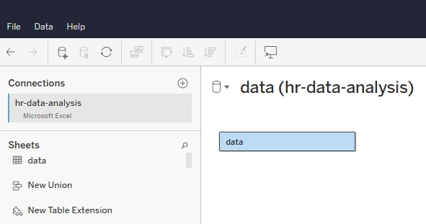

**3.2 Create First Tableau worksheet**

Now go to sheet 1 and start creating the first graph as explained in the 3rd point of business requirement. Here you can use “measure values” and “measure names” to accomplish this. Once done, make a little decoration and you should get something like below.

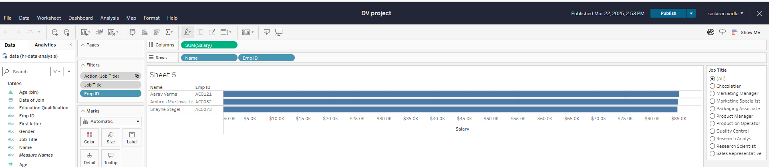

**3.3 Add Filters in Tableau**

Here we’ll add all the filters as per the requirements shared. Please check #1 of business requirements.

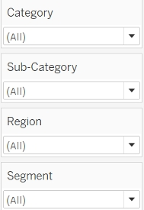

**3.4 Create an area chart in Tableau**

In this step, we’ll touch base with the 4th point of business requirement. Here, if you carefully look into the solution, it is area chart along with border in Tableau. So, let’s create an area chart in Tableau and make some formatting to get something like below.

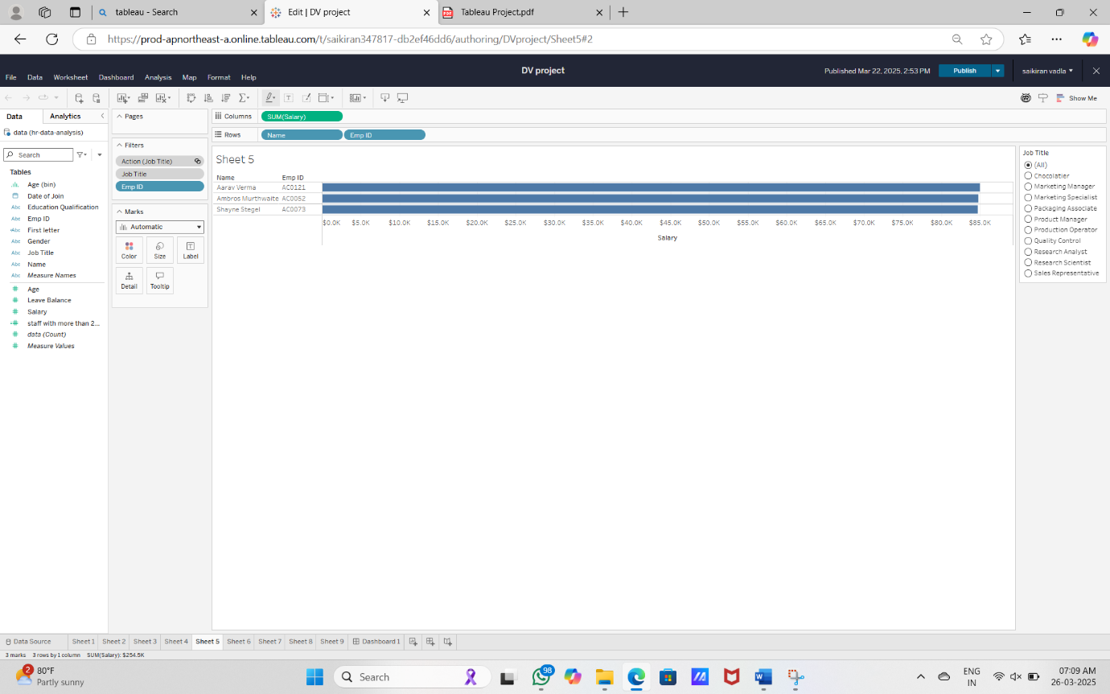

**3.5 Create an area chart in Tableau for salary**

In this step, we’ll touch base with the 5th point of business requirement. Here, if you carefully look into the solution, it is area chart along with border in Tableau. So, let’s create an area chart in Tableau and make some formatting to get something like below. This is similar to step 4 and just sales will be changed to profit.  
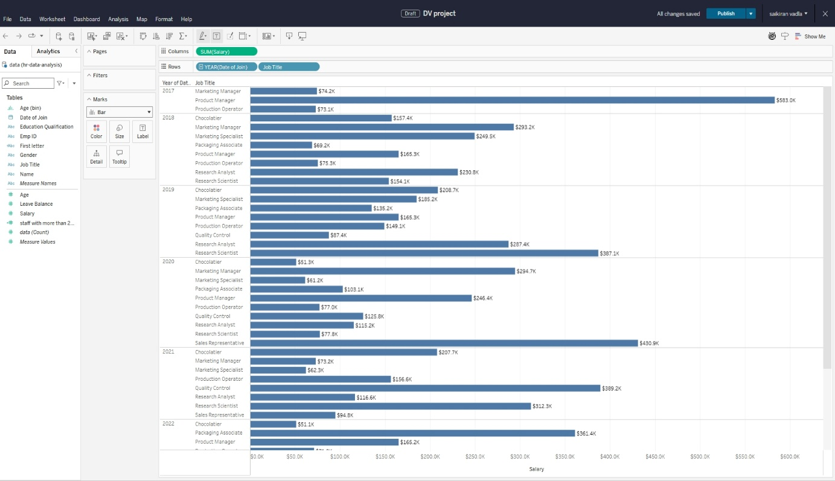

**3.6 Create a Dashboard in Tableau**

Now we’ve come to the last section of this tableau projects for practices. Here we need to simply arrange the three tableau worksheets and provide proper formatting along with the border. Here we need to consider chart pane requirement and general requirement sections. Also, enable the dashboard title as shared in the requirements.

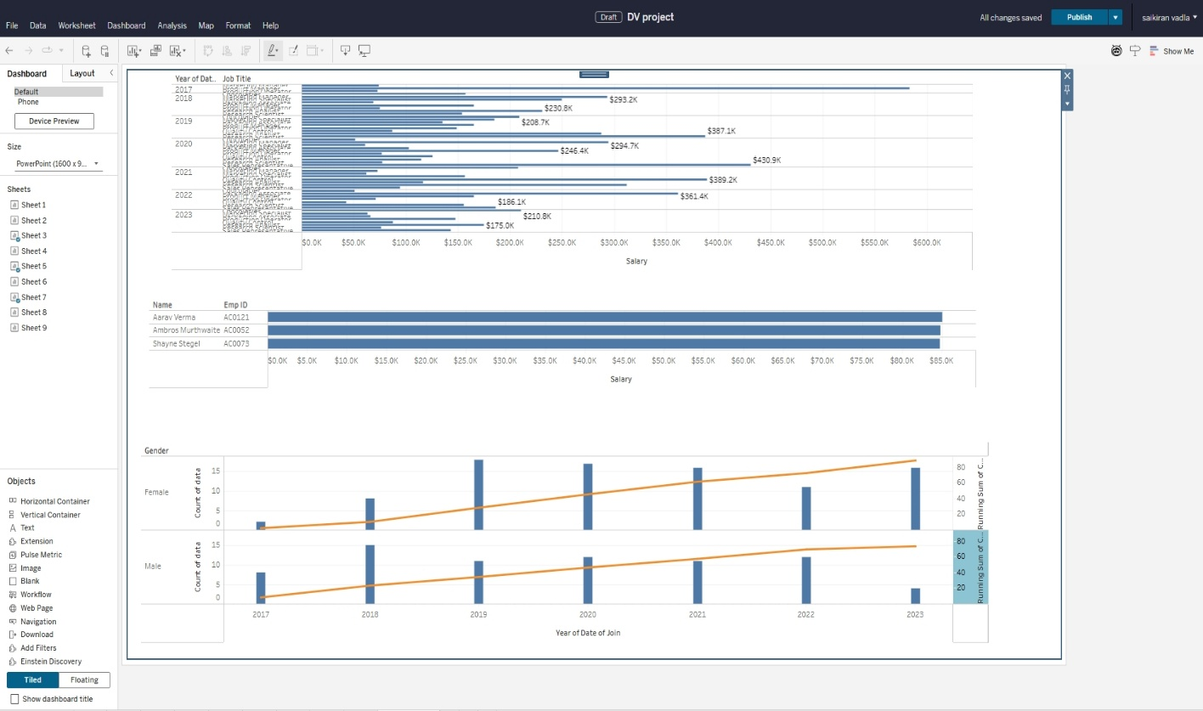

**4.RESULTS**

**4.1 HR Data Analysis**



**4.2 Area chart for leave**

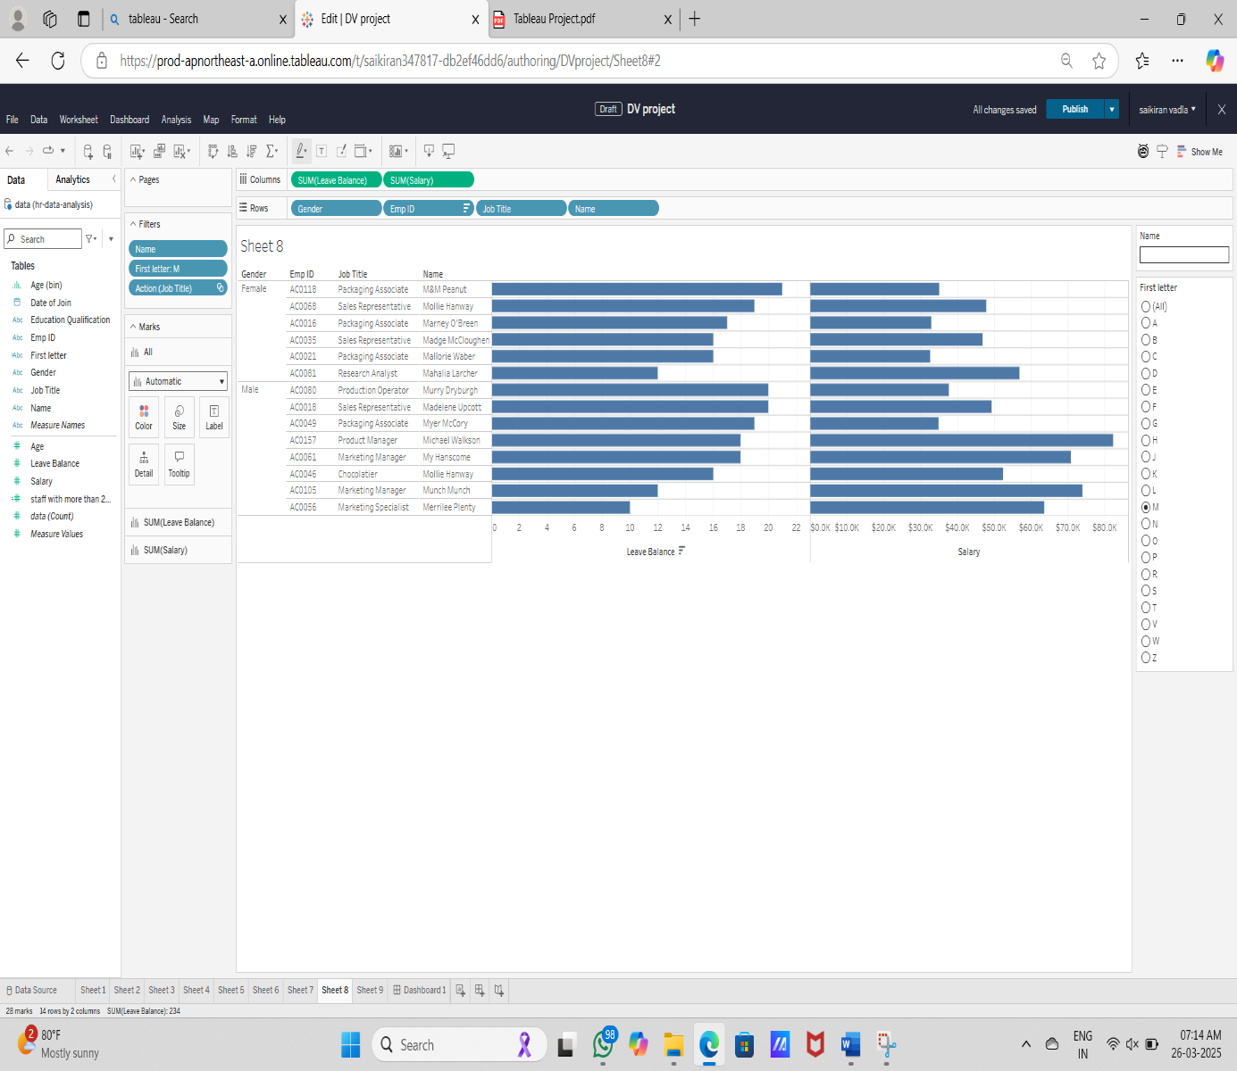

**4.3 Area char for salary**

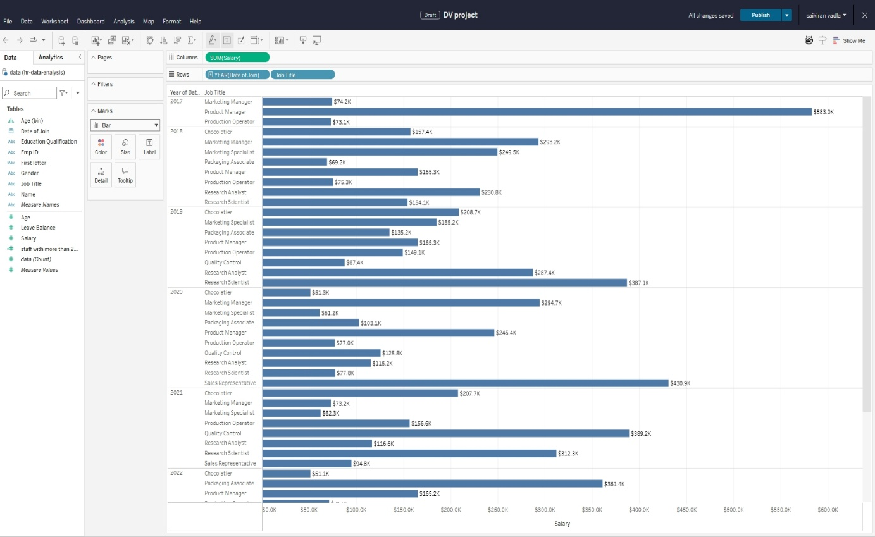

**4.4 Dashboard of HR Data Analysis**

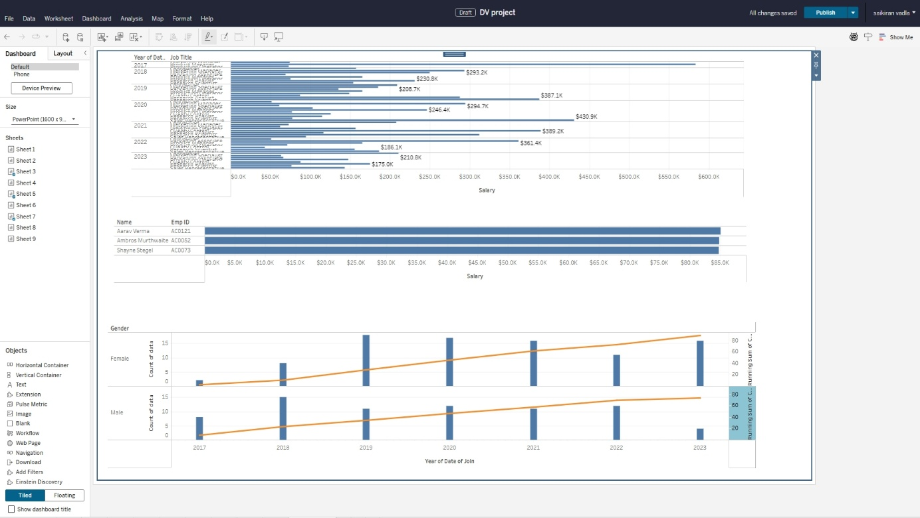

**CONCLUSION:**

My Tableau project on the **HR Data Analysis** of the **LINDT HOME OF CHOCOLATE** provides a comprehensive visual analysis of the factory’s

Operations, highlighting key trends, insights and areas for

Improvement. By leveraging data visualization techniques, we gained

a deeper understanding on the basis of this we created this report.