Support Vector Machine (SVM)
Complete Notes — Intro · Math · Soft Margin · Kernel Trick

1. What is SVM?
- SVM = Supervised Machine Learning algorithm
- Used for: Classification (most common) | Regression (less common)

Main Idea: Find a best boundary (hyperplane) that separates classes with MAXIMUM MARGIN

2. Key Concepts

2.1 Hyperplane (Decision Boundary)
- A line (2D) / plane (3D) / higher-dimensional surface
- Divides data into different classes
Equation: w^T · x + b = 0

2.2 Margin
- Distance between the hyperplane and the nearest data points
- SVM goal → MAXIMIZE this margin
Why? Larger margin = better generalization (model works well on unseen data)

2.3 Support Vectors
- Closest points to the hyperplane
- Most important points — if they move, the boundary changes
- That is WHY it is called Support Vector Machine

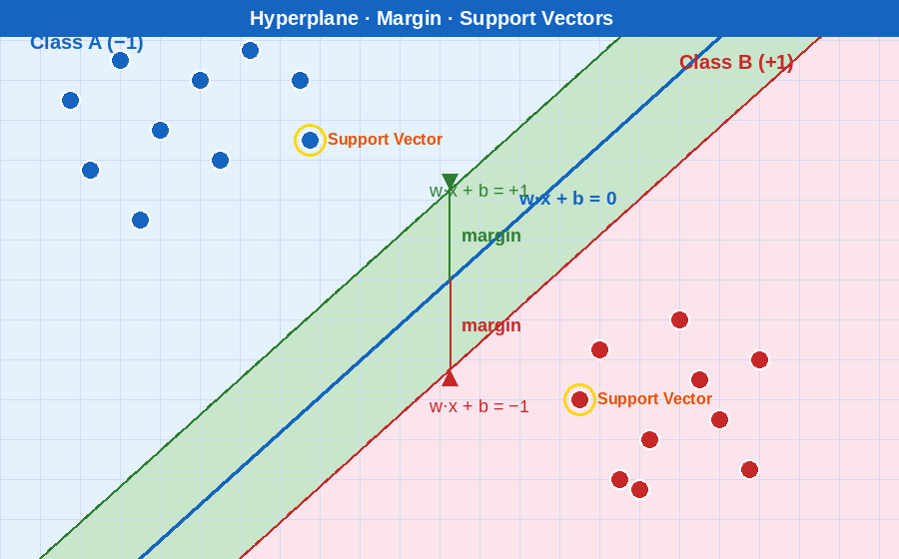
Figure 1: Hyperplane (blue) · Margin band (green) · Support Vectors (gold rings)

3. Types of SVM

3.1 Hard Margin SVM
- Used when data is perfectly separable
- No misclassification allowed — all points must be on correct side
Problem: Not practical — real-world data is noisy and has outliers

3.2 Soft Margin SVM
- Allows some misclassification → more flexible
- Uses regularization parameter C
- C High → less error allowed → small margin → overfitting risk
- C Low → more error allowed → large margin → underfitting risk
Real-world models mostly use Soft Margin SVM

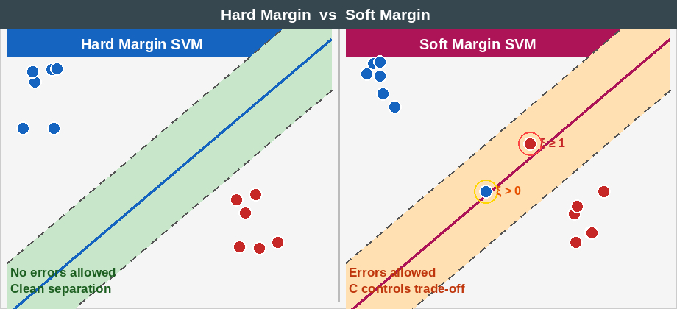
Figure 2: Hard Margin (no errors) vs Soft Margin (ξ = slack violation allowed)

4. Mathematical Intuition

4.1 Three Key Lines
SVM uses 3 lines, not just 1:
Decision boundary : w·x + b = 0
Upper margin line : w·x + b = +1
Lower margin line : w·x + b = −1
- The two outer lines touch the support vectors

4.2 Margin Formula
Margin = 2 / ||w||
- ||w|| small → margin large ✅
- ||w|| big → margin small ❌

4.3 Optimization Objective
Maximize margin ⟺ Minimize:
min ½ · ||w||²
Why ||w||²/2? → Easier to differentiate. Mathematically identical to maximizing 2/||w||.

4.4 Constraint (for every point)
y_i · (w·x_i + b) ≥ 1
- Ensures each point is on the correct side
- Ensures each point lies outside the margin

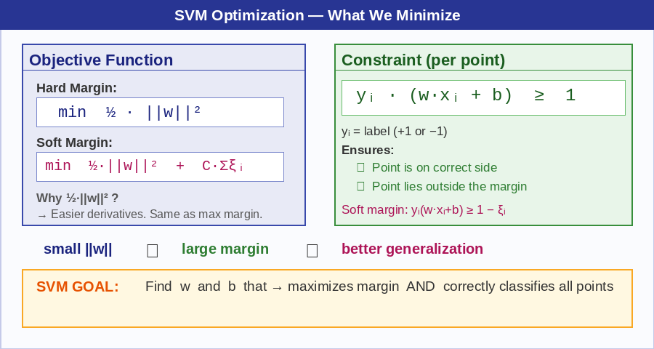
Figure 3: Objective function · Constraint · The core SVM optimization goal

5. Soft Margin — Objective Function & Slack Variable

5.1 Full Objective Function
min ½·||w||² + C · Σ ξᵢ
- ||w||²/2 → margin term (small = large margin)
- ξᵢ (xi) → slack variable = how wrong one point is
- Σ ξᵢ → total mistakes across all points
- C → controls how much to penalize mistakes

5.2 Slack Variable (ξᵢ) — The Penalty Meter
- ξ = 0 → correctly classified AND outside margin ✅
- 0 < ξ < 1 → inside the margin zone ⚠️
- ξ ≥ 1 → misclassified ❌
Think of ξ as a MISTAKE METER — bigger ξ = bigger mistake = higher cost added to objective

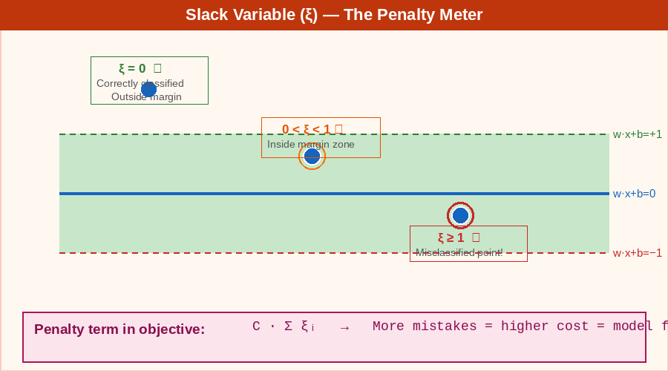
Figure 4: Slack variable (ξ) cases — ξ=0 (correct), 0<ξ<1 (margin zone), ξ≥1 (misclassified)

5.3 Why Penalty is Useful — Core Intuition
Without penalty:
- Model ignores mistakes, just tries to make margin huge
- Result: bad classification ❌
With penalty:
- Every mistake adds to total cost
- Model is forced to reduce mistakes
- Result: balanced, realistic boundary ✅
Total Cost = Margin Cost + Mistake Cost → Model minimizes BOTH

5.4 The Internal Trade-Off
- Many mistakes → ξ ↑ → penalty ↑ → total cost ↑ → model adjusts boundary
- Too strict (no mistakes) → margin shrinks (||w|| ↑) → also costly
- So model balances: increase margin OR reduce mistakes?
Slack variable creates a CONTROLLED TRADE-OFF — not just punishment. It guides learning.
One-line trick: SVM = Maximum Margin + Minimum Penalty

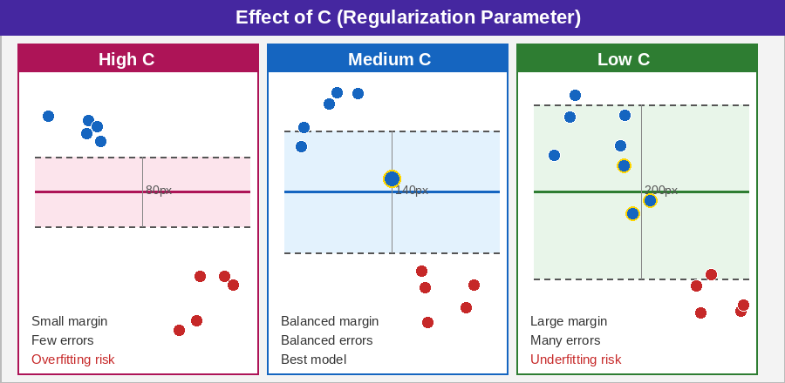
Figure 5: Effect of C — High C = small margin, Low C = large margin with more errors

6. Kernel Trick

6.1 The Problem
- Data is not linearly separable in original (2D) space
- Example: circular data — impossible to draw a straight line

6.2 The Idea
- Map data to a higher dimension where it becomes separable
- 2D → 3D (or higher) → apply linear SVM there
K(x, x') = ϕ(x) · ϕ(x')
- Computes dot product in high-dim WITHOUT explicitly transforming data
Kernel = Smart shortcut: Change space → Make problem easy → Apply linear SVM

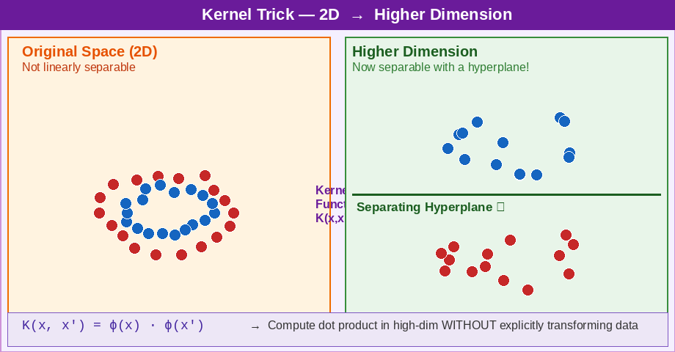
Figure 6: Kernel trick — circular data (not separable in 2D) becomes separable in higher dimension

6.3 Common Kernels
1. Linear Kernel
K(x, x') = xᵀ · x'
- Used when data is already linearly separable · Fastest
2. Polynomial Kernel
K(x, x') = (xᵀ·x' + r)^d
- Captures curved boundaries · Models feature interactions
3. RBF / Gaussian Kernel ⭐ Most Important
K(x, x') = exp(−γ · ||x − x'||²)
- Handles complex non-linear patterns
- Works well in most real-world cases · Default choice
4. Sigmoid Kernel
K(x, x') = tanh(γ·xᵀ·x' + r)
- Similar to neural networks · Less commonly used

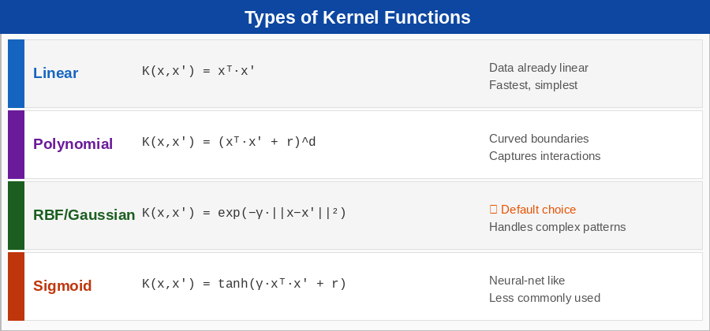
Figure 7: Summary of all 4 kernel types with formulas and use cases

6.4 Gamma (γ) — RBF Hyperparameter
- γ controls the influence range of each data point
- High γ → complex, wiggly boundary → overfitting risk
- Low γ → smooth, broad boundary → underfitting risk

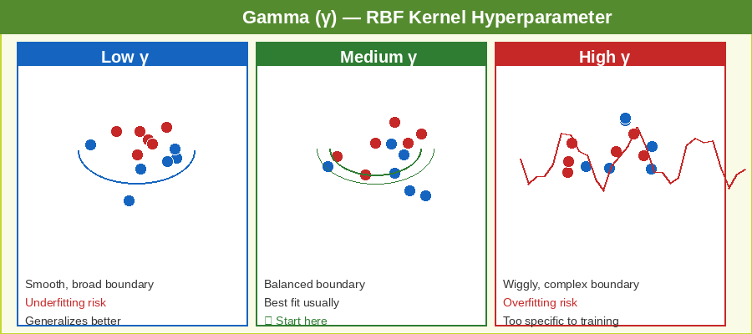
Figure 8: Gamma effect on RBF boundary — Low γ (smooth) · Medium γ (balanced) · High γ (overfit)

7. Quick Reference Table

Concept | Meaning
Hyperplane | Decision boundary separating classes
Margin | Distance from boundary to support vectors
Support Vectors | Closest points — define the margin
Hard Margin | No misclassification allowed (ideal only)
Soft Margin | Allows errors — uses C to control trade-off
Kernel Trick | Map to higher dim to solve non-linear problems
Slack Variable (ξ) | Measures how wrong a point is (penalty meter)
C (Regularization) | Controls margin vs. mistakes balance
γ (Gamma) | Controls RBF influence — high γ = overfitting

8. Analogies to Remember

Margin Intuition
- Draw a line between 2 groups of people
- Many lines possible — SVM picks the one with MAXIMUM distance from closest people
- That distance = margin

Slack Variable / Penalty
- You are minimizing total expenses
- Two costs: bigger margin costs + mistakes cost
- You balance both → minimize total expense
- Without penalty → model ignores errors; with penalty → every error has a price tag

C Parameter — The Strict Teacher
- C large → 'No mistakes allowed' → small margin, overfitting risk
- C small → 'Mistakes okay' → large margin, underfitting risk

Kernel Trick
- Circular data on a table (2D) — cannot separate
- Lift one class of points up → separable in 3D with a flat plane
- Kernel does this mathematically without actually moving points

9. Next Topics to Study
- Hinge Loss — connection to soft margin (same idea, different form)
- Why exactly +1 and −1 in the margin lines (not 2 or 3)?
- Why dot product works in the kernel trick (deep concept)
- SVM in scikit-learn — code implementation
- Interview-ready 30-second explanation of SVM

Golden Rule: After reading — close notes and explain in your own words. If you can't explain, you haven't understood.

