Ensemble Learning & Bagging
Complete Notes — Concepts · Bagging · Bootstrap · Random Forest · Comparison

1. What is Ensemble Learning?
Definition: An ML technique that aggregates two or more learners to produce better predictions than any single model.

- Instead of relying on ONE model, we combine MULTIPLE models
- Each individual model is called a Base Learner (or weak learner)
- The combination is called an Ensemble

Core Idea: Wisdom of the crowd — multiple weak models together form a strong model

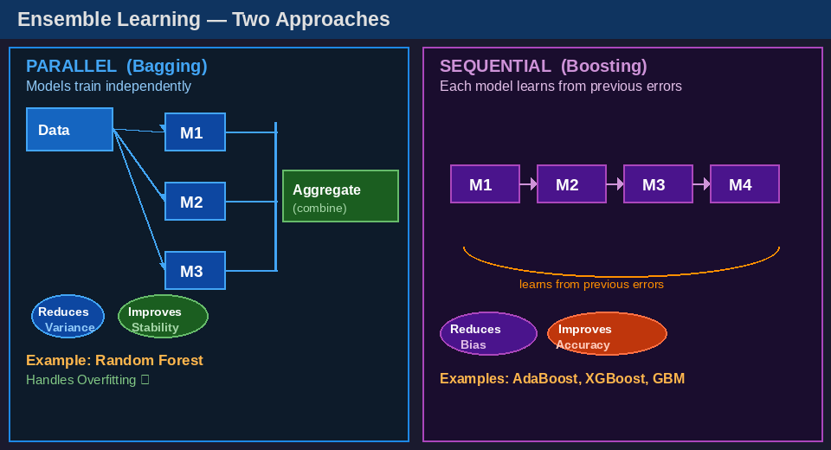
Figure 1: Two approaches — Parallel (Bagging) vs Sequential (Boosting)

2. Two Main Types of Ensemble Methods

2.1 Bagging (Bootstrap Aggregating)
- Models are trained IN PARALLEL — independently, at the same time
- Each model sees a different random sample of the data
- Predictions are combined at the end (aggregated)
- Goal: Reduce Variance → fixes Overfitting
- Stability ↑ — less sensitive to fluctuations in data

Bagging = Parallel + Bootstrap Sampling + Aggregation

2.2 Boosting
- Models are trained SEQUENTIALLY — one after another
- Each new model focuses on errors made by the previous model
- Weighted combination at the end
- Goal: Reduce Bias → fixes Underfitting
- Accuracy ↑ — each iteration corrects previous mistakes

Boosting = Sequential + Error-Focused Training + Weighted Aggregation

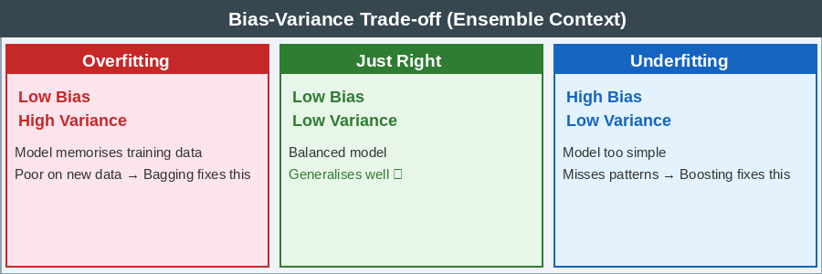
Figure 2: Bias-Variance context — Bagging fixes overfitting, Boosting fixes underfitting

3. Bagging — Deep Dive
Full Name: Bootstrap Aggregating
Definition: Uses modified replicates of training data to train multiple base learners generated with the same training algorithm

3.1 Three Steps of Bagging
Step 1 — Data Sampling (Bootstrap Sampling with Replacement)
- Take the original training dataset
- Create multiple random subsets (bootstrap samples)
- Sampling is done WITH REPLACEMENT — same point can appear multiple times
- Each bootstrap sample is approximately the same size as original
- ~63% of original points appear (unique) in each sample
- ~37% of points are left out → called Out-of-Bag (OOB) samples

With Replacement = a data point picked once can be picked again in the same sample

Step 2 — Model Training
- Train one base learner on each bootstrap sample
- All learners use the SAME algorithm (e.g., all Decision Trees)
- But each sees different data → each model is slightly different
- Models are trained independently (can be parallelized)

Step 3 — Aggregation (Combining Predictions)
- Classification → Majority Voting (whichever class gets most votes wins)
- Regression → Mean / Average of all predictions

Example: 3 learners predict Yes(5), Yes(4), No(3) → Final = YES (majority vote)

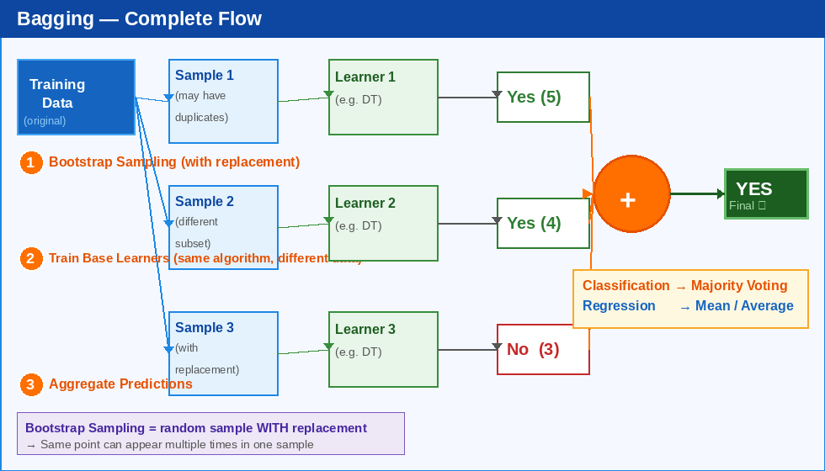
Figure 3: Complete Bagging flow — Bootstrap → Train Learners → Aggregate predictions

4. Bootstrap Sampling — Explained

4.1 What is Bootstrap Sampling?
- A statistical technique of sampling WITH replacement
- From a dataset of N points, we create a new sample of N points
- Each point is independently chosen randomly — duplicates allowed

4.2 Why 'with replacement' matters
- WITHOUT replacement = every sample is a different partition (no overlap in one sample)
- WITH replacement = point can repeat → introduces diversity across samples
- This diversity forces each learner to see slightly different data
- Diversity in training → different models → better ensemble

Key Insight: Diversity among base learners is what makes the ensemble powerful

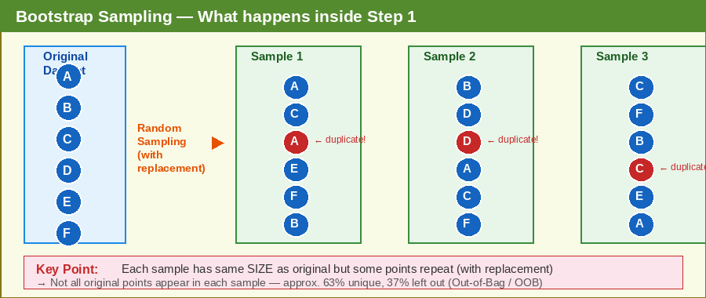
Figure 4: Bootstrap sampling detail — original data, 3 samples, duplicates highlighted in red

5. Random Forest — Bagging's Most Famous Application
Random Forest = Bagging + Extra Randomness (random feature selection at each split)

5.1 How Random Forest extends Bagging
- Base learners: Decision Trees (always)
- Bagging already does: bootstrap row sampling
- Random Forest adds: random feature (column) selection at each tree split
- At each split → only √n or log₂(n) features are considered
- This creates MORE diversity between trees
- Reduces correlation between individual trees

5.2 Why Random Forest is powerful
- More robust to overfitting than a single Decision Tree
- Handles high-dimensional data (many features) very well
- Works for both Classification and Regression
- Gives feature importance scores — very useful for EDA
- Less tuning required compared to Boosting methods

Interview Answer: Random Forest is a Bagging ensemble of Decision Trees with random feature selection at each split

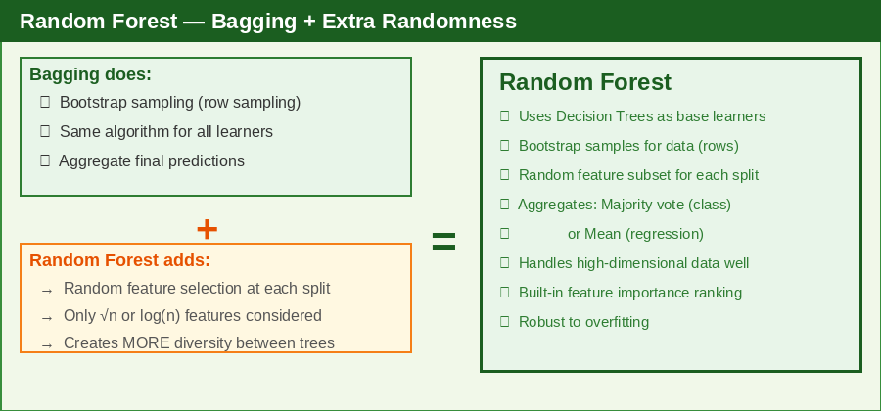
Figure 5: Random Forest = Bagging + Feature Randomness → robust, powerful ensemble

6. Bagging vs Boosting — Quick Comparison

Aspect | Bagging | Boosting
Training | Parallel (all at once) | Sequential (one after another)
Data sampling | Bootstrap (random) | Weighted (focus on errors)
Goal | Reduce Variance | Reduce Bias
Problem fixed | Overfitting | Underfitting
Aggregation | Majority vote / Mean | Weighted vote
Speed | Fast (parallelizable) | Slower (sequential)
Example | Random Forest | AdaBoost, XGBoost, GBM
Noise sensitivity | Less sensitive to outliers | More sensitive to noisy data

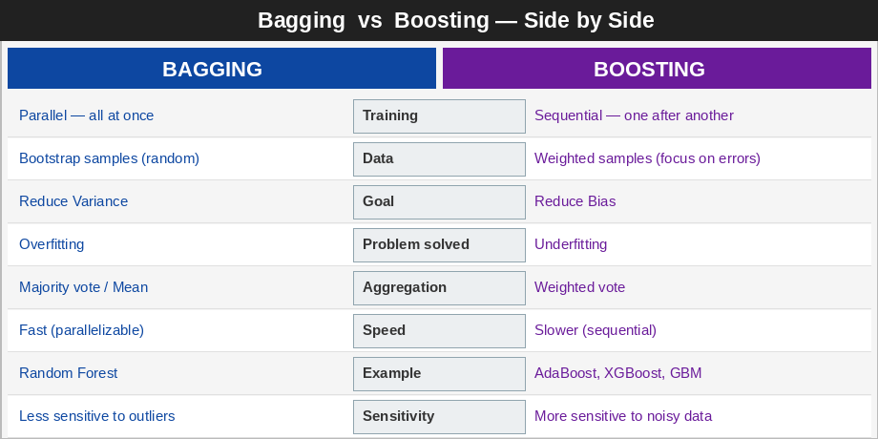
Figure 6: Bagging vs Boosting — full side-by-side comparison

7. Quick Summary for Revision

Ensemble Learning = combining multiple models for better predictions

Bagging = Parallel + Bootstrap Sampling + Aggregation → Reduces Variance → fixes Overfitting

Boosting = Sequential + Error-focused + Weighted vote → Reduces Bias → fixes Underfitting

Random Forest = Bagging + Decision Trees + Random Feature Selection at each split

Key Terms to Remember
- Bootstrap Sampling — random sampling WITH replacement
- Base Learner / Weak Learner — individual model in the ensemble
- Aggregation — combining predictions (vote / mean)
- Out-of-Bag (OOB) — the ~37% of data not in a bootstrap sample (used for validation)
- Variance — how much model changes with different training data
- Bias — how far predictions are from true values

8. Likely Interview Questions

Q1: What is Ensemble Learning?
- Combining multiple ML models to produce better predictions than any single model
- Reduces bias or variance depending on the technique used

Q2: What is the difference between Bagging and Boosting?
- Bagging: parallel training, reduces variance, example = Random Forest
- Boosting: sequential training, reduces bias, example = XGBoost

Q3: What is Bootstrap Sampling?
- Random sampling WITH replacement from original dataset
- Each sample has ~63% unique points, ~37% are OOB

Q4: Why does Bagging reduce variance?
- Each model sees different data → different errors
- Averaging/voting cancels out individual errors → stable prediction

Q5: How is Random Forest different from a Decision Tree?
- Random Forest = many Decision Trees (Bagging ensemble)
- Uses bootstrap sampling + random feature selection
- Much more robust, less overfitting than single tree

9. Next Topics to Study
- Boosting in detail — AdaBoost, Gradient Boosting, XGBoost
- Random Forest hyperparameters (n_estimators, max_features, max_depth)
- Out-of-Bag (OOB) error — using leftover samples for validation
- Feature Importance in Random Forest
- Stacking (third ensemble technique)

Golden Rule: After reading — close notes and explain in your own words. If you can't explain, you haven't understood.

