**Instructions and output to run confserver and confUser programs:**

1. Run the confserver program in eclipse

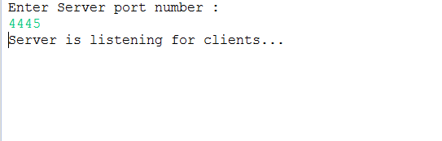

2. Run confUser program in eclipse twice or thrice depending on the number of clients u need

client 1 :

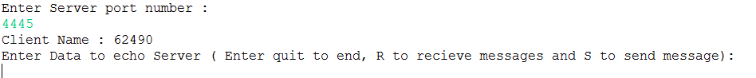

client 2 :



Consoles of different clients and server can be seen using the dropdown of console icon in eclipse

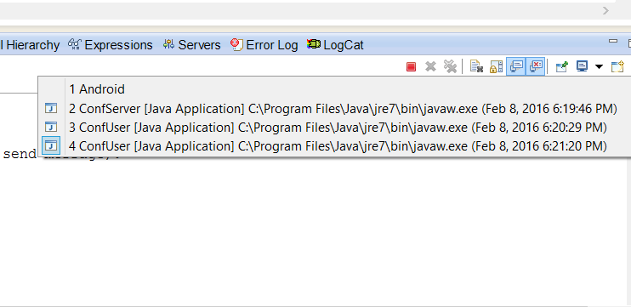

3. Client 1 sends message to client 2 (console of client 1)

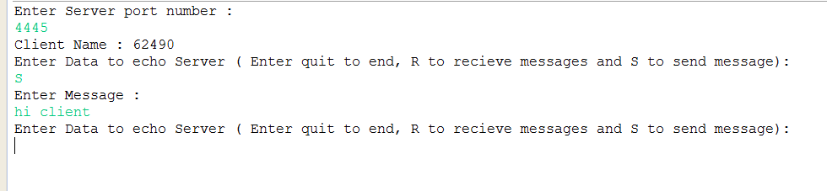

4. Client 2 receives message from client 1

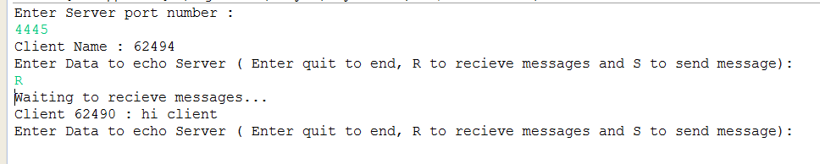

5. Client 2 disconnects from server using quit

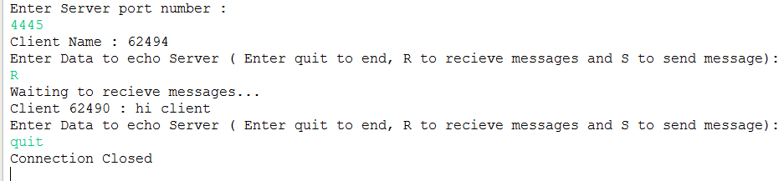

6. Server console

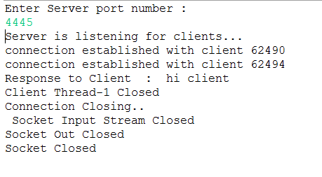

7. Using whisper command (showing with 3 clients)

**client 62490 sending to client 62506 :**

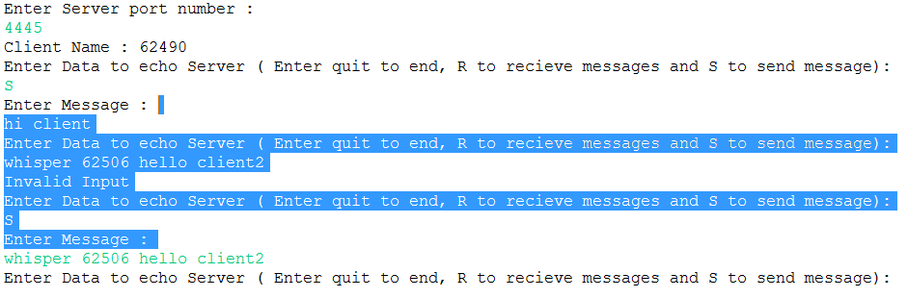

**Client 62506 receiving message from client 62490**

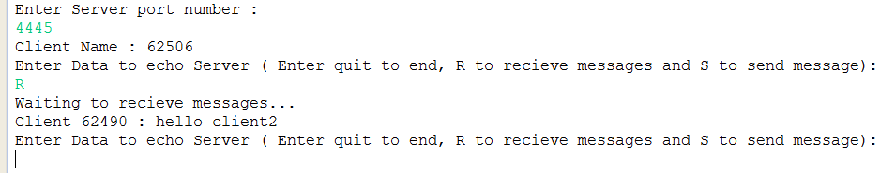

**Client 62507 does not receive any message from client 62490**

