Instructions :

1. Compile the code and run the WebProxyServer class

2. Enter port number for web proxy server socket creation



3. Go to Chrome -- settings -- show advanced settings -- change proxy settings -- lan settings and make following changes :

a. Find IP address using the **ipconfig command** in the command prompt and enter the IPV4 address

b. Port number is the one which u have entered as the input for proxy server creation

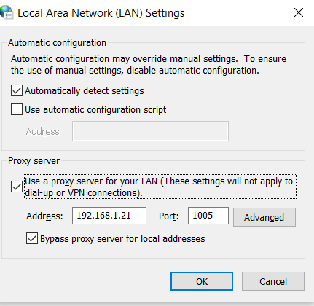

Then Run any http sites in the browser and see the pages . The requests and responses are handled by web proxy server.

Example site : stackoverflow.com

**Before hitting the site :**

**Clear cache**

**quit skype**

**Disable firewall**