**Assignment**

**CSA0814 – Python Programming**

|  |  |
| --- | --- |
| **Register Number** | **192324205** |
| **Name** | **K.Kiran** |

**Title:**

**Markdown to HTML Converter**

**Problem Statement:**

**Design a Python program that converts Markdown documents to HTML format using the markdown module, preserving formatting, headers, lists, and other elements.**

**Code:**

**import markdown**

**import argparse**

**import os**

**def convert_markdown_to_html(input_file: str, output_file: str):**

**# Check if the input file exists**

**if not os.path.isfile(input_file):**

**print(f"Error: The file '{input_file}' does not exist.")**

**return**

**# Read the Markdown file**

**with open(input_file, 'r', encoding='utf-8') as file:**

**markdown_text = file.read()**

**# Convert Markdown to HTML**

**html_text = markdown.markdown(markdown_text)**

**# Write the HTML to the output file**

**with open(output_file, 'w', encoding='utf-8') as file:**

**file.write(html_text)**

**print(f"Converted '{input_file}' to '{output_file}'")**

**if __name__ == '__main__':**

**parser = argparse.ArgumentParser(description='Convert Markdown files to HTML.')**

**parser.add_argument('input', help='Path to the Markdown file to be converted.')**

**parser.add_argument('output', help='Path where the HTML file will be saved.')**

**args = parser.parse_args()**

**convert_markdown_to_html(args.input, args.output)**

**Output Screen Shots:**

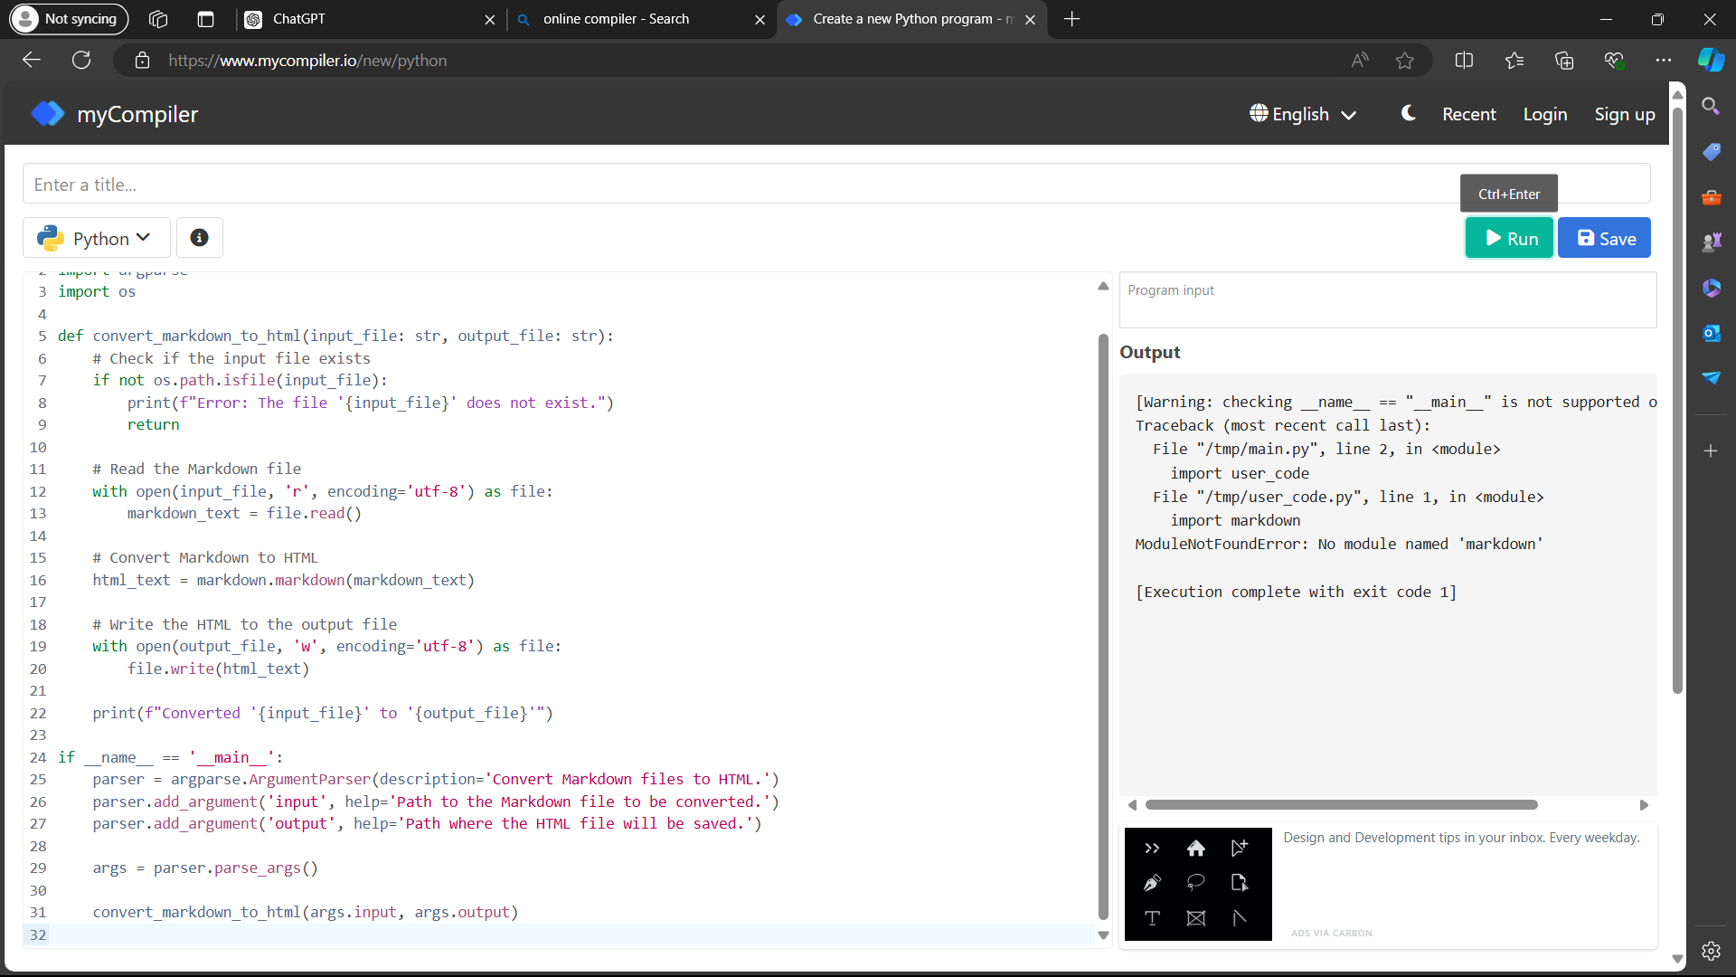

**Conclusion:**

**The Python program outlined above effectively converts Markdown documents into HTML using the `markdown` module. By reading the content from a Markdown file, converting it using the `markdown.markdown()` function, and saving the resulting HTML, the program preserves the structure and formatting of headers, lists, and other elements. This approach provides a simple and efficient way to transform Markdown content into web-compatible HTML, making it useful for various applications like static site generation, documentation, or content management systems.**