**TITLE OF YOUR PROJECT: DEVELOPMENT AND DESIGNING OF A DATABASE SYSTEM FOR A COMPANY**

**YOUR NAME: SAI KIRAN ETIKAPALLY**

**YOUR GITHUB URL:** [**https://github.com/Saikiran91777/Databaseprojectpart1**](https://github.com/Saikiran91777/Databaseprojectpart1)

**CURRENT DATE: 12.07.2022**

**Part 1: Design**

**#1.About the Business**

My business is a retail business, which sells items or goods to consumers. Retailers offer a wide range of products, including hardware supplies, apparel, jewelry, home furnishings, home appliances, electronics, groceries, and health products.

**#2. Comparison of the Business**

A similar business is Walmart.

The annual revenue of Walmart for 2021 is **559.151 billion dollars**, which is around a **6.72%increase** from the past years.

I found this information at:

<https://www.macrotrends.net/stocks/charts/WMT/walmart/revenue#:~:text=Walmart%20annual%20revenue%20for%202021,a%201.86%25%20increase%20from%202019.>

Walmart maintains over 10,600 retail locations in 24 countries across 46 brands, as well as e-Commerce websites. They employ roughly 3 million colleagues worldwide, with 1.7 million in the United States exclusively.

I found this information at:

<https://corporate.walmart.com/askwalmart/how-many-people-work-at-walmart#:~:text=We%20employ%20approximately%202.3%20million,million%20in%20the%20U.S.%20alone.&text=Ready%20to%20begin%20your%20career%20with%20Walmart%3F>

**#3.Network Architecture**

This model architecture is best suitable and divided into 2 tiersincluding 1-Tier and 2-Tier.

In 1-Tier architecture, the Client-server and the database all are allocated in a single device, whereas in 2-Tier architecture, the Client has the interface where they will be able to send some commands and the commands are executed in a designed database.

Aiming towards thisbusiness model, the 2-Tier architecture is very effective since the website interface will be shown on the client's side, where they will be able to put some orders, and the orders will be passed through the database of all items where the clients can select their desired items. A 2-Tier business architecture eliminates feebleness, heavy traffic, and resource conservation while increasing efficiency and operational ease. The two-tier concept addresses network equipment modernization.

The database is distributed for this business model.

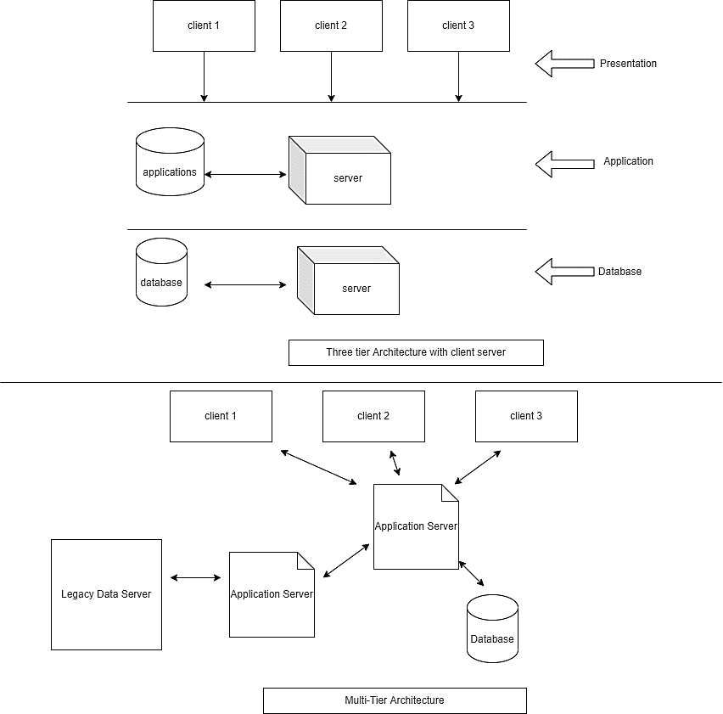

**Figure. Business Network Design (Created by the Author)**

**#4.Five Important Types of Data**

The important types of data that are related to our business include:

**Marketing Information**: This information primarily offers results about revenue generation.

**Catalogue Data**: Understanding inventory data is the key to enhancing productivity. The inventory will be used to assess operational expenses and calculate data such as supply and inventory levels.

**Operational Data**: The daily, quarterly, and yearly figures need to be analyzed on a regular basis. Bringing past data under consideration when considering choices to lower administrative expenditures may be quite beneficial.

**Customer Data:** While using the material, targeted promotions for loyal consumers need to be created. Knowing the clients will help to decide how to start providing them with the best possible experience at your store. And, in general, greater sales follow a good sensation.

**POS Software:** This information may be included in your retail analytics system to identify your most loyal customers, determine which things are the most popular, and determine which commodities you may want to consider discontinuing. It also indicates the peak weeks of the year the times of day when you can anticipate making big money.

**#5. Transfer to new System**

I need a Big data tool for cloud database management.

Examples of that tools are Neo4j and HPCC.

The common file formats are zip format(.zip), iso format(.iso) and csv format(.csv) which are used to transfer data between systems.