Screenshots:
Week5 & 6
Postman Testing: Use bearer token
Post Goal Data: URL: http://localhost:4000/api/goals

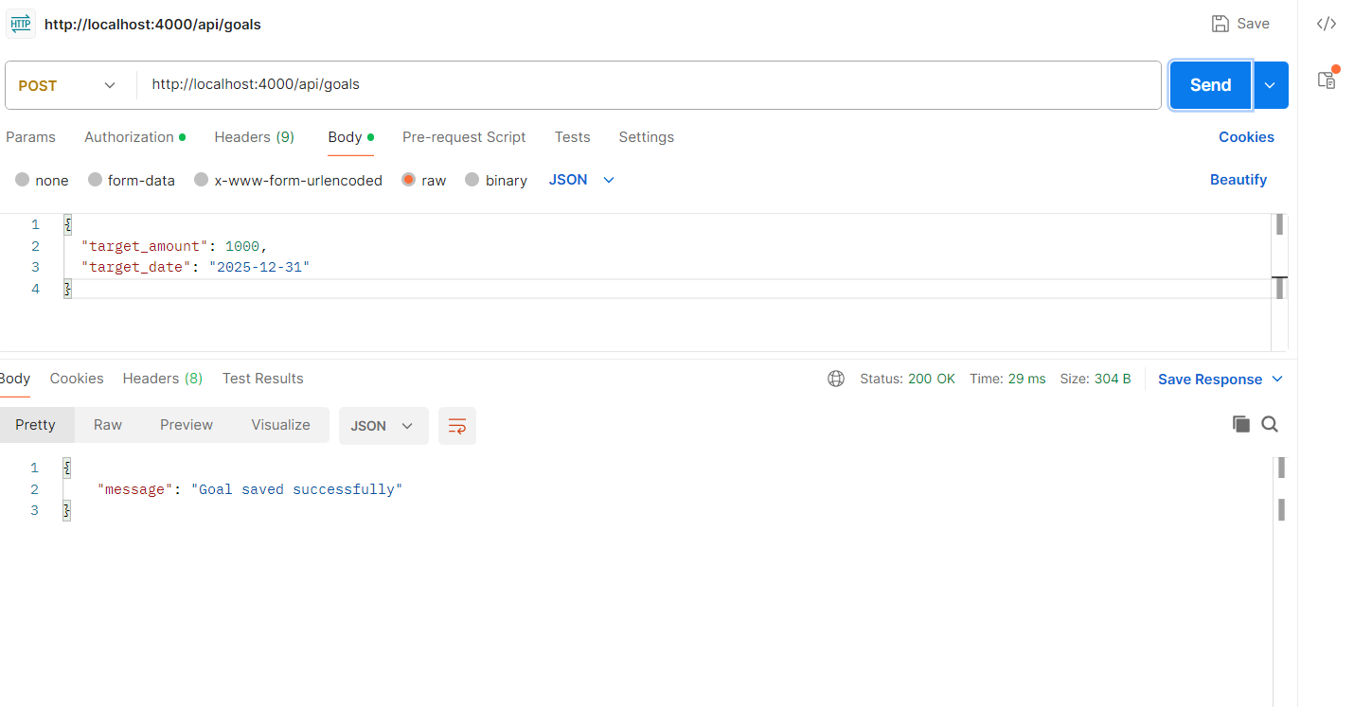
Get Goal planner: http://localhost:4000/api/goals
Pass bearer token
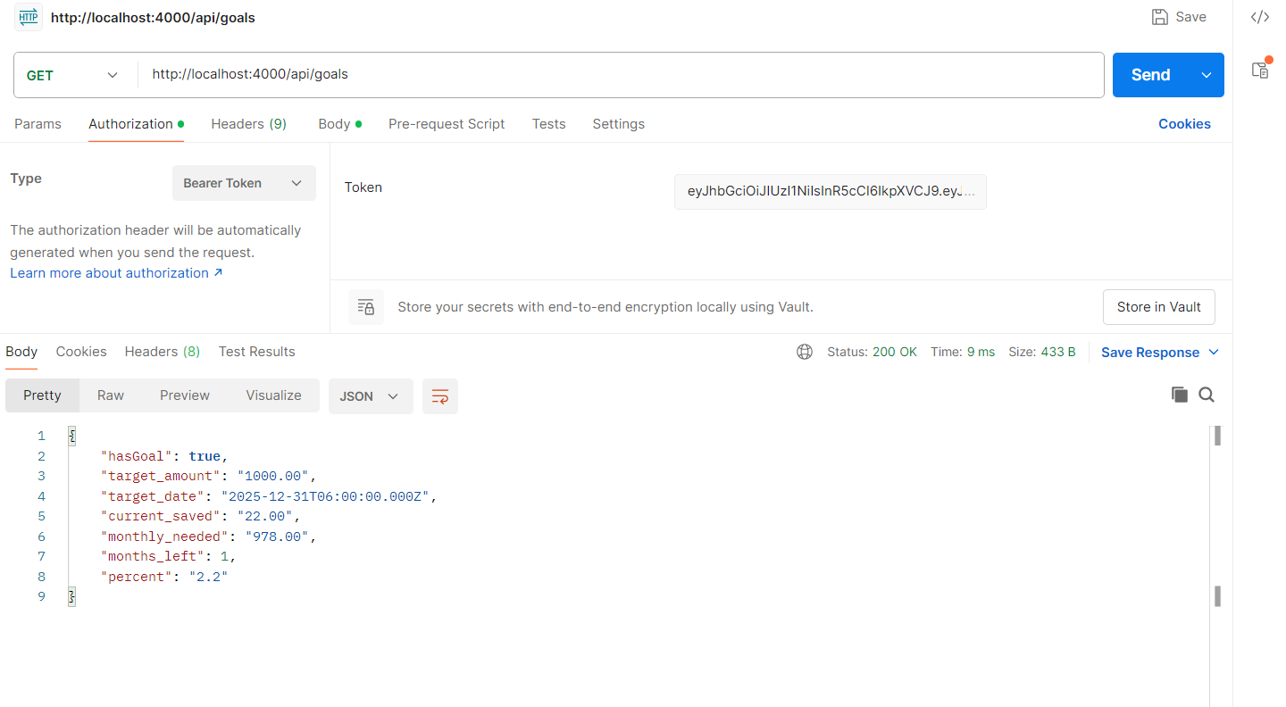
CSV Export: http://localhost:4000/api/export/csv
Pass bearer token
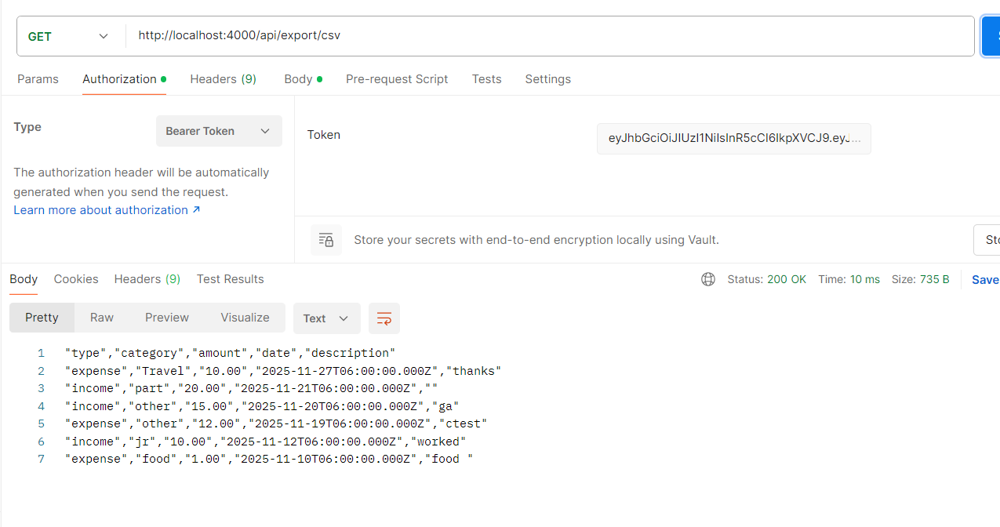
Invalid token:
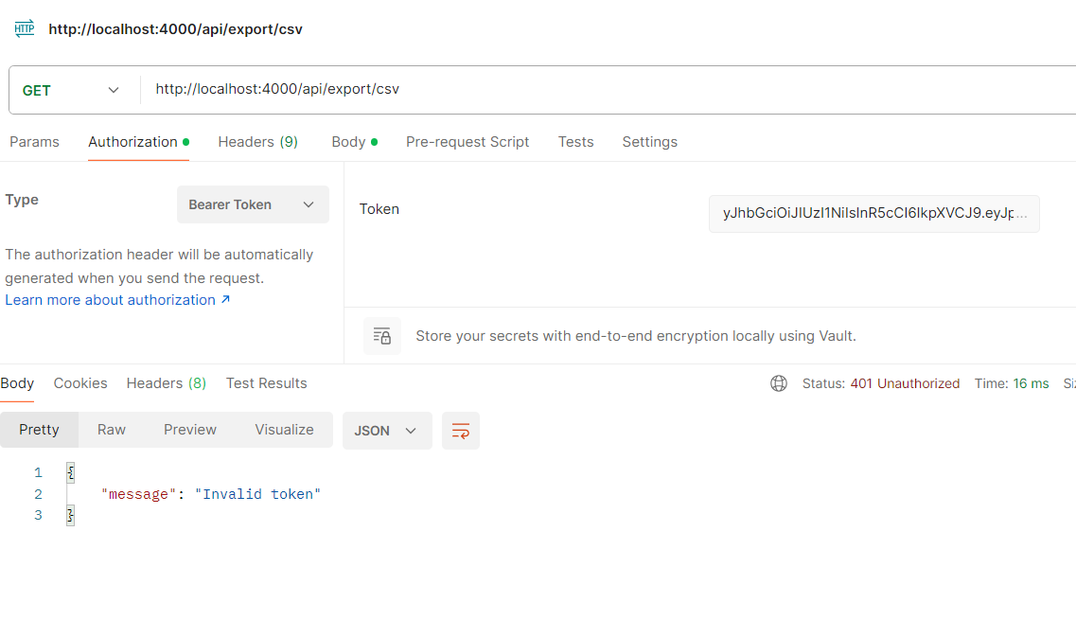
Implemented front end pages: applied styles to improve look and feel of the dashboard.

Transaction page:
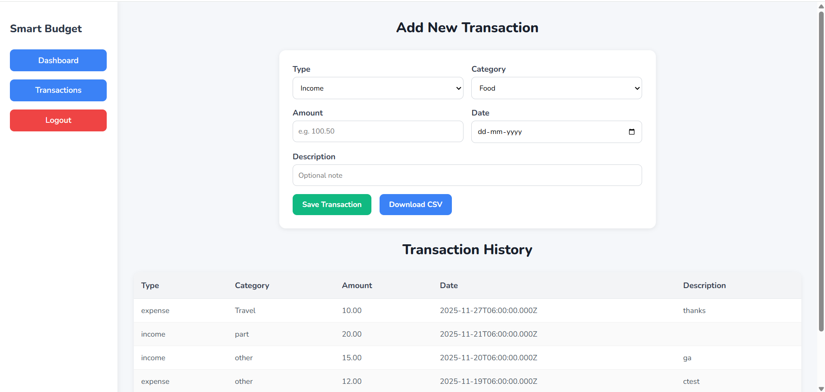

Dashboard page:
