Screenshots:
Week2
Postman Testing:
Register: http://localhost:4000/api/transactions
{
"type": "expense",
"category": "Groceries",
"amount": 50.25,
"date": "2025-11-05",
"description": "Weekly food shopping"
}
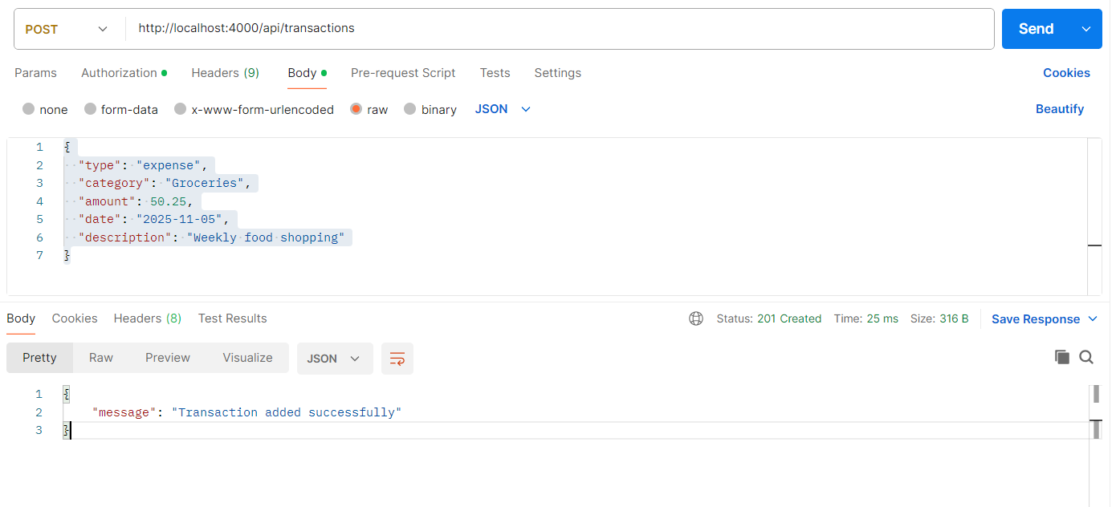

Login: http://localhost:4000/api/transactions
Pass bearer token

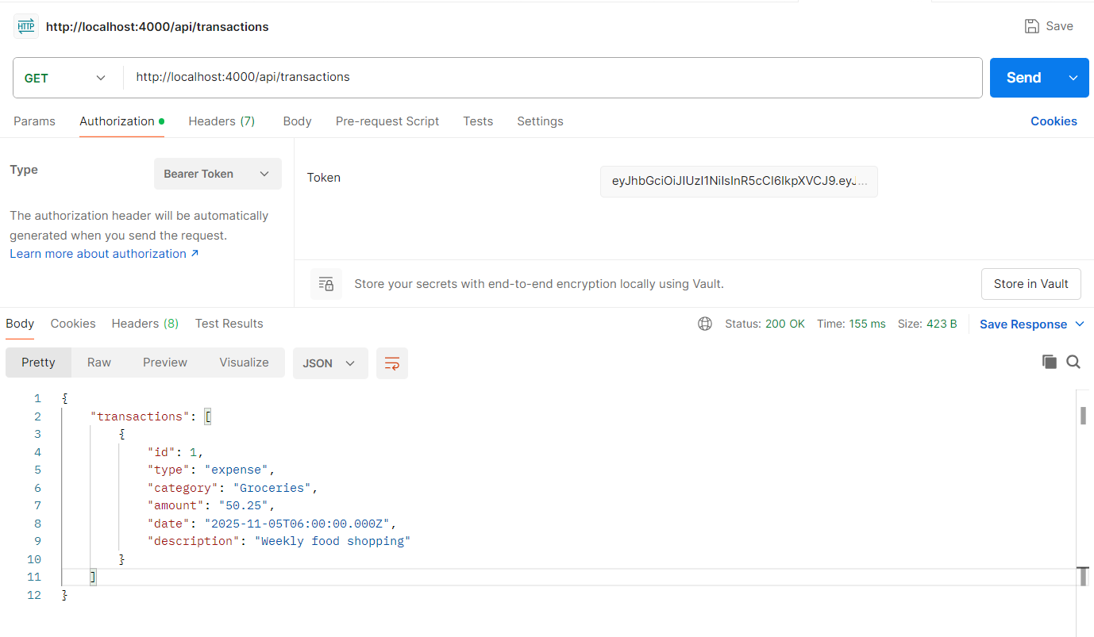

GET transaction on with single id
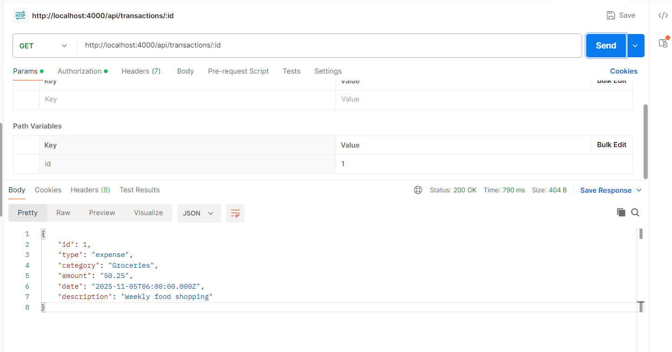

Invalid token
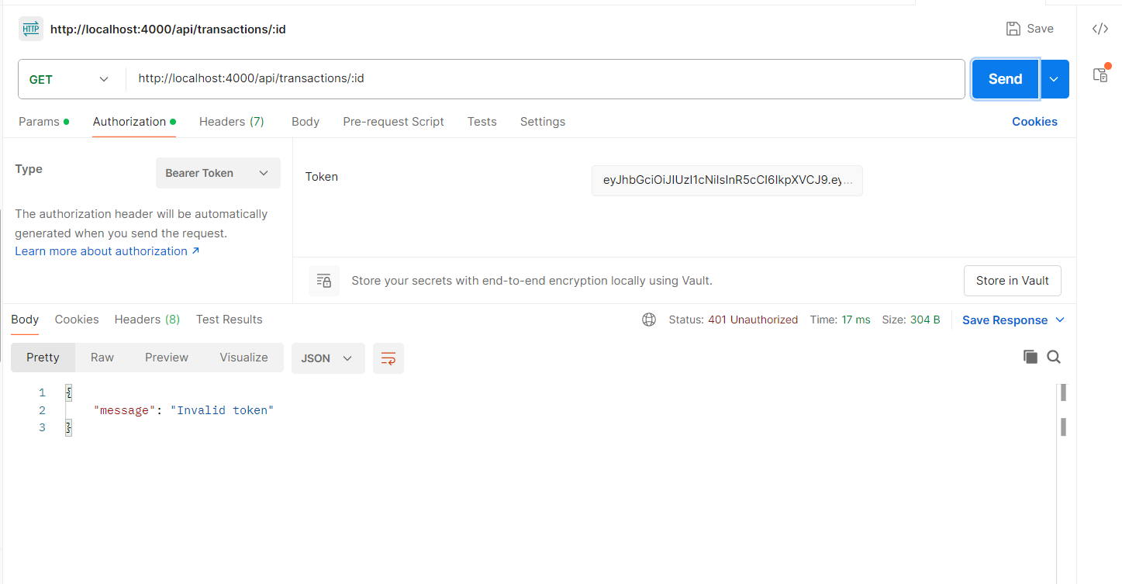
DB with Transaction table:
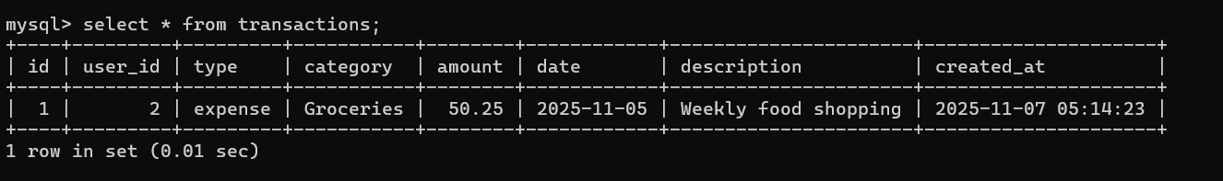

Implemented front end pages: Sample HTML drafted – need to apply CSS styles
Login page
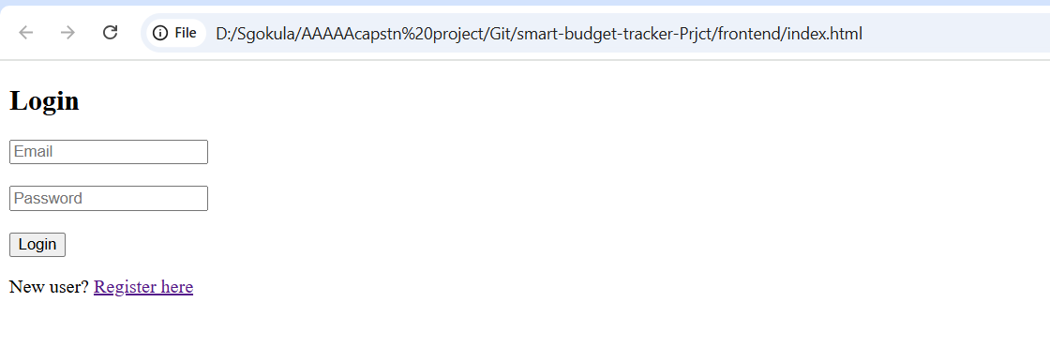
Registration Page Sample HTML drafted – need to apply CSS styles
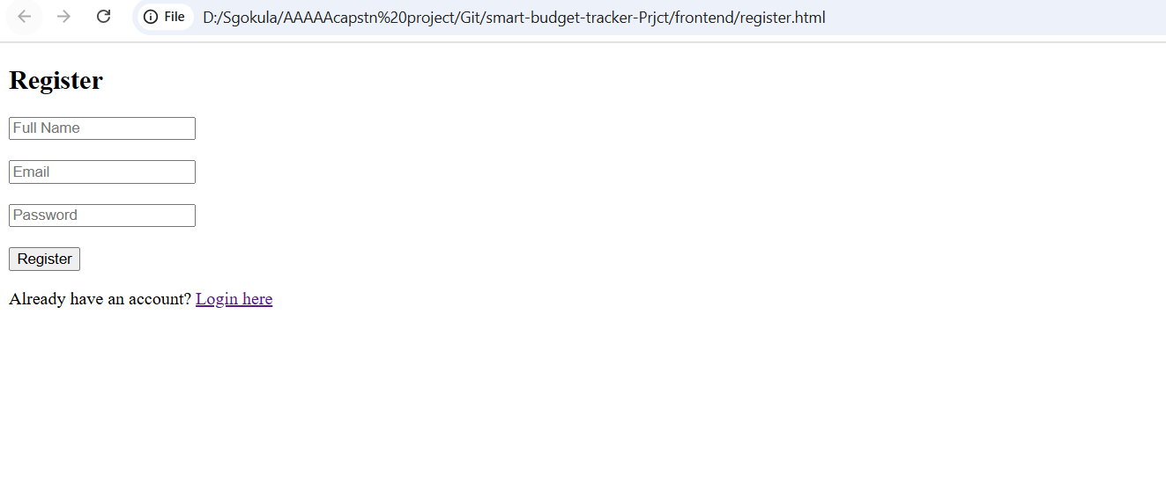
Transactions page – Sample HTML drafted – need to apply CSS styles
