Screenshots:
Week4
Postman Testing: Use bearer token
Get categories Data: URL: http://localhost:4000/api/category-totals
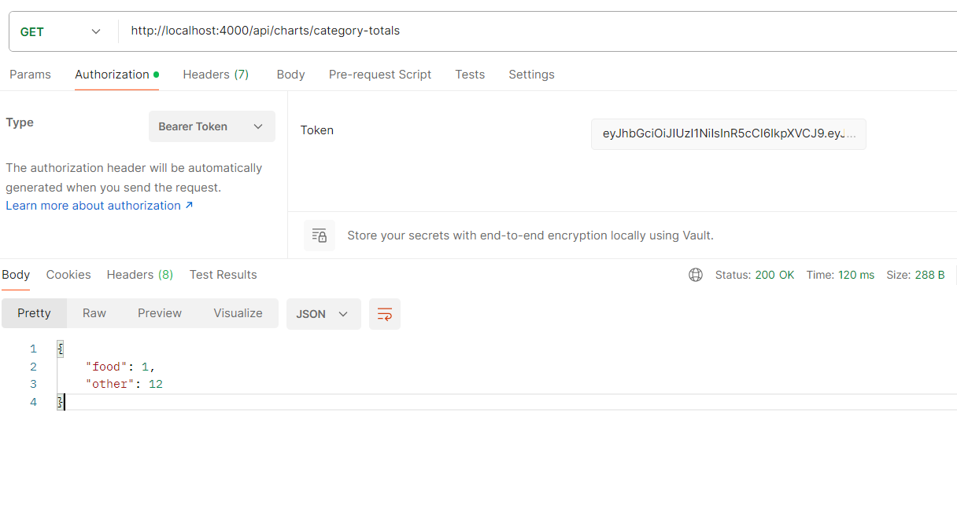

Get monthly summary:
Pass bearer token
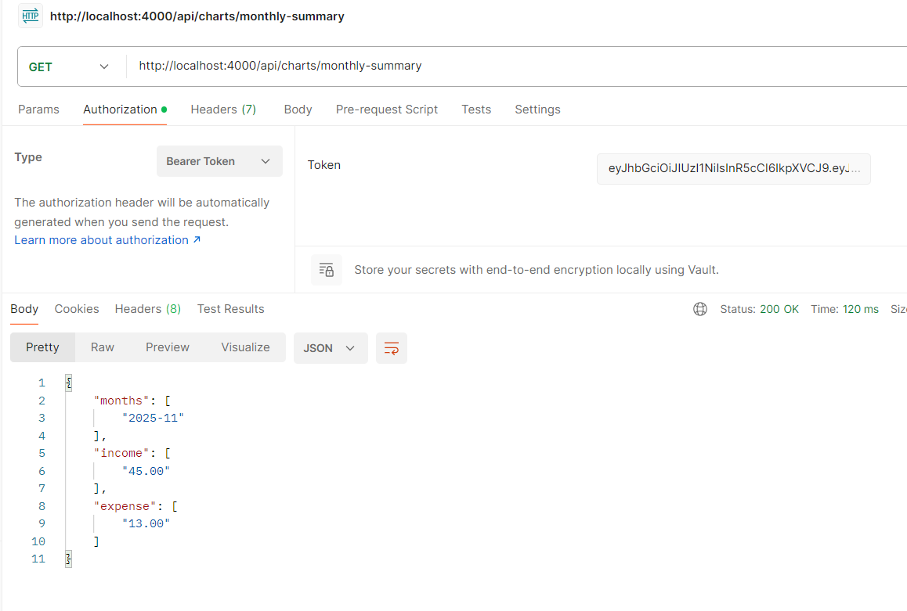

Implemented front end pages:
