Screenshots:
Week3
Postman Testing: Use bearer token
Get Summary Data: URL: http://localhost:4000/api/summary

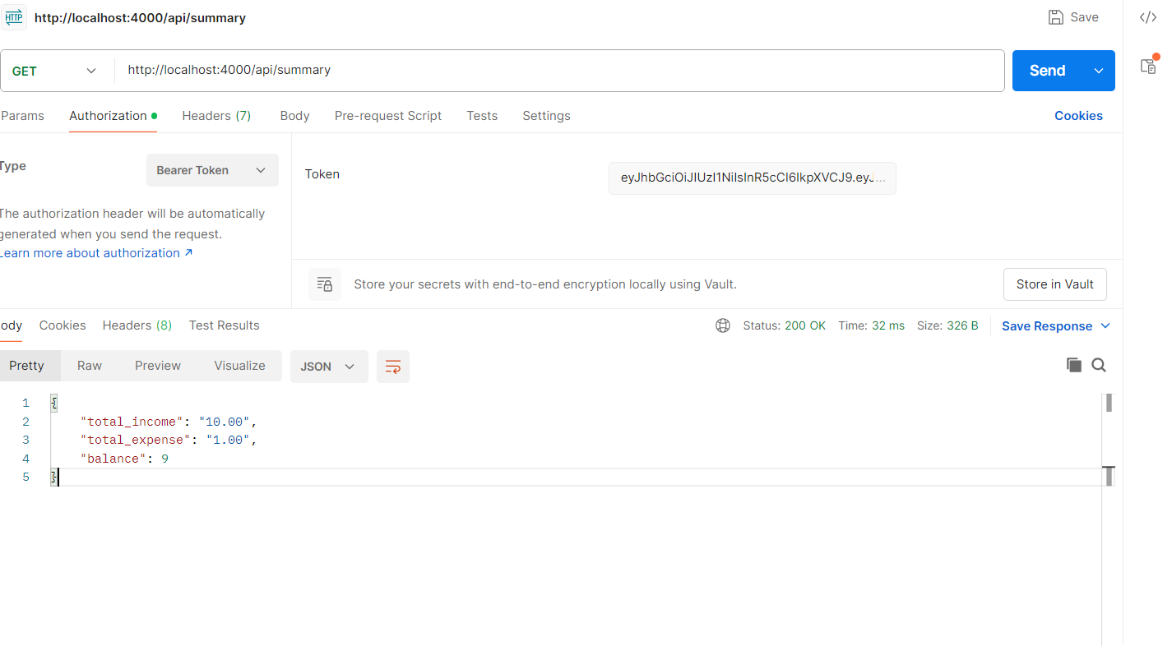
Get summary data with filters:
Pass bearer token
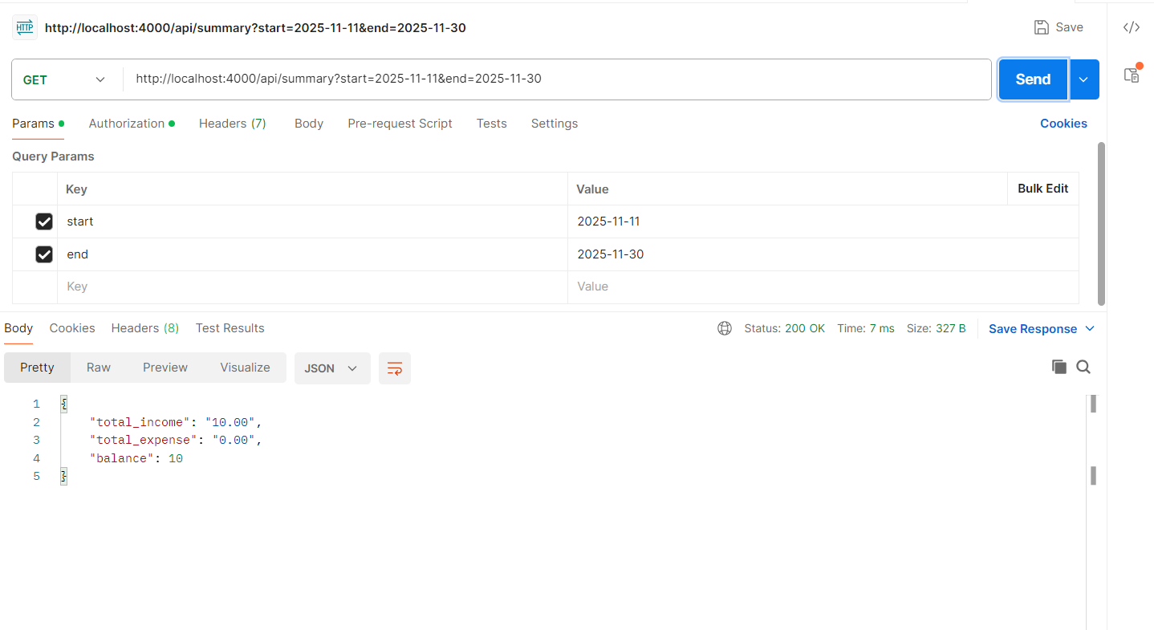

Invalid token
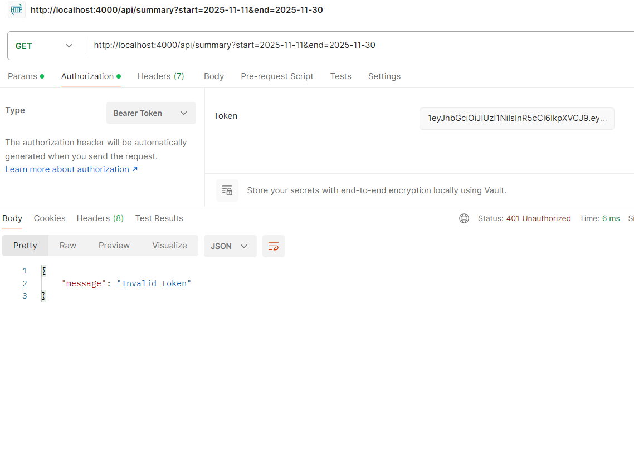
DB with Transaction table:
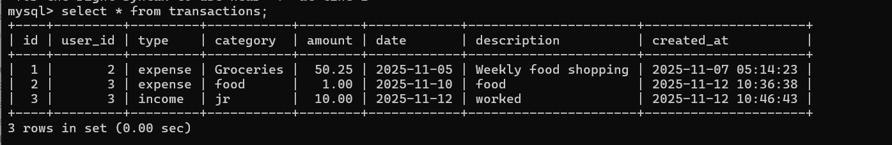

Implemented front end pages: Sample HTML
Login page
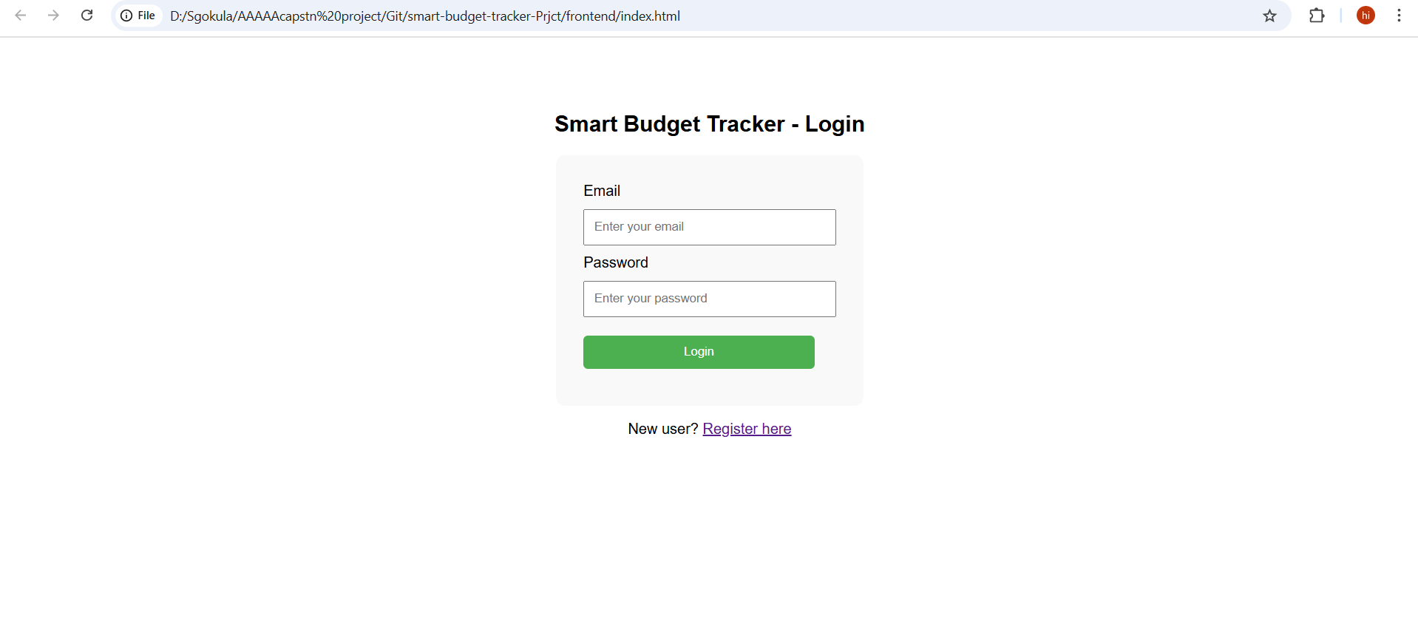

Success message:
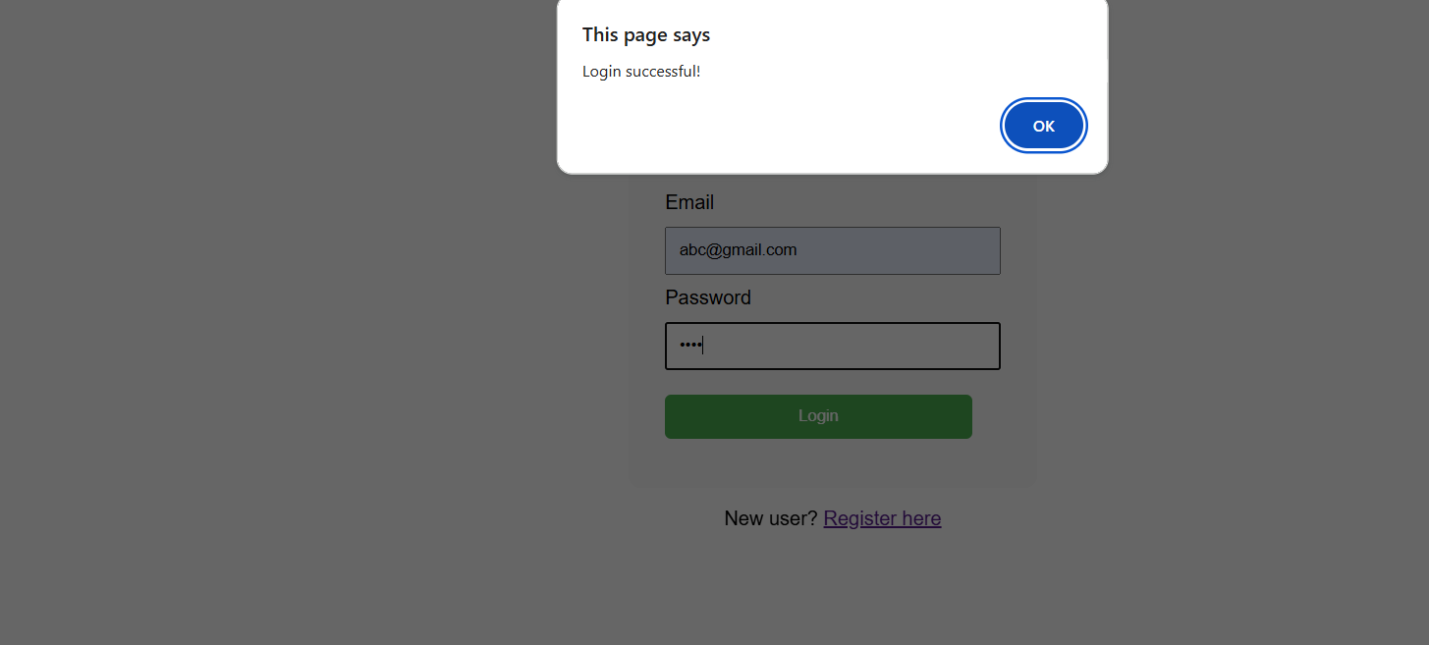

Invalid credentials:
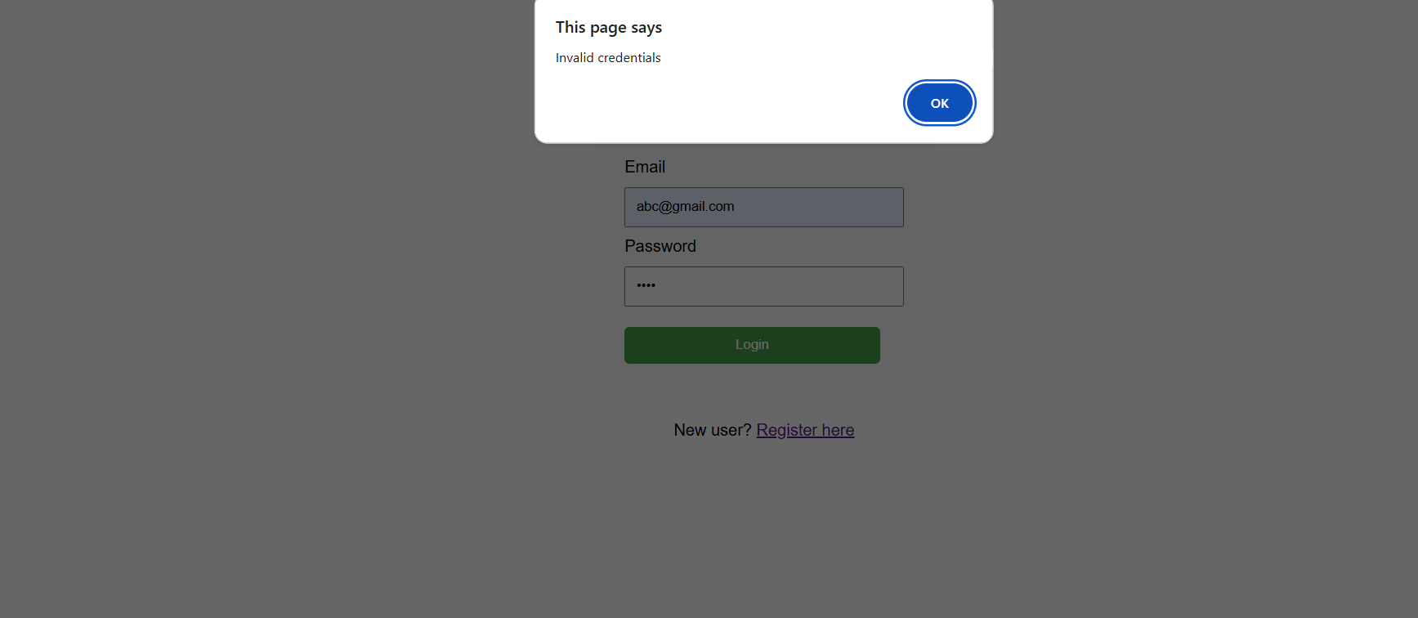
Dashboard page with default transactions page – Sample HTML
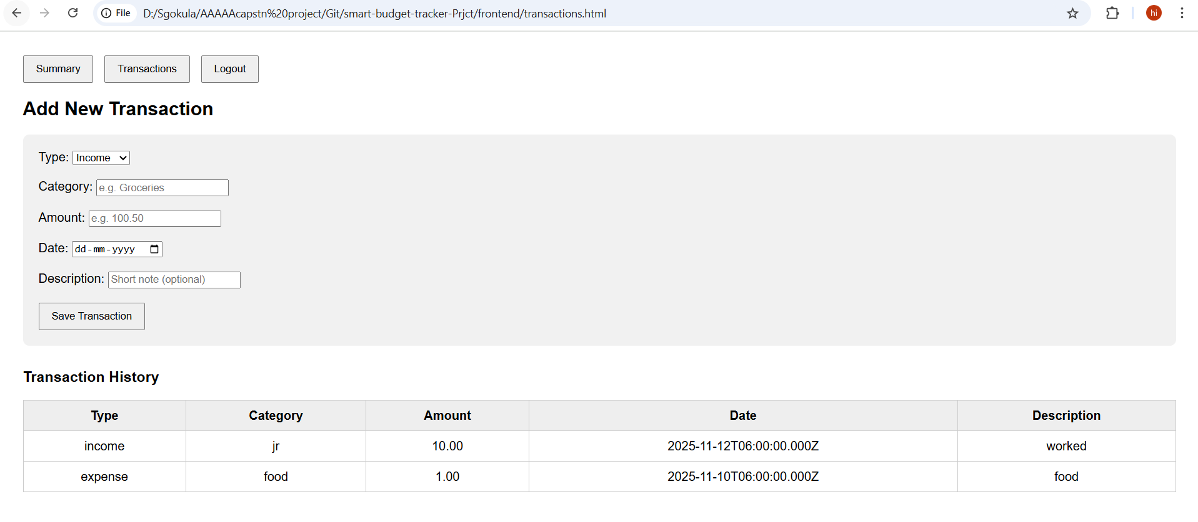

Summary page
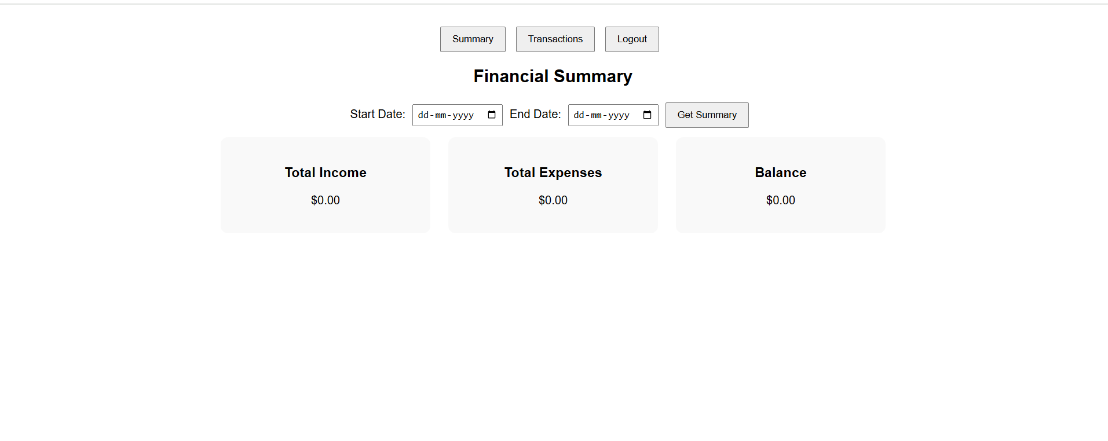
Applied filters:
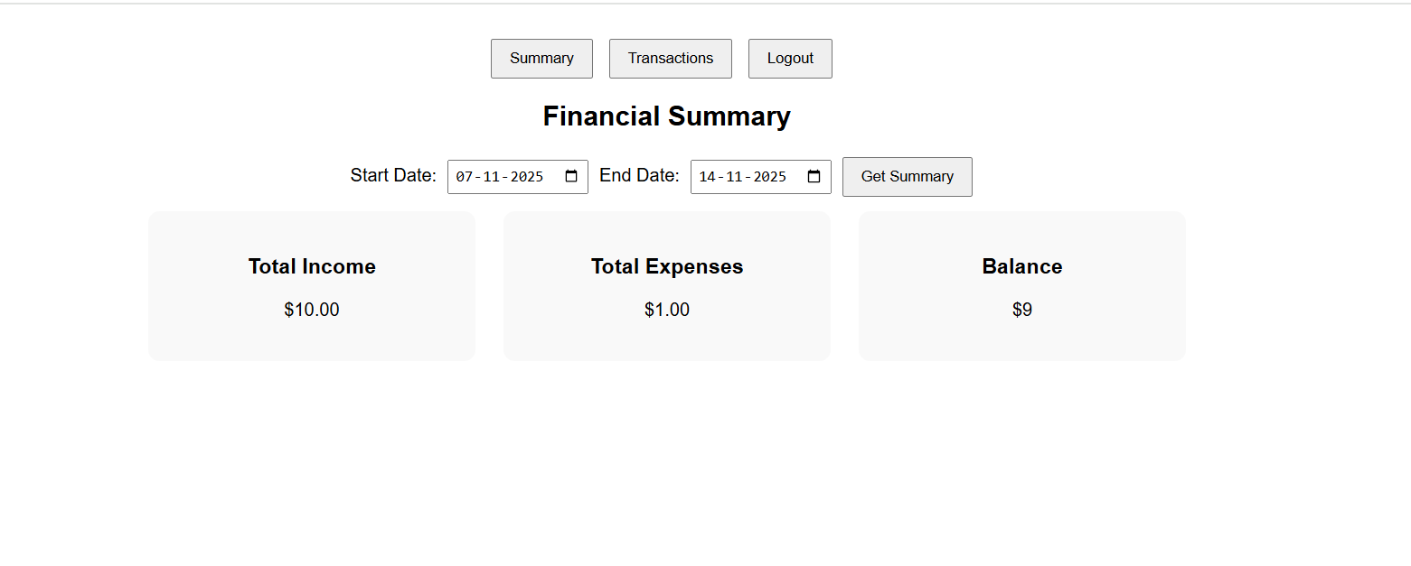
Logout – navigated to login page
