CHALLENGES:-

1. Install apache http server?



1. Install nginx

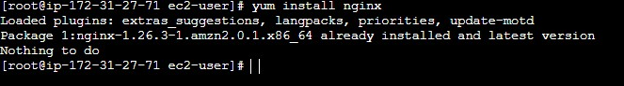

1. Install Docker

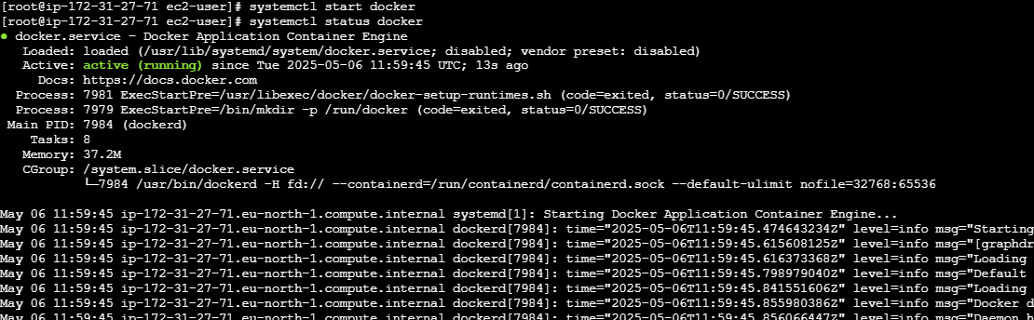

1. Install Tomcat

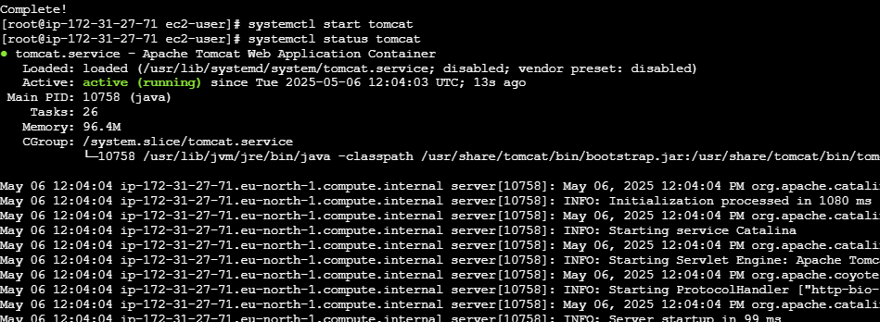

5.Install Jenkins.

