AZURE DEVOPS documentation

first we have to create account using link https://dev.azure.com after creation of account u have to sign with credentials. Afetr login into account it shows popup below image.

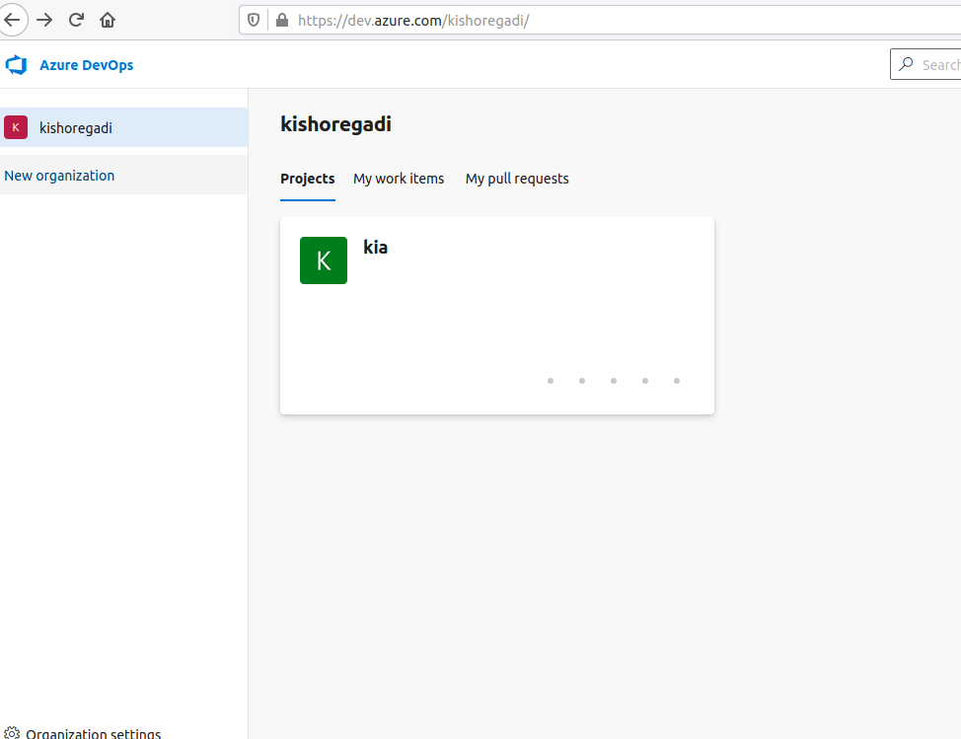
In this image neworganzation is appear click that it shows below image

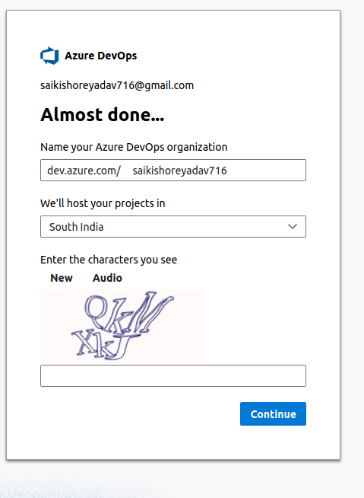

here we create organization name and select region enter captcha. Afetr this one organization created in this oraganization we have to crate project.

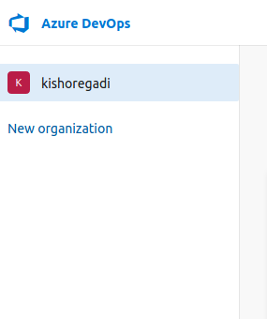

above one kishoregadi is oraganoization name by clicking the name it will show this image.

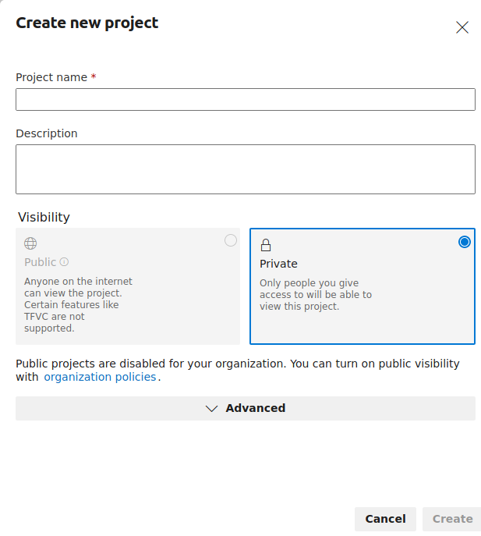

give project name and select public r private and click create and project crated.

By using project u can create the ci cd pipelines and service connections .

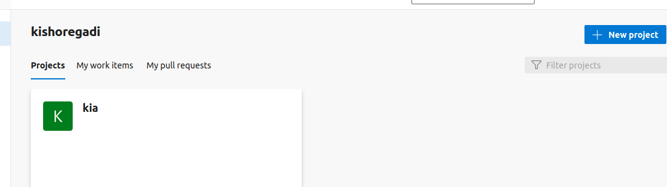

above one is project click on project then it will appear the pipelines and repos first we have to configure the github to azure devops for this we want to create the service connection to create this first we have to enter the project in that corner project settings is there click that project settings in that service connection is there click that service connection

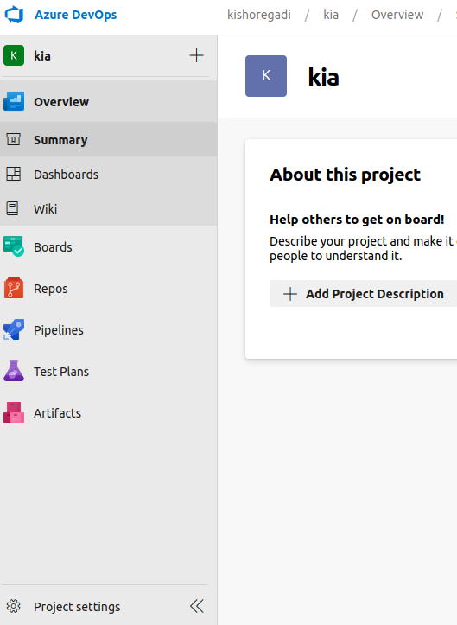

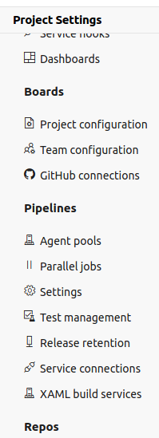

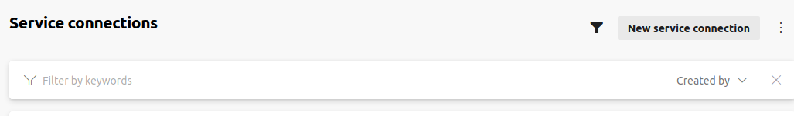

click new service connection and then some services will appear which service u want u can configure that service mostly we do git hub and sonar cloud , maven,docker registry, kubernetis. So now we are doing git hub select git hub

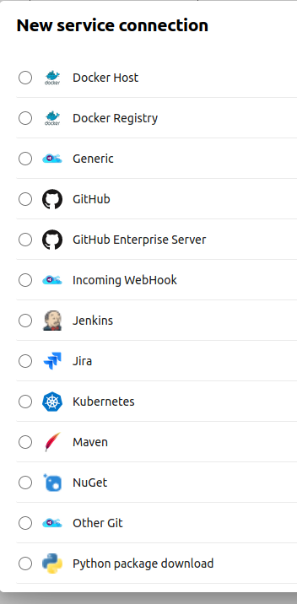

and click next and select personal access token and give token from git hub and give service connection name what ever u want and save now we can access the git hub in azure devops.
For sonar cloud same as like select sonar cloud click next here we have to give sonar cloud token.
How can u generate the sonar cloud token?
First we have to browse sonarclod login in browser like chrome

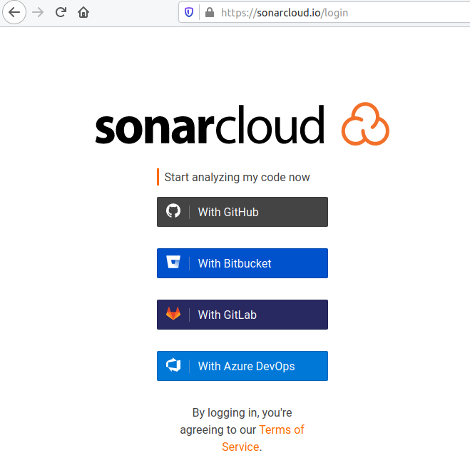

then we see the above pic and click the azure devops give azure account credentials if required then it shows like this below image.

click on pink colour box that is account wehn u click it shows below image

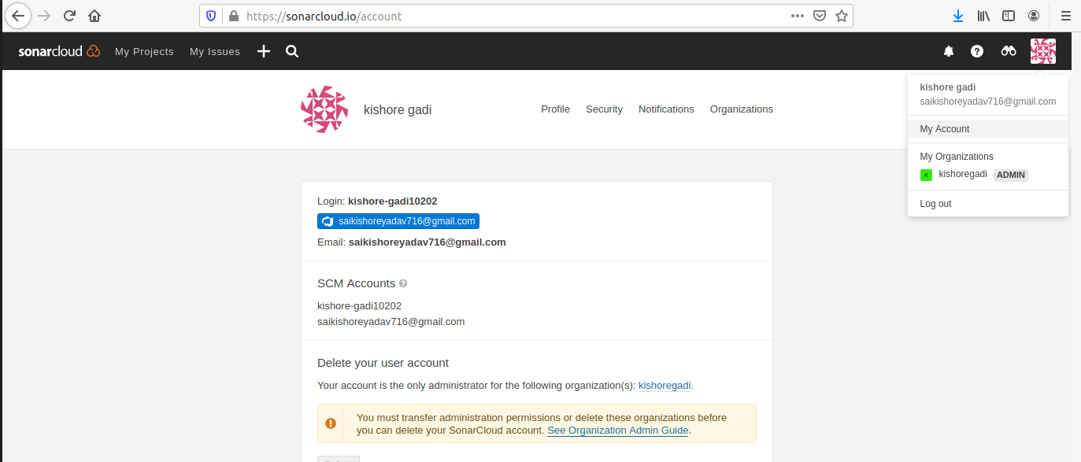

in this iamge we see security then click on security we see the below image geneate token pop up give any name and generate the token copy the token and give that token in service connection.
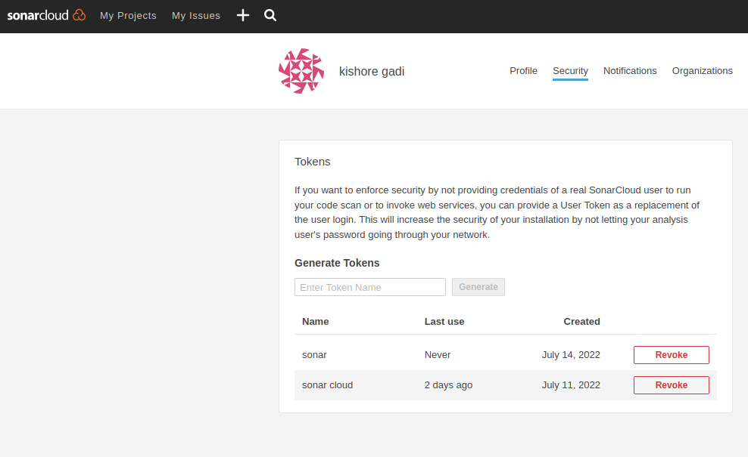

for the maven we have install softare in self hosted or localhost and run the maven and then give the Display name what u want and maven POM file give where the pom file stored pom.xml file path where it stored

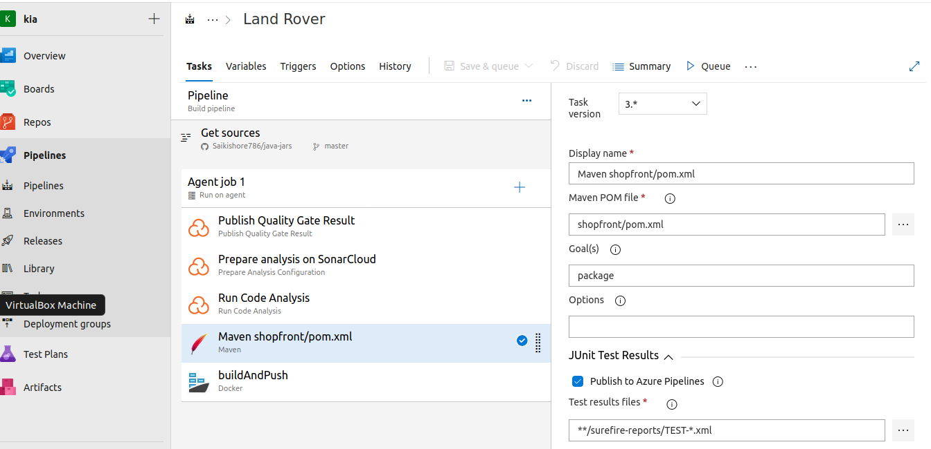

Docker registry service connection

for docker registry same like git hub go to service connection select docker registry click next select docker hub in that give docker hub id and password click save.

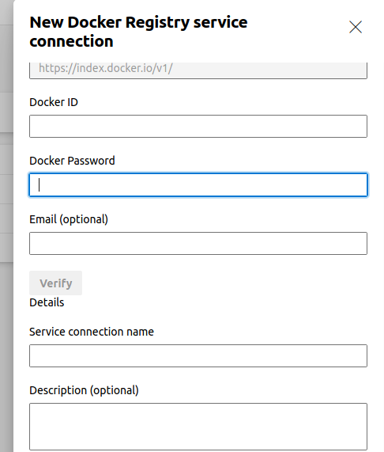

Kubernetis service connection:

for kubernetis service connection go to service connection then selectkubernetis click next select kubeconfig
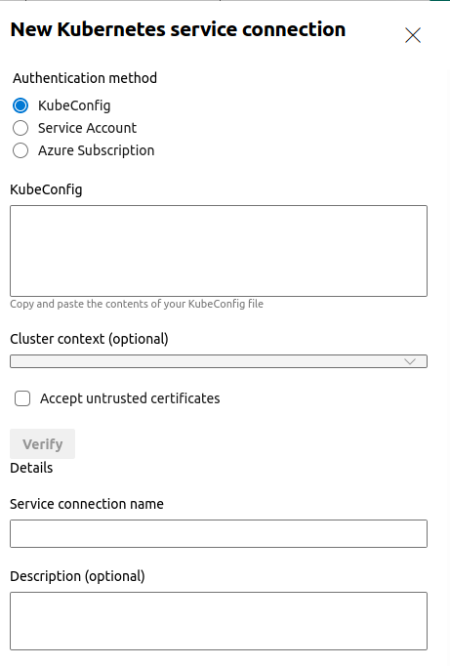

in kubeconfig we have to give kubernetis config file which we are created cluster in localhost.

Path of config file is

.kube/config in this file we have to copy that binary data and paste it in kubeconfig and save kubernetis service connnection is completed.

CI and CD pipeline

first we are creating pipeline for CI

1) click on project

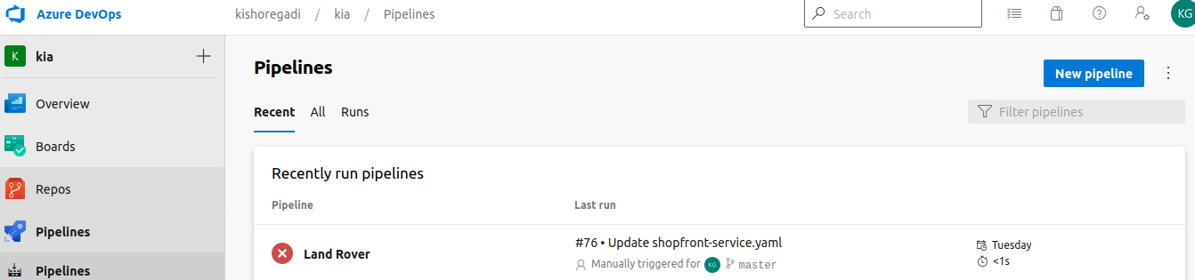

click on pipelines and then new pipe line will visible click on new pipeline then click on classic editor in below image it appear bottom line.

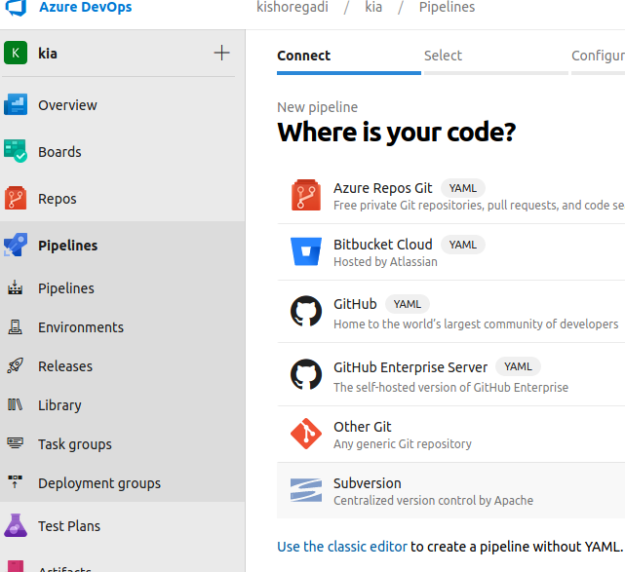

Then select the repository either it is azure repo or git hub where the code is placed in our environment i stored code in git hub so iam selecting git hub and giving repository where the code is stored.
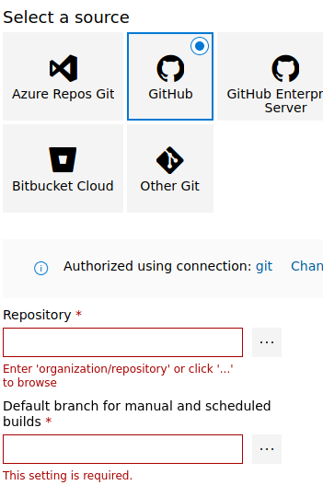

provide the repository name and it takes branch name default when u selecting repository and continue

then it shows below image

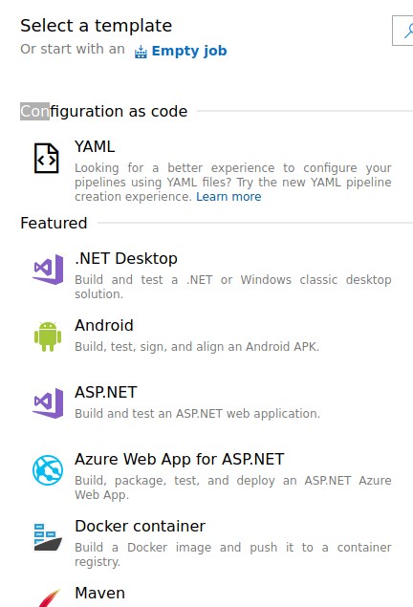

click on empty job it shows the agent pool for this agent pool first we have to create one pool with anyname. first the click project (projectname) bottom line project settings visible click on project settings and click on agent polls click add pool there select new agent and pool type self hosted and give pool name and create.
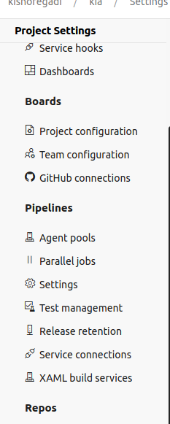

then go to the pipeline agent job we give agent display name and agent section select pool what we created (selfhosted) and click manage and click new agent
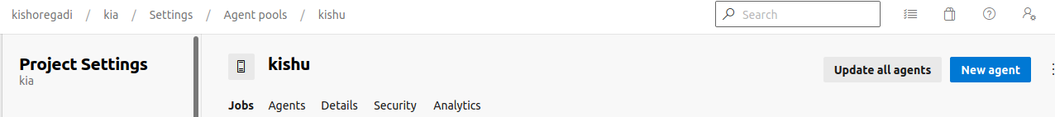
click new agent select linux apply below commands in loacalhost.

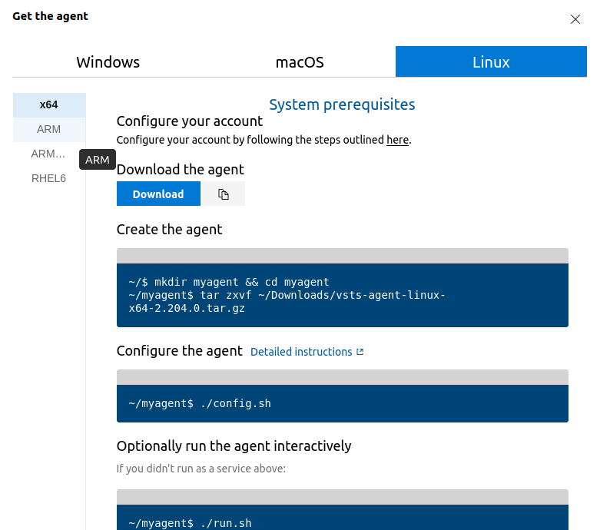

Then localhost and azuredevops will connected . Suppose we have kubernetis cluster in localhost it run in azure devops because we connected to localhost to azure devops.

After completion of creating agent then we have create job

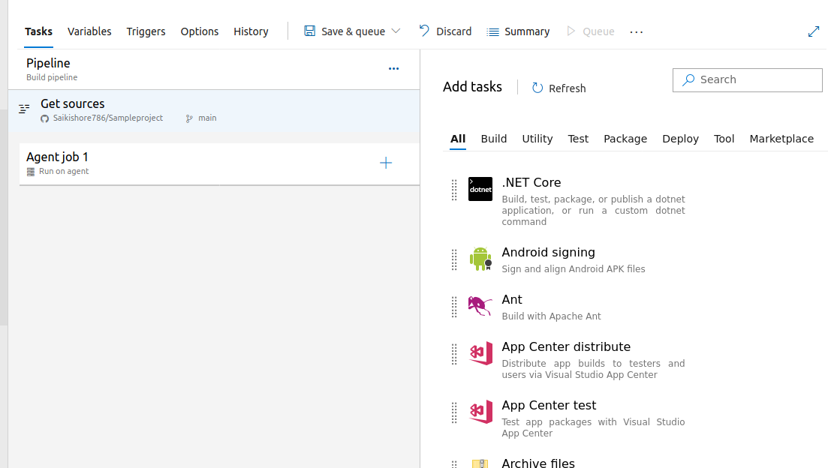

click on plus symbol(+) in agent job jobs will appear which job we want select that job and add that job that appears in below agent job1.

Now iam adding sonar cloud job for this we have to add below three jobs in these three jobs one of that prepare analysis on sonar cloud job we have to give sonar token name which already we did configure in service connection and organization we give organization name.

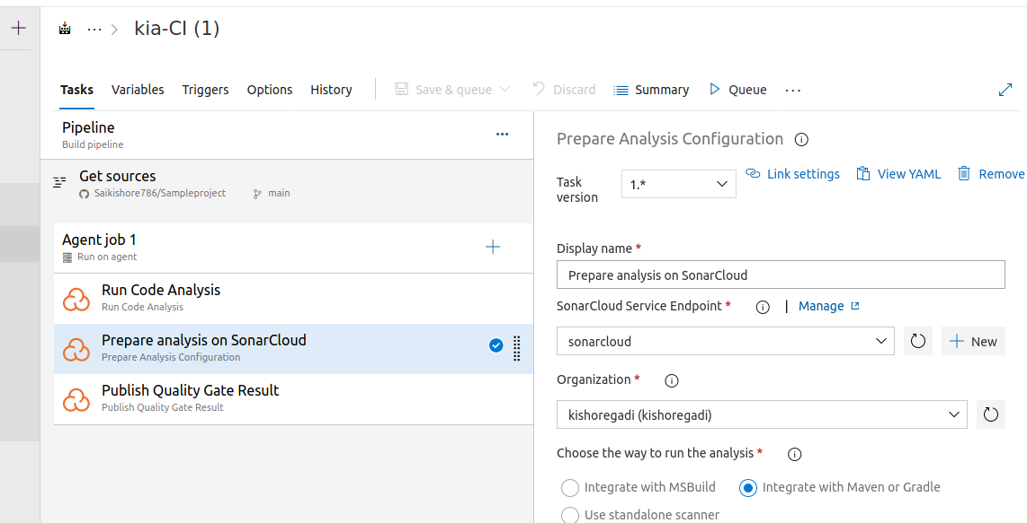

For maven job:

for maven suppose we selected selfhosted in that self host (localhost must and should we have maven installation.
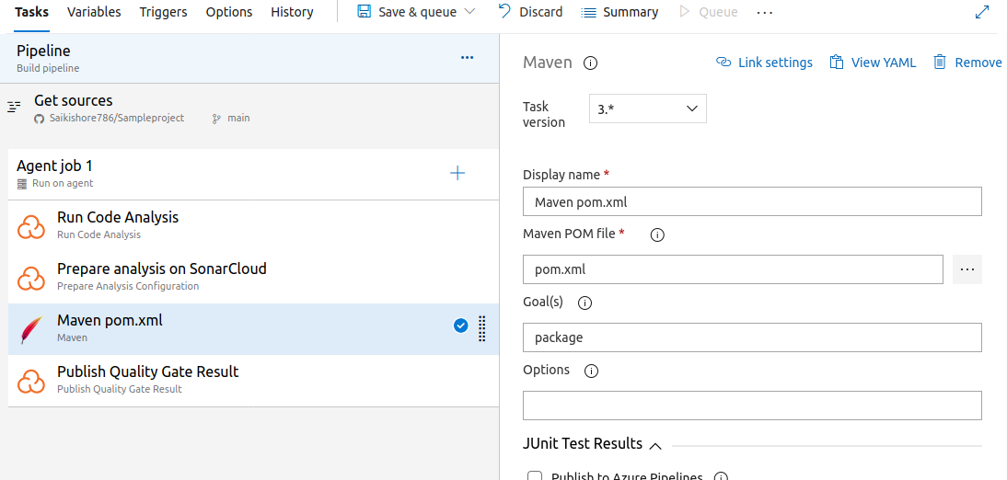

Given maven displayname and maven pom file it is locaten git repository by clicking 3 dots beside pom.xml it shows git repositories we can select the repository where the code is stored.

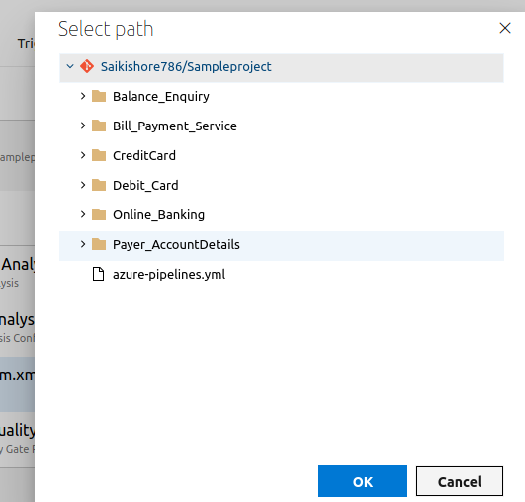

DOCKER:

docker job we have to specify the display name build and push and container registry we already created in service connection we specify that name and for container repository we should give docker hub username and imagename imagename we can give anything by using that name image will created
in command blank we give build and push and in Docker file : we should specify the Docker file path where file is stored in git repo.

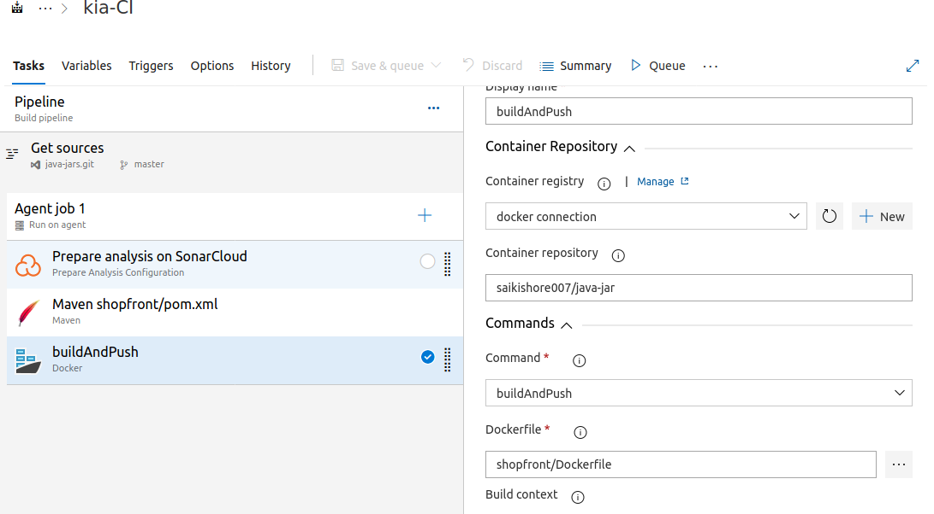

Continous Deployment(CD):
After completion of CI we will run the CD now we can see how to do CD first we have to create the release pipeline for that first go to releases and click new and click new pipeline
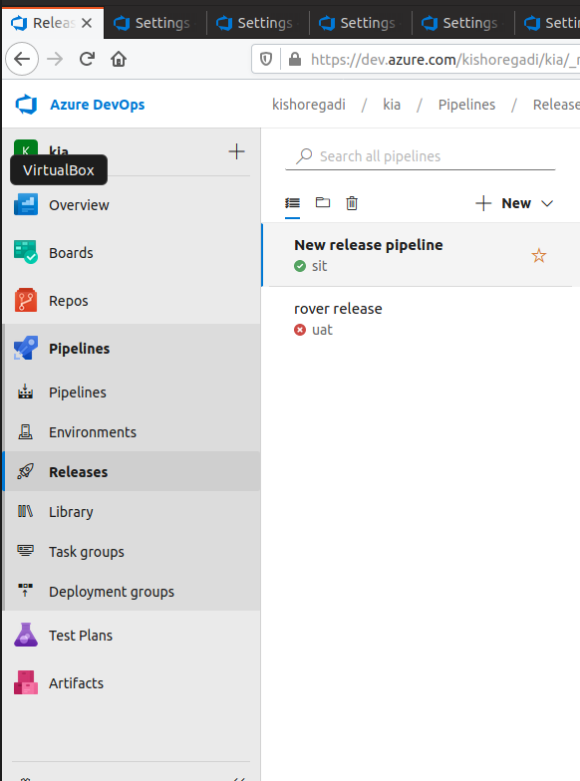

then see the below image :
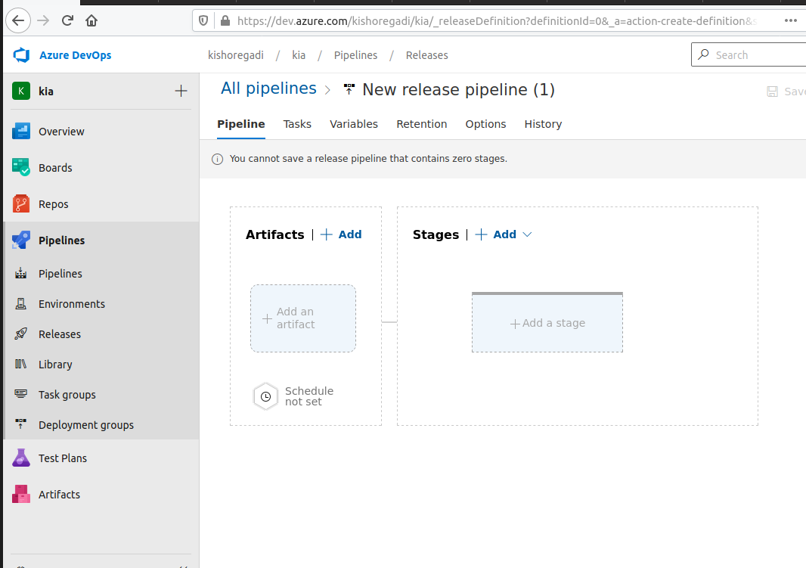

we absorb above image artifacts and stages in artifacts we add the repo either it is azure repo or git repo
where the yaml is stored.we give that service here iam giving git hub source repository is where yaml is stored we gave that folder and branch it takes it self and version is latest.
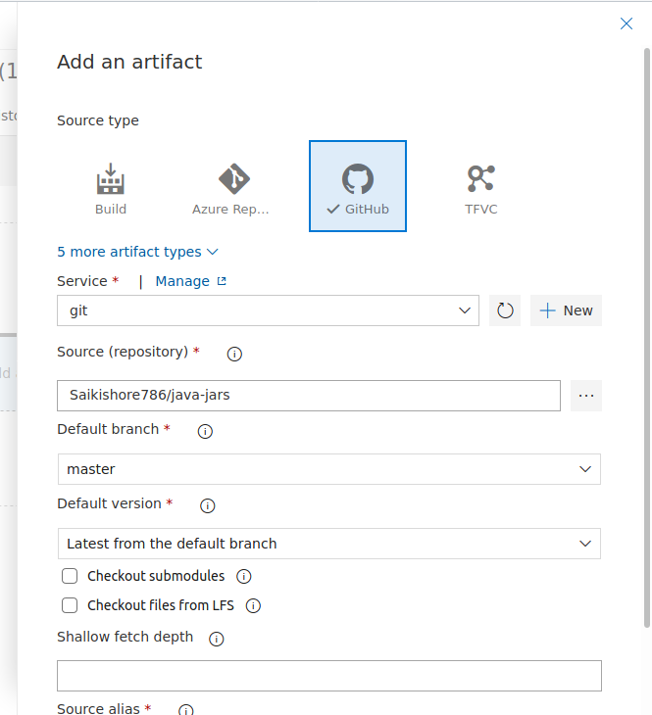

After creation artifacts in atifacts we absorb thunder symbol click on thunder symbol we see continous deployment trigger that is disable state we make it enable state why because when u run the stage it take artifacts automatically (ante artifacts lo unna yaml file automatic ga tiskuntundhi enable chesaka adikuda first a stage untadho aa stage matrame run avutundhi second stage run kavali ante pre deployment lo set cheskovali first stage create cheste stage lo thuder symbol untadhi adi pre deployment condition anna mata second stage automatic ga run cheyyali ante ekkada set cheslovali .)

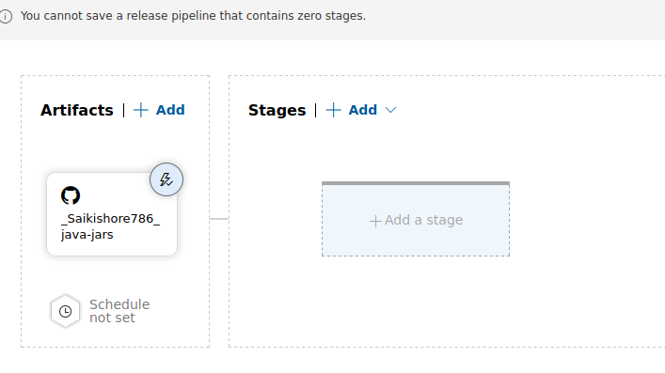

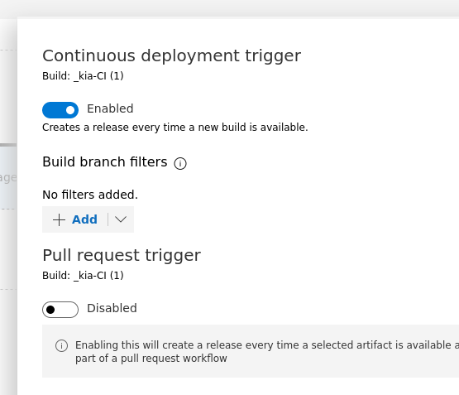

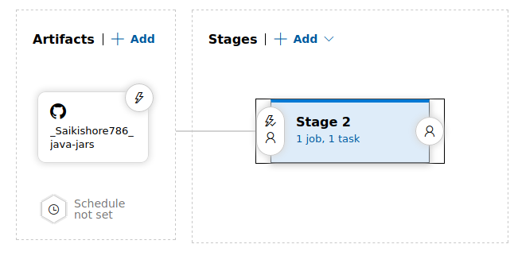

to create stage click on stage and give stage name and organization it willl shows one job click on job and click on emty job it shows agent job in that select pool name as project requires. Click on plus symbol then we select deploment tools that is kubectl add that and click on kubectl it shows display name and service connection type is we can select project requieres where kuberetis intall and give service connection name and namespace box give namespace name if u created otherwise it takes default name space, in command give what u requres for deploy iam giving ‘apply’ command in arguments ‘-f’ and like this commands for deploy -f need so iam giving this. Working directory we give where the kubernetis yaml is there path and save.

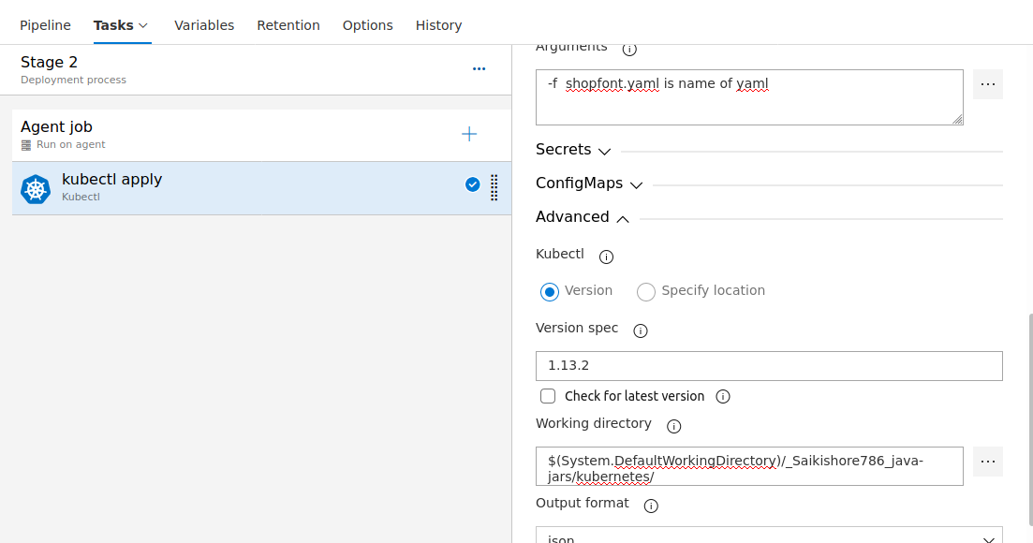

predeployments:
in predeployments lo manam artifacts nunchi yaml vastundhi kabatti stag1 lo after release set cheskuntam when manam stage 2 run cheseppudu manam stage1 select cheskovali stage1 selectcheskovali ante ‘after stage select’ cheskovali and below image obsorb cheste telustadhi example ga kindha stages lo stage1 undhi ante stage1 tarwata stage2 run avtadhi adevidanga stage3 run cheyali ante stage3 ki velli stages lo stage2 select cheskovali.

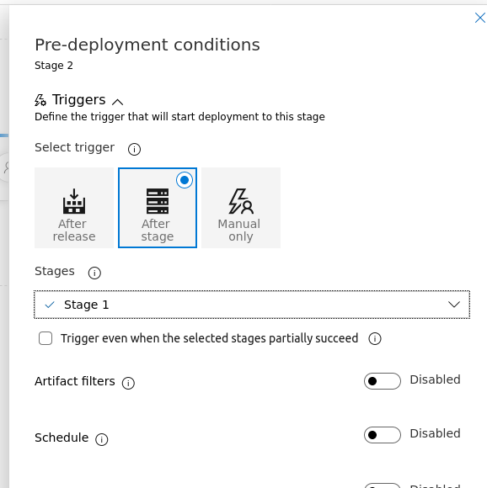

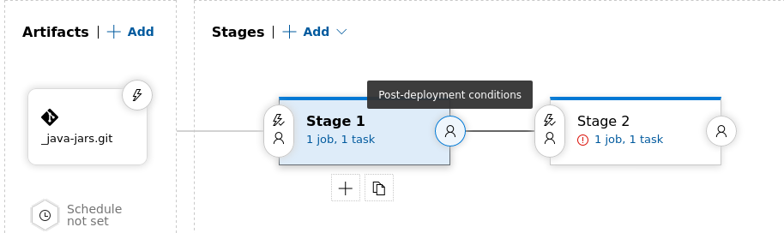

Replace tokens :
Replace Tokens is an extension that can be used in Azure DevOps, which provides the possibility to replace tokens in the code files with variables values (which can be configured in the Pipelines Library) during the execution of the CI/CD process. (build variables environment variabels yaml file define cheydaniki replace tokens task must and should add cheyyali

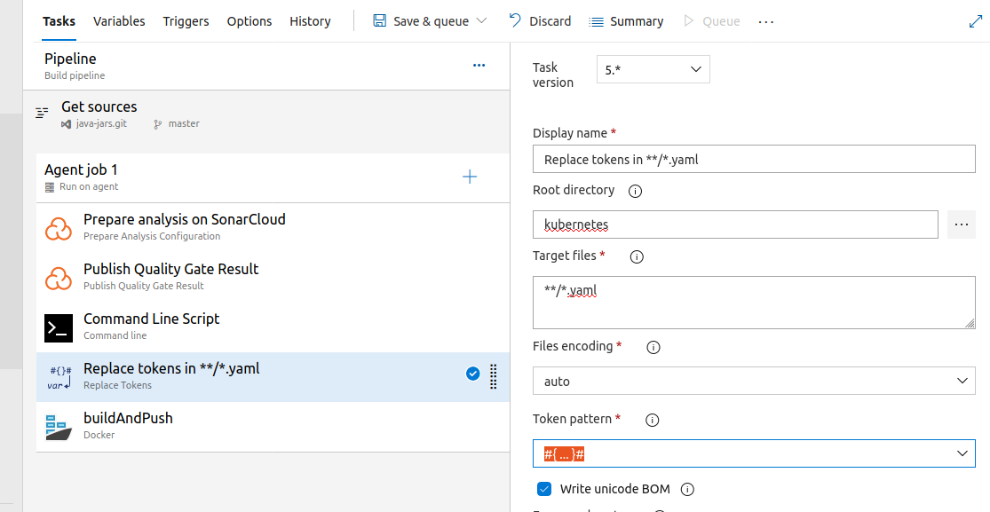

dispalyname u can give what u want and root directory is the where the yaml files is stored we give that path target path is the we can specify the yaml file to which file these variables applicable files encoding “auto” token pattern ante manam define cheskone values ala undali ani for ex # ...# undhi kadha ante # tag madyalo defined variables mention chestam yaml file lo.

