**INFANT INCUBATOR WITH FAULT DETECTION BASED ON MACHINE LEARNING CLASSIFIERS**

**Internet of Things Domain analyst – BECE351E**

*Submitted by*

**C. Sai Koushik – 21BEC1497**

**Kadapa. Rajashekar Reddy – 21BEC1496**

**P. Venkata sai rahul – 21BEC1686**

**A. Naga Harshith 21BEC1493**

TO

Faculty In-Charge

**Mr M Manigandan**

**Assistant Professor**

**School of Electronics and Engineering**

*in partial fulfillment for the award of the degree of*

**BACHELOR OF TECHNOLOGY**

in

**ELECTRONICS AND COMMUNICATION ENGINEERING**



APRIL 2024

**School of Electronics Engineering**

**INFANT INCUBATOR WITH FAULT DETECTION BASED ON MACHINE LEARNING CLASSIFIERS**

C. Sai Koushik – 21BEC1497, Kadapa. Rajashekar Reddy – 21BEC1496, P. Venkata sai rahul – 21BEC1686, A. Naga Harshith 21BEC1492.

Mr M Manigandan

Assistant Professor

School of Electronics and Engineering

Vellore Institute Of Technology - Chennai

**KEY WORDS:**

fault detection, infant incubator, Raspberry Pi 4, decision tree (DT), support vector machine (SVM).

1. **ABSTRACT:**
   1. Because of their gestational age or birth weight, certain newborn newborns are at a higher risk of death. Because of their unmet demand for warmth, the majority of preterm newborns born between 32 and 37 weeks of gestation die. The neonatal incubator is a device that provides a regulated and closed environment to preterm newborns. An intelligent system has been designed to monitor the performance of the incubator sensors depending on three features (temperature, humidity, fan current) to detect any fault in the system. For classification, tasks adopted many algorithms like Decision Tree (DT), Support Vector Machine (SVM).
2. **INTRODUCTION**

2.1

The incubator provides a constant temperature as well as a certain level of moisture to keep the baby in a safe and healthy condition. Any temperature change will turn on or off the fan to adjust the optimum temperature. Any fault in any of these parameters will lead to an imbalance in the system and the loss of a safe environment. Therefore, must work on monitoring and detecting the input and output faults in the various sensors of the incubator . A fault indicates a system malfunction, which leads to unsatisfactory performance and, consequently, the deterioration of the system .

Providing constantly monitor to manage these conditions to preserve temperature and humidity in the baby incubator is crucial for the appropriate development of premature babies. The main purpose of an infant incubator is to keep the temperature of a baby’s care at (25-35.5) degrees Celsius and the relative humidity at (20-30%) percent. This device can keep the infant’s temperature comfortable and maintain a high relative humidity to prevent thermal loss. The proposed system depends on machine learning algorithms to classify the fault and non-fault parameters.

1. **PROPOSED SYSTEM**
   1. The proposed system works on monitoring and detecting the input and output faults of the transducer by using various sensors. A transducer model is created consisting of a microcontroller (NodeMCU ESP8266), a power supply that connects to the relay to operate the heater element, a fan to equalize the Temperature.

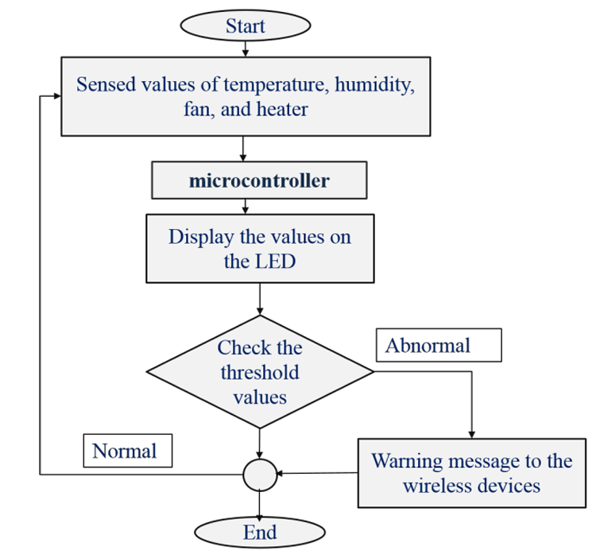

1. **CLASSIFICATION**
   1. **DECISION TREE (DT)**

It is a supervised learning approach that is non-parametric for classification and regression. To build a model that forecasts the value of a target variable, it is necessary to learn straightforward decision rules from data properties. A tree is an approximation to a piecewise constant.

* 1. **SUPPORT VECTOR MACHINE (SVM)**

This method of supervised machine learning can address classification and regression issues. However, it is mostly used to address categorization issues. Each feature in the SVM method is represented by the value of a particular coordinate, and each feature in n-dimensional space is represented as a point (where n is the number of available features).Then, categorization is achieved by identifying the hyper-plane that effectively separates the two groups.

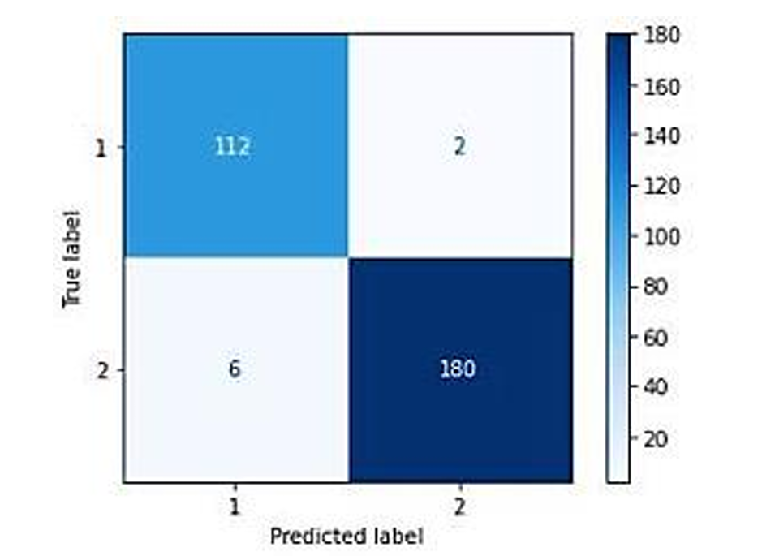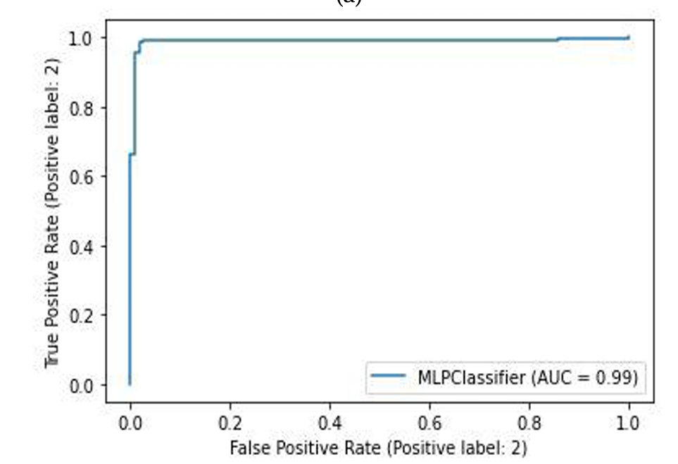

1. **COMPONENTS**
   1. **DHT22 sensor**

Its dependability and stability are ensured by a patented digital signal-collection technique and humidity sensor technology. Its sensors are coupled to a single-chip 8-bit CPU. Each sensor in this design has been temperature corrected, calibrated, and kept in a precise calibration chamber. When a sensor detects, it will quote the calibration coefficient from memory that has been saved in OTP memory in the form of a program. The DHT22 is suitable for a wide range of demanding application areas thanks to its small size (as shown in Figure 3), low power consumption, and high bandwidth distance (20m).

* 1. **NODEMCU ESP8266**

Figure 4 depicts NodeMCU, an open-source Internet of Things platform. It consists of firmware running on Espressif Systems' ESP8266 Wi-Fi SoC and hardware depending on the ESP-12 module. The moniker “NodeMCU” refers to the firmware rather than the DevKit by default. The Lua programming language is used in the firmware. It is constructed utilizing the Espressif Non-OS SDK for ESP8266 and is depending on the eLua project. It makes extensive use of open source programs like lua-cjson and spiffs.

**5.3 RELAY MODULE**

A 4-relay module is an electrical device that allows you to control four separate electrical circuits or devices using a single control input. It typically consists of four electromagnetic relays that can be switched on or off remotely. Relays are commonly used in automation and control systems to control various electrical devices, such as lights, motors, and solenoids. The 4-relay module is widely used in a variety of applications, including home automation, industrial automation, and robotics.

**5.4 ACS712 30A CURRENT SENSOR**

The ACS712 current sensor is based on the Hall Effect principle, where a magnetic field perpendicular to the current flow generates a voltage proportional to the current passing through the sensor.

1. **DATASET**

Data is recorded in real-time from sensors of the designed virtual infant incubator. It consists of THREE important parameters (temperature, humidity, fan current) from which to identify the situation of the incubator when it is a class 2 fault (abnormal) or class 1 non-fault (normal). We used three features (temperature, humidity, and fan), but in the practical stage (online), we used only two features (temperature, and humidity), which are heat and humidity.

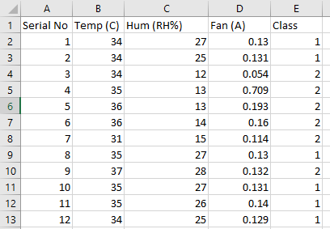 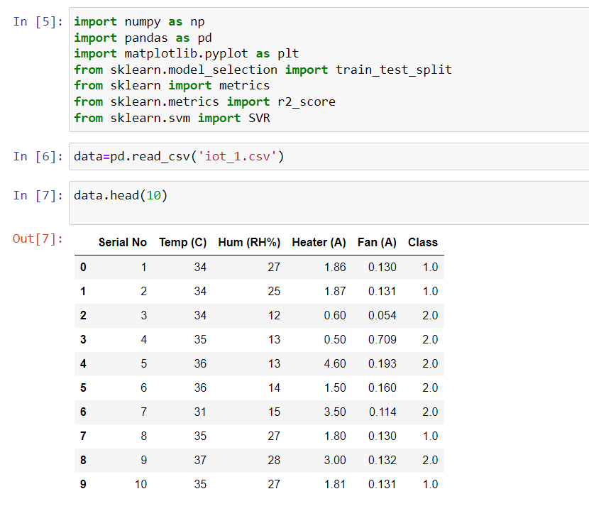

1. **RESULTS**

The virtual incubator that was designed was connected to a personal computer (PC). The proposed system works as follows:

Sensors are connected to the NodeMCU ESP8266 unit for temperature, humidity, and fan readings.

The NodeMCU ESP8266 is connected to Thingspeak from which data set is generated.

Generated dataset is extracted and fed to SVM machine learning model which then classifies the fault and non fault systems.

1. **CONCLUSIONS**

Continuous monitoring of incubator sensors prevents unsafe conditions, saving time for medical staff and protecting infants from harm. Our technology detects faults in real-time, including temperature, humidity, fan issues. By integrating machine learning algorithms like DT, SVM our lightweight solution offers affordability, simplicity, and sufficient computational power. Next step: connecting to a secure server for IoT integration.

1. **REFERENCES**
2. <https://www.researchgate.net/profile/Abbas-Hussain-3/publication/367224093_Multiple_Fault_Detection_and_Smart_Monitoring_System_Based_on_Machine_Learning_Classifiers_for_Infant_Incubators_Using_Raspberry_Pi_4/links/63d039b4d7e5841e0bf23491/Multiple-Fault-Detection-and-Smart-Monitoring-System-Based-on-Machine-Learning-Classifiers-for-Infant-Incubators-Using-Raspberry-Pi-4.pdf>
3. <https://ieeexplore.ieee.org/abstract/document/9243665/>
4. https://iopscience.iop.org/article/10.1088/1742-6596/1171/1/012015/meta