Abstract— In current situation, we come across various problems in traffic regulations in India which can be solved with different ideas. Riding motorcycle/mopeds without wearing helmet is a traffic violation which has resulted in increase in number of accidents and deaths in India. Existing system monitors the traffic violations primarily through CCTV recordings, where the traffic police have to look into the frame where the traffic violation is happening, zoom into the license plate in case rider is not wearing helmet. But this requires lot of manpower and time as the traffic violations frequently and the number of people using motorcycles is increasing day-by-day. What if there is a system, which would automatically look for traffic violation of not wearing helmet while riding motorcycle/moped and if so, would automatically extract the vehicles' license plate number. Recent research have successfully done this work based on CNN, R-CNN, LBP, HoG, HaaR features,etc. But these works are limited with respect to efficiency, accuracy or the speed with which object detection and classification is done. In this research work, a Non-Helmet Rider detection system is built which attempts to satisfy the automation of detecting the traffic violation of not wearing helmet and extracting the vehicles' license plate number. The main principle involved is Object Detection using Deep Learning at three levels. The objects detected are person, motorcycle/moped at first level using YOLOv2, helmet at second level using YOLOv3, License plate at the last level using YOLOv2. Then the license plate registration number is extracted using OCR (Optical Character Recognition). All these techniques are subjected to predefined conditions and constraints, especially the license plate number extraction part. Since, this work takes video as its input, the speed of execution is crucial. We have used above said methodologies to build a holistic system for both helmet detection and license plate number extraction.

Keywords—helmet detection; number plate recognition; computer vision; machine learning; convolutional neural networks; transfer learning
Introduction
  - Overview
Currently, in practice, Traffic Police are entrusted with the task of ensuring that motorcycle riders wear helmet. But, this method of monitoring motorcyclists is inefficient due to insufficient police force and limitations of human senses. Also, all major cities use CCTV surveillance based methods. But, those require human assistance and are not automated. Due to the increasing number of motorcycles and the concern for human safety, there has been a growing amount of research in the domain of road transport. The system proposed in this paper automates the task of monitoring motorcyclists. The system detects motorcyclists not wearing helmets and retrieves their motorcycle number plate in real time from videos captured by CCTV cameras at road junctions by making use of Machine Learning and Computer Vision techniques. Classifiers are built using Convolutional Neural Networks.
  - Objective
Helmet reduces the chances of skull getting decelerated, hence sets the motion of the head to almost zero. Cushion inside the helmet absorbs the impact of collision and as time passes head comes to a halt. It also spreads the impact to a larger area, thus safeguarding the head from severe injuries. More importantly it acts as a mechanical barrier between head and object to which the rider came into contact. Injuries can be minimized if a good quality full helmet is used. Traffic rules are there to bring a sense of discipline, so that the risk of deaths and injuries can be minimized significantly. However strict adherence to these laws is absent in reality. Hence efficient and feasible techniques have to be created to overcome these problems. Manual surveillance of traffic using CCTV is an existing methodology. But here so many iterations have to be performed to attain the objective and it demands a lot of human resource. Therefore, cites with millions of population having so many vehicles running on the roads cannot afford this inadequate manual method of helmet detection. So here we propose a methodology for full helmet detection and license plate extraction using YOLOv2, YOLOv3 and OCR. Basically helmet detection system involves following steps such as collection of dataset, moving object detection, background subtraction, object classification using neural networks.
  - Project Formation
Due to the increasing number of motorcycles and the concern for human safety, there has been a growing amount of research in the domain of road transport. The system proposed in this paper automates the task of monitoring motorcyclists. The system detects motorcyclists not wearing helmets and retrieves their motorcycle number plate in real time from videos captured by CCTV cameras at road junctions by making use of Machine Learning and Computer Vision techniques. Classifiers are built using Convolutional Neural Networks.
  - Scope
Most of the existing systems for this problem statement use classifiers built on handcrafted features on the images/frames in video. Coming up with really good handcrafted features is a difficult task. This is why, deep Convolutional Neural Networks (CNNs) [14] have become popular in recent years for the job of image classification. CNNs learn rich feature representations from a broad range of images which often outperform handcrafted features and lead to more accurate and efficient image classification. Thus, implementation of system for this problem statement is done using CNN classifiers. One CNN classifier is used to classify between motorcyclist and non-motorcyclist and another CNN classifier is used to classify between helmet and nonhelmet.

  - Existing System
Existing system monitors the traffic violations primarily through CCTV recordings, where the traffic police have to look into the frame where the traffic violation is happening, zoom into the license plate in case rider is not wearing helmet. But this requires lot of manpower and time as the traffic violations frequently and the number of people using motorcycles is increasing day-by-day. What if there is a system, which would automatically look for traffic violation of not wearing helmet while riding motorcycle/moped and if so, would automatically extract the vehicles’ license plate number. Recent research have successfully done this work based on CNN, R-CNN, LBP, HoG, HaaR features,etc. But these works are limited with respect to efficiency, accuracy or the speed with which object detection and classification is done
  - Proposed Method
In this project we are detecting whether two wheeler rider wearing helmet or not, if he is not wearing helmet then we are extracting number plate of that two wheeler. To extract number plate we have YOLO CNN model with some train and test images and if you want to add some other images then send those images to us so we can include those images in YOLO model with annotation to extract number plate of those new images.
To implement above technique we are following or implemented below modules
- First image will be upload to the application and the using YOLOV2 we will check whether image contains person with motor bike or not, if YOLO model detect both person and motor bike then we will proceed to step 2.
- In this module we will use YOLOV3 model to detect whether object wear helmet or not, if he wear helmet then application will stop hear itself. If rider not wear helmet then application proceed to step 3.
- In this module we will extract number plate data using python tesseract OCR API. OCR will take input image and then extract vehicle number from it.

  - Feasability
The feasibility of the project is analyzed in this phase and business proposal is put forth with a very general plan for the project and some cost estimates. During system analysis the feasibility study of the proposed system is to be carried out. This is to ensure that the proposed system is not a burden to the company. For feasibility analysis, some understanding of the major requirements for the system is essential.
Three key considerations involved in the feasibility analysis are
- ECONOMICAL FEASIBILITY
- TECHNICAL FEASIBILITY
- SOCIAL FEASIBILITY
ECONOMICAL FEASIBILITY:
This study is carried out to check the economic impact that the system will have on the organization. The amount of fund that the company can pour into the research and development of the system is limited. The expenditures must be justified. Thus the developed system as well within the budget and this was achieved because most of the technologies used are freely available. Only the customized products had to be purchased.

TECHNICAL FEASIBILITY:
This study is carried out to check the technical feasibility, that is, the technical requirements of the system. Any system developed must not have a high demand on the available technical resources. This will lead to high demands on the available technical resources. This will lead to high demands being placed on the client. The developed system must have a modest requirement, as only minimal or null changes are required for implementing this system.
SOCIAL FEASIBILITY:
The aspect of study is to check the level of acceptance of the system by the user. This includes the process of training the user to use the system efficiently. The user must not feel threatened by the system, instead must accept it as a necessity. The level of acceptance by the users solely depends on the methods that are employed to educate the user about the system and to make him familiar with it. His level of confidence must be raised so that he is also able to make some constructive criticism, which is welcomed, as he is the final user of the system.
  - Requirements of Project
Functional Requirements
- Graphical User interface with the User.

Software Requirements
For developing the application the following are the Software Requirements:
- Python
- Django
- Mysql
- Wampserver
Operating Systems supported
- Windows 7
- Windows XP
- Windows 8
Technologies and Languages used to Develop
- Python
Debugger and Emulator
- Any Browser (Particularly Chrome)
Hardware Requirements
For developing the application the following are the Hardware Requirements:
- Processor: Pentium IV or higher
- RAM: 256 MB
- Space on Hard Disk: minimum 512MB

Requirements
2.1 Requirement Specification
Requirements Specification
Use this Requirements Specification template to document the requirements for your product or service, including priority and approval. Tailor the specification to suit your project, organizing the applicable sections in a way that works best, and use the checklist to record the decisions about what is applicable and what isn't.
The format of the requirements depends on what works best for your project.
This document contains instructions and examples which are for the benefit of the person writing the document and should be removed before the document is finalized.
To regenerate the TOC, select all (CTL-A) and press F9.
Executive Summary
Project Overview
Describe this project or product and its intended audience, or provide a link or reference to the project charter.
Purpose and Scope of this Specification
Describe the purpose of this specification and its intended audience. Include a description of what is within the scope what is outside of the scope of these specifications. For example:
In scope
This document addresses requirements related to phase 2 of Project A:
modification of Classification Processing to meet legislative mandate ABC.
modification of Labor Relations Processing to meet legislative mandate ABC.
Out of Scope
The following items in phase 3 of Project A are out of scope:
modification of Classification Processing to meet legislative mandate XYZ.
modification of Labor Relations Processing to meet legislative mandate XYZ.
(Phase 3 will be considered in the development of the requirements for Phase 2, but the Phase 3 requirements will be documented separately.)
Product/Service Description
In this section, describe the general factors that affect the product and its requirements. This section should contain background information, not state specific requirements (provide the reasons why certain specific requirements are later specified).
Product Context
How does this product relate to other products? Is it independent and self-contained? Does it interface with a variety of related systems? Describe these relationships or use a diagram to show the major components of the larger system, interconnections, and external interfaces.
User Characteristics
Create general customer profiles for each type of user who will be using the product. Profiles should include:
Student/faculty/staff/other
experience
technical expertise
other general characteristics that may influence the product
Assumptions
List any assumptions that affect the requirements, for example, equipment availability, user expertise, etc. For example, a specific operating system is assumed to be available; if the operating system is not available, the Requirements Specification would then have to change accordingly.
Constraints
Describe any items that will constrain the design options, including
parallel operation with an old system
audit functions (audit trail, log files, etc.)
access, management and security
criticality of the application
system resource constraints (e.g., limits on disk space or other hardware limitations)
other design constraints (e.g., design or other standards, such as programming language or framework)
Dependencies
List dependencies that affect the requirements. Examples:
This new product will require a daily download of data from X,
Module X needs to be completed before this module can be built.
Requirements
Describe all system requirements in enough detail for designers to design a system satisfying the requirements and testers to verify that the system satisfies requirements.
Organize these requirements in a way that works best for your project. See , Organizing the Requirements for different ways to organize these requirements.
Describe every input into the system, every output from the system, and every function performed by the system in response to an input or in support of an output. (Specify what functions are to be performed on what data to produce what results at what location for whom.)
Each requirement should be numbered (or uniquely identifiable) and prioritized.
See the sample requirements in Functional Requirements, and System Interface/Integration, as well as these example priority definitions:
Priority Definitions
The following definitions are intended as a guideline to prioritize requirements.
Priority 1 – The requirement is a “must have” as outlined by policy/law
Priority 2 – The requirement is needed for improved processing, and the fulfillment of the requirement will create immediate benefits
Priority 3 – The requirement is a “nice to have” which may include new functionality
It may be helpful to phrase the requirement in terms of its priority, e.g., "The value of the employee status sent to DIS must be either A or I" or "It would be nice if the application warned the user that the expiration date was 3 business days away". Another approach would be to group requirements by priority category.
A good requirement is:
Correct
Unambiguous (all statements have exactly one interpretation)
Complete (where TBDs are absolutely necessary, document why the information is unknown, who is responsible for resolution, and the deadline)
Consistent
Ranked for importance and/or stability
Verifiable (avoid soft descriptions like “works well”, “is user friendly”; use concrete terms and specify measurable quantities)
Modifiable (evolve the Requirements Specification only via a formal change process, preserving a complete audit trail of changes)
Does not specify any particular design
Traceable (cross-reference with source documents and spawned documents).
Functional Requirements
In the example below, the requirement numbering has a scheme - BR_LR_0## (BR for Business Requirement, LR for Labor Relations). For small projects simply BR-## would suffice. Keep in mind that if no prefix is used, the traceability matrix may be difficult to create (e.g., no differentiation between '02' as a business requirement vs. a test case)
The following table is an example format for requirements. Choose whatever format works best for your project.
Req# | Requirement | Comments | Priority | Date Rvwd | SME Reviewed / Approved
BR_LR_05 | The system should associate a supervisor indicator with each job class. | Business Process = “Maintenance | 3 | 7/13/04 | Bob Dylan, Mick Jagger
BR_LR_08 | The system should handle any number of fees (existing and new) associated with unions. | Business Process = “Changing Dues in the System”  An example of a new fee is an initiation fee. | 2 | 7/13/04 | Bob Dylan, Mick Jagger
BR_LR_10 | The system should capture and maintain job class status (i.e., active or inactive) | Business Process = “Maintenance”  Some job classes are old and are no longer used. However, they still need to be maintained for legal, contract and historical purposes. | 2 | 7/13/04 | Bob Dylan, Mick Jagger
BR_LR_16 | The system should assign the Supervisor Code based on the value in the Job Class table and additional criteria as specified by the clients. | April 2005 – New requirement. It is one of three new requirements from BR_LR_03. | 2
BR_LR_18 | The system should provide the Labor Relations office with the ability to override the system-derived Bargaining Unit code and the Union Code for to-be-determined employee types, including hourly appointments. | April 2005 – New requirement. It is one of three new requirements from BR_LR_04.  5/11/2005 – Priority changed from 2 to 3. | 2  3
For Example:
User Interface Requirements
In addition to functions required, describe the characteristics of each interface between the product and its users (e.g., required screen formats/organization, report layouts, menu structures, error and other messages, or function keys).
Usability
Include any specific usability requirements, for example,
Learnability
The user documentation and help should be complete
The help should be context sensitive and explain how to achieve common tasks
The system should be easy to learn
(See http://www.usabilitynet.org/)
Performance
Specify static and dynamic numerical requirements placed on the system or on human interaction with the system:
Static numerical requirements may include the number of terminals to be supported, the number of simultaneous users to be supported, and the amount and type of information to be handled.
Dynamic numerical requirements may include the number of transactions and tasks and the amount of data to be processed within certain time period for both normal and peak workload conditions.
All of these requirements should be stated in measurable form. For example, "95% of the transactions shall be processed in less than 1 second" rather than “an operator shall not have to wait for the transaction to complete”.
Capacity
Include measurable capacity requirements (e.g., the number of simultaneous users to be supported, the maximum simultaneous user load, per-user memory requirements, expected application throughput)
Availability
Include specific and measurable requirements for:
Hours of operation
Level of availability required
Coverage for geographic areas
Impact of downtime on users and business operations
Impact of scheduled and unscheduled maintenance on uptime and maintenance communications procedures
reliability (e.g., acceptable mean time between failures (MTBF), or the maximum permitted number of failures per hour).
Latency
Include explicit latency requirements, e.g., the maximum acceptable time (or average time) for a service request.
Manageability/Maintainability
Monitoring
Include any requirements for product or service health monitoring, failure conditions, error detection, logging, and correction.
Maintenance
Specify attributes of the system that relate to ease of maintenance. These requirements may relate to modularity, complexity, or interface design. Requirements should not be placed here simply because they are thought to be good design practices.
Operations
Specify any normal and special operations required by the user, including:
periods of interactive operations and periods of unattended operations
data processing support functions
backup and recovery operations
safety considerations and requirements
disaster recovery and business resumption
System Interface/Integration
Specify the use of other required products (e.g., a database or operating system), and interfaces with other systems (e.g., UWHires package interfaces with PubCookie and ODS, HEPPS system interfaces with Budget system). For each interface, define the interface in terms of message format and content. For well-documented interfaces, simply provide a reference to the documentation.
Outline each interface between the product and the hardware or network components of the system. This includes configuration characteristics (e.g., number of ports, instruction sets), what devices are to be supported, and protocols (e.g., signal handshake protocols).
Network and Hardware Interfaces
Specify the logical characteristics of each interface between the product and the hardware or network components of the system. This includes configuration characteristics (e.g., number of ports, instruction sets), what devices are to be supported, and protocols (e.g., signal handshake protocols).
Systems Interfaces
Example systems interface requirements:
- System1-to-System2 Interface
The <external party> will create and send a fixed length text file as an email attachment to System2mail@u.washington.edu to be imported into the System2 system for payroll calculation. This file must be received on EDIT day by 4:00 PM in order to be processed in the EDIT night run. The requirements below document the file specifications, data transfer process, and specific schedule. This file is referred to as "FileName" in this document.
File Structure and Format
  - The FileName file is a fixed length text file.
  - The FileName file is an unformatted ASCII file (text-only).
  - The FileName file contains a batch totals record and several detail records.
File Description: Batch Totals Record
  - The batch totals record can be placed at the beginning, in the middle, or at the end of the file.
  - The batch totals record contains the following:
Record Type (value: XA)
Process Type (value: A)
Batch Number (3 digit number assigned by Payroll Dept)
Origin Code (AIG)
Total number of detail records
Total deduction amount
File Description: Detail Records
  - The FileName file contains a row for each record meeting xxx criteria.
  - Each row in the FileName file contains the following fields, comma-delimited and encased in double-quotes where the data includes commas or spaces:
Employee Id
Record Type
Process Date (MMDDYY)
XYG Number
Element Code
Amount
Amount Sign
Year Flag
Total Amount
Total Amt Sign
Security
Protection
Specify the factors that will protect the system from malicious or accidental access, modification, disclosure, destruction, or misuse. For example:
encryption
activity logging, historical data sets
restrictions on intermodule communications
data integrity checks
Authorization and Authentication
Specify the Authorization and Authentication factors. Consider using standard tools such as PubCookie.
Data Management
Specify the requirements for any information that is to be placed into a database, including
types of information used by various functions
frequency of use
data access rules
data entities and relationships
integrity constraints
data retention
valid range, accuracy, and/or tolerance
units of measure
data formats
default or initial values
Standards Compliance
Specify the requirements derived from existing standards, policies, regulations, or laws (e.g., report format, data naming, accounting procedures, audit tracing). For example, this could specify the requirement for software to trace processing activity. Such traces are needed for some applications to meet minimum regulatory or financial standards. An audit trace requirement may, for example, state that all changes to a payroll database must be recorded in a trace file with before and after values.
Portability
If portability is a requirement, specify attributes of the system that relate to the ease of porting the system to other host machines and/or operating systems. For example,
Percentage of components with host-dependent code;
Percentage of code that is host dependent;
Use of a proven portable language;
Use of a particular compiler or language subset;
Use of a particular operating system;
The need for environment-independence - the product must operate the same regardless of operating systems, networks, development or production environments.
User Scenarios/Use Cases
Provide a summary of the major functions that the product will perform. Organize the functions to be understandable to the customer or a first time reader. Include use cases and business scenarios, or provide a link to a separate document (or documents). A business scenario:
Describes a significant business need
Identifies, documents, and ranks the problem that is driving the scenario
Describes the business and technical environment that will resolve the problem
States the desired objectives
Shows the “Actors” and where they fit in the business model
Is specific, and measurable, and uses clear metrics for success
Deleted or Deferred Requirements
Req# | Business Requirement | Status | Comments | Pri | Date Rvwd | SME Reviewed /Approved
BR_LR_01 | The system should validate the relationship between Bargaining Unit/Location and Job Class. | April 2005: Deleted.  This requirement has been replaced by BR_LR_036 and BR_CC_33. | Business Process = “Assigning a Bargaining Unit to an Appointment” | 1 | 7/13/04 | Bob Dylan, Mick Jagger
BR_LR_02 | The system should validate that the supervisor indicator is correct according to job class.  Deferred to Phase 2B: 3/29/2005 | April 2005: Deferred to Phase 2B. | Business Process = “Assigning a Bargaining Unit to an Appointment” | 3 | 7/13/04 | Bob Dylan, Mick Jagger
BR_LR_03 | The system should derive the bargaining unit code, union code, and supervisor indicator from the job class code and location. | April 2005: Deleted  Replaced by BR_LR_16 and BR_LR_17. | Business Process = “Assigning a Bargaining Unit to an Appointment”; This will eliminate the need, typically, for the user to enter the bargaining unit code, union code and supervisor indicator. | 1 | 7/13/04 | Bob Dylan, Mick Jagger
Identify any requirements that have been deleted after approval or that may be delayed until future versions of the system. For example:
Requirements Confirmation/Stakeholder sign-off
Meeting Date | Attendees (name and role) | Comments
7/13/07 | Bob Dylan, Labor Relations SME  Mick Jagger, Labor Relations SME  Ringo Starr, Technical Project Manager  Debbie Harry, Technical Analyst  Janis Joplin, Technical Analyst  Fred Meyer, Project Manager | Confirmed BR_LR_01 – BR_LR_15
04/15/05 | Bob Dylan, Labor Relations SME  Mick Jagger, Labor Relations SME  Ringo Starr, Technical Project Manager | Deferred / Deleted: BR_LR_01 - BR_LR_04, BR_LR_07, BR_LR_12, BR_LR_14, BR_LR_15, BR_LR_06, BR_LR_17
Include documentation of the approval or confirmation of the requirements here. For example:

APPENDIX
The appendixes are not always considered part of the actual Requirements Specification and are not always necessary. They may include
Business Requirement | Area | Deliverables | Status
BR_LR_01  The system should validate the relationship between Bargaining Unit/Location and Job Class.---Comments: Business Process = "Assigning a Bargaining Unit to an Appointment" (Priority 1) | BUA | BUA-CD-01  Assign BU Conceptual Design | Accepted
 | BUA | BUA-PF-01  Derive Bargaining Unit-Process Flow Diagram | Accepted
 | BUA | BUA-PF-01  Derive Bargaining Unit-Process Flow Diagram | Accepted
BR_LR_09  The system should provide the capability for the Labor Relations Office to maintain the job class/union relationship.---Comments: Business Process = "Maintenance" (Priority 1) | BUA | BUA-CD-01  Assign BU Conceptual Design | Accepted
 | BUA | BUA-PF-02  BU Assignment Rules Maint Process Flow Diagram | ReadyForReview
Sample input/output formats, descriptions of cost analysis studies, or results of user surveys;
Supporting or background information that can help the readers of the Requirements Specification;
A description of the problems to be solved by the system;
Special packaging instructions for the code and the media to meet security, export, initial loading, or other requirements.
When appendixes are included, the Requirements Specification should explicitly state whether or not the appendixes are to be considered part of the requirements.
Definitions, Acronyms, and Abbreviations
Define all terms, acronyms, and abbreviations used in this document.
References
List all the documents and other materials referenced in this document.
Requirements Traceability Matrix
The following trace matrix examples show one possible use of naming standards for deliverables (FunctionalArea-DocType-NN). The number has no other meaning than to keep the documents unique. For example, the Bargaining Unit Assignment Process Flow would be BUA-PF-01.
For example (1):
For example (2):
BizReqID | Pri | Major Area | DevTstItems DelivID | Deliv Name | Status
BR_LR_01 | 1 | BUA | BUA-CD-01 | Assign BU Conceptual Design | Accepted
BR_LR_01 | 1 | BUA | BUA-DS-02 | Bargaining Unit Assignment DB Modification Description | Accepted
BR_LR_01 | 1 | BUA | BUA-PF-01 | Derive Bargaining Unit-Process Flow Diagram | Accepted
BR_LR_01 | 1 | BUA | BUA-UCD-01 | BU Assign LR UseCase Diagram | ReadyForReview
BR_LR_01 | 1 | BUA | BUA-UCT-001 | BU Assignment by PC UseCase - Add Appointment and Derive UBU | Reviewed
BR_LR_01 | 1 | BUA | BUA-UCT-002 | BU Assignment by PC UseCase - Add Appointment (UBU Not Found) | Reviewed
BR_LR_01 | 1 | BUA | BUA-UCT-006 | BU Assignment by PC UseCase - Modify Appointment (Removed UBU) | Reviewed
BR_LR_09 | 1 | BUA | BUA-CD-01 | Assign BU Conceptual Design | Accepted
BR_LR_09 | 1 | BUA | BUA-DS-02 | Bargaining Unit Assignment DB Modification Description | Accepted
BR_LR_09 | 1 | BUA | BUA-PF-02 | BU Assignment Rules Maint Process Flow Diagram | Accepted
BR_LR_09 | 1 | BUA | BUA-UCD-03 | BU Assign Rules Maint UseCase Diagram | Reviewed
BR_LR_09 | 1 | BUA | BUA-UCT-045 | BU Assignment Rules Maint: Successfully Add New Assignment Rule | Reviewed
BR_LR_09 | 1 | BUA | BUA-UCT-051 | BU Assignment Rules MaintUseCase: Modify Rule | Reviewed
BR_LR_09 | 1 | BUA | BUA-UCT-053 | BU Assignment Rules MaintUseCase - Review Assignment Rules | Reviewed
BR_LR_09 | 1 | BUA | BUA-UCT-057 | BU Assignment Rules MaintUseCase: Inactivate Last Rule for a BU | Reviewed
BR_LR_09 | 1 | BUA | BUA-UI-02 | BU AssignRules Maint UI Mockups | ReadyForReview
BR_LR_09 | 1 | BUA | BUA-TC-021 | BU Assignment Rules Maint TestCase: Add New Rule (Associated Job Class Does Not Exist) – Success | ReadyForReview
BR_LR_09 | 1 | BUA | BUA-TC-027 | BU Assignment Rules Maint TestCase: Modify Rule – Success | ReadyForReview
BR_LR_09 | 1 | BUA | BUA-TC-035 | BU Assignment Rules Maint TestCase: Add New Rule (Associated Job Class Does Not Exist) - Error Condition | ReadyForReview
BR_LR_09 | 1 | BUA | BUA-TC-049 | BU Assignment Rules Maint TestCase: Modify Rule - Error Condition | ReadyForReview
For example (3):
BizReqID | CD01 | CD02 | CD03 | CD04 | UI01 | UI02 | UCT01 | UCT02 | UCT03 | TC01 | TC02 | TC03 | TC04
BR_LR_01 |  |  | X |  | X |  | X |  |  | X |  | X
BR_LR_09 | X |  |  | X |  | X |  |  | X |  | X |  | X
BR_LR_10 | X |  |  | X |  |  |  |  | X |  | X
BR_LR_11 |  | X
Organizing the Requirements
This section is for information only as an aid in preparing the requirements document.
Detailed requirements tend to be extensive. Give careful consideration to your organization scheme. Some examples of organization schemes are described below:
By System Mode
Some systems behave quite differently depending on the mode of operation. For example, a control system may have different sets of functions depending on its mode: training, normal, or emergency.
By User Class
Some systems provide different sets of functions to different classes of users. For example, an elevator control system presents different capabilities to passengers, maintenance workers, and fire fighters.
By Objects
Objects are real-world entities that have a counterpart within the system. For example, in a patient monitoring system, objects include patients, sensors, nurses, rooms, physicians, medicines, etc. Associated with each object is a set of attributes (of that object) and functions (performed by that object). These functions are also called services, methods, or processes. Note that sets of objects may share attributes and services. These are grouped together as classes.
By Feature
A feature is an externally desired service by the system that may require a sequence of inputs to affect the desired result. For example, in a telephone system, features include local call, call forwarding, and conference call. Each feature is generally described in a sequence of stimulus-response pairs, and may include validity checks on inputs, exact sequencing of operations, responses to abnormal situations, including error handling and recovery, effects of parameters, relationships of inputs to outputs, including input/output sequences and formulas for input to output.
By Stimulus
Some systems can be best organized by describing their functions in terms of stimuli. For example, the functions of an automatic aircraft landing system may be organized into sections for loss of power, wind shear, sudden change in roll, vertical velocity excessive, etc.
By Response
Some systems can be best organized by describing all the functions in support of the generation of a response. For example, the functions of a personnel system may be organized into sections corresponding to all functions associated with generating paychecks, all functions associated with generating a current list of employees, etc.
By Functional Hierarchy
When none of the above organizational schemes prove helpful, the overall functionality can be organized into a hierarchy of functions organized by common inputs, common outputs, or common internal data access. Data flow diagrams and data dictionaries can be used to show the relationships between and among the functions and data.
Additional Comments
Whenever a new Requirements Specification is contemplated, more than one of the organizational techniques given above may be appropriate. In such cases, organize the specific requirements for multiple hierarchies tailored to the specific needs of the system under specification.
There are many notations, methods, and automated support tools available to aid in the documentation of requirements. For the most part, their usefulness is a function of organization. For example, when organizing by mode, finite state machines or state charts may prove helpful; when organizing by object, object-oriented analysis may prove helpful; when organizing by feature, stimulus-response sequences may prove helpful; and when organizing by functional hierarchy, data flow diagrams and data dictionaries may prove helpful.
2.2 User Interface
The input design is the link between the information system and the user. It comprises the developing specification and procedures for data preparation and those steps are necessary to put transaction data in to a usable form for processing can be achieved by inspecting the computer to read data from a written or printed document or it can occur by having people keying the data directly into the system. The design of input focuses on controlling the amount of input required, controlling the errors, avoiding delay, avoiding extra steps and keeping the process simple. The input is designed in such a way so that it provides security and ease of use with retaining the privacy. Input Design considered the following things:
- What data should be given as input?
- How the data should be arranged or coded?
- The dialog to guide the operating personnel in providing input.
- Methods for preparing input validations and steps to follow when error occur.

OBJECTIVES
1.Input Design is the process of converting a user-oriented description of the input into a computer-based system. This design is important to avoid errors in the data input process and show the correct direction to the management for getting correct information from the computerized system.
2. It is achieved by creating user-friendly screens for the data entry to handle large volume of data. The goal of designing input is to make data entry easier and to be free from errors. The data entry screen is designed in such a way that all the data manipulates can be performed. It also provides record viewing facilities.
3.When the data is entered it will check for its validity. Data can be entered with the help of screens. Appropriate messages are provided as when needed so that the user will not be in maize of instant. Thus the objective of input design is to create an input layout that is easy to follow
2.3 Constraints And Prerequisite
A quality output is one, which meets the requirements of the end user and presents the information clearly. In any system results of processing are communicated to the users and to other system through outputs. In output design it is determined how the information is to be displaced for immediate need and also the hard copy output. It is the most important and direct source information to the user. Efficient and intelligent output design improves the system’s relationship to help user decision-making.
1. Designing computer output should proceed in an organized, well thought out manner; the right output must be developed while ensuring that each output element is designed so that people will find the system can use easily and effectively. When analysis design computer output, they should Identify the specific output that is needed to meet the requirements.
2.Select methods for presenting information.
3.Create document, report, or other formats that contain information produced by the system.
The output form of an information system should accomplish one or more of the following objectives.
- Convey information about past activities, current status or projections of the
- Future.
- Signal important events, opportunities, problems, or warnings.
- Trigger an action.
- Confirm an action.

2.4 Modules
Modules of Detection of Non-Helmet Riders and Extraction of License Plate Number using Yolo v2 and OCR Method

1.Upload Image
2. Detect Motor Bike & Person
The frame chosen is given as input to YOLOv2 object detection model, where the classes to be detected are „Motorbike‟, „Person‟. At the output, image with required class detection along with confidence of detection through bounding box and probability value is obtained.
With the help of functions given by Image AI library, only the detected objects are extracted and stored as separate images and named with class name and image number in order. For example, it will be saved as motorcycle-1, motorcycle-2, etc.… if extracted object is motorcycle or person-1, person-2, etc.… if extracted image is of person. The details of these extracted images which is stored in a dictionary which can be later used for further processing.
3. Detect Helmet
Once the person-motorcycle pair is obtained, the person images is given as input to helmet detection model. While testing the helmet detection model, some false detections were observed. So, the person image was cropped to get only top one-fourth portion of image.This ensures that false detection cases are eliminated as well as avoid cases leading to wrong results when the rider is holding helmet in hand while riding or keeping it on motorcycle while riding instead of wearing.
4.Exit
3.Analysis
UML DIAGRAMS

UML stands for Unified Modeling Language. UML is a standardized general-purpose modeling language in the field of object-oriented software engineering. The standard is managed, and was created by, the Object Management Group.
The goal is for UML to become a common language for creating models of object oriented computer software. In its current form UML is comprised of two major components: a Meta-model and a notation. In the future, some form of method or process may also be added to; or associated with, UML.
The Unified Modeling Language is a standard language for specifying, Visualization, Constructing and documenting the artifacts of software system, as well as for business modeling and other non-software systems.
The UML represents a collection of best engineering practices that have proven successful in the modeling of large and complex systems.
The UML is a very important part of developing objects oriented software and the software development process. The UML uses mostly graphical notations to express the design of software projects.

GOALS:
The Primary goals in the design of the UML are as follows:
- Provide users a ready-to-use, expressive visual modeling Language so that they can develop and exchange meaningful models.
- Provide extendibility and specialization mechanisms to extend the core concepts.
- Be independent of particular programming languages and development process.
- Provide a formal basis for understanding the modeling language.
- Encourage the growth of OO tools market.
- Support higher level development concepts such as collaborations, frameworks, patterns and components.
- Integrate best practices.

1.USE CASE DIAGRAM:
A use case diagram in the Unified Modeling Language (UML) is a type of behavioral diagram defined by and created from a Use-case analysis. Its purpose is to present a graphical overview of the functionality provided by a system in terms of actors, their goals (represented as use cases), and any dependencies between those use cases. The main purpose of a use case diagram is to show what system functions are performed for which actor. Roles of the actors in the system can be depicted.

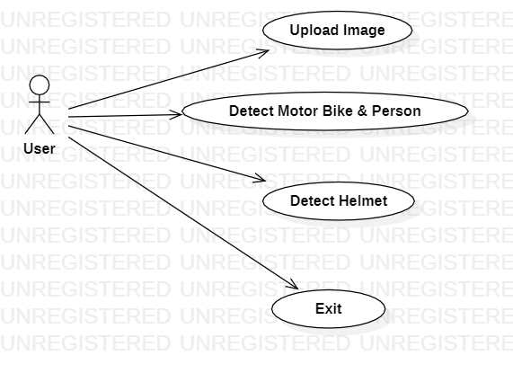

2.CLASS DIAGRAM:
In software engineering, a class diagram in the Unified Modeling Language (UML) is a type of static structure diagram that describes the structure of a system by showing the system's classes, their attributes, operations (or methods), and the relationships among the classes. It explains which class contains information.

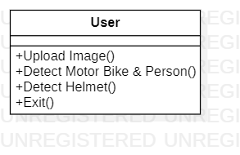

3.SEQUENCE DIAGRAM:
A sequence diagram in Unified Modeling Language (UML) is a kind of interaction diagram that shows how processes operate with one another and in what order. It is a construct of a Message Sequence Chart. Sequence diagrams are sometimes called event diagrams, event scenarios, and timing diagrams.

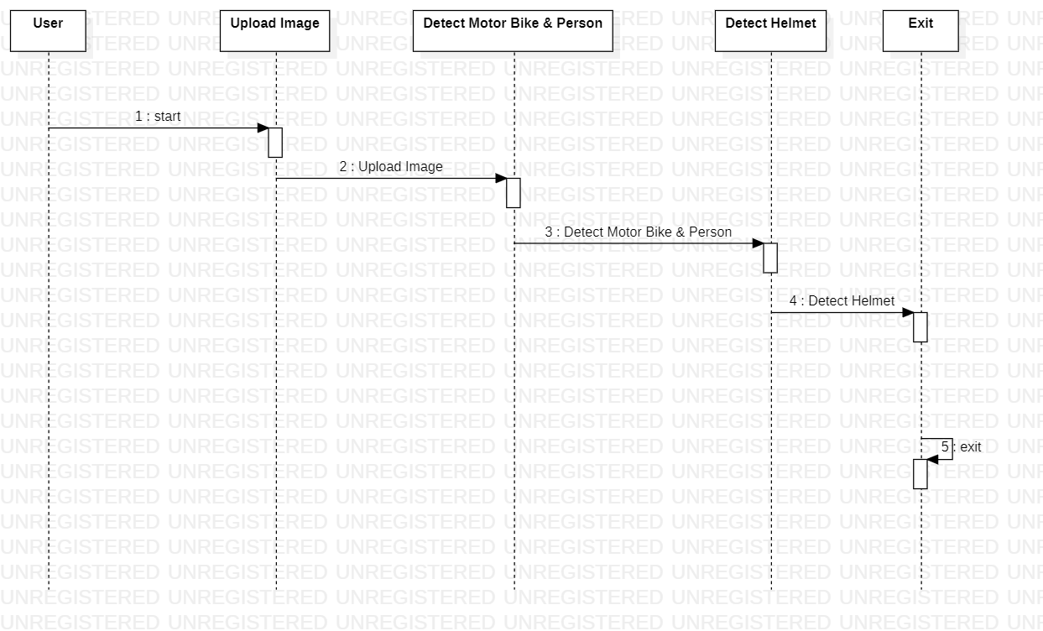

4.ACTIVITY DIAGRAM:
Activity diagrams are graphical representations of workflows of stepwise activities and actions with support for choice, iteration and concurrency. In the Unified Modeling Language, activity diagrams can be used to describe the business and operational step-by-step workflows of components in a system. An activity diagram shows the overall flow of control.

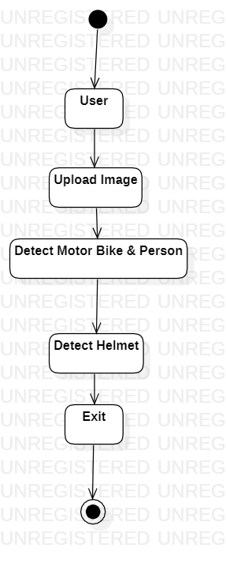
DEPLOYMENT DIAGRAM:
Deployment diagram represents the deployment view of a system. It is related to the component diagram. Because the components are deployed using the deployment diagrams. A deployment diagram consists of nodes. Nodes are nothing but physical hardware’s used to deploy the application.
.
COLLABORATION DIAGRAM:
In collaboration diagram the method call sequence is indicated by some numbering technique as shown below. The number indicates how the methods are called one after another. We have taken the same order management system to describe the collaboration diagram. The method calls are similar to that of a sequence diagram. But the difference is that the sequence diagram does not describe the object organization where as the collaboration diagram shows the object organization.

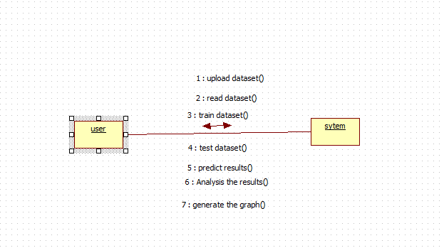

DEPLOYMENT DIAGRAM:
Deployment diagram represents the deployment view of a system. It is related to the component diagram. Because the components are deployed using the deployment diagrams. A deployment diagram consists of nodes. Nodes are nothing but physical hardware’s used to deploy the application.
.
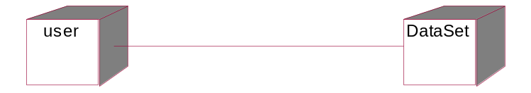
4.Design
4.1 Architecture

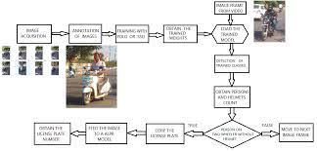

5.Implementation
Alogorithm
Yolo
def loadLibraries(): #function to load yolov3 model weight and class labels
global class_labels
global cnn_model
global cnn_layer_names
class_labels = open('yolov3model/yolov3-labels').read().strip().split('\n') #reading labels from yolov3 model
print(str(class_labels)+" == "+str(len(class_labels)))
cnn_model = cv.dnn.readNetFromDarknet('yolov3model/yolov3.cfg', 'yolov3model/yolov3.weights') #reading model
cnn_layer_names = cnn_model.getLayerNames() #getting layers from cnn model
cnn_layer_names = [cnn_layer_names[i[0] - 1] for i in cnn_model.getUnconnectedOutLayers()] #assigning all layers

def detectFromImage(imagename): #function to detect object from images
#random colors to assign unique color to each label
label_colors = (0,255,0)#np.random.randint(0,255,size=(len(class_labels),3),dtype='uint8')
try:
image = cv.imread(imagename) #image reading
image_height, image_width = image.shape[:2] #converting image to two dimensional array
except:
raise 'Invalid image path'
finally:
image, _, _, _, _ = detectObject(cnn_model, cnn_layer_names, image_height, image_width, image, label_colors, class_labels,indexno)#calling detection function
displayImage(image,0)#display image with detected objects label

def detectFromVideo(videoFile): #function to read objects from video

#random colors to assign unique color to each label
label_colors = (0,255,0)#np.random.randint(0,255,size=(len(class_labels),3),dtype='uint8')
indexno = 0
try:

video = cv.VideoCapture(videoFile)
frame_height, frame_width = None, None #reading video from given path
video_writer = None
except:
raise 'Unable to load video'
finally:
while True:
frame_grabbed, frames = video.read() #taking each frame from video
#print(frame_grabbed)
if not frame_grabbed: #condition to check whether video loaded or not
break
if frame_width is None or frame_height is None:
frame_height, frame_width = frames.shape[:2] #detecting object from frame
frames, _, _, _, _ = detectObject(cnn_model, cnn_layer_names, frame_height, frame_width, frames, label_colors, class_labels,indexno)
#displayImage(frames,index)
#indexno = indexno + 1
print(indexno)
if indexno == 5:
video.release()
break

print ("Releasing resources")
#video_writer.release()
video.release()

if __name__ == '__main__':
loadLibraries()
print("sample commands to run code with image or video")
print("python yolo.py image input_image_path")
print("python yolo.py video input_video_path")
if len(sys.argv) == 3:
if sys.argv[1] == 'image':
detectFromImage(sys.argv[2])
elif sys.argv[1] == 'video':
detectFromVideo(sys.argv[2])
else:
print("invalid input")
else:
print("follow sample command to run code")

#video_path = None
#video_output_path = "out.avi"

Sample Code
from tkinter import *
import tkinter
from tkinter import filedialog
import numpy as np
from tkinter.filedialog import askopenfilename
import pandas as pd
from tkinter import simpledialog
import numpy as np
import cv2 as cv
import subprocess
import time
import os
from yoloDetection import detectObject, displayImage
import sys
from time import sleep
from tkinter import messagebox
import pytesseract as tess
from keras.models import model_from_json
from keras.utils.np_utils import to_categorical

main = tkinter.Tk()
main.title("Helmet Detection") #designing main screen
main.geometry("800x700")

global filename
global loaded_model

global class_labels
global cnn_model
global cnn_layer_names

frame_count = 0
frame_count_out=0

confThreshold = 0.5
nmsThreshold = 0.4
inpWidth = 416
inpHeight = 416
global option
labels_value = []
with open("Models/labels.txt", "r") as file: #reading MRC dictionary
for line in file:
line = line.strip('\n')
line = line.strip()
labels_value.append(line)
file.close()

with open('Models/model.json', "r") as json_file:
loaded_model_json = json_file.read()
plate_detecter = model_from_json(loaded_model_json)

plate_detecter.load_weights("Models/model_weights.h5")
plate_detecter._make_predict_function()

classesFile = "Models/obj.names";
classes = None

with open(classesFile, 'rt') as f:
classes = f.read().rstrip('\n').split('\n')

modelConfiguration = "Models/yolov3-obj.cfg";
modelWeights = "Models/yolov3-obj_2400.weights";

net = cv.dnn.readNetFromDarknet(modelConfiguration, modelWeights)
net.setPreferableBackend(cv.dnn.DNN_BACKEND_OPENCV)
net.setPreferableTarget(cv.dnn.DNN_TARGET_CPU)

def getOutputsNames(net):
layersNames = net.getLayerNames()
return [layersNames[i[0] - 1] for i in net.getUnconnectedOutLayers()]

def loadLibraries(): #function to load yolov3 model weight and class labels
global class_labels
global cnn_model
global cnn_layer_names
class_labels = open('yolov3model/yolov3-labels').read().strip().split('\n') #reading labels from yolov3 model
print(str(class_labels)+" == "+str(len(class_labels)))
cnn_model = cv.dnn.readNetFromDarknet('yolov3model/yolov3.cfg', 'yolov3model/yolov3.weights') #reading model
cnn_layer_names = cnn_model.getLayerNames() #getting layers from cnn model
cnn_layer_names = [cnn_layer_names[i[0] - 1] for i in cnn_model.getUnconnectedOutLayers()] #assigning all layers

def upload(): #function to upload tweeter profile
global filename
filename = filedialog.askopenfilename(initialdir="bikes")
#messagebox.showinfo("File Information", "image file loaded")

def detectBike():
global option
option = 0
indexno = 0
label_colors = (0,255,0)
try:
image = cv.imread(filename)
image_height, image_width = image.shape[:2]
except:
raise 'Invalid image path'
finally:
image, ops = detectObject(cnn_model, cnn_layer_names, image_height, image_width, image, label_colors, class_labels,indexno)
if ops == 1:
displayImage(image,0)#display image with detected objects label
option = 1
else:
displayImage(image,0)

def drawPred(classId, conf, left, top, right, bottom,frame,option):
global frame_count
#cv.rectangle(frame, (left, top), (right, bottom), (255, 178, 50), 3)
label = '%.2f' % conf
if classes:
assert(classId < len(classes))
label = '%s:%s' % (classes[classId], label)
labelSize, baseLine = cv.getTextSize(label, cv.FONT_HERSHEY_SIMPLEX, 0.5, 1)
top = max(top, labelSize[1])
label_name,label_conf = label.split(':')
print(label_name+" === "+str(conf)+"== "+str(option))
if label_name == 'Helmet' and conf > 0.50:
if option == 0 and conf > 0.90:
cv.rectangle(frame, (left, top - round(1.5*labelSize[1])), (left + round(1.5*labelSize[0]), top + baseLine), (255, 255, 255), cv.FILLED)
cv.putText(frame, label, (left, top), cv.FONT_HERSHEY_SIMPLEX, 0.75, (0,0,0), 1)
frame_count+=1
if option == 0 and conf < 0.90:
cv.putText(frame, "Helmet Not detected", (10, top), cv.FONT_HERSHEY_SIMPLEX, 0.75, (0,255,0), 2)
frame_count+=1
img = cv.imread(filename)
img = cv.resize(img, (64,64))
im2arr = np.array(img)
im2arr = im2arr.reshape(1,64,64,3)
X = np.asarray(im2arr)
X = X.astype('float32')
X = X/255
preds = plate_detecter.predict(X)
predict = np.argmax(preds)
#img = cv.imread(filename)
#img = cv.resize(img,(500,500))
#text = tess.image_to_string(img, lang='eng')
#text = text.replace("\n"," ")
#messagebox.showinfo("Number Plate Detection Result", "Number plate detected as "+text)
textarea.insert(END,filename+"\n\n")
textarea.insert(END,"Number plate detected as "+str(labels_value[predict]))
if option == 1:
cv.rectangle(frame, (left, top - round(1.5*labelSize[1])), (left + round(1.5*labelSize[0]), top + baseLine), (255, 255, 255), cv.FILLED)
cv.putText(frame, label, (left, top), cv.FONT_HERSHEY_SIMPLEX, 0.75, (0,0,0), 1)
frame_count+=1

if(frame_count> 0):
return frame_count

def postprocess(frame, outs, option):
frameHeight = frame.shape[0]
frameWidth = frame.shape[1]
global frame_count_out
frame_count_out=0
classIds = []
confidences = []
boxes = []
classIds = []
confidences = []
boxes = []
cc = 0
for out in outs:
for detection in out:
scores = detection[5:]
classId = np.argmax(scores)
confidence = scores[classId]
if confidence > confThreshold:
center_x = int(detection[0] * frameWidth)
center_y = int(detection[1] * frameHeight)
width = int(detection[2] * frameWidth)
height = int(detection[3] * frameHeight)
left = int(center_x - width / 2)
top = int(center_y - height / 2)
classIds.append(classId)
#print(classIds)
confidences.append(float(confidence))
boxes.append([left, top, width, height])

indices = cv.dnn.NMSBoxes(boxes, confidences, confThreshold, nmsThreshold)
count_person=0 # for counting the classes in this loop.
for i in indices:
i = i[0]
box = boxes[i]
left = box[0]
top = box[1]
width = box[2]
height = box[3]
frame_count_out = drawPred(classIds[i], confidences[i], left, top, left + width, top + height,frame,option)
my_class='Helmet'
unknown_class = classes[classId]
print("===="+str(unknown_class))
if my_class == unknown_class:
count_person += 1

print(str(frame_count_out))
if count_person == 0 and option == 1:
cv.putText(frame, "Helmet Not detected", (10, 50), cv.FONT_HERSHEY_SIMPLEX, 0.75, (0,255,0), 2)
if count_person >= 1 and option == 0:
#path = 'test_out/'
#cv.imwrite(str(path)+str(cc)+".jpg", frame) # writing to folder.
#cc = cc + 1
frame = cv.resize(frame,(500,500))
cv.imshow('img',frame)
cv.waitKey(50)

def detectHelmet():
textarea.delete('1.0', END)
if option == 1:
frame = cv.imread(filename)
frame_count =0
blob = cv.dnn.blobFromImage(frame, 1/255, (inpWidth, inpHeight), [0,0,0], 1, crop=False)
net.setInput(blob)
outs = net.forward(getOutputsNames(net))
postprocess(frame, outs,0)
t, _ = net.getPerfProfile()
label = 'Inference time: %.2f ms' % (t * 1000.0 / cv.getTickFrequency())
print(label)
cv.putText(frame, label, (0, 15), cv.FONT_HERSHEY_SIMPLEX, 0.5, (0, 0, 255))
print(label)
else:
messagebox.showinfo("Person & Motor bike not detected in uploaded image", "Person & Motor bike not detected in uploaded image")

def videoHelmetDetect():
global filename
videofile = askopenfilename(initialdir = "videos")
video = cv.VideoCapture(videofile)
while(True):
ret, frame = video.read()
if ret == True:
frame_count = 0
filename = "temp.png"
cv.imwrite("temp.png",frame)
blob = cv.dnn.blobFromImage(frame, 1/255, (inpWidth, inpHeight), [0,0,0], 1, crop=False)
net.setInput(blob)
outs = net.forward(getOutputsNames(net))
postprocess(frame, outs,1)
t, _ = net.getPerfProfile()
#label=''
#cv.putText(frame, label, (0, 15), cv.FONT_HERSHEY_SIMPLEX, 0.5, (0, 0, 255))
cv.imshow("Predicted Result", frame)
if cv.waitKey(5) & 0xFF == ord('q'):
break
else:
break
video.release()
cv.destroyAllWindows()

def exit():
global main
main.destroy()

font = ('times', 16, 'bold')
title = Label(main, text='Number Plate Detection without Helmet', justify=LEFT)
title.config(bg='lavender blush', fg='DarkOrchid1')
title.config(font=font)
title.config(height=3, width=120)
title.place(x=100,y=5)
title.pack()

font1 = ('times', 14, 'bold')
model = Button(main, text="Upload Image", command=upload)
model.place(x=200,y=100)
model.config(font=font1)

uploadimage = Button(main, text="Detect Motor Bike & Person", command=detectBike)
uploadimage.place(x=200,y=150)
uploadimage.config(font=font1)

classifyimage = Button(main, text="Detect Helmet", command=detectHelmet)
classifyimage.place(x=200,y=200)
classifyimage.config(font=font1)

exitapp = Button(main, text="Exit", command=exit)
exitapp.place(x=200,y=250)
exitapp.config(font=font1)

font1 = ('times', 12, 'bold')
textarea=Text(main,height=15,width=60)
scroll=Scrollbar(textarea)
textarea.configure(yscrollcommand=scroll.set)
textarea.place(x=10,y=300)
textarea.config(font=font1)

loadLibraries()

main.config(bg='light coral')
main.mainloop()
6.Results and Screen shots

RESULTS

After setting path double click on ‘run.bat’ file to run project and to get below screen

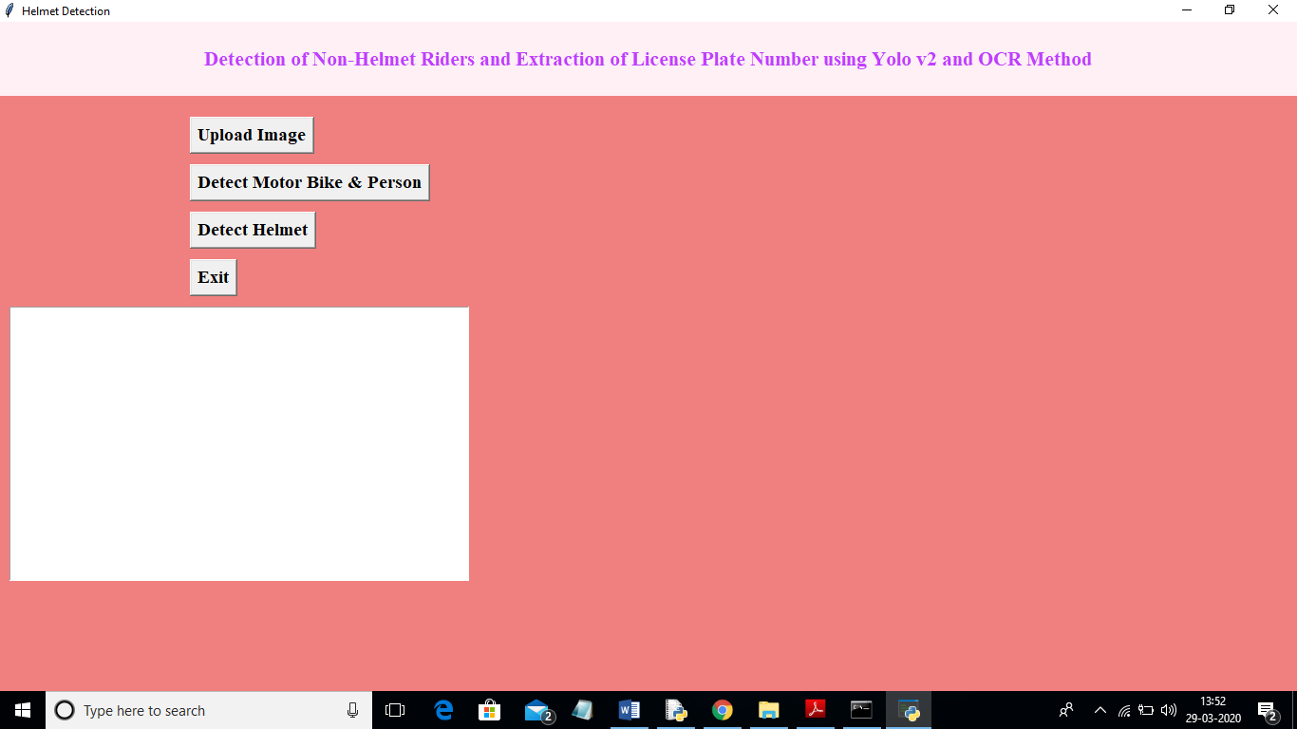
In above screen click on ‘Upload Image’ button and upload image
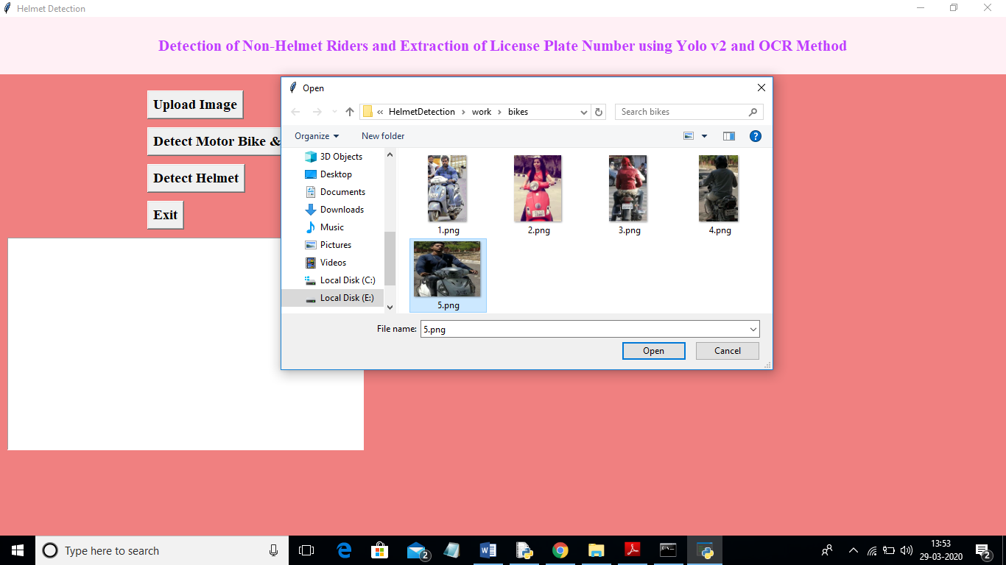
In above screen I selected one image as ‘5.png’ and click on ‘Open’ button to load image. Now click on ‘Detect Motor Bike & Person’ button to detect whether image contains person with motor bike or not
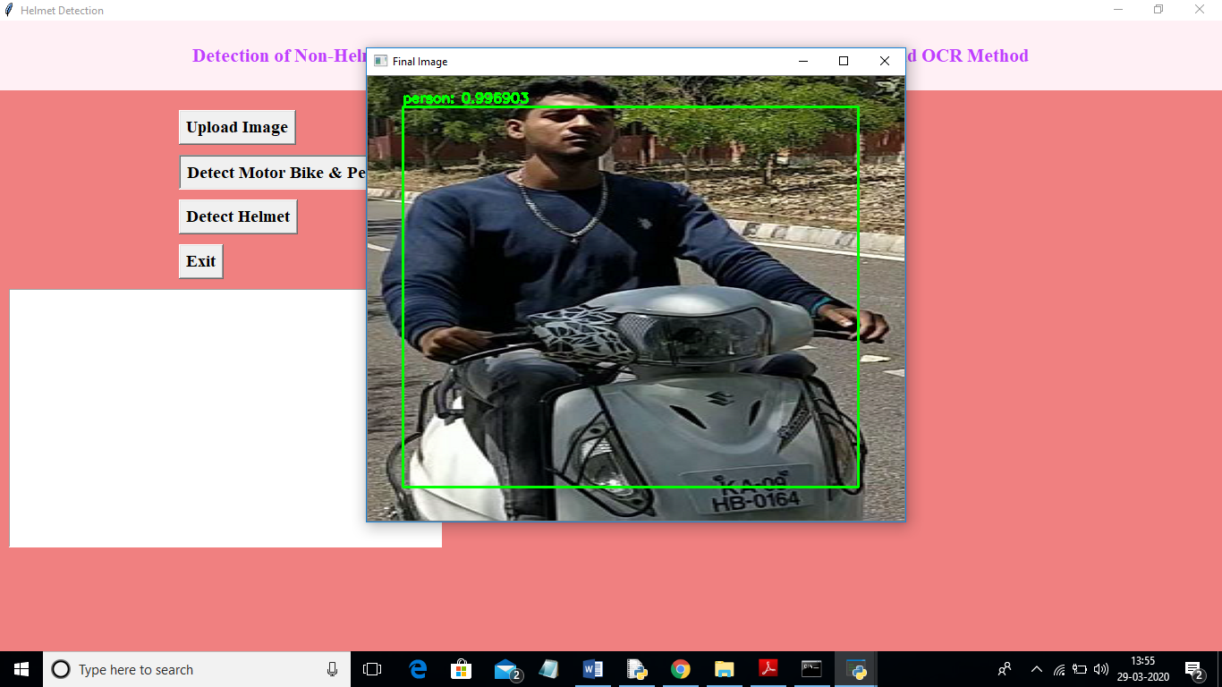
In above screen yolo detected image contains person and bike and now click on ‘Detect Helmet’ button to detect whether he is wearing helmet or not
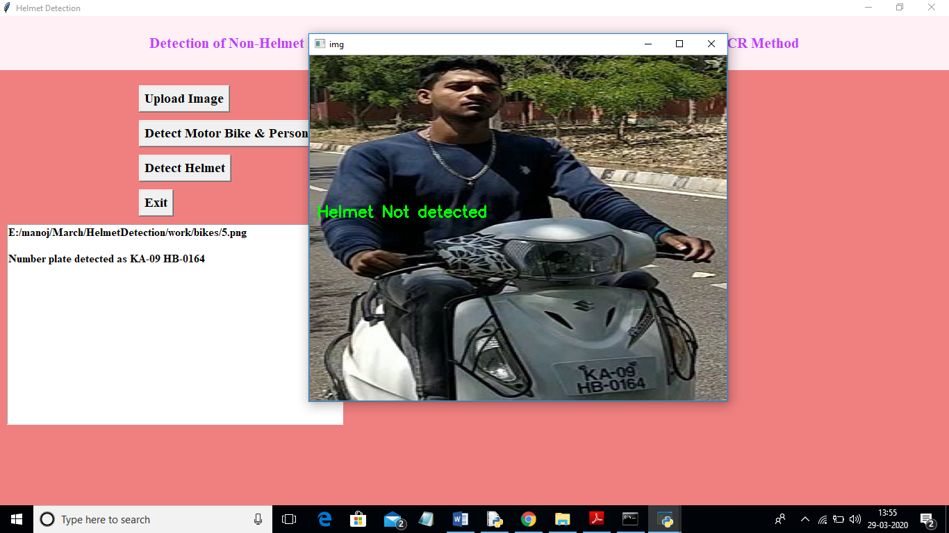
In above screen application detected that person is not wearing helmet and its extracted number from vehicle and display in beside text area. Now we will check with helmet image
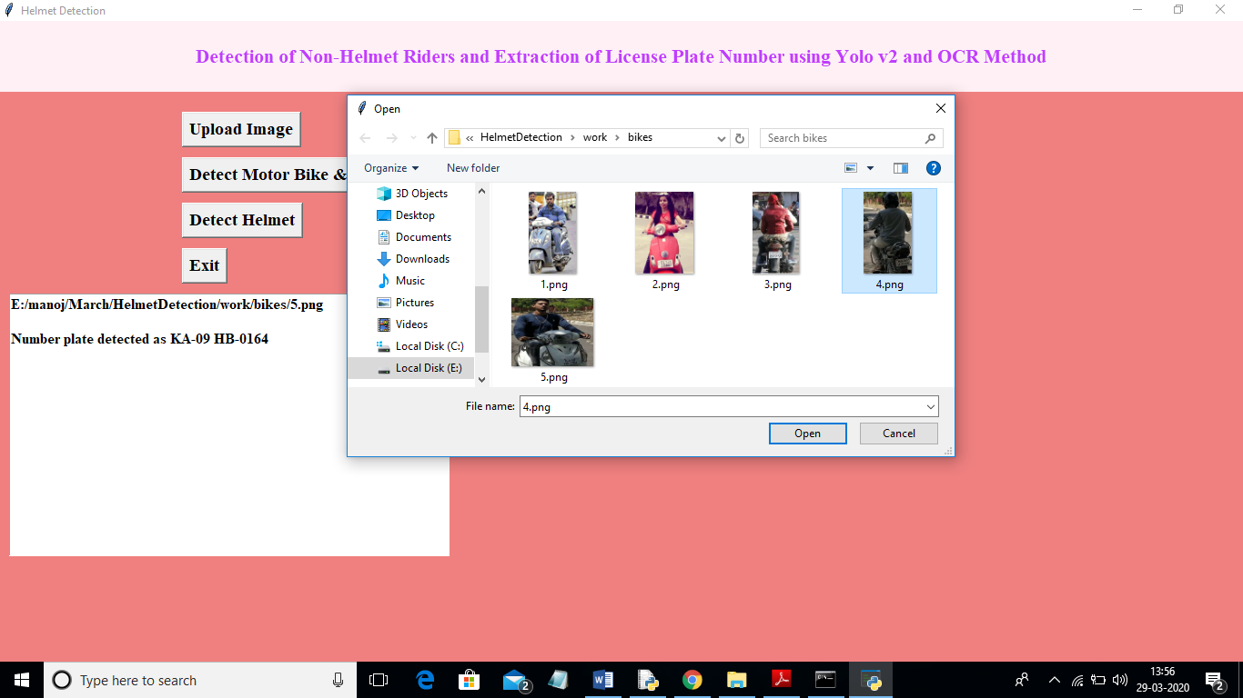
In above screen I am uploading 4.png which is wearing helmet and now click on ‘Detect Motor Bike & Person’ button to get below result
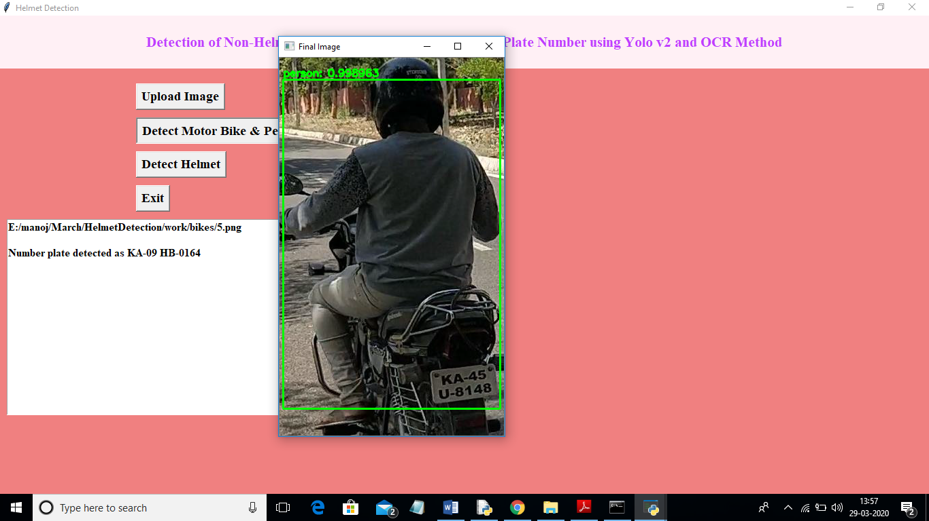
In above screen yolo detected person with motor bike and now click on ‘Detect Helmet’ button to get below result
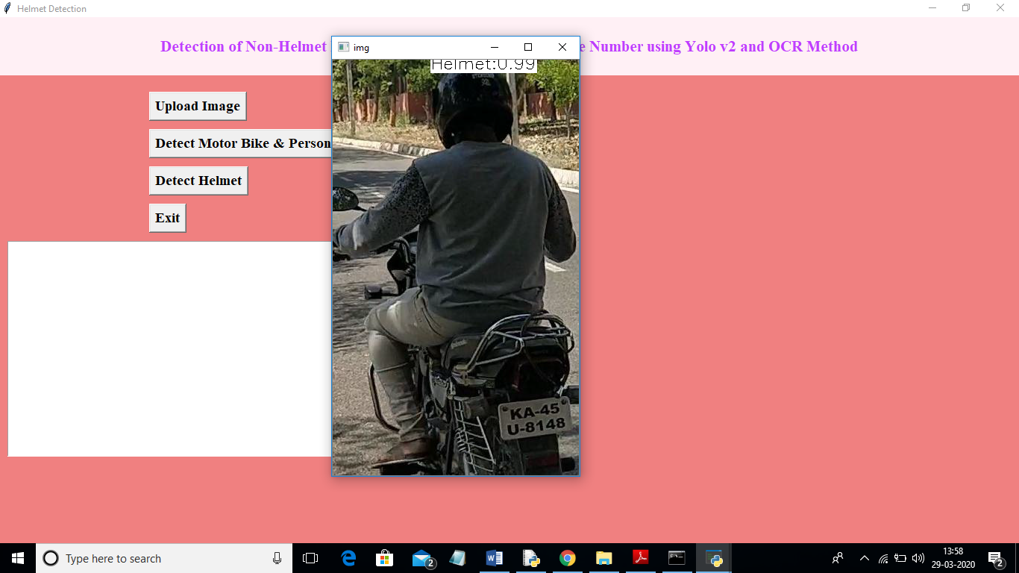
In above screen application detected person is wearing helmet and that label is displaying around his head and application stop there itself and not scanning number plate.
Note: To implement this project and to extract number plate we have trained few images and if u want to extract for new images then send those new images to us, so we include those images in yolo model to extract new images number plate also.

- Testing

SYSTEM TEST
The purpose of testing is to discover errors. Testing is the process of trying to discover every conceivable fault or weakness in a work product. It provides a way to check the functionality of components, sub assemblies, assemblies and/or a finished product It is the process of exercising software with the intent of ensuring that the Software system meets its requirements and user expectations and does not fail in an unacceptable manner. There are various types of test. Each test type addresses a specific testing requirement.

TYPES OF TESTS

Unit testing
Unit testing involves the design of test cases that validate that the internal program logic is functioning properly, and that program inputs produce valid outputs. All decision branches and internal code flow should be validated. It is the testing of individual software units of the application .it is done after the completion of an individual unit before integration. This is a structural testing, that relies on knowledge of its construction and is invasive. Unit tests perform basic tests at component level and test a specific business process, application, and/or system configuration. Unit tests ensure that each unique path of a business process performs accurately to the documented specifications and contains clearly defined inputs and expected results.

Integration testing
Integration tests are designed to test integrated software components to determine if they actually run as one program. Testing is event driven and is more concerned with the basic outcome of screens or fields. Integration tests demonstrate that although the components were individually satisfaction, as shown by successfully unit testing, the combination of components is correct and consistent. Integration testing is specifically aimed at exposing the problems that arise from the combination of components.

Functional test

Functional tests provide systematic demonstrations that functions tested are available as specified by the business and technical requirements, system documentation, and user manuals.
Functional testing is centered on the following items:
Valid Input : identified classes of valid input must be accepted.
Invalid Input : identified classes of invalid input must be rejected.
Functions : identified functions must be exercised.
Output : identified classes of application outputs must be exercised.
Systems/Procedures : interfacing systems or procedures must be invoked.
Organization and preparation of functional tests is focused on requirements, key functions, or special test cases. In addition, systematic coverage pertaining to identify Business process flows; data fields, predefined processes, and successive processes must be considered for testing. Before functional testing is complete, additional tests are identified and the effective value of current tests is determined.

System Test
System testing ensures that the entire integrated software system meets requirements. It tests a configuration to ensure known and predictable results. An example of system testing is the configuration oriented system integration test. System testing is based on process descriptions and flows, emphasizing pre-driven process links and integration points.

White Box Testing
White Box Testing is a testing in which in which the software tester has knowledge of the inner workings, structure and language of the software, or at least its purpose. It is purpose. It is used to test areas that cannot be reached from a black box level.

Black Box Testing

Black Box Testing is testing the software without any knowledge of the inner workings, structure or language of the module being tested. Black box tests, as most other kinds of tests, must be written from a definitive source document, such as specification or requirements document, such as specification or requirements document. It is a testing in which the software under test is treated, as a black box .you cannot “see” into it. The test provides inputs and responds to outputs without considering how the software works.
Unit Testing
Unit testing is usually conducted as part of a combined code and unit test phase of the software lifecycle, although it is not uncommon for coding and unit testing to be conducted as two distinct phases.
Test strategy and approach
Field testing will be performed manually and functional tests will be written in detail.
Test objectives
- All field entries must work properly.
- Pages must be activated from the identified link.
- The entry screen, messages and responses must not be delayed.

Features to be tested
- Verify that the entries are of the correct format
- No duplicate entries should be allowed
- All links should take the user to the correct page.

Integration Testing
Software integration testing is the incremental integration testing of two or more integrated software components on a single platform to produce failures caused by interface defects.
The task of the integration test is to check that components or software applications, e.g. components in a software system or – one step up – software applications at the company level – interact without error.
Test Results: All the test cases mentioned above passed successfully. No defects encountered.

Acceptance Testing
User Acceptance Testing is a critical phase of any project and requires significant participation by the end user. It also ensures that the system meets the functional requirements.
Test Results: All the test cases mentioned above passed successfully. No defects encountered.
TEST CASES:

S.NO | Test Case | Excepted Result | Result
1. | click on ‘Upload Image’ button to upload image | selecting and uploading ‘6.jpg’ file and then click on ‘Open’ button to load image and then click on ‘Detect Motor Bike & Person’ button to detect whether image contains person with bike or not | Pass
2. | Upload image | if person with bike detected then it put bounding box and then click on ‘Detect Helmet’ button to get below output | Pass
3 | Helmet not detected | we can see helmet not detected and then application identify number plate and display on the text area as ‘AP13Q 8815’. Now try with other image by uploading it | Pass
4 | Helmet detected | selecting and uploading ‘h3.jpg’ file and then click on ‘Open’ button then click on ‘Detect Motor Bike & Person’ button to get below result | pass

Conclusion and Future Enhancement
In the paper, we have described a framework for automatic detection of motorcycle riders without helmet from CCTV video and automatic retrieval of vehicle license number plate for such motorcyclists. The use of Convolutional Neural Networks (CNNs) and transfer learning has helped in achieving good accuracy for detection of motorcyclists not wearing helmets. The accuracy obtained was 98.72%. But, only detection of such motorcyclists is not sufficient for taking action against them. So, the system also recognizes the number plates of their motorcycles and stores them. The stored number plates can be then used by Transport Office to get information about the motorcyclists from their database of licensed vehicles. Concerned motorcyclists can then be penalized for breach of law.
REFERENCES
[1]. .J.Chiverton, "Helmet presence classification with motorcycle detection and tracking," in IET Intelligent Transport Systems, vol. 6, no. 3, pp. 259-269, September 2012.
[2]. R. Silva, K. Aires, T. Santos, K. Abdala, R. Veras and A. Soares, "Automatic detection of motorcyclists without helmet," 2013 XXXIX Latin American Computing Conference (CLEI), Naiguata, 2013, pp. 1-7.
[3]. R. R. V. e. Silva, K. R. T. Aires and R. d. M. S. Veras, "Helmet Detection on Motorcyclists Using Image Descriptors and Classifiers," 2014 27th SIBGRAPI Conference on Graphics, Patterns and Images, Rio de Janeiro, 2014, pp. 141-148.
[4]. P. Doungmala and K. Klubsuwan, "Helmet Wearing Detection in Thailand Using Haar Like Feature and Circle Hough Transform on Image Processing," 2016 IEEE International Conference on Computer and Information Technology (CIT), Nadi, 2016, pp. 611-614.
[5]. K. Dahiya, D. Singh and C. K. Mohan, "Automatic detection of bike-riders without helmet using surveillance videos in real-time," 2016 International Joint Conference on Neural Networks (IJCNN), Vancouver, BC, 2016, pp. 3046-3051.
[6]. C. Vishnu, D. Singh, C. K. Mohan and S. Babu, "Detection of motorcyclists without helmet in videos using convolutional neural network," 2017 International Joint Conference on Neural Networks (IJCNN), Anchorage, AK, 2017, pp. 3036-3041.
[7]. B. V. Kakani, D. Gandhi and S. Jani, "Improved OCR based automatic vehicle number plate recognition using features trained neural network," 2017 8th International Conference on Computing, and Networking Technologies (ICCCNT), Delhi, 2017, pp. 1-6.
[8]. N. Dalal and B. Triggs, “Histograms of oriented gradients for human detection,” in 2005 IEEE Computer Society Conference on Computer Vision and Pattern Recognition (CVPR’05), vol. 1, June 2005, pp. 886– 893 vol. 1.

