**SPIKE**: **Integrating Kafka with Backstage IDP**

**ConductedBy**: Saikrishna Vemuri

**Sprint:**

Goal

The purpose of this spike is to investigate and document the integration of Kafka with the Backstage Identity Provider (IDP) within our project. Specifically, we aim to provide visibility into Kafka details through the Backstage UI.

Method:

* Creating a backstage application from NPM and intializing it with the required configuration.[**GUIDE**: [Creating a backstage App](https://backstage.io/docs/getting-started/)]
* Add the kafka plugin to backstage as mentioned in the repository of plugins  
  [[backstage kafka plugin config](https://github.com/backstage/backstage/tree/master/plugins/kafka)]
* Create a free confulent account and create a topic in a cluster and add those details to the kafka config as mentioned in the plugin guide.
* Also create an API Key and secret in confluent and use those details in backstage to connect to the kafka cluster.

**Evidence:**

**Confulent cluster**

**Clustername**: sagent_test_kafka

**Topic name**: sagent_test_topic1

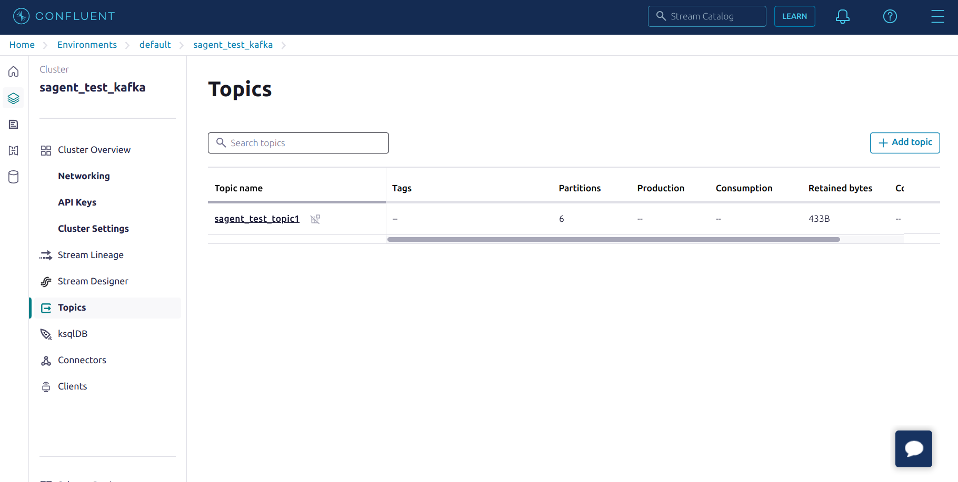

**API Keys:**

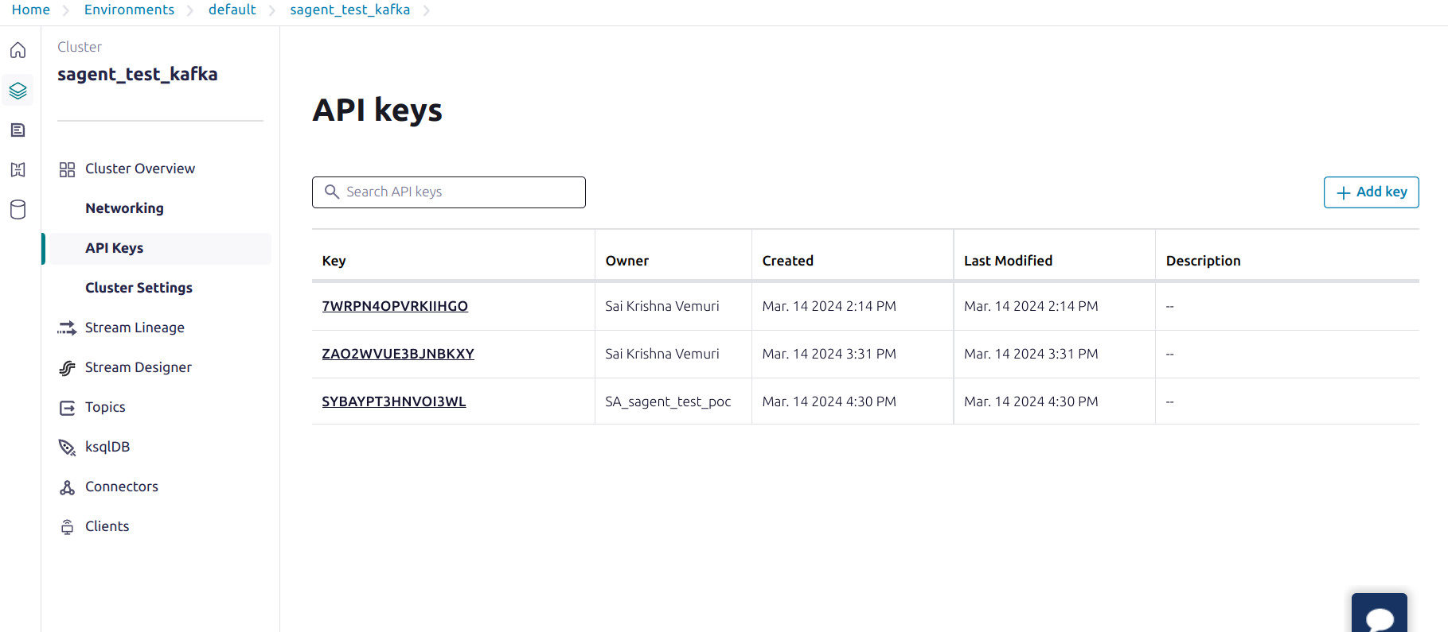

**Backstage Kakfa tab:**

The details being displayed for a consumer group which was created the moment i consumed messages from confluent CLI.

**Consumer group**: confluent_cli_consumer_c6dc18e1-0a43-4d35-92da-7b469885b171

**Cluster:** sagent_test_kafka

