Student Marks Prediction using Simple Linear Regression

Table of Contents
- 1. Project Summary
- 2. Project Workflow
- 3. Code Explanation
- 3.1 Import Libraries
- 3.2 Load Dataset
- 3.3 Feature Selection
- 3.4 Train-Test Split
- 3.5 Train Model
- 3.6 Prediction
- 3.7 Model Parameters
- 3.8 Model Evaluation
- 3.9 Graph Explanation
- 3.10 Save Model
- 4. Errors Faced and Solutions
- 5. Results
- 6. Conclusion

1. Project Summary
Objective: Build a Simple Linear Regression model to predict student marks using study hours.
Dataset:
• Feature: Study_Hours
• Target: Marks
• Algorithm: Simple Linear Regression
Tools: Python, Pandas, NumPy, Matplotlib, Scikit-learn, Pickle.

2. Project Workflow
Student Dataset
↓
Load Dataset
↓
Select Feature & Target
↓
Train-Test Split
↓
Train Model
↓
Predict
↓
Evaluate
↓
Plot Graph
↓
Save Model

3. Code Explanation

Import Libraries
- import matplotlib.pyplot as plt - Imports plotting library.
- import numpy as np - Performs mathematical operations.
- import pandas as pd - Reads and manages dataset.
- import pickle - Saves trained model.
- import os - Verifies saved model file.
- train_test_split - Splits data into training and testing.
- LinearRegression - Creates regression model.
- mean_absolute_error, mean_squared_error, r2_score - Evaluate model accuracy.

Load Dataset
- dataset = pd.read_csv(...) - Loads CSV into DataFrame.
- print(dataset.head()) - Displays first five rows to verify data.

Feature Selection
- X = dataset[['Study_Hours']].values - Selects input feature.
- y = dataset['Marks'].values - Selects target values.

Train-Test Split
- train_test_split(...) - Splits data into 80% training and 20% testing.
- test_size=0.20 - Keeps 20% for testing.
- random_state=0 - Produces same split every run.
- print(X_train.shape), print(X_test.shape) - Displays dataset sizes.

Train Model
- model = LinearRegression() - Creates SLR model.
- model.fit(X_train,y_train) - Learns relationship between study hours and marks.

Prediction
- y_pred = model.predict(X_test) - Predicts marks for test data.

Model Parameters
- model.coef_ - Displays slope (marks gained per additional study hour).
- model.intercept_ - Displays predicted marks when study hours are zero.

Model Evaluation
- MAE - Average prediction error.
- MSE - Average squared error.
- RMSE = np.sqrt(mse) - Error in original units.
- R² Score - Shows how well the model fits the data.

Graph Explanation
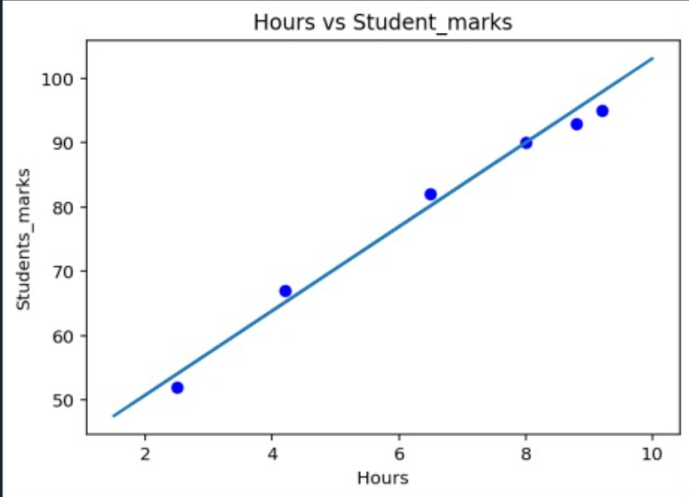
- plt.scatter() - Plots actual student data.
- plt.plot() - Draws regression line.
- plt.title() - Adds graph title.
- plt.xlabel() - Labels X-axis.
- plt.ylabel() - Labels Y-axis.
- plt.show() - Displays graph.
- Observation: Blue dots are actual values and the line is the predicted trend. Upward slope indicates that students studying more hours generally score higher marks.

Save Model
- with open(...,'wb') - Creates binary file.
- pickle.dump(model,file) - Saves trained model.
- os.path.exists() - Checks if model was saved successfully.

4. Errors Faced and Solutions
Error | Cause | Solution
FileNotFoundError | Incorrect dataset path | Corrected CSV path.
ModuleNotFoundError | Library missing | Installed required package.
ValueError | Wrong input format | Converted data using .values.
Graph not displayed | plt.show() missing | Added plt.show().
Model not saved | Incorrect file path | Verified using os.path.exists().

5. Results
• Coefficient: Shows increase in marks for every additional study hour.
• Intercept: Predicted marks when study hours are zero.
• Low MAE, MSE and RMSE indicate low prediction error.
• High R² Score indicates an excellent model fit.

6. Conclusion
The project successfully predicts student marks using Simple Linear Regression. The model was trained, evaluated, visualized and saved for future use. The graph and evaluation metrics show a strong positive relationship between study hours and student marks.

