**Experiment-4**

**Aim-**

**CREATE A SNAPSHOT AND CLONING OF A VM AND TEST IT BY LOADING THE PREVIOUS VERSION/CLONED VM.**

Click on the settings.

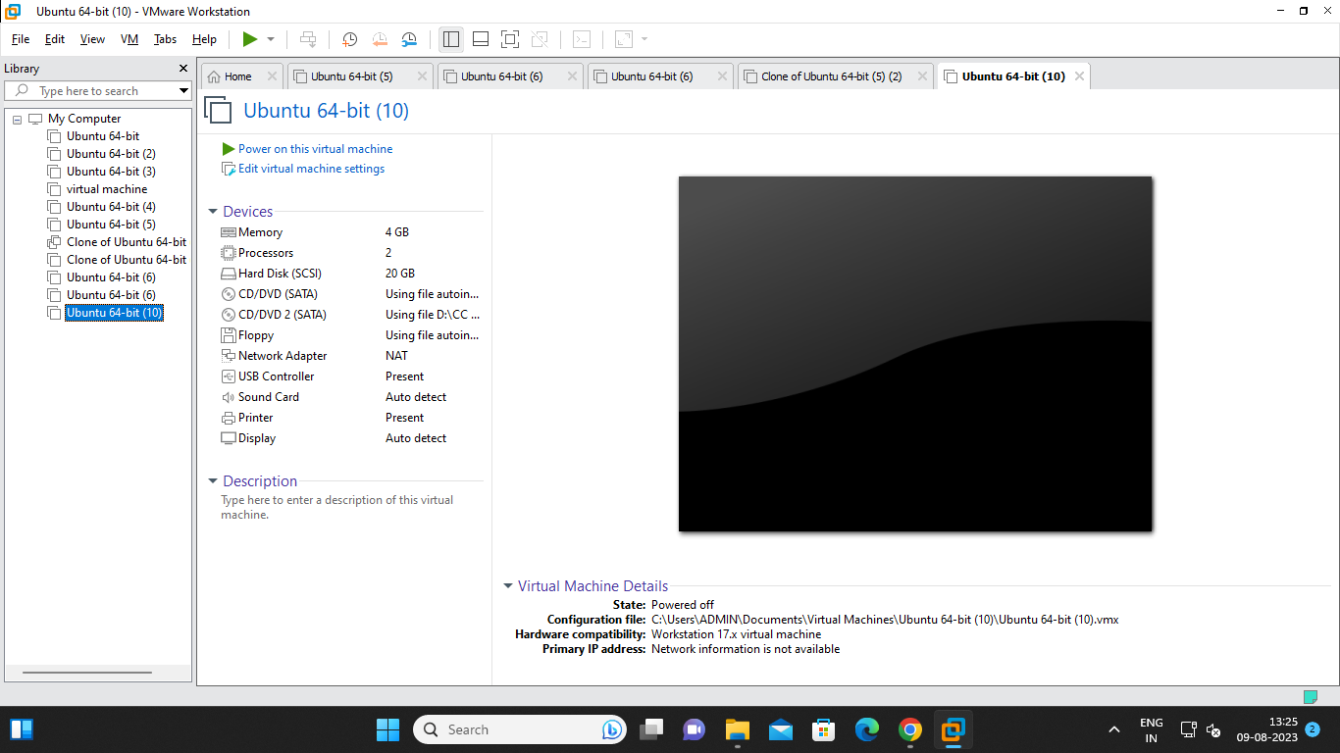

Click on the snapshot.

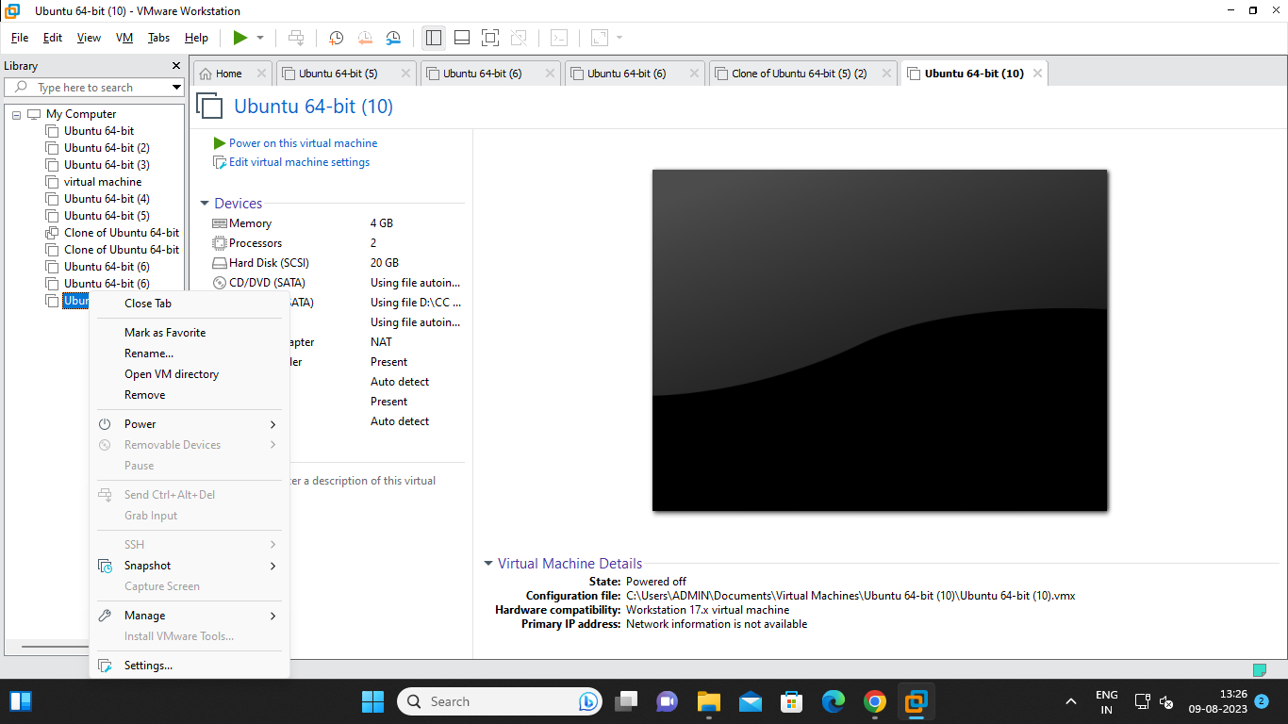

Take a snapshot.

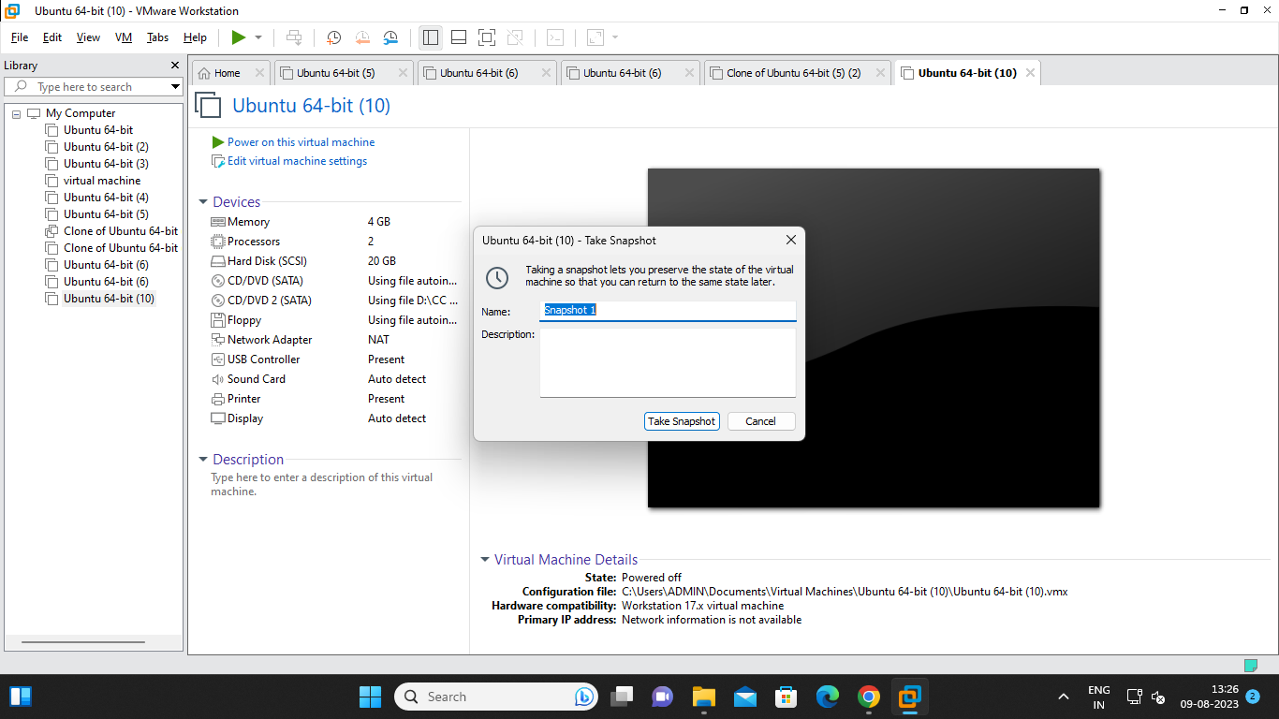

Click on the manage.

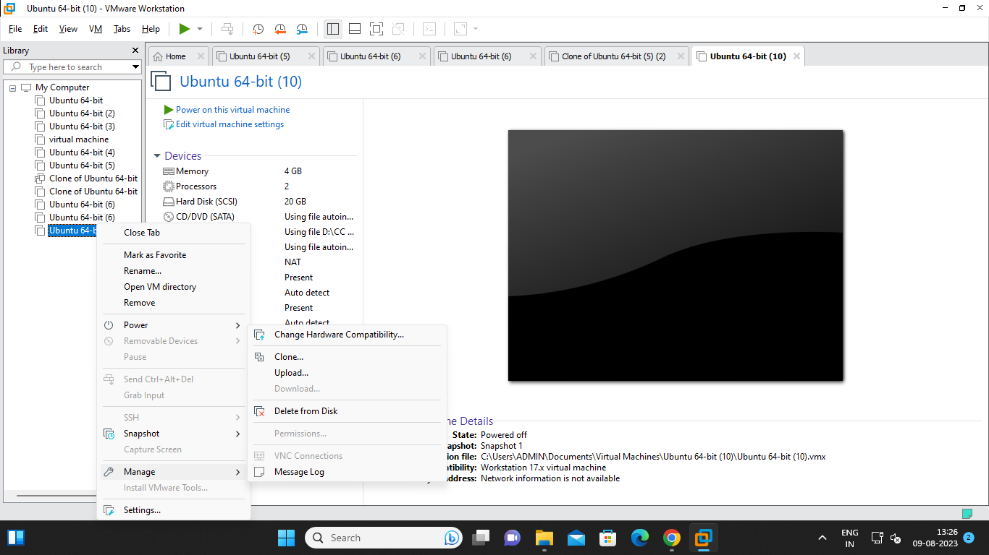

Click on the clone option.

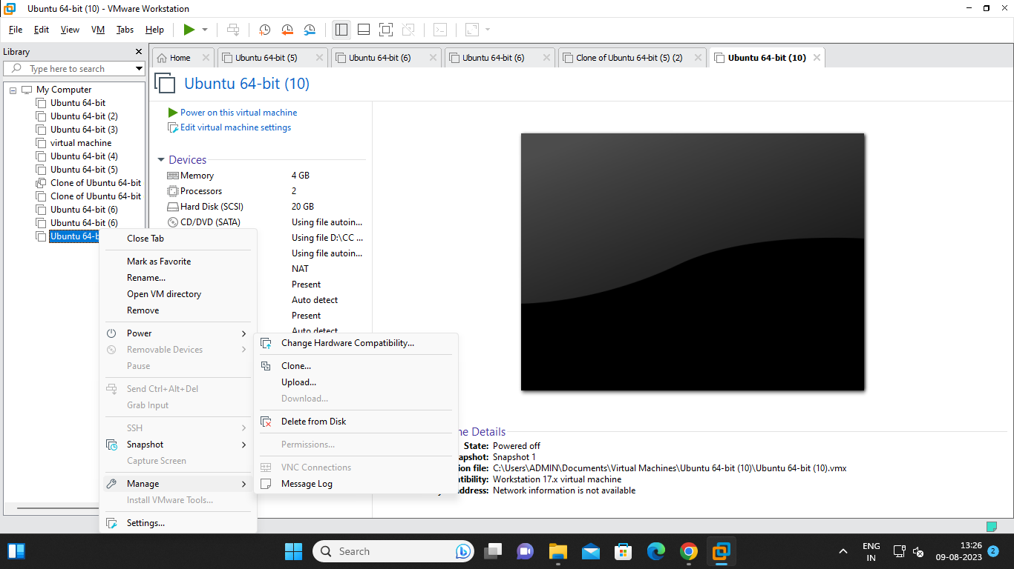

**Click on next**

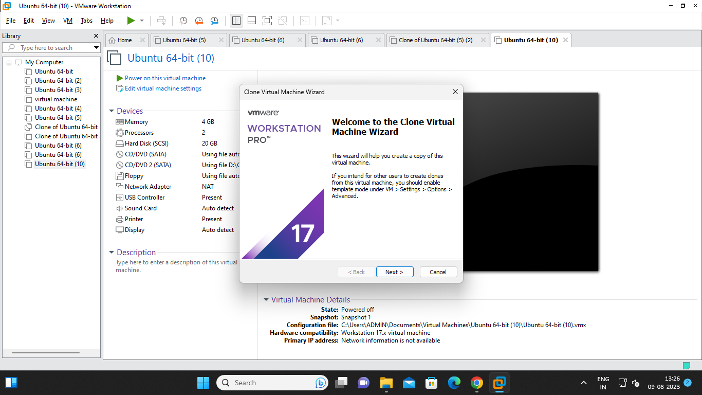

Click on next

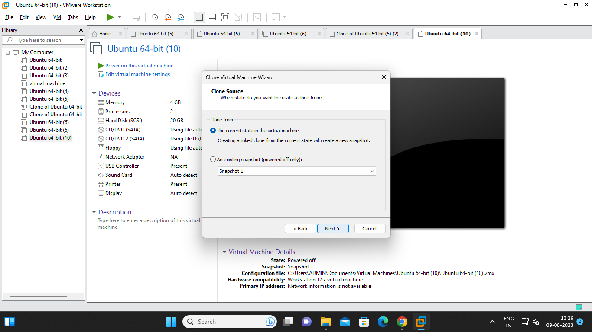

Click on next

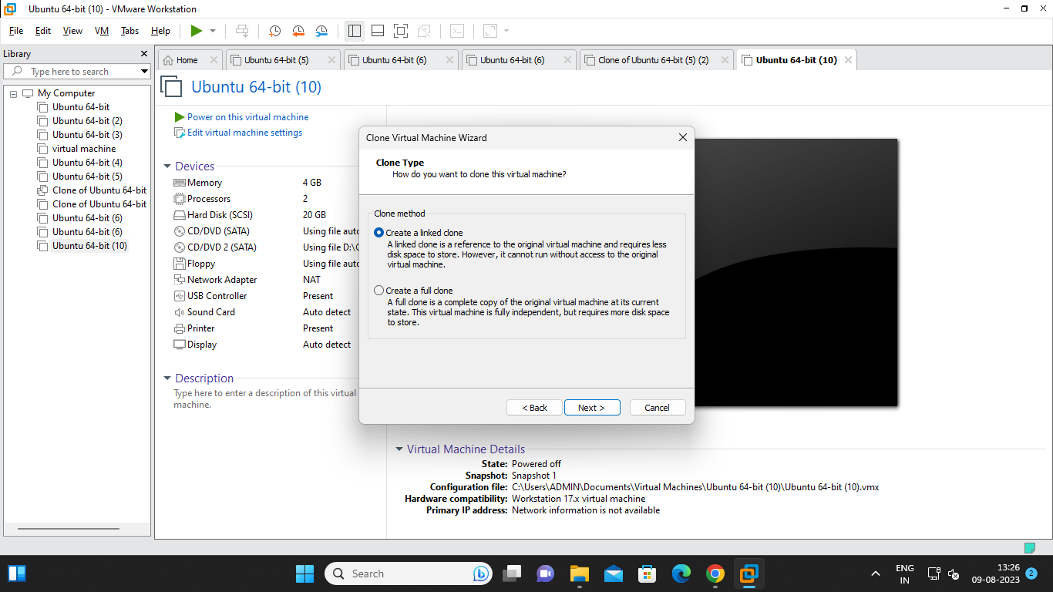

Click on finish and the clone of the vm is successfully completed.

