**EXPERIMENT-3**

**Aim-**

**Create a Virtual Hard Disk and allocate the storage using VM ware Workstation**

Right click on the required workstation and open the settings option.

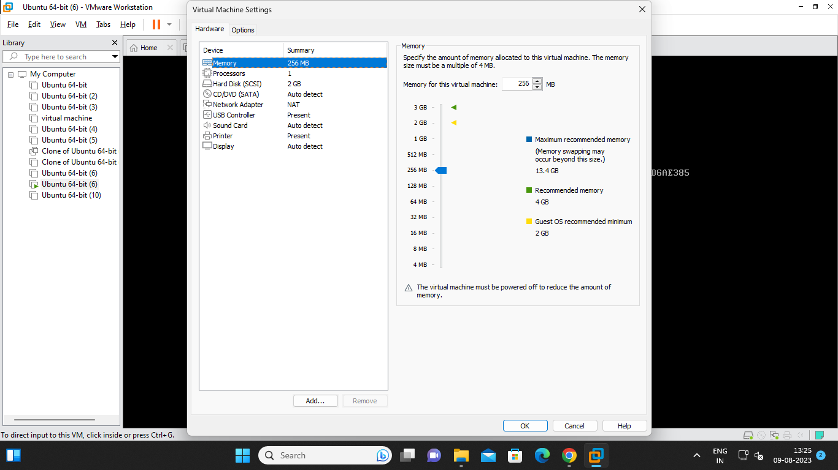

Click on the add option and click on the hard disk.

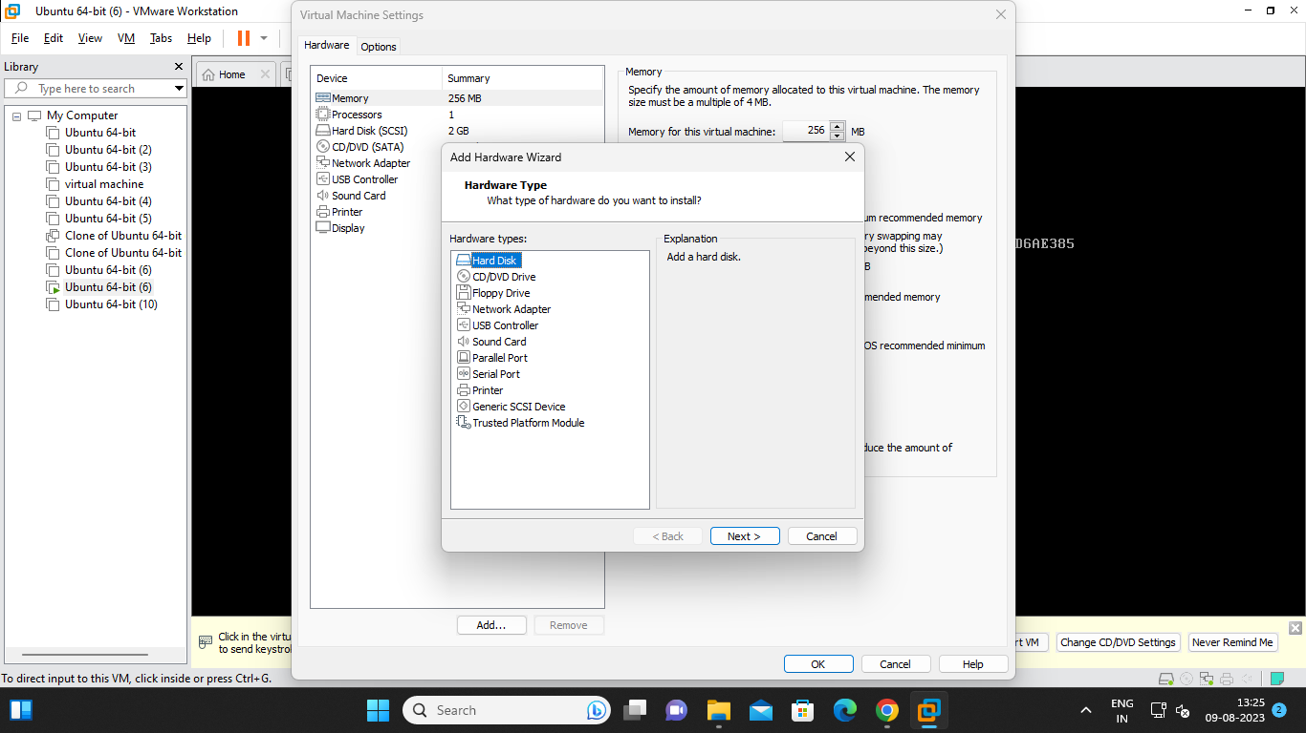

Click on next.

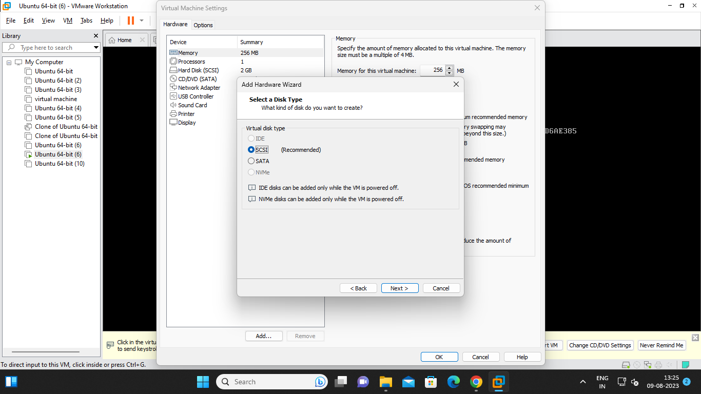

Enter the required storage data and enter next

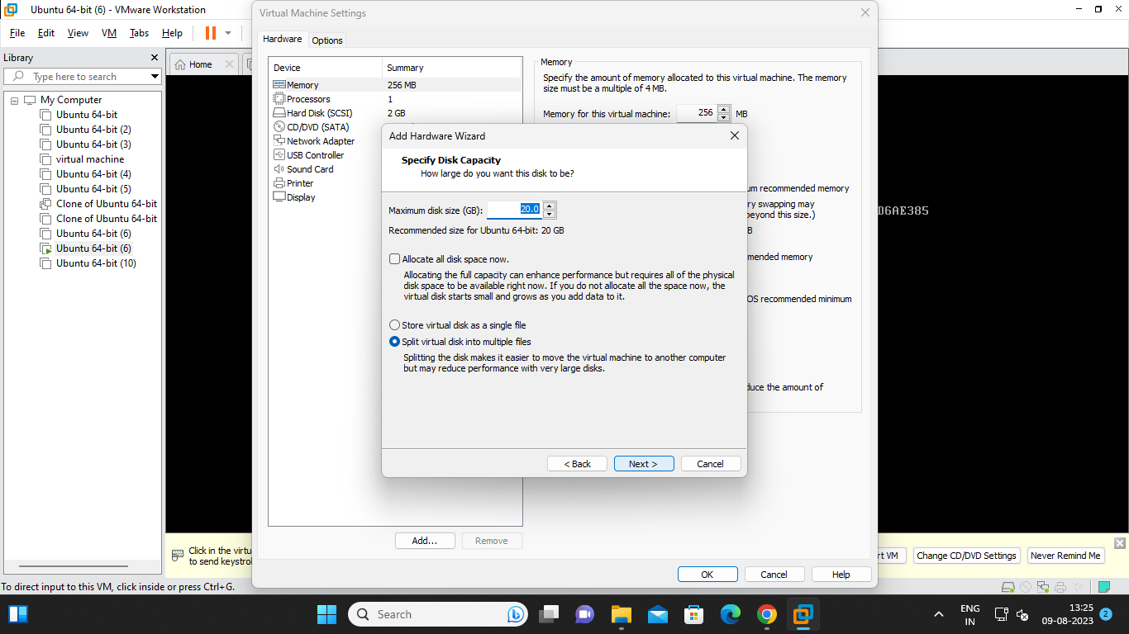

The new harddisk is created successfully.click on finish.

