**experiment-6**

**Aim-**

**CREATE A SIMPLE WEBSITE USING ANY PUBLIC CLOUD SERVICE PROVIDER (AZURE/GCP/AWS) AND CHECK THE PUBLIC ACCESSIBILITY OF THE STORED FILE TO DEMONSTRATE STORAGE AS A SERVICE**

Open the app services.

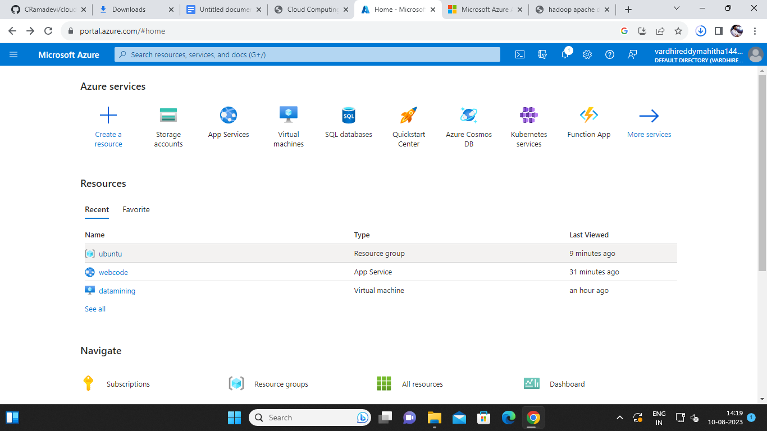

Select on the create option.

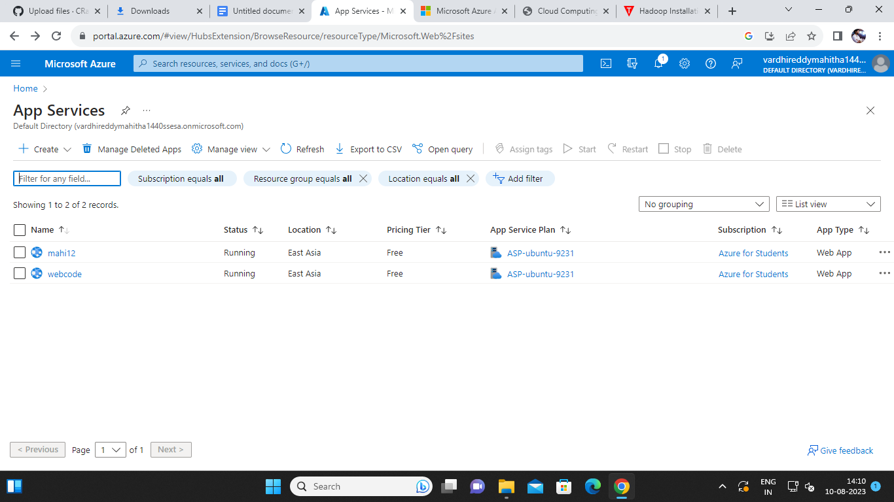

Enter the required details and click on the review and create.

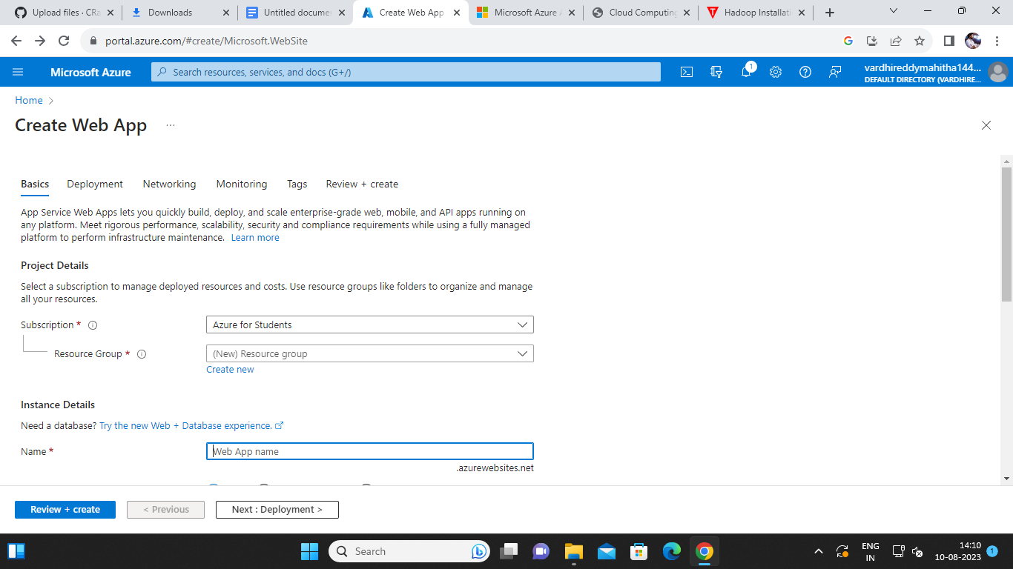

Now review the details and click on the create.

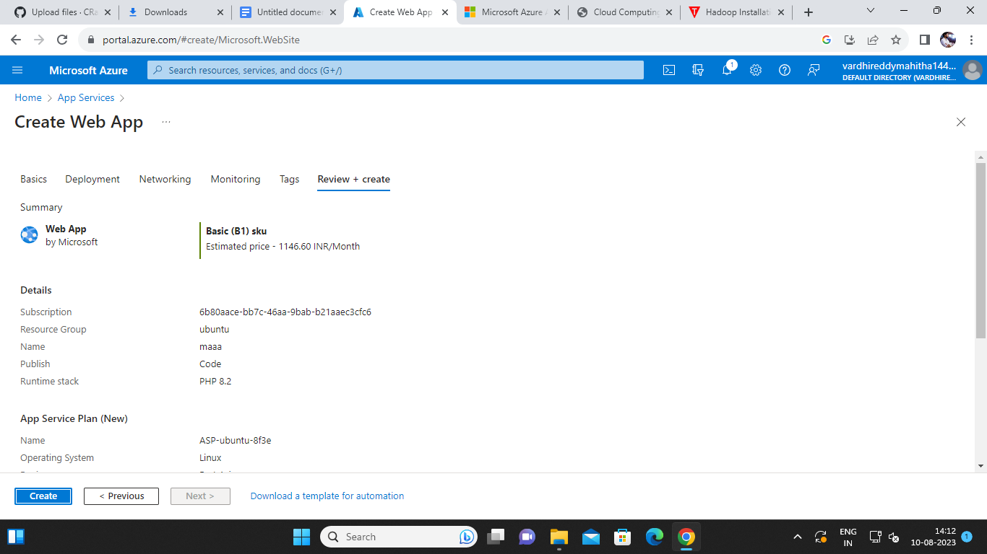

The deployment is completed successfully.

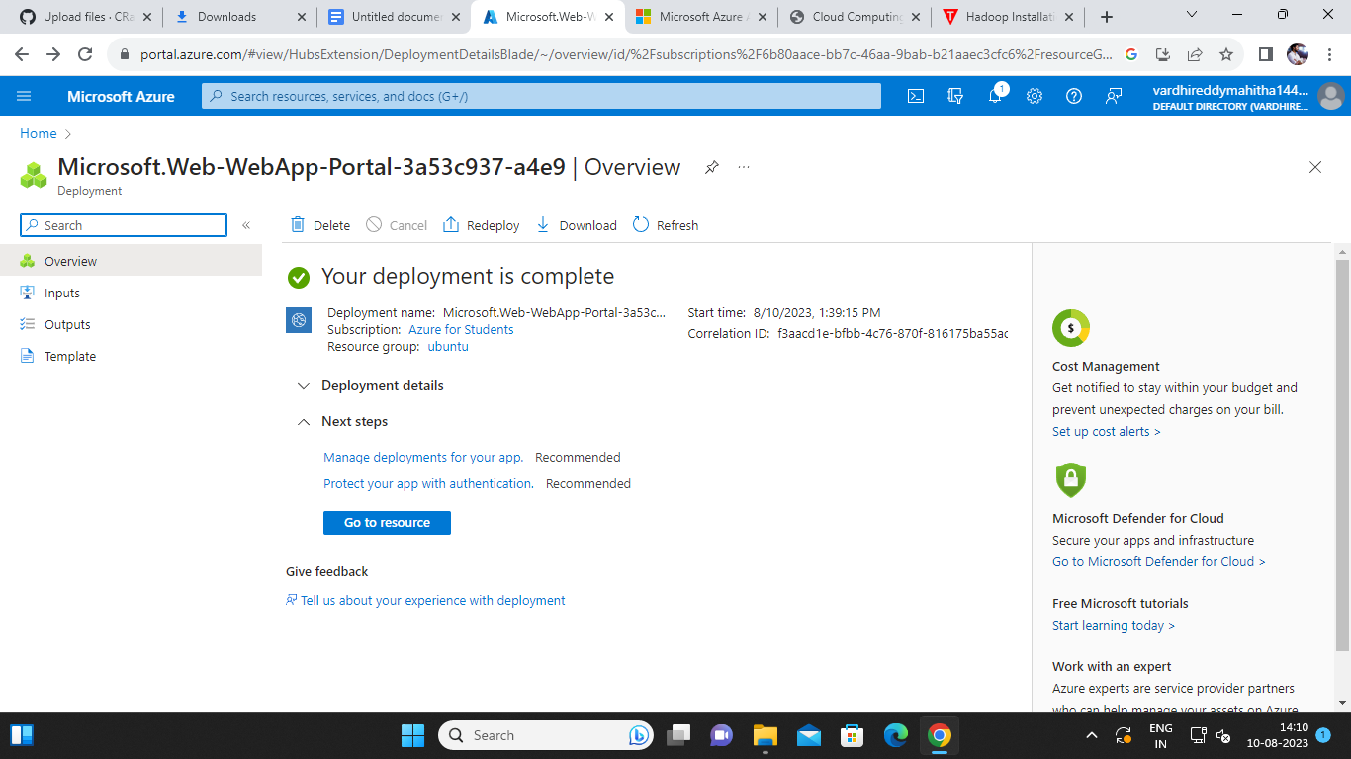

Open the app service and open the website that created



Click on the default domain link.

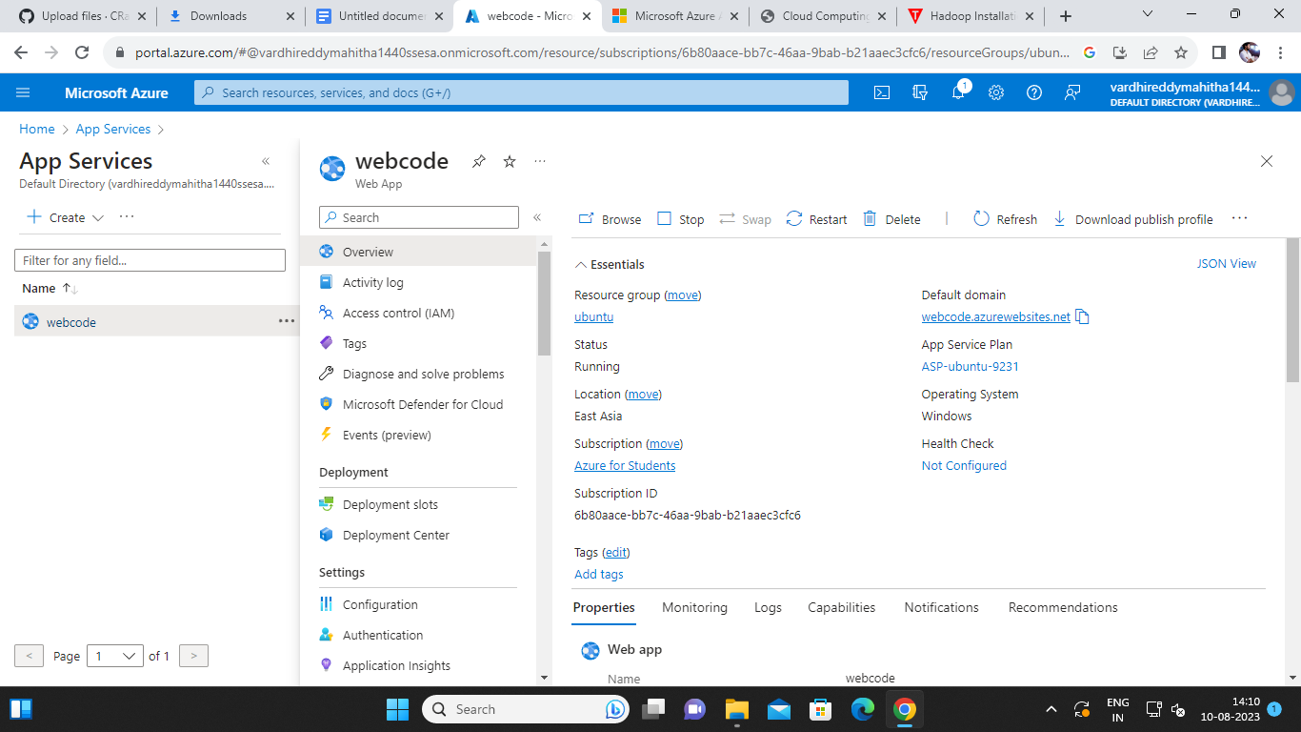

Open that link and the website is created successfully.

