**EXPERIMENT-1**

**AIM-**

TO CREATE A SIMPLE CLOUD SOFTWARE APPLICATION AND PROVIDE IT AS A SERVICE USING ANY CLOUD SERVICE PROVIDER TO DEMONSTRATE SOFTWARE AS A SERVICE (SAAS).

**Login to www.zoho.com**

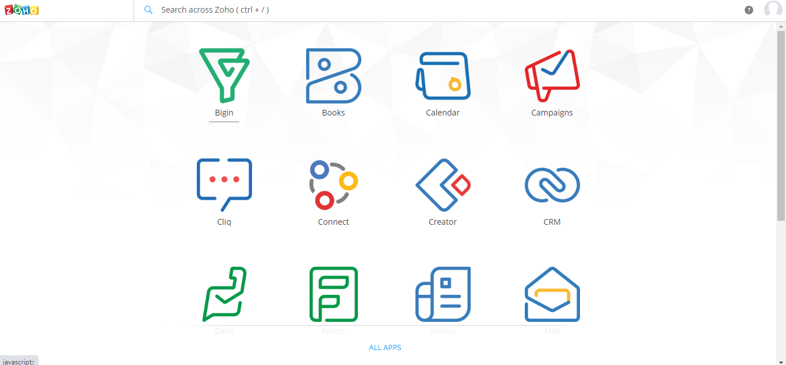

**Click o the forms option and click on new forms**

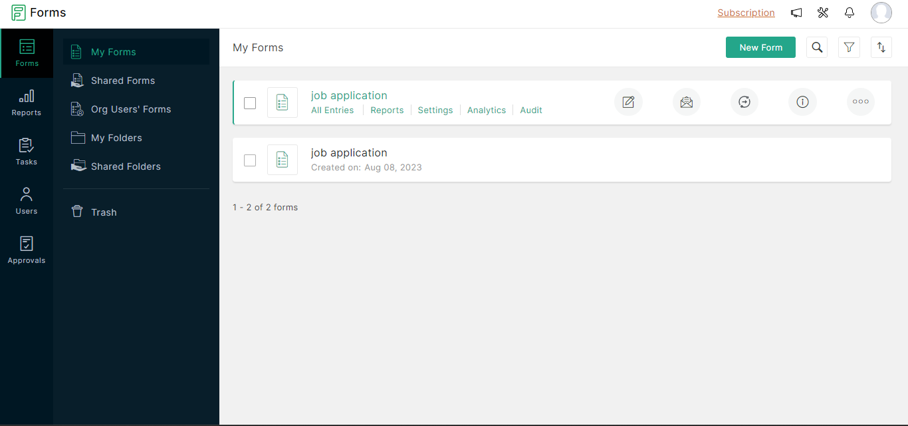

**Create your required form**

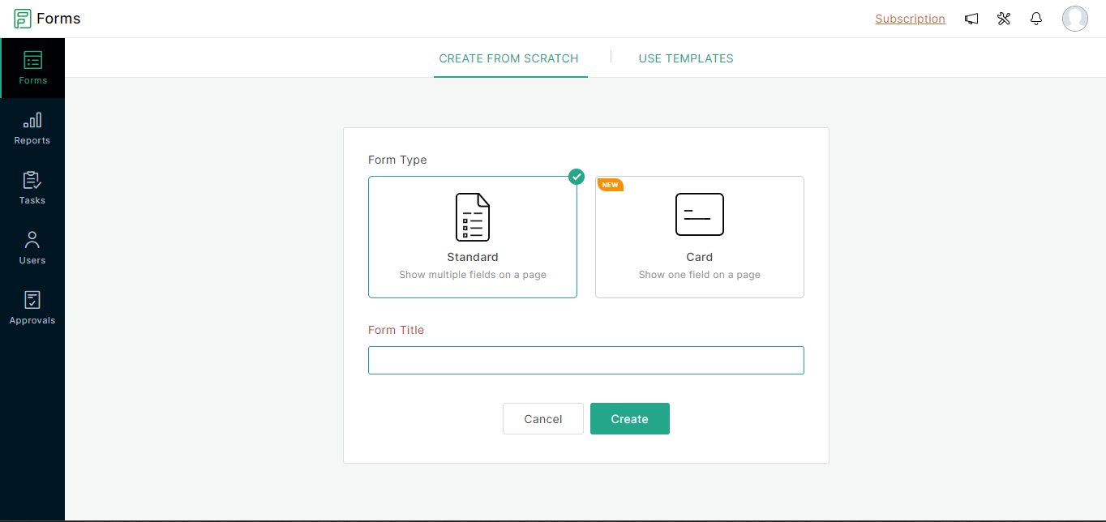

**Complete the whole form with required files**

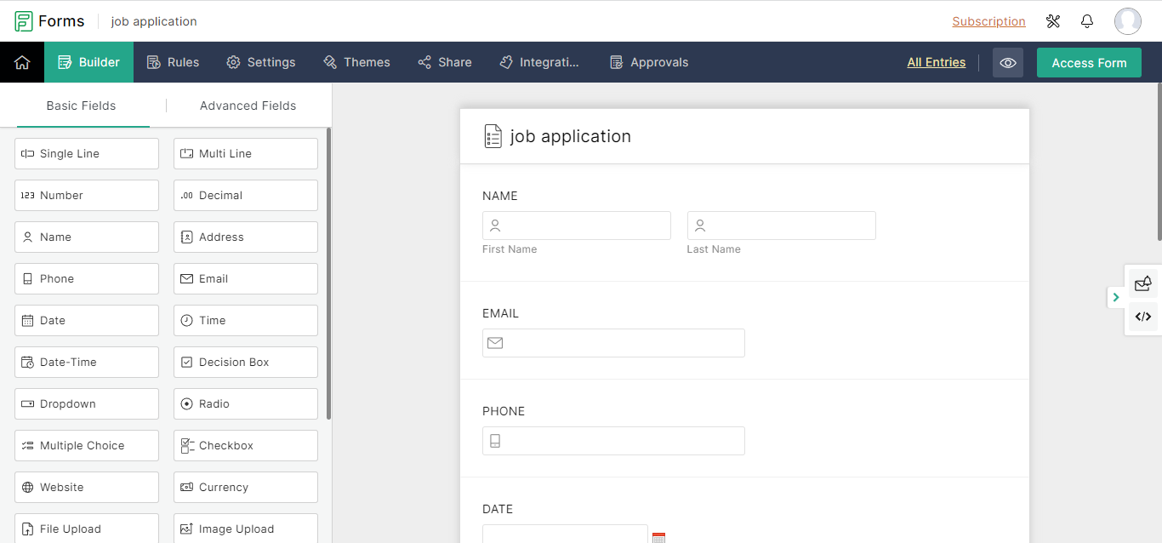

**This is the form**