Technical details

Spring Boot

Maven

H2

Junit

Steps to run the Application

1. Do the project check out from git
2. Do maven import of the project
3. Do maven clean install
4. Right click and run the project using as Java application (run as🡪Java Application)

Follow below steps to get the reward points calculations

<http://localhost:8080/createData> 🡪 this will calculate the reward points and create dataset information in H2 DB.

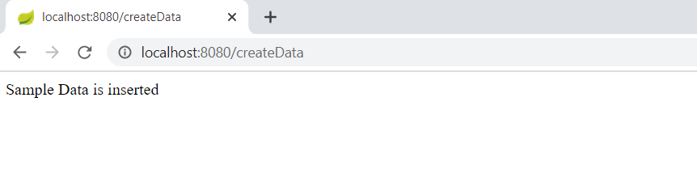

<http://localhost:8080/getRewardPoints?customerName=customer1> 🡪 Get the customer total earning points and monthly wise total earning points

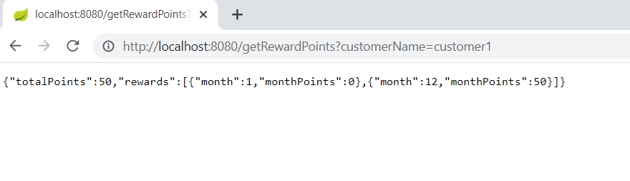

[http://localhost:8080/getRewardPoints?customerName=customer](http://localhost:8080/getRewardPoints?customerName=customer1)2 🡪 Get the customer total earning points and monthly wise total earning points

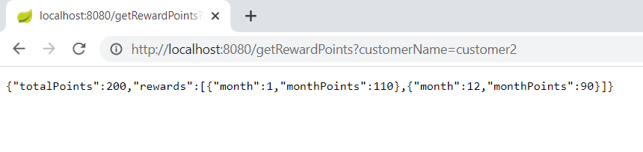

Run Junit test cases

Run RetailerRewardsTest.Java , for running unit test cases

