NO SQL TASKS

TASK:1

Import beer sample

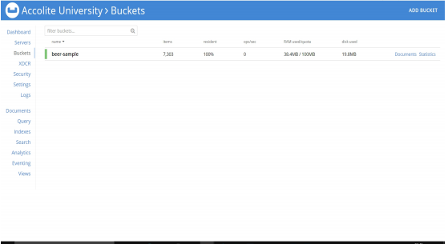

TASK 2:

Write a join query to fetch the Top 10 brewery(type=”beer”) and their country(type=”brewery”) which produces more varieties of beers

Query:

select b1.name as beer_name, b2.country as country_name FROM `beer-sample` b1 JOIN `beer-sample` b2 ON KEYS b1.brewery_id WHERE b1.type="beer" AND b2.type="brewery" LIMIT 10

OUTPUT:

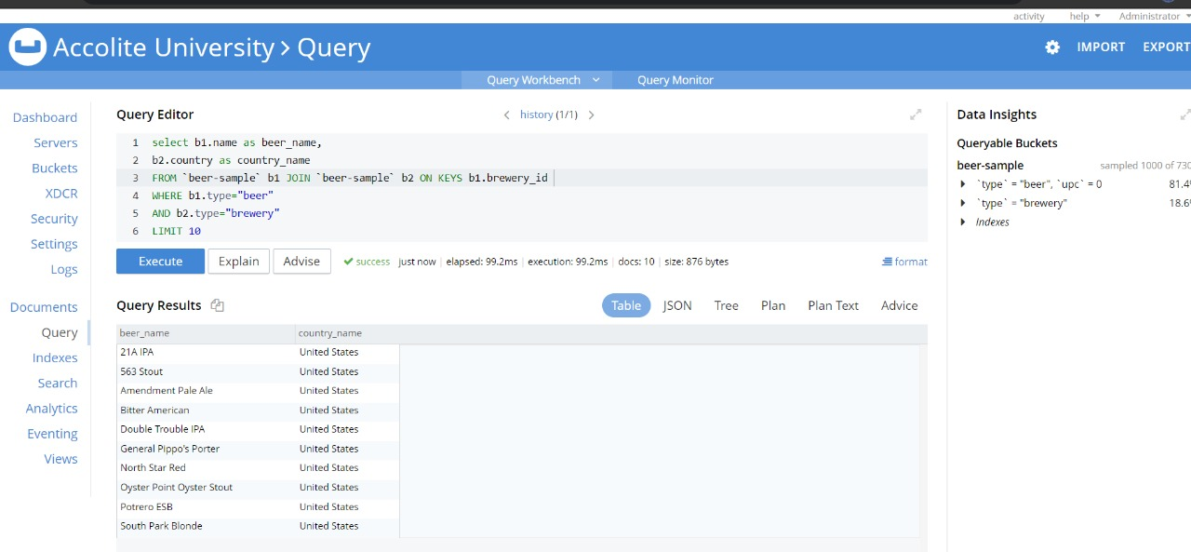

beer_name country_name

"21A IPA" "United States"

"563 Stout" "United States"

"Amendment Pale Ale" "United States"

"Bitter American" "United States"

"Double Trouble IPA" "United States"

"General Pippo's Porter" "United States"

"North Star Red" "United States"

"Oyster Point Oyster Stout" "United States"

"Potrero ESB" "United States"

"South Park Blonde" "United States"

TASK 3:

. Write a mapreduce to get the number of breweries based on country. Please attach the mapreduce code and json output screenshot.

TASK 4:

XDCR: a) Add a new bucket “Brewery”. b) Create a XDCR with a filter(type=’brewery’) to replicate only the brewery entity from `beer-sample` bucket.

