Assignment-4.2
2303A52321
K.Saikrishna

Task Description-1
• Zero-shot: Prompt AI with only the instruction. Write a Python function to determine
whether a given number is prime
Expected Output-1
• A basic Python function to check if a number is prime, demonstrating correct logical
conditions without relying on examples or additional context
prompt:
Write a Python function to determine whether a given integer is a prime number.
Return True if it is prime and False otherwise, return the error
Code:
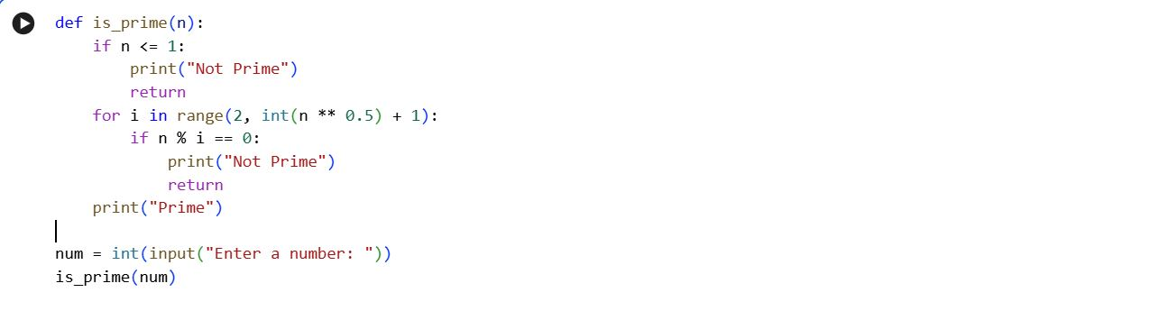
Output:
Explanation of code:
The function first checks if the number is less than or equal to 1 and prints Not Prime if true.
It then checks divisibility from 2 up to the square root of the number to find any factors.
If no divisor is found, it prints Prime; otherwise, it prints Not Prime.
Observation:
The program efficiently determines whether a number is prime by checking divisors only up to its square root.
It correctly handles edge cases such as numbers less than or equal to 1
Task Description-2
• One-shot: Provide one example: Input: [1, 2, 3, 4], Output: 10 to help AI generate a
function that calculates the sum of elements in a list.
Expected Output-2
• A correct conversion function guided by the single example.
Prompt:
Write a Python function to calculate the sum of all elements in a list.
Example: Input [1, 2, 3, 4] : Output 10
Code:
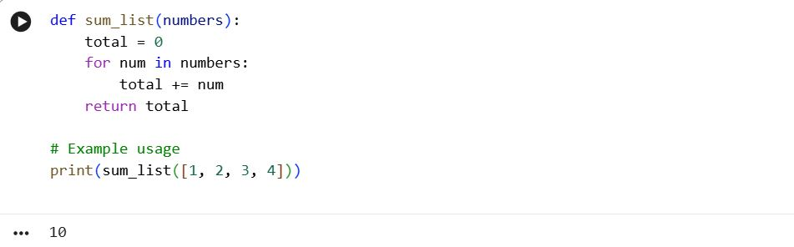
Explanation of code:
• The function initializes a variable to store the total and adds each element of the list to it using a loop.
• Finally, it returns the total sum of all elements in the list.
Observation:
1). The program correctly computes the sum of list elements using a simple and clear loop-based approach.
2). The single example effectively guides the function’s expected behavior.
Task Description-3
• Few-shot: Give 2–3 examples to create a function that extracts digits from an
alphanumeric string.
Expected Output-3
• Accurate function that returns only the digits from alphanumeric string
Prompt:
Write a Python function that extracts and returns only the digits from a given alphanumeric string.
Examples: "a1b2c3" → "123", "x9y8z7" → "987", "abc" → "".
Code:

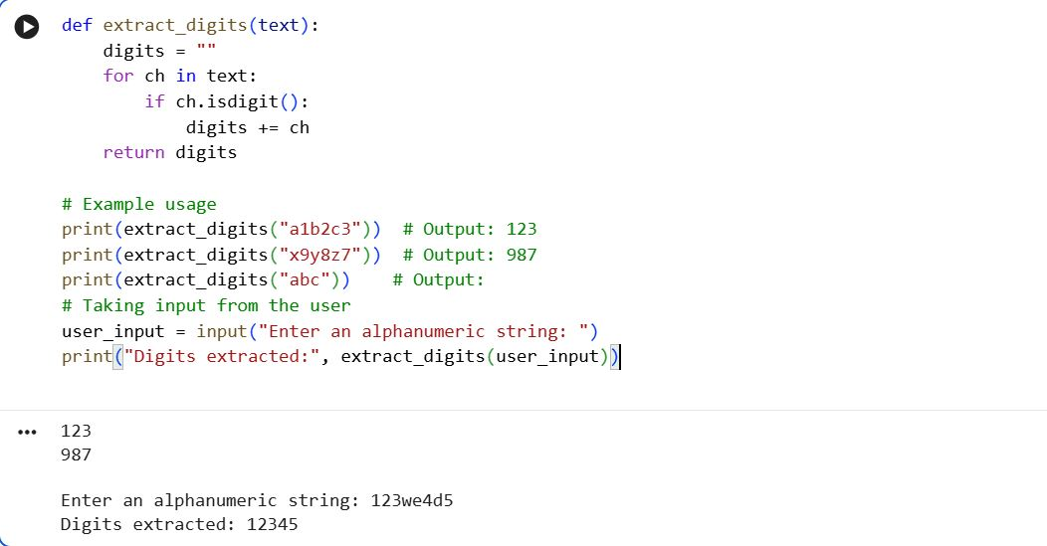
Explanation of code:
The extract_digits function loops through each character of the input string and appends it to digits if it is a numeric character.
The program prompts the user to enter an alphanumeric string.
It then calls the function with the user input and prints the extracted digits.
Task Description-4
• Compare zero-shot vs few-shot prompting for generating a function that counts the
number of vowels in a string.
Expected Output-4
• Output comparison + student explanation on how examples helped the model.
Prompt:
Write a Python function that counts the number of vowels in a string.
Consider only a, e, i, o, u (both uppercase and lowercase) as vowels.
Example: "Apple" → 2, "Orange" → 3, "Sky" → 0.
Code:
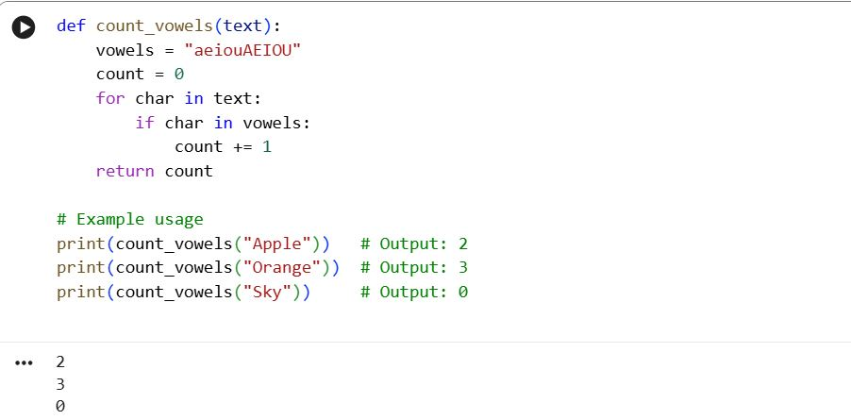

Explanation of code:
The function count_vowels loops through each character of the input string.
It checks if the character is a vowel (a, e, i, o, u) in either uppercase or lowercase.
If a vowel is found, it increments a counter.
Finally, the function returns the total count of vowels in the string.
Task Description-5
• Use few-shot prompting with 3 sample inputs to generate a function that determines
the minimum of three numbers without using the built-in min() function.
Expected Output-5
• A function that handles all cases with correct logic based on example patterns.
Prompt:
Write a Python function to find the minimum of three numbers without using the built-in min() function.
Example 1: Input: (5, 2, 9) → Output: 2
Example 2: Input: (7, 7, 3) → Output: 3
Example 3: Input: (4, 4, 4) → Output: 4
Code:
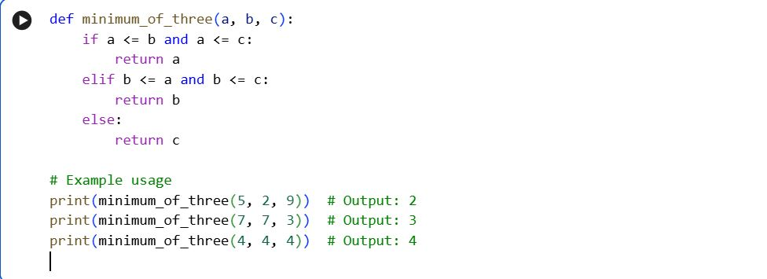
Explanation of code:
The function compares the three numbers using conditional statements to find the smallest.
First, it checks if a is less than or equal to both b and c. If so, it returns a.
Otherwise, it checks if b is the smallest; if true, it returns b.
If neither a nor b is the smallest, c is returned.
Observation:
The few-shot examples help the AI understand how to handle ties and equal values.
It ensures that all edge cases, like multiple equal minimums, are correctly handled.

