AI – ASSIGNMENT – 8.2
2303a52321
K.SAIKRISHNA
Task 1 – Test-Driven Development for Even/Odd Number Validator
• Use AI tools to first generate test cases for a function is_even(n)
and then implement the function so that it satisfies all generated
tests.
Requirements:
• Input must be an integer
• Handle zero, negative numbers, and large integers
Example Test Scenarios:
is_even(2) → True
is_even(7) → False
is_even(0) → True
is_even(-4) → True
is_even(9) → False
Expected Output -1
• A correctly implemented is_even() function that passes all AI-
generated test cases.
PROMPT:
Use Test-Driven Development (TDD) to first generate test cases for a Python function is_even(n)The function should accept only integer inputs and correctly handle zero, negative numbers, and large integers. Then implement the function so that it passes all the generated test cases and returns True for even numbers and False for odd numbers.
CODE:
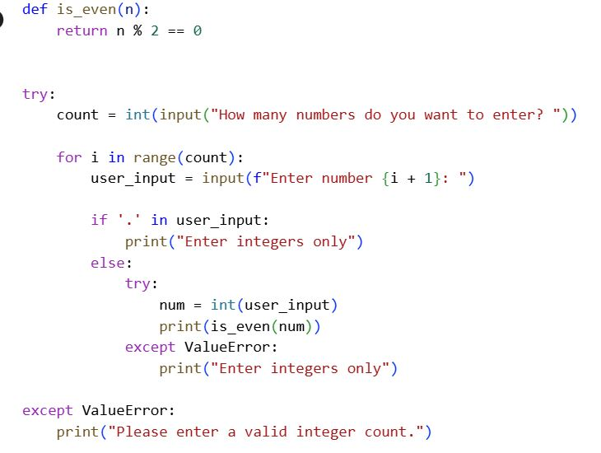
Output:
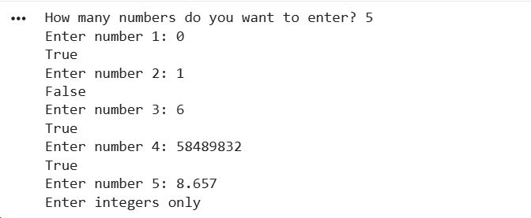
Explanation of code:
This program first defines a function is_even(n) that returns True if a number is even and False if it is odd using the modulus operator. It then asks the user how many numbers they want to enter and converts this value into an integer using a try block to handle invalid input. For each number entered, the program checks if the input contains a decimal point and, if so, prints a message asking for integers only. If the input does not contain a decimal, it attempts to convert the value into an integer and prints whether it is even or odd. Any invalid inputs, including non-integer values, are safely handled using try-except blocks to prevent the program from crashing.
Task 2 – Test-Driven Development for String Case Converter
• Ask AI to generate test cases for two functions:
• to_uppercase(text)
• to_lowercase(text)
Requirements:
• Handle empty strings
• Handle mixed-case input
• Handle invalid inputs such as numbers or None
Example Test Scenarios:
to_uppercase("ai coding") → "AI CODING"
to_lowercase("TEST") → "test"
to_uppercase("") → ""
to_lowercase(None) → Error or safe handling
Expected Output -2
• Two string conversion functions that pass all AI-generated test
cases with safe input handling.
Prompt:
Use Test-Driven Development (TDD) to first generate test cases for two Python functions, to_uppercase(text) and to_lowercase(text). The functions should correctly handle empty strings, mixed-case input, and safely manage invalid inputs such as numbers or None.
Code:
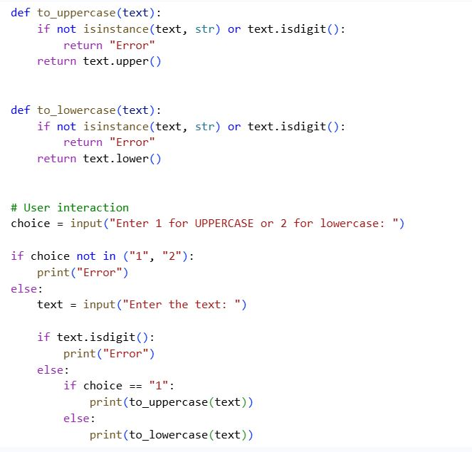
Output:
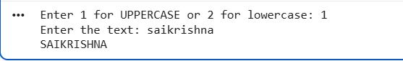
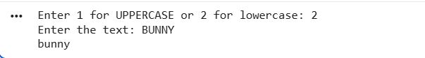
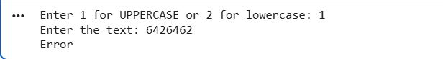
Explanation of code:
This Python program converts user-entered text to either uppercase or lowercase based on the user’s choice. It first defines two functions that check whether the input is a valid string and not purely numeric; otherwise, they return "Error". The program then asks the user to choose between uppercase or lowercase conversion. If the choice is invalid, it prints an error message immediately. Finally, it takes the text input and applies the selected conversion function, displaying the result if the input is valid.
Task 3 – Test-Driven Development for List Sum Calculator
• Use AI to generate test cases for a function sum_list(numbers)
that calculates the sum of list elements.
Requirements:
• Handle empty lists
• Handle negative numbers
• Ignore or safely handle non-numeric values
Example Test Scenarios:
sum_list([1, 2, 3]) → 6
sum_list([]) → 0
sum_list([-1, 5, -4]) → 0
sum_list([2, "a", 3]) → 5
Expected Output 3
• A robust list-sum function validated using AI-generated test
cases.
Prompt:
Generate Python test cases using Test-Driven Development for a function sum_list(numbers).
The function should correctly return the sum of numeric elements in a list.
It must handle empty lists, negative numbers, and safely ignore non-numeric values.
Ensure the function is robust and passes all generated test cases.
Code:
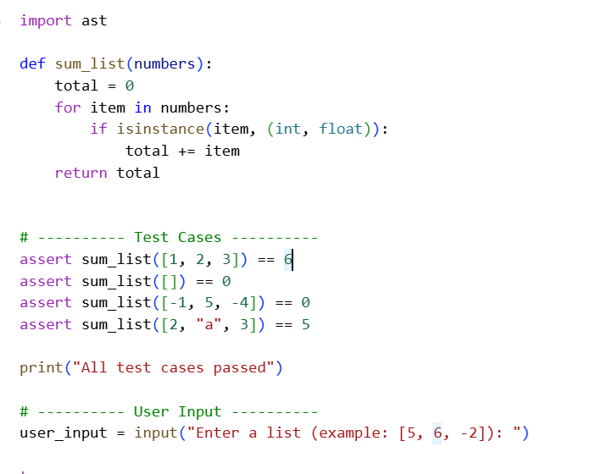
Output:
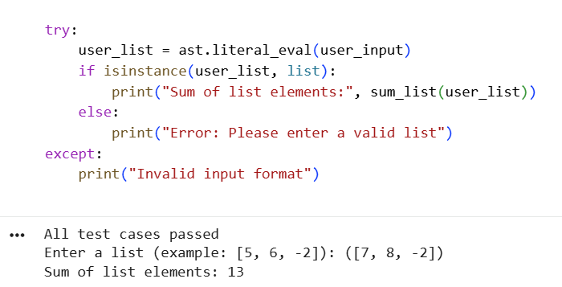

Explanation of the Code
The sum_list function initializes a variable total to store the sum. It iterates through each element in the list and adds only numeric values (int or float) to the total, ignoring non-numeric items. This ensures safe handling of mixed data types. The test cases validate correct behavior for empty lists, negative values, and invalid inputs, confirming the function works as expected.
Task 4 – Test Cases for Student Result Class
• Generate test cases for a StudentResult class with the following
methods:
• add_marks(mark)
• calculate_average()
• get_result()
Requirements:
• Marks must be between 0 and 100
• Average ≥ 40 → Pass, otherwise Fail
Example Test Scenarios:
Marks: [60, 70, 80] → Average: 70 → Result: Pass
Marks: [30, 35, 40] → Average: 35 → Result: Fail
Marks: [-10] → Error
Expected Output -4
• A fully functional StudentResult class that passes all AI-
generated test
Prompt:
Generate AI-based test cases using Test-Driven Development for a Python StudentResult class. The class should include methods to add marks, calculate the average, and determine pass or fail status. Ensure marks are validated to be between 0 and 100 and handle invalid inputs safely. The final implementation should accept user input and pass all generated test cases.
Code:

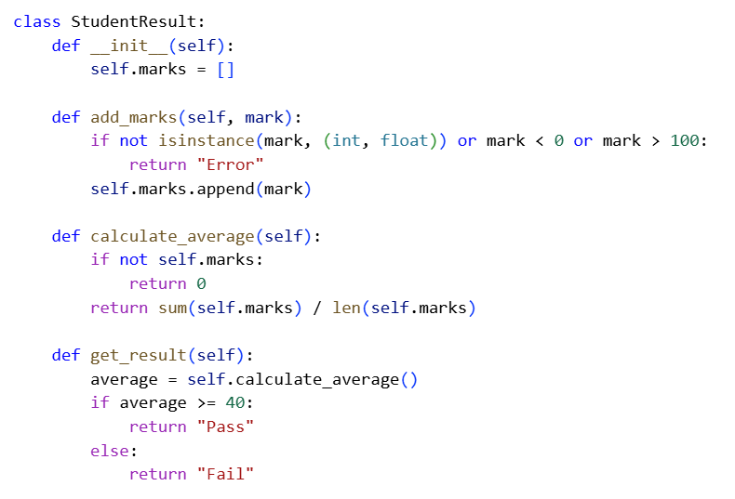
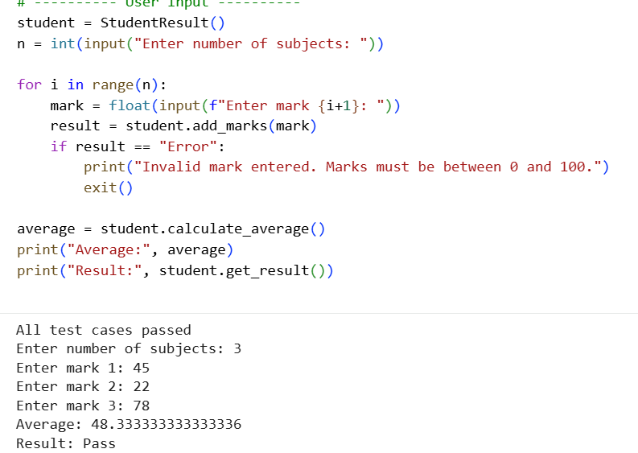

Explanation of code:
This program defines a StudentResult class to store and manage student marks with proper validation. The add_marks() method ensures only marks between 0 and 100 are accepted, while calculate_average() computes the mean of the marks. The get_result() method decides whether the student passes or fails based on an average of 40. Test cases verify correctness, and user input is taken to display the final average and result.
Task 5 – Test-Driven Development for Username Validator
Requirements:
• Minimum length: 5 characters
• No spaces allowed
• Only alphanumeric characters
Example Test Scenarios:
is_valid_username("user01") → True
is_valid_username("ai") → False
is_valid_username("user name") → False
is_valid_username("user@123") → False
Expected Output 5
A username validation function that passes all AI-generated test cases.
Prompt:
Generate AI-based test cases using Test-Driven Development for a Python function is_valid_username(username). The function should validate usernames with a minimum length of five characters. It must reject usernames containing spaces or non-alphanumeric characters. Ensure the final implementation passes all generated test cases.
Code:
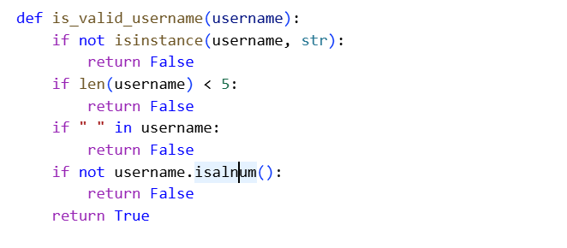

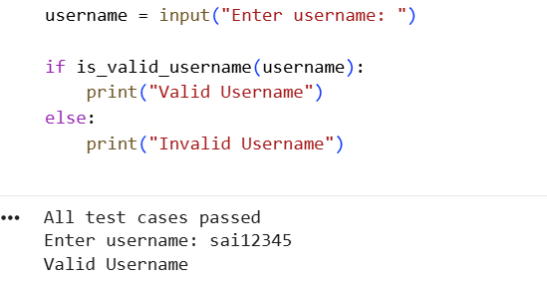
Output:
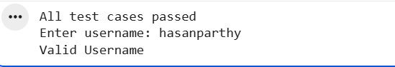
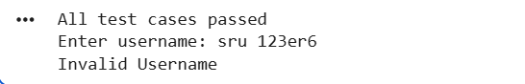

Explanation of code:
This program defines a function to validate usernames based on length, spaces, and allowed characters. It checks that the username is at least five characters long, contains no spaces, and includes only alphanumeric characters. Test cases using assert statements confirm the function works correctly before user interaction.

