Lab 20 – Security Testing: Identifiying Vulnerabilities in AI-Generated Code

Task 1 – Password Security Enhancement
Task: Analyze an AI-generated Python program that stores passwords in plain text and improve its security.

Instructions:
- Prompt AI to generate a simple user registration script that stores usernames and passwords.
- Check whether passwords are stored as plain text.
- Identifiy the security risks associated with plain-text password storage.
- Refiactor the program to use secure password hashing (e.g., hashlib or bcrypt).
- Test the updated script to ensure proper authentication fiunctionality.
Prompt
"Generate a vulnerable Python script fior user registration that stores passwords in plain text. Explain the security risks. Then, provide a refiactored, secure version ofi the script that uses the built-in hashlib library to hash passwords with a salt befiore storing them, and include a login fiunction to test authentication."
Code

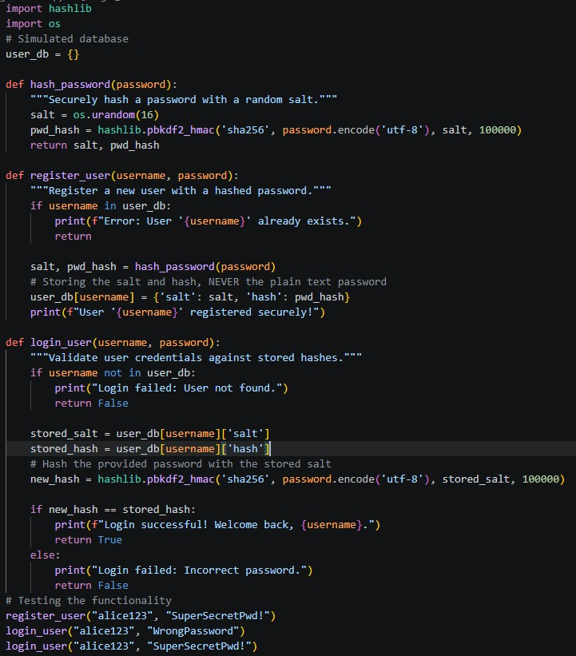

Output
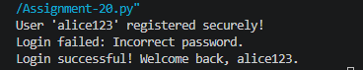

Explanation
Storing plain-text passwords exposes users to severe risks ifi the database is breached, allowing attackers immediate access to accounts. The refiactored code neutralizes this threat by hashing the password using pbkdfi2_hmac combined with a unique, random salt, ensuring the original password cannot be mathematically reversed.

Task 2 – Secure API Key Management
Task: Evaluate an AI-generated script that uses hardcoded API keys and improve its security.

Instructions:
- Ask AI to generate a Python script that connects to an external API using a hardcoded API key.
- Identifiy the risks ofi embedding sensitive credentials directly in the source code.
- Refiactor the program to use environment variables fior storing API keys securely.
- Demonstrate that the modifiied script successfiully retrieves data without exposing credentials.
Prompt
"Create a Python script that connects to a hypothetical weather API using a hardcoded API key. Explain why hardcoding API keys is dangerous. Then, refiactor the code to securely retrieve the API key firom environment variables using os.getenv(), adding error handling ifi the key is missing."
Code

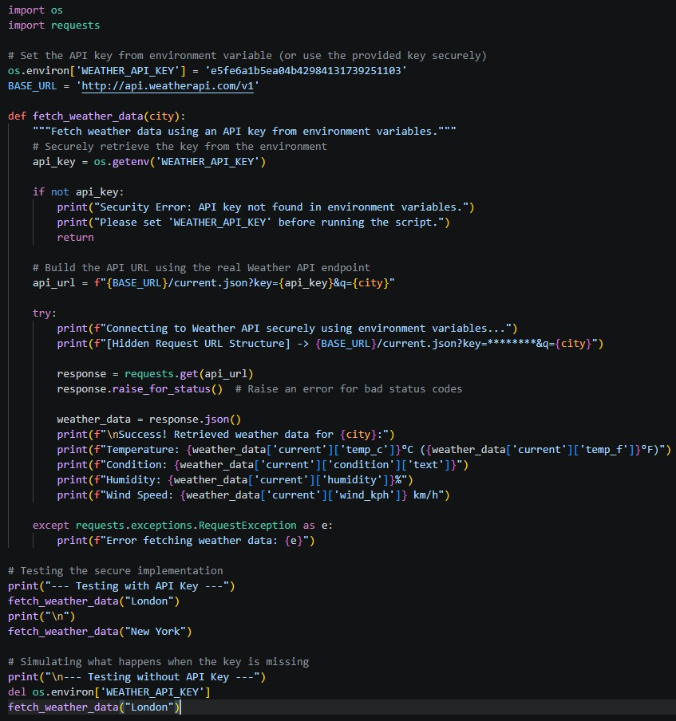

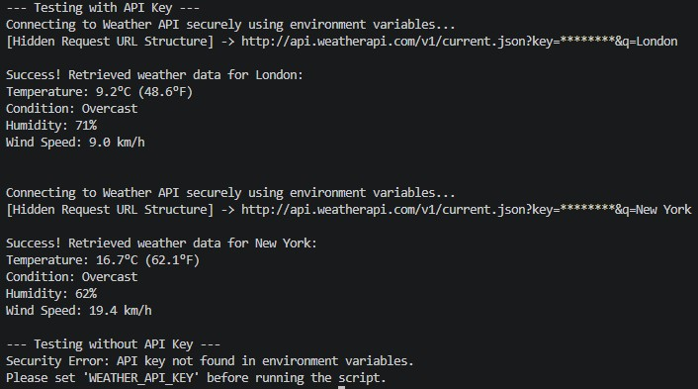
Output

Explanation
Hardcoding API keys in source code risks exposing sensitive credentials when code is pushed to public repositories, leading to potential data breaches and massive fiinancial charges. The secure version leverages the os module to pull the API key dynamically firom the system's environment variables, keeping secrets strictly out ofi the codebase.

Task 3 – Weak Encryption Detection
Task: Examine an AI-generated program that uses weak encryption techniques and strengthen it.

Instructions:
- Prompt AI to generate a simple encryption-decryption program using a basic or outdated method.
- Identifiy weaknesses in the encryption approach (e.g., reversible encoding or outdated algorithms).
- Refiactor the program using stronger encryption techniques available in Python libraries.
- Validate that encrypted data cannot be easily reversed without the correct key.
Prompt

"Provide a Python script that 'encrypts' a string using Base64 encoding and explain why this is considered weak/insecure. Then, refiactor the program to use strong, modern encryption using the cryptography.fiernet symmetric encryption module to securely encrypt and decrypt a message."
Code
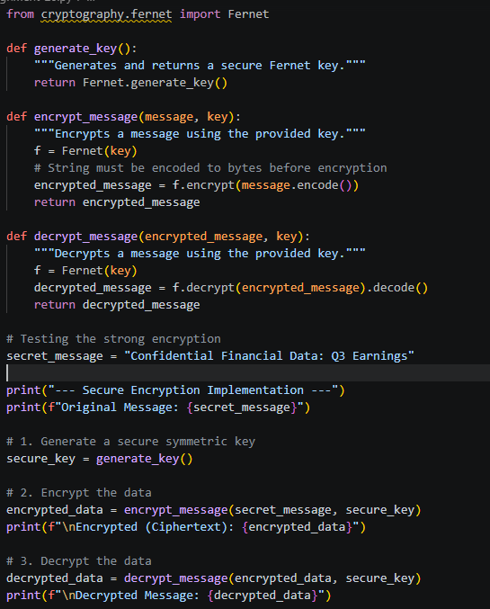

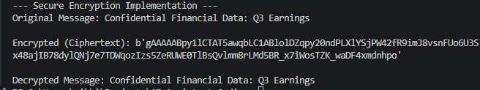
Output

Explanation
Base64 encoding is easily identifiiable and completely reversible by anyone without a key, making it merely an obfiuscation technique, not encryption. The refiactored code upgrades to AES-based symmetric encryption via the cryptography.fiernet module, ensuring that interceptors cannot read or tamper with the data without the securely generated secret key.

Task 4 – Real-Time Application: Security Review ofi AI- Generated Web Service
Scenario: Students select an AI-generated web service snippet (e.g., REST API, fiile upload handler, or authentication module).

Instructions:
- Perfiorm a structured security review ofi the generated code.
- Identifiy at least three potential vulnerabilities.
- Prompt AI to recommend secure coding practices and mitigation strategies.
- Implement the suggested improvements and test the secured version.
- Document the dififierences between the insecure and secured implementations.
Prompt
"Act as a security auditor. I have an AI-generated Flask SQLite snippet that uses fi- strings fior database queries (SQL Injection risk), has no error handling, and prints detailed database errors to the user. Document these three vulnerabilities. Then, provide the secured refiactored Python code using parameterized SQL queries and safie error messages."
Code

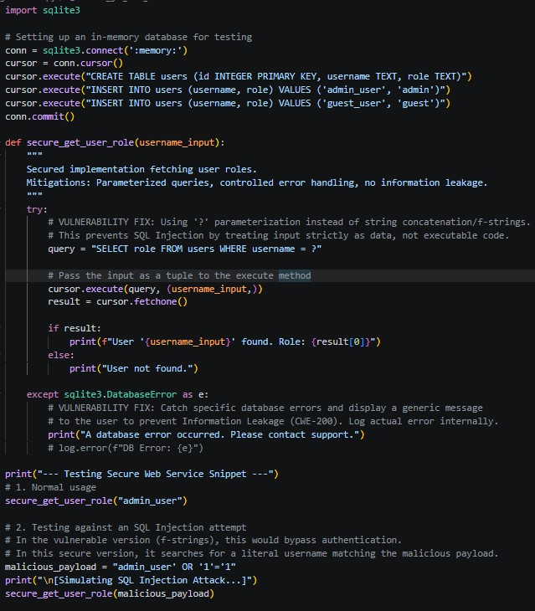

Output
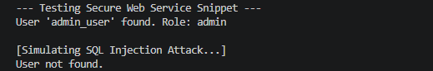

Explanation
The original snippet was vulnerable to SQL Injection, Infiormation Leakage, and Application Crashes. The secured version replaces dangerous fi-strings with ? parameter substitution (blocking SQL injection), and wraps the database call in a try-except block to return generic, safie error messages rather than exposing sensitive stack traces to potential attackers.

Task 5 – Exception Handling Improvement
Task: Analyze an AI-generated Python program that does not handle runtime errors and improve its reliability.

Instructions:
- Prompt AI to generate a simple program that takes user input and perfiorms arithmetic operations.
- Identifiy possible runtime errors (e.g., invalid input, division by zero).
- Modifiy the program to include proper try-except blocks.
- Provide meaningfiul error messages fior invalid inputs.
- Test the improved version with valid and invalid test cases.
Prompt
"Write a basic Python division calculator that prompts the user fior two numbers. Identifiy that it will crash on non-numeric input and division by zero. Then, provide a refiactored version using proper try-except blocks handling ValueError and ZeroDivisionError, displaying user-firiendly error messages."
Code

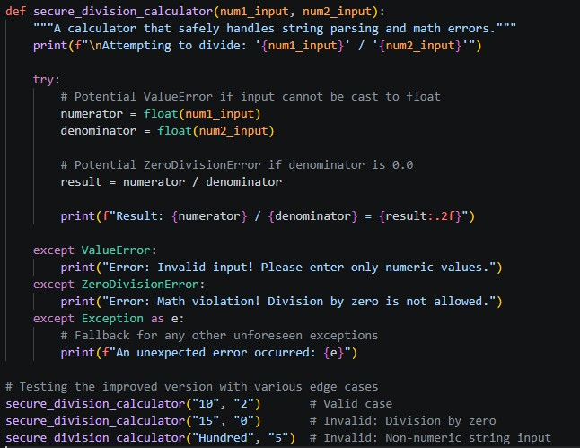

Output
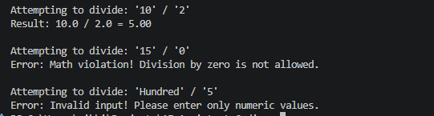

Explanation
A raw arithmetic script will abruptly terminate with ugly stack traces ifi a user inputs alphabetical characters or attempts to divide by zero. By encapsulating the type-casting and arithmetic operations within specifiic try-except blocks, the program elegantly traps these

exceptions and communicates the issue gracefiully, ensuring continuous uptime.

